PBIS Overview
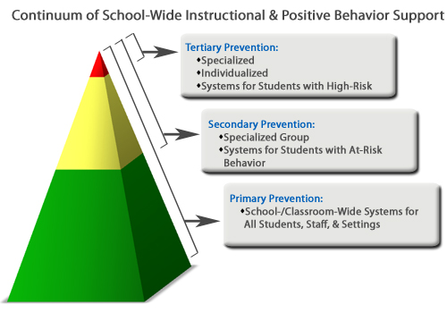
Schoolwide PBIS has 3 key components:

Tier I
Universal support/Primary Prevention—Your classroom management system must be successful with at least 80-85% of the population. Provision of support to all students in a wide range of school settings in a proactive way to enable students to receive support and recognition.
*Examples: School-wide Behavior Expectations
Paloma ticket store
Masters of Mindfulness
Student of the Month
Zones of Regulation
Paloma de Paz trimester Award

Tier II
Group support/Secondary Prevention—Supports for 10-15% of the population. Provision of support and intervention for students who have received universal support who require further intervention and support in order to experience success.
*Examples: Behavior Contracts
Check in Check Out (CHICO)
Daily Self-Evaluation
Student Incident Report (SIR)
Zones of Regulation
Circulos de Paz

Tier III
Individual support/Tertiary Prevention—This is for the remaining 5% of the population. The most intensive support provided to students on an individual basis who have not had their needs adequately met through universal and group support because they require more intensive supports specifically tailored to their strengths, preferences, and unique needs.
*Examples: Office Discipline Referral (ODR)
Counseling Referral
Coordination of Services Team (COST)
Functional Behavior Assessment (FBA)
Behavior Implementation plan (BIP)

