Character Counts
Months in review: 2023 – 2024
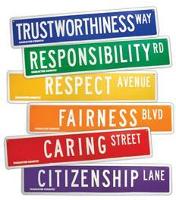

August, September: RESPONSIBILITY
October/November: RESPECT
December/January: TRUSTWORTHINESS
February: CARING
March: FAIRNESS
April: CITIZENSHIP
May: ALL TRAITS
Last updated 08/31/2022 NV

