Understanding Your BCBS Health & State Life Insurance Premiums and Pay Schedule
Important Information for New Hires
Welcome to your new job! We want to help you understand how your insurance premiums are paid, as your first paycheck may look a little different than you expect.
Your insurance premiums are paid a month in advance. This means that your first paycheck may have deductions for multiple months of coverage.
For example:
If you are hired on August 12th, your August paycheck will include deductions for both the full month of August and the full month of September.
- August Premium: $50 (Employee Only)
- September Premium: $50 (Employee Only)
- Total Deduction: $100
If you have additional people on your plan, such as a spouse or children, your total deduction will be higher. The specific costs are outlined in the Department of Finance and Administration's premium rate sheet. (If you are hired the 1st through the 14th you must pay a full month premium. If hired the 15 through the 31st, you will be responsible for one half of the month’s premium.)
Important Note on Pay Periods and Dates
Please remember that your pay is based on a pay period, not a calendar month. The number of days you work in a given month does not necessarily correspond to the number of days you'll be paid for in that month's paycheck. Usually for certified and annualized jobs, the yearly pay is determined and divided by 12 for 12 even payments.
Your Hire Date and Board Approval Date will also affect the date of your first paycheck.
Employees working 232 days checks run July through June.
All other Employees checks run August through July.
Attached are the current year's pay periods.
Important Note on Pay Rates
For details on pay scales, you can visit the district website at www.jcsd.ms and find the information under Policies (Section G).
If you have questions specific to your situation, please contact the Business Office.

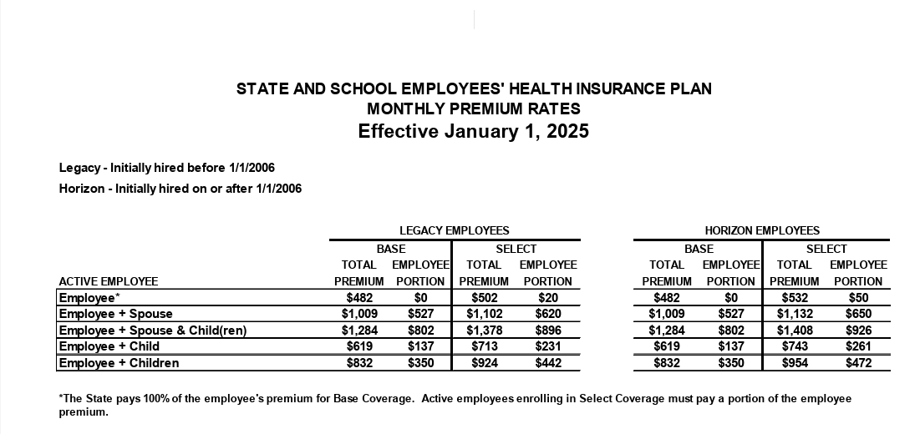
This rates subject to change in January of each year which will be reflected in your December check.
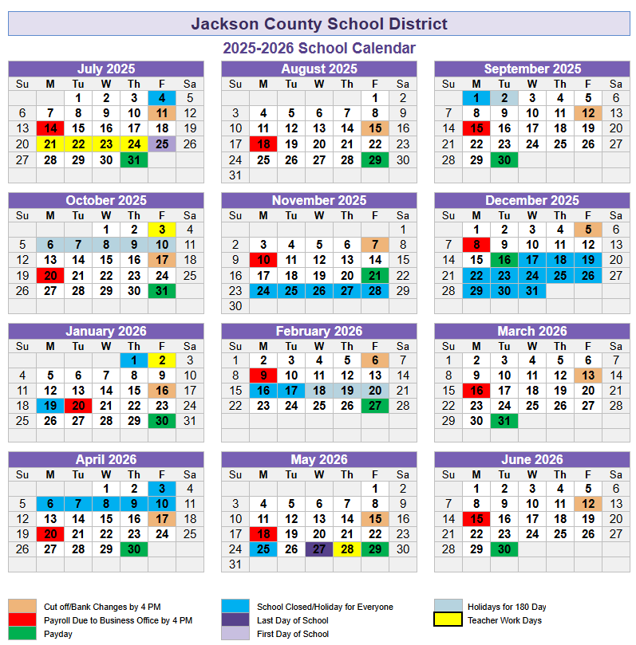

Pay Periods for Part Time and Import Jobs
Month | Cutoff | Time Period | Days in Period | Cumulative Days | Leave Period
July 2025 | 18-Jul | July 1- July 19 | 0 | 0 | n/a
August 2025 | 15-Aug | July 20 - Aug 16 | 16 | 16 | July 25 - Aug 15
September 2025 | 5-Sept | Aug 17 - Sept 6 | 13 | 29 | Aug 18 - Sept 12
October 2025 | 26-Sept | Sept 7 - Sept 27 | 15 | 44 | Sept 15 - Oct 17
November 2025 | 24-Oct | Sept 28 - Oct 25 | 14 | 58 | Oct 20 - Nov 7
December 2025 | 14-Nov | Oct 26 - Nov 15 | 15 | 73 | Nov 10 - Dec 5
January 2026 | 12-Dec | Nov 16 - Dec 13 | 15 | 88 | Dec 8 - Jan 16
February 2026 | 23-Jan | Dec 14 - Jan 24 | 16 | 104 | Jan 20 - Feb 6
March 2026 | 20-Feb | Jan 25- - Feb 21 | 15 | 119 | Feb 9 - Mar 13
April 2026 | 13-Mar | Feb 22 - Mar 14 | 15 | 134 | Mar 16 - April 17
May 2026 | 17-Apr | Mar 15 - Apr 18 | 19 | 153 | Apr 20 - May 15
June 2026 | 8-May | Apr 19 - May 9 | 15 | 168 | May 18 - June 12
July 2026 | 30-Jun | May 10 - June 30 | 12 | 180 | n/a
Transportation |  | Tutor - SIG - FT ((38) |  | PT ISI Assistant
Bus Aide - Regular (7)
Bus Aide - Blended (7) |  | Tutor SIG - PT (35)
Bus Driver - Regular (3) |  |  |  | PT Teacher Asst.
Bus Driver - Blended (3) |  | Tutor - SIG - As Needed (49)
Bus Aide - Sub (9)
Bus Driver - Sub (6) |  | District Tutor (36) |  | Tutor - Title I - PT (33)
ELDT Trainer
 |  | District Tutor/Teacher (36) |  | Tutor - Title I -- FT (32)
PT Custodian |  | Extra Curricular (19) |  | Tutor - Title I - As Needed (37)
 |  |  |  | Tutor - EL - PT (34)
PT Office Asst. |  | PT Food Service

