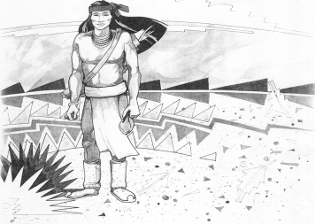
Cochise School District No. 26

5025 N. Bowie Ave.
P.O. Box 1088
Cochise, AZ 85606
(520) 384-2540 (520) 384-4836 Fax
Karl Uterhardt, Superintendent

COCHISE ELEMENTARY SCHOOL DISTRICT NO. 26

Notice is hereby given that the School District Governing Board will hold a public meeting on
August 6, 2025 following the public hearing in the media center, approximately 6:05pm.
The agenda for the meeting is as follows:

I. Call to Order Time _________

- Pledge of Allegiance to the Flag

- Adoption of Agenda Motion ____/____Vote____

IV. Call to the Audience (3 minute limit)

- The Governing Board may vote to go into Executive Session under A.R.S. 38-431.03 (A)(3) to receive legal advice either in person or telephonically, on any item on the Consent or Action agenda

VI. Consent Agenda
- Approve minutes of Regular Meeting of July 9, 2025
- Approve fund balances report for July 2025
- Approve Ms. Maria Hirshouer, School Website Coordinator
- Approve Mr. Joaquin Ochoa, Athletic Director
- Approve Mr. Robert Spitzer, Yearbook Director
- Approve Mrs. Sabrina Oscar, Testing Coordinator
- Approve Mrs. Tina Mascarenas, Knowledge Bowl Coach
- Approve vouchers Payroll #1-2 Expenditure #2500-2501 Motion ____/____Vote____

VII. Action Agenda
- Approve Mrs. Cristi Swan bid for the FY25 audit Motion____/____ Vote____
- Policy GDD Support staff vacations and holidays, 2nd reading Motion____/____ Vote____
- Approve FY26 School Tax Rate Motion____/____ Vote____

VIII. Summary of reports about current events
A. Superintendent’s Report
1. August calendar of events-School starts August 6, Meet the teacher night August 7, 4-6pm, VB game August 15, away, August 22 Home August 29, Bye
2. Future board meeting dates: September 3, October 1, November 5
B. Governing Board member’s report

IX. Adjourn Motion ____/____Vote____ Time ____

