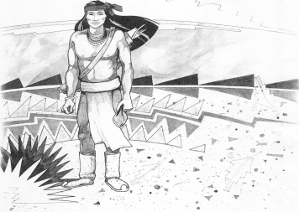
Cochise School District No. 26

5025 N. Bowie Ave.
P.O. Box 1088
Cochise, AZ 85606

(520) 384-2540 (520) 384-4836 Fax
Karl Uterhardt, Superintendent

NOTICE & AGENDA OF GOVERNING BOARD MEETING
COCHISE ELEMENTARY SCHOOL DISTRICT NO. 26

Notice is hereby given that the School District Governing Board will hold a public meeting on
June 25, 2025, at 6:00pm in the Cochise Elementary School Library.
The agenda for the meeting is as follows:

I. Call to Order Time _________

- Pledge of Allegiance to the Flag

- Adoption of Agenda Motion ____/____Vote____

- Call to the Audience (3 minute limit)

- The Governing Board may vote to go into Executive Session under A.R.S. 38-431.03 (A)(3) to receive legal advice either in person or telephonically, on any item on the Consent or Action agenda.

VI. Consent Agenda
- Approve minutes of Regular Meeting of May 7, 2025
- Approve fund balances report for May 2025
- Policy Advisories 819-862 first reading
- Policy GDD Support staff vacations and holidays first reading
- Approve vouchers # (Payroll) & # (Expense) Motion ____/____Vote____

- Action Agenda
- Approval of FY26 Proposed Budget Motion____/____ Vote____
- Approval of Mrs. Kaylee Retana, Reading Interventionist FY26 Motion____/____ Vote____
- Approve St. David Consortium SY25-26 Motion____/____ Vote____
- Approval of Bus Repair RFP bids for SY25-26 Motion____/____ Vote____
- Approval of IT bids for SY25-26 Motion____/____ Vote____
- Approval of one year Audit Bid for FY25 Motion____/____ Vote____
- Approval for carpeting work for eight classrooms Motion____/____ Vote____
- Approval of Fence Bid SE property Motion____/____ Vote____
- Update on Board Member search Discussion Only

VIII. Summary of reports about current events
A. Superintendent’s Report
1. July calendar of events: Office closed July 3-4, School starts August 6th.
2. Next Board meetings: July 9, August 6, September 3
B. Governing Board member’s report

IX. Adjourn Motion ____/____Vote____ Time ____

