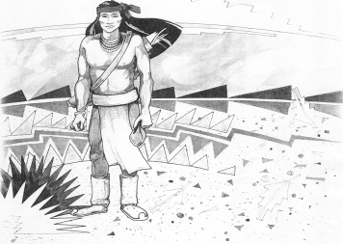
Cochise School District No. 26

5025 N. Bowie Ave.
P.O. Box 1088
Cochise, AZ 85606

(520) 384-2540 (520) 384-4836 Fax
Karl Uterhardt, Superintendent

NOTICE & AGENDA OF GOVERNING BOARD MEETING
COCHISE ELEMENTARY SCHOOL DISTRICT NO. 26

Notice is hereby given that the School District Governing Board will hold a public meeting on
May 7, 2025, at 6:00pm in the Cochise Elementary School Library.
The agenda for the meeting is as follows:

I. Call to Order Time _________

- Pledge of Allegiance to the Flag

- Adoption of Agenda Motion ____/____Vote____

- Call to the Audience (3 minute limit)

- The Governing Board may vote to go into Executive Session under A.R.S. 38-431.03 (A)(3) to receive legal advice either in person or telephonically, on any item on the Consent or Action agenda.

VI. Consent Agenda
- Approve minutes of Regular Meeting of April 2, 2025
- Approve fund balances report for April 2025
- Approve vouchers #21-22 (Payroll) & #2521-2522 (Expense) Motion ____/____Vote____

- Action Agenda
- Approve FY25 Expenditure Budget revision #1 Motion____/____ Vote____
- Approve policy advisories 809-818 second reading Motion____/____ Vote____
- Approve Ms. Marissa Paz, SPED paraeducator Motion____/____ Vote____
- Approve Superintendent Performance Pay FY25 Motion____/____ Vote____
- Presentation by Mrs. Cristi Swan, for Cochise School Audit FY24 Discussion Only
- Approve Cochise School Financial Audit for Fiscal Year 2024 Motion____/____ Vote____
- Approve Continuing Resolution with the Cochise County Treasurer Motion____/____ Vote____
- Approve Classroom site fund payment for teachers May 23, 2025 Motion____/____ Vote____

VIII. Summary of reports about current events
A. Superintendent’s Report
1. May calendar of events: Staff student VB game 5/16, School field day 5/20; Kinder & 4th promotion 5/21 1pm; 8th grade promotion 5/22 4pm; last day of school 5/23
2. Next Board meetings: June 25, July 9, August 6
3. AASA & AzSCI testing update
B. Governing Board member’s report

IX. Adjourn Motion ____/____Vote____ Time ____

