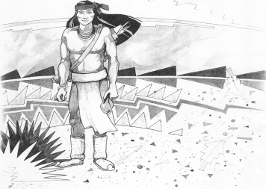
Cochise School District No. 26

5025 N. Bowie Ave.
P.O. Box 1088
Cochise, AZ 85606

(520) 384-2540 (520) 384-4836 Fax
Karl Uterhardt, Superintendent

NOTICE & AGENDA OF GOVERNING BOARD MEETING
COCHISE ELEMENTARY SCHOOL DISTRICT NO. 26

Notice is hereby given that the School District Governing Board will hold a public meeting on
April 2, 2025, at 6:00pm in the Cochise Elementary School Library.
The agenda for the meeting is as follows:

I. Call to Order Time _________

- Pledge of Allegiance to the Flag

- Adoption of Agenda Motion ____/____Vote____

- Call to the Audience (3 minute limit)

- The Governing Board may vote to go into Executive Session under A.R.S. 38-431.03 (A)(3) to receive legal advice either in person or telephonically, on any item on the Consent or Action agenda.

VI. Consent Agenda
- Approve minutes of Regular Meeting of March 5, 2025
- Approve fund balances report for March 2025
- Approve vouchers #19-20 (Payroll) & #2519-2520 (Expense)
- Approve policy advisories 809-818 first reading
- Approve Mrs. Mascarenas extra duty contract Knowledge Bowl
- Authorization to dispose of district property: Cafeteria Freezer Motion ____/____Vote____

- Action Agenda
- Mrs. Tina Rone, 1st grade teacher Discussion Only
- Approve raise of $1,000.00 for all full-time staff members Motion____/____ Vote____
- Approve contract for Mr. Uterhardt, Superintendent for the
2026-2027, 2027-2028, & 2028-2029 school years Motion____/____ Vote____
- Approve FY26 contract for Ms. Candy Acuna, Business Manager Motion____/____ Vote____
- Approve FY26 certified teaching contracts for:
Mrs. White, Mrs. Graham, Ms. Estrella, Mr. Ochoa, Ms. Hirshouer,
Mrs. Mascarenas, Mr. Spitzer, & Mrs. Oscar Motion____/____ Vote____
- Approve FY26 non-certified Letters of Intent for:
Ms. Peterson, Mr. D. Brown, Mr. Morales, Mrs. Williammee, Mr. AJ Brown,
Mrs. Cavey, and Mrs. Leksell Motion____/____ Vote____
- Approve Retirement of Mrs. Gina Nohl, Reading Interventionist
effective May 24, 2025. Motion____/____ Vote____

VIII. Summary of reports about current events
A. Superintendent’s Report
1. April calendar of events: AASA testing begins April 3, two track meets 4/3 & 4/29
2. Next Board meetings: May 7, June 25, July 9
B. Governing Board member’s report

IX. Adjourn Motion ____/____Vote____ Time ____

