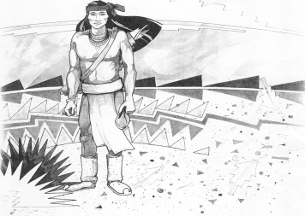
Cochise School District No. 26

5025 N. Bowie Ave.
P.O. Box 1088
Cochise, AZ 85606
(520) 384-2540 (520) 384-4836 Fax
Karl Uterhardt, Superintendent

COCHISE ELEMENTARY SCHOOL DISTRICT NO. 26

Notice is hereby given that the School District Governing Board will hold a public meeting on
September 3, 2025 following the public hearing in the media center, approximately 6:00pm.
The agenda for the meeting is as follows:

Swearing in of Mrs. Debra Regnier, Cochise Elementary School District No. 26 School Board Member

I. Call to Order Time _________

- Pledge of Allegiance to the Flag

- Adoption of Agenda Motion ____/____Vote____

IV. Call to the Audience (3 minute limit)

- The Governing Board may vote to go into Executive Session under A.R.S. 38-431.03 (A)(3) to receive legal advice either in person or telephonically, on any item on the Consent or Action agenda

VI. Consent Agenda
- Approve minutes of Regular Meeting of August 6, 2025
- Approve fund balances report for August 2025
- Approve vouchers Payroll #4-5 and Expenditure #2603-2605
- Approve Policy Advisories 866-875 First reading
- Declare John Deere Lawnmower as an auction item
- Declare old freezer in the kitchen as auction/trash item Motion ____/____Vote____

VII. Action Agenda
- Mrs. Lori White, 2nd grade teacher Discussion Only
- Approve increase in substitute pay to $115.00 Motion____/____ Vote____
- Approve Mr. Chris Ochoa Temporary Maintenance Motion____/____ Vote____
- Approve Superintendent’s performance goals 2025-2026 Motion____/____ Vote____
- Approve conflict of interest forms for Board members Motion____/____ Vote____

VIII. Summary of reports about current events
A. Superintendent’s Report
1. September calendar of events-Volleyball games on Fridays
2. Future board meeting dates: October 1, November 5, December 3
B. Governing Board member’s report

IX. Adjourn Motion ____/____Vote____ Time ____

