Cooperative Summer School
Attendance Reports
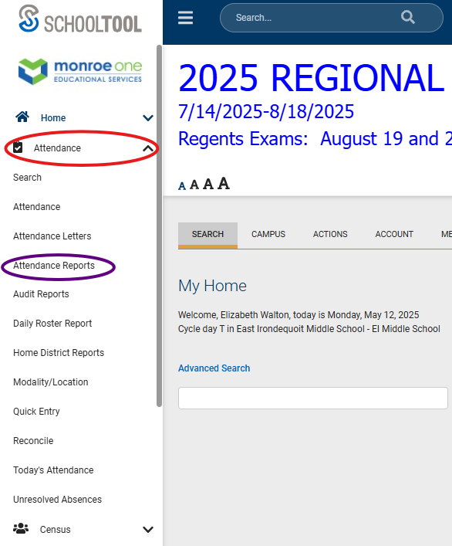
Step 1: Attendance Module
- Select the Attendance module in the left menu
- Under the Attendance module heading, select “Attendance Reports”

Step 2: Enter Needed Information
- Enter School Year: 2025-2026
- Select a Date Range or Marking Period

Step 3: Select Attendance Report Type:
- Period Attendance Report – Works best as a week by week range
- Summary Report – Choose attendance type, absentee reason, order by type, student, or date
- Summary of Attendance Report – 1 page/student
- Daily Overview: Order by student or date (no date range), search by student or all students
*left off here – need guidance

Step 4: Student Tab
- Once student has been created, go to the Student Tab within the student’s information page.
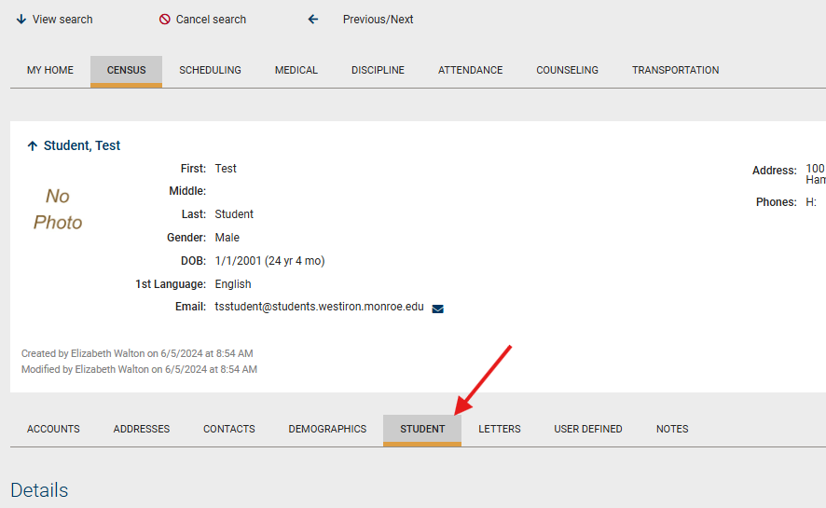
- Under Details, with Dropdown set on Enrollment, complete projected enrollment or enrollment process (see Counselor registration instructions)
Step 5: Select Courses
- See Counselor registration instructions
Step 6: Assign emails and portal logins
- Go to Census in the top menu bar of the student.
- Select Edit
- Add student email if not included.

- Select Accounts in 2nd menu
- Select
- Confirm creation of local account
- Select Generate New Password
- Select Primary Contact >
- Select Edit
- Add contact email if not included

- Select Accounts in 2nd menu
- Select
- Confirm creation of local account

