ART
Teacher | Course | Requested Materials
Mrs. Quattrociocchi  &  Mrs. Zakalik | PAINT AND DRAWING I AND II | - 20 x 30” portfolio  - 9x12” sketchbook (can be one already in use)  - 3 #2 pencils  - set of 24 Prismacolor pencils
Mrs. Quattrociocchi | AP ART AND DESIGN/PORTFOLIO | - 9x12 sketchbook (new)  - 2 pocket folder  - USB flash drive  - 20 x 30” portfolio
Mrs. Curran | GRAPHIC DESIGN I AND II | - USB flash drive  - 20 x 30 portfolio
Mrs. Curran | ANIMATION I AND II | - 5 #2 pencils  - 2 pocket folder  - 9 x12” spiral bound sketchbook  - USB flash drive  - headphones/earbuds  - 16G SD memory card
Mrs. Curran  Mrs. Quattrociocchi  &  Mrs. Zakalik | STUDIO ART | - 3 # 2 pencils  - 2 pocket folder  - 9 X 12” Spiral bound sketch book
Mrs. Quattrociocchi | PHOTOGRAPHY I | - USB flash drive  - 2 pocket folder  - Digital camera (recommended, not required)
 | ADVANCED PHOTOGRAPHY | - USB flash drive  - 2 pocket folder  Digital camera (recommended, not required)
Mrs. Zakalik | SCULPTURE I AND II | - 3 #2 pencils  - 2 pocket folder
 | CONTEMPORARY MATERIALS I AND II | - 3 #2 pencils  - 2 pocket folder

MATH
Teacher | Course | Requested Materials
Mr. Dougherty  Mrs. Lanctot  Mrs. Amann | Algebra 1 CC  Algebra 1 Part 2 | - Agenda or planner to keep track of assignments  - Pencils and Pens  - Loose-leaf paper or spiral notebook for note-taking  - 2-inch binder or 2-pocket folder for hand-outs  - TI-Nspire CX or CX II calculator to participate in class, complete assignments, and prepare for assessments. These calculators will be used during all 4 years of high school.  - Pad of graph paper
Mrs. Bonin  Mr. Catalfano  Mrs. Gunther | Geometry  Geometry CC  Geometry CC Honors | - Agenda or planner to keep track of assignments  - Pencils and Pens  - Loose-leaf paper or spiral notebook for notetaking  - 2-inch binder or 2-pocket folder for hand-outs  - Graph paper  - 12" ruler  - A compass  - Colored pencils or highlighters  - TI-Nspire CX or CX II calculator to participate in class, complete assignments, and prepare for assessments.
Mrs. Gunther  Mr. March  Mrs. Lanctot | Algebra 2  Algebra 2 CC  Algebra 2 CC Hon  Functions and Trig | - Agenda or planner to keep track of assignments  - Pencils and Pens  - Loose-leaf paper or spiral notebook for notetaking  - Graph Paper  - 2-inch binder or 2-pocket folder for hand-outs  - TI-Nspire CX or CX II calculator to participate in class, complete assignments, and prepare for assessments  - Pad of graph paper
Mrs. Gunther | Decision Making Math | Students may bring their own digital devices for accessing online resources in and out of school. If needed, computer access will be provided. Also required: Agenda or planner
Mr. Catalfano | Pre-Calculus | - TI-Nspire CX or CX II (CAS Calculators are allowed) will be used in class. It would benefit  students GREATLY to have their own in order to complete homework, study, and prepare for assessments.  - Loose-leaf paper or spiral notebook for note taking  - 2 in binder  - 2 pocket folder  - Pens and pencils  - An agenda or planner to keep track of assignments.
Ms. Stockslader  Mrs. Amann | Pre-Calculus Honors | - TI-Nspire CX or CX II (CAS Calculators are allowed) will be used in class. It would benefit  students GREATLY to have their own in order to complete homework, study, and prepare for assessments.  - A spiral notebook for note taking or 2 in binder with loose leaf paper  - 2 pocket folder  - Graph paper  - Pens and pencils  - An agenda or planner to keep track of assignments
Mr. March  Mr. Dougherty  Ms. Stockslader | College Math  AP Calculus AB  AP Calculus BC  Multivariable Calculus | - TI-Nspire CX or CX II (CAS Calculators are allowed) will be used in class. It would benefit students GREATLY to have their own in order to complete homework, study, and prepare for assessments.  - Loose-leaf paper or spiral notebook for note taking  - 2 in binder  - 2 pocket folder  - Graph paper
Mrs. Bonin  Mrs. Lanctot | AP Statistics | - TI-Nspire CX or CX II (CAS Calculators are allowed) will be used in class. It would benefit students GREATLY to have their own in order to complete homework, study, and prepare for assessments.  - Loose-leaf paper or spiral notebook for note taking  - 2 in binder  - 2 pocket folder  - Pens and pencils  - An agenda or planner to keep track of assignments
Mr. Catalfano | AP Computer Science | - Agenda or planner to keep track of assignments  - Loose-leaf paper or spiral notebook for note-taking  - 1-inch binder or 2-pocket folder for hand-outs

List and pictures of Calculators for High School Math:
Calculators for high school math.
NOTE: CAS calculators offer advanced computation techniques that are only permitted in higher levels of math. However, the CX II CAS allows teachers/students to disable the prohibited features when necessary. Note the two CAS calculators will say CAS in the top right corner.

Ti-nPsire CX | Ti-nSpire CX II | Ti-nSpire CX II CAS | Ti-nSpire CX CAS
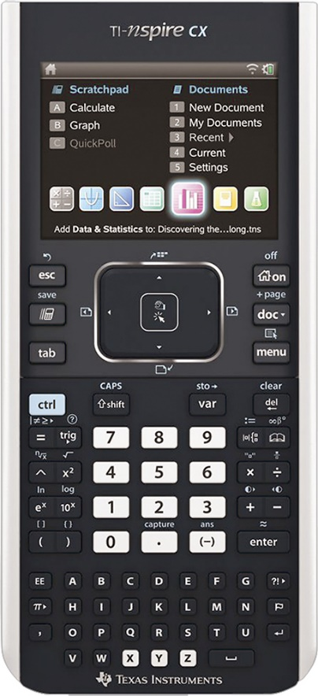 | 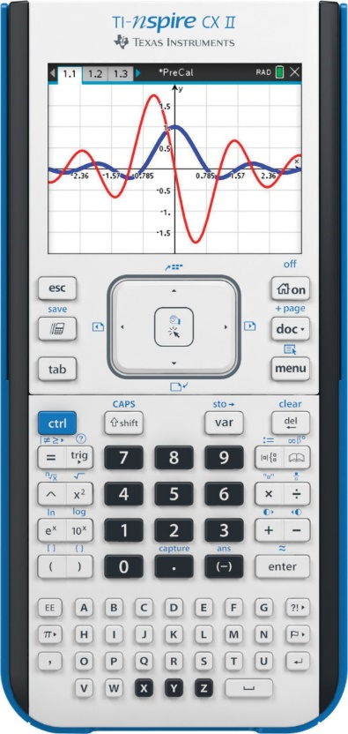 | 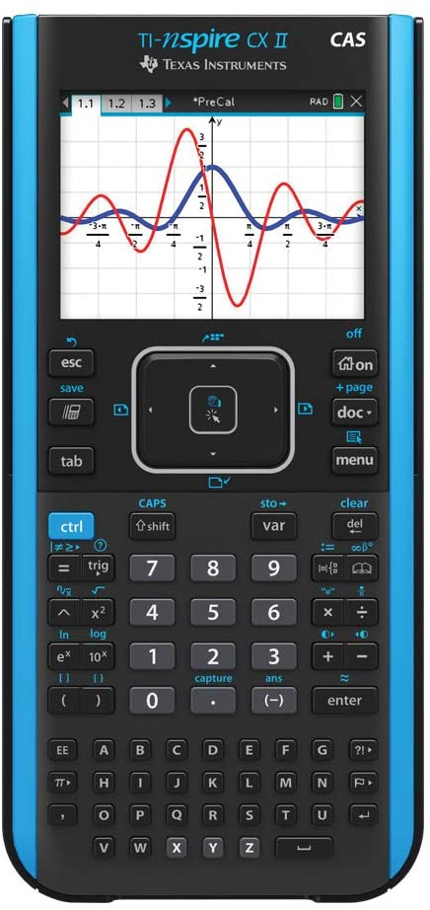 | 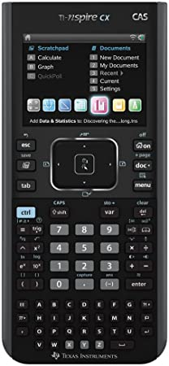
Can be used in:  - Algebra 1  - Geometry  - Algebra 2  - Functions and Trig  - Pre Calculus  - Calculus  - Statistics | Can be used in:  - Algebra 1  - Geometry  - Algebra 2  - Functions and Trig  - Pre Calculus  - Calculus  - Statistics | Can be used in:  - Algebra 1  - Geometry  - Algebra 2  - Functions and Trig  - Pre Calculus  - Calculus  - Statistics | Can be used in:  - Pre Calculus  - Calculus  - Statistics
BUSINESS
Teacher | Course | Requested Materials
 | Accounting | - Folder or binder  - Writing Utensils  - Calculator (any type can be used during instruction but a 4-function will be provided for assessments)
 | Financial Planning | - Folder or binder (can be shared with other classes)  - Writing Utensils  - Laptop and charger
 | Virtual Enterprise
 | Business Dynamics
 | Entertainment and Hospitality Management and Marketing
 | Sports Marketing and Management
 | Leadership Development Seminar
 | Keyboarding
 | Digital Business Strategies
 | Principles of Marketing | - Binder  - Writing utensils  - Laptop and charger
 | Work-Based Learning and Advanced Microsoft Applications | - Writing Utensils  - Laptop and charger

HEALTH
Teacher | Course | Requested Materials
James Hedler | Health | - Notebook  - Binder

ENGLISH
Teacher | Course | Requested Materials
Rachel McDonald | Literacy | One inch binder, one set of tabs
 |  | Sticky Notes/Composition NB/UBS drive/highlighters/multiple writing utensils/loose leaf paper/pocket folders
  All English Courses

SCIENCE
Teacher | Course | Requested Materials
Mr. Smith | AP Biology | - Basic four-function calculator (with square root)  - 3-ring binder larger than 1.5"
Mrs. Salerno | AP Biology | - 2 quad ruled composition notebooks (no spirals)  - Small binder or folder  - Calculator (four-function with square root, scientific, or graphing calculator)  - Highlighters, colored pencils or pens- optional
Mrs. Salerno | Life Sciences Biology | - 1 composition notebook (quad ruled or lined)  - Pens, pencils  - Highlighters, colored pencils or pens- optional
Mrs. Salerno | Animal Behavior | - 1 composition notebook (quad ruled or lined)  - Pens, pencils  - Highlighters, colored pencils or pens- optional
Mrs. Emmerson | AP Chemistry | - 3 ring binder larger than 1.5"  - Scientific calculator (graphing ok)  - Pen/ pencil  - At least 5 COLORED PENS/PENCILS
Mrs. Holliday | Anatomy | - 3 ring binder larger than 1.5"  - colored pencils  - dividers
Mr. Kennell Mrs. Slominski | Chemistry | - Pens (blue or black ink only)  - Pencils with erasers  - Colored pencils  - Highlighter  - 3 ring binder larger than 1.5"  - Non-graphing calculator  - Agenda
Mrs. Emmerson | General Chemistry | - Folder/binder  - Pen/pencil  - At least 5 COLORED PENS/PENCILS
Mrs. Cedruly/ Mr. Dougherty | Earth Science | - Pens (blue or black ink only)  - Pencils, Erasers  - 2 different colored highlighters  - 3 ring Binder with dividers  - Non-graphing 4-function calculator
Mr. Smith | Astronomy | - 3 ring binder larger than 1.5"  - Colored pencils  - Dividers
Mr. Mucenski | Biology | - 3 ring binder larger than 1.5",  - Colored pencils  - Dividers
Mr. Mauks | Biology | - 3 ring binder larger than 1.5"  - Colored pencils  - Dividers  - EXPO Marker
Mr. Smith | Biology
Mrs. Holliday | Biology
Mrs. Voss | Biology | - 2 composition notebooks - grid/graph ruled if possible  - 1 folder  - 3-ring binder (2" size)  - 4-function or scientific calculator (graphing not permitted)
Mrs. Holliday | Animal Behavior | - 2 Pocket Folder
Mr. Madden | Physics AP | - Basic 4 function calculator(with square root)  - Black ink pens  - 3 ring binder larger than 1.5"  - Colored pencils  - Dividers

World Language Suggested School Supply List
Course | Teacher | Supplies Needed
Latin 1 | Michael Kutny | - 2 whiteboard markers to leave in classroom
Latin 2 | Michael Kutny | - 2 whiteboard markers to leave in classroom
Latin 3 | Lynn Smith | - Pens and Pencils
Latin Lit Honors
AP Latin | Lynn Smith | - Pens and Pencils
French 1
French 2 | Critelli | - Folder or 3-ring Binder  - 2 whiteboard markers to leave in classroom  - Looseleaf Paper
French 3 | Critelli | - Folder or 3-ring Binder  - 2 whiteboard markers to leave in classroom  - Looseleaf Paper
French 3H | Danella | - Folder or 3-ring Binder  - 2 whiteboard markers to leave in classroom  - Looseleaf Paper
French 4H | Critelli | - Folder or 3-ring Binder  - 2 whiteboard markers to leave in classroom  - Looseleaf Paper
French 4/5 | Danella | - Folder or 3-ring Binder  - 2 whiteboard markers to leave in classroom  - Looseleaf Paper
AP French | Critelli | - Folder or 3-ring Binder  - 2 whiteboard markers to leave in classroom  - Looseleaf Paper
Spanish 1
Spanish 2 | Ebert | - 2 whiteboard markers to leave in classroom
Spanish 2 | Bedrin-Staub | - Folder or 3-ring Binder  - 2 whiteboard markers to leave in classroom
Spanish 2 | Spitz | - 3-ring Binder  - 4 dividers  - 2 whiteboard markers to leave in classroom
Spanish 3 | Matthews | - 3-ring Binder  - 4 whiteboard markers: 2 to keep with you, 2 to leave in classroom  - Looseleaf Paper
Spanish 3H | Spitz | - 3-ring Binder  - 4 dividers  - 2 whiteboard markers to leave in classroom
Spanish 3H | Bedrin-Staub | - Folder or 3-ring Binder  - 2 whiteboard markers to leave in classroom
Spanish 4 | Bedrin-Staub | - Folder or 3-ring Binder  - 2 whiteboard markers to leave in classroom
Spanish 4H | Matthews | - 3-ring Binder  - 4 whiteboard markers: 2 to keep with you, 2 to leave in classroom  - Looseleaf Paper
Spanish 5 | Spitz | - Folder or 3-ring Binder  - 2 whiteboard markers to leave in classroom
AP Spanish | Ebert | - 2 whiteboard markers to leave in classroom

TECHNOLOGY
Teacher | Course | Requested Materials
 | Design Draw & Prod. | - 1-1/2" Blue 3-ring binder w/ clear cover  - Set of 10 dividers  - 24ct colored pencils  - 6ct #2 pencils
 | Computer Integ. Manf. | - 1" Black 3-ring binder w/ clear cover  - set of 5 dividers  - 6ct+ #2 pencils
 | Princ. Of Engineering | - 1-1/2" White 3-ring binder w/ clear cover  - Set of 5 dividers  - Scientific calculator
 | Engineering Des. & Dev | - 1" Black 3-ring binder
 | Auto | - 1-1/2" Red 3-ring Binder

