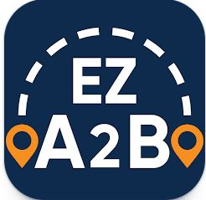

Our new way for parents to manage their student transportation needs and get bussing information.
We understand how important it is for parents and guardians to stay informed about their students’ transportation, which is why we’re excited to share that our district is now using EZ A2B, a new bus tracking app that will provide you with timely and accurate transportation information.

With EZ A2B, you can:
- See your student’s assigned bus stop and schedule
- Track their bus’s location in real time
- Receive notifications when the bus is approaching the stop
- Receive alerts when unexpected delays or route changes occur

The EZ A2B app is free to download and easy to use. Simply download it, create an account, link to your student, and you’re all set.
Please keep in mind, Granite Falls and Lake Stevens school districts are a transportation co-op. We are working with the vendor to update the district name on the app, but for the time being parents will need to type in Lake Stevens School District when setting up account
To begin, first download the app:
- Apple Store
- Google Play
- Search for EZ A2B: K12 Transportation app

If you need help creating your account, just access our “Getting Started with the EZ A2B App” guide
for step-by-step instructions and helpful tips for creating your account.
If you have any questions or need assistance, please contact our Transportation team at [email or phone number].

We’re confident that EZ A2B will make it easier for you to plan your day and give you greater peace
of mind about your student’s ride to and from school.
Thank you for helping us to keep student transportation safe and efficient!

