Virginia’s Comprehensive School Support Plan

Virginia’s comprehensive school support plan (CSSP) integrates findings from Virginia’s needs assessment to help guide schools as they prioritize work, predict and neutralize barriers, and catalyze transformative practices that will improve student outcomes. There are four sections to the comprehensive school support plan, aligned to the Virginia Support Framework:
- Academic Supports
- Staffing Supports
- Professional Learning Supports
- School Climate Supports
High-quality plans support school leaders as they work to allocate human and fiscal resources, establish short-and long-term goals, monitor processes, and scale successes. Specifically, a high-quality plan is:
- Grounded in the continuous improvement process and high expectations for all students;
- Developed and revised through engagement with stakeholders-- including families; and,
- Based on evidence-and research-based strategies aligned to the needs and context of the school.
Effective plans are based on the most important changes needed in the school and demonstrate alignment to federal, state, division, and school priorities by relating goals, measures, strategies, and resources to division plans, federal and state laws and guidance, including Virginia’s Support Framework.
How to use the Virginia Comprehensive School Support Plan:
- Review the Virginia Support Framework domains and the results of the Virginia Support Framework Needs Assessment.
- Become familiar with the explanation and example of the Comprehensive School Support Plan template which includes a description and example for each item.
- Complete the profile information, providing information on designations, School Quality Indicators, Levels, and/or federal identification. An overview of the internal and external stakeholder, including families, that have been engaged in the school improvement process should also be documented.
- Use the results from the needs assessment to develop the plan for each domain and indicator, including barriers from a root-cause analysis establishing SMART goals, the alignment to evidence and research-based strategies, the development and implementation of the plan, and the artifacts to be regularly collected and analyzed for progress monitoring.

Domain of Support | Description
Academic | Providing high-quality instructional materials, routines, and prioritized placement are critical to the successful operation of the school division, and focuses on alignment, engagement, rigor, and organizing staff based on need.
Staffing | Recruiting, allocating, and retaining teachers and principals to address schools and areas with the greatest needs, to include building capacity from those within and the retention of high-quality staff are integral to school division success.
Professional Learning | Managing a school building effectively by providing logistical support to maximize learning through clear calendars and master schedules; and targeting professional learning centered on the instructional cycle with a focus on student outcomes.
School Climate | Engaging with families and providing instructional materials, learning opportunities, and supports to improve attendance creates a welcoming culture. Connecting each student with an adult creates a safe and orderly environment.
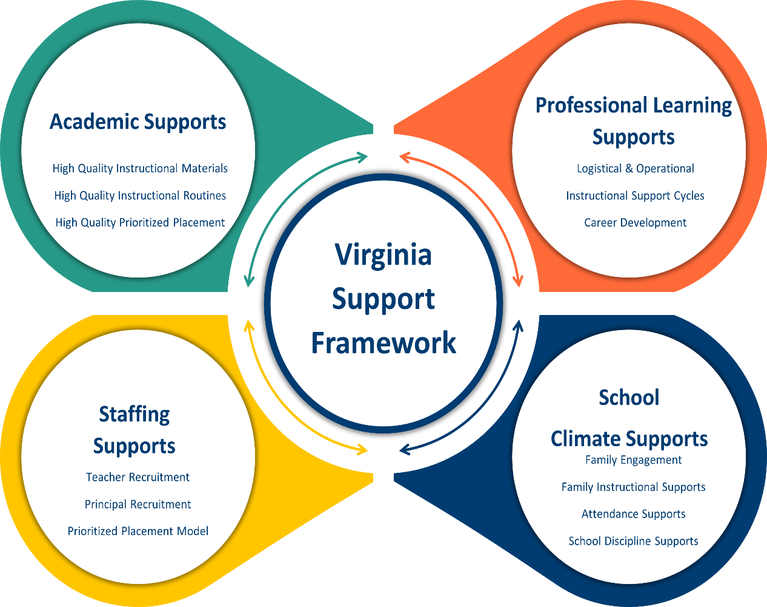

Profile Information
Division: Roanoke City Public Schools | School: Morningside Elementary School
Principal: Dr. Megan Arthur | Designations (if applicable):
Stakeholder/Family Engagement
Describe how the school will routinely involve internal and external stakeholders in the school improvement process to include conducting the needs assessment; selecting evidence-and research-based strategies; and developing, implementing, monitoring, and evaluating the plan.
Morningside Elementary will engage internal and external stakeholders throughout the school improvement process to enhance student engagement and reduce absenteeism. Teachers, staff, students, and the leadership team will collaborate to conduct a needs assessment by analyzing data and gathering input through surveys and focus groups. Parents and community partners will provide additional feedback and insights into external factors affecting engagement. Based on this input, evidence-based strategies will be selected, with staff and stakeholders collaborating on the development of the school improvement plan. Implementation will involve professional development for teachers, regular progress monitoring through data analysis, and ongoing communication with parents and community partners. The plan's success will be evaluated through quarterly reviews of engagement and absenteeism data, and adjustments will be made as needed. Stakeholders will be kept informed and involved through regular updates, feedback opportunities, and an annual evaluation meeting to assess progress and plan future improvements.
Domain I: Academic Supports |  |  |  | Content Area: English
Barrier(s):
- Students in Grades 3-5 lack background knowledge, executive function skills, fluent reading, and comprehension strategies, which impacts their overall achievement in core subjects.
- Students with disabilities lack growth and proficiency on grade level reading tests.

SMART Goal Statement: By June 2025, Morningside Elementary School will increase overall achievement in reading for all students in grades 3-5 by at least 5%, Black students by 10%, Economically Disadvantaged Students by 5%, and Students with Disabilities by 5%.
(Evidence-based) Strategy Name: Providing Reading Interventions for Students in Grades 4-9 (Educator’s Practice Guide 29)  Recommendation 2: Provide purposeful fluency-building activities to help students read effortlessly.  Recommendation 3: Routinely use a set of comprehension-building practices to help students make sense of the text  Part 3A. Build students’ world and word knowledge so they can make sense of the text  Part 3B. Consistently provide students with opportunities to ask and answer questions to better understand the text they read  Part 3C. Teach students a routine for determining the gist of a short section of text  Part 3D. Teach students to monitor their comprehension as they read  Tier of Evidence: Tier 1- Strong |  | Description:  To improve reading skills, Recommendation 2 emphasizes using targeted fluency-building activities to help students read effortlessly, enhancing their accuracy and smoothness. Recommendation 3 focuses on a set of comprehension-building practices, including expanding students' world and word knowledge, encouraging them to ask and answer questions about the text, teaching routines for determining the gist of short passages, and helping students monitor their own comprehension as they read. These strategies work together to deepen understanding and promote more effective reading.
Student Measure #1:  MAP comprehension data/ Fluency Data / LexiaCore Data |  | Student Measure #2:  Use of High-Quality Tier One Instructional Materials
Staff Measure #1:  Lesson plans |  | Staff Measure #2:  Observations, quick visits, and walk-throughs
Action Plan
Action Steps  (Describe the step and include who will implement and how often it will be implemented) | Start of Action Step | End of Action Step |  | Position Responsible for Monitoring | Budget (local, state, federal funds)
Develop and monitor lesson plans and collaborative learning team structures to ensure instruction is aligned with Virginia's SOLs and Curriculum Framework | August 2024 | June 2025 |  | Principal  Assistant Principal | na
Develop and monitor data meetings to review student data to inform instruction and group students based on their academic needs | August 2024 |  | June 2025 | Principal  Assistant Principal  Reading Specialist  Classroom Teachers  SPED Teachers | na
Provide feedback to teachers through the observation process to ensure that instruction aligns with the Virginia SOLs and Curriculum Framework. | August 2024 |  | June 2025 | Principal  Assistant Principal | na
Implement fluency progress monitoring. | November 2024 | June 2025 |  | Reading Specialist  Classroom Teachers  Principal  Assistant Principal
Local Educational Agency (LEA) Support: Describe how the LEA will support in implementing, monitoring, and evaluating this strategy.
Evidence: Based on the action steps, define what measurable evidence would indicate progress towards the long-term goal.
Analysis: Address impact and next steps.
Evidence of Progress (update monthly) |  | Analysis of Progress (update monthly)

Domain I: Academic Supports |  | Content Area: Mathematics
Barrier(s):
- Students in grades 3-5 struggle with problem-solving and multi-step problems, particularly for students with disabilities.
- Students with disabilities lack growth and proficiency on grade level math tests.
SMART Goal Statement: By June 2025, Morningside Elementary School will increase overall achievement in math for all students in grades 3-5 by at least 5%, Students with Disabilities by 17% and Hispanic students by 4%.
(Evidence-based) Strategy Name: Teach cognitive and meta-cognitive strategies to support student learning and foster independence  Tier of Evidence: Strong  (Evidence-based) Strategy Name: Assisting student struggling with Mathematics intervention in the elementary grades.  Tier of Evidence: Strong | Description: Strategies that enable students to become aware of how to solve mathematical problems by considering the correct problem-solving approach, using the correct problem-solving approach, and ensuring that their answers make sense. Students can decide how to approach the math problem, make sure their approach is working, and determine if the answer makes sense. They also learn to adjust their approach based on incorrect answers.  Systematic Instruction: Provide systematic instruction during intervention to develop student understanding of mathematical ideas. Mathematical Language: Teach clear and concise mathematical language and support students’ use of the language to help students effectively communicate their understanding of mathematical concepts. Number Lines: Use the number line to facilitate the learning of mathematical concepts and procedures, build understanding of grade-level material, and prepare students for advanced mathematics.
Student Measure #1: Snapshots on Mastery Connect / IXL Arena Data / Post Assessments from Tiered Math Groups / MAP data | Student Measure #2: Use of High-Quality Tier One Instructional Materials
Staff Measure #1: Lesson Plans | Staff Measure #2: Observations, Quick Visits, and Walk-throughs

Action Plan
Action Steps  (Describe the step and include who will implement and how often it will be implemented) | Start of Action Step | End of Action Step | Position Responsible for Monitoring | Budget (local, state, federal funds)
Conduct walkthroughs and provide feedback to ensure that identified strategies are delivered during instruction | August 2024 | June 2025 | Principal  Assistant Principal  Math Resource Specialist  District Math Specialist | na
Provide intensive, systematic instruction on foundational math skills in small groups to students who score below benchmark on assessments | August 2024 | June 2025 | Principal  Assistant Principal  Math Resource Specialist  District Math Specialist  Classroom Teachers  SPED Teachers | na
Implement and monitor student interventions by including intervention staff in planning, tracking specific student interventions, and evaluating student progress to determine which interventions result in positive student outcomes. | August 2024 | June 2025 | Principal  Assistant Principal  Math Resource Specialist  District Math Specialist  Classroom Teachers  SPED Teachers | na
Implement the reversed release model to help build cognitive and metacognitive skills while increasing math literacy. | October 2024 | June 2025 | Principal  Assistant Principal  Math Resource Specialist  District Math Specialist  Classroom Teachers  SPED Teachers | na
Local Educational Agency (LEA) Support: Describe how the LEA will support in implementing, monitoring, and evaluating this strategy.
Evidence: Based on the action steps, define what measurable evidence would indicate progress towards the long-term goal.
Analysis: Address impact and next steps.
Evidence of Progress (update monthly) |  | Analysis of Progress (update monthly)

Domain I: Academic Supports |  | Content Area: Science
Barrier(s):
- Knowledge building in science to increase comprehension and application.
SMART Goal Statement: By June 2025, Morningside Elementary School will increase the percentage of students passing the Science SOL assessment from a 64.1% to 70%.
(Evidence-based) Strategy Name:  Tier of Evidence: Strong  (Evidence-based) Strategy Name: Acquiring Science and Social Studies Knowledge in Kindergarten through Fourth Grade using content-area literacy instruction (CALI) https://eric.ed.gov/?id=EJ1136513  https://ies.ed.gov/ncee/WWC/Study/85545  Tier of Evidence: Strong | Description: With national focus on reading and math achievement, science and social studies have received less instructional time. Yet, accumulating evidence suggests that content knowledge is an important predictor of proficient reading. Starting with a design study, we developed content-area literacy instruction (CALI) as an individualized (or personalized) instructional program for kindergarteners through 4th graders to build science and social studies knowledge.
Student Measure #1: Snapshots on Mastery Connect / IXL Data | Student Measure #2: Use of High-Quality Tier One Instructional Materials
Staff Measure #1: Lesson Plans | Staff Measure #2: Observations, Quick Visits, and Walk-throughs

Action Plan
Action Steps  (Describe the step and include who will implement and how often it will be implemented) | Start of Action Step | End of Action Step | Position Responsible for Monitoring | Budget (local, state, federal funds)
Conduct walkthroughs and provide feedback to ensure that identified strategies are delivered during instruction | August 2024 | June 2025 | Principal  Assistant Principal | na
Provide evidence-based feedback to teachers with an explicit focus on student learning outcomes. | August 2024 | June 2025 | Principal  Assistant Principal  District Science Supervisor | na
Students in K-5 will participate in STEAM instruction at least once per week to make real-world connections. | August 2024 | June 2025 | Principal  Assistant Principal  Math Resource Specialist  District Math Specialist  Classroom Teachers  SPED Teachers | na
Science Literature Connections (5 Ponds Press) in grades 4-5 to increase knowledge of science content. | August 2024 | June 2025 | Principal  Assistant Principal  Classroom Teachers | na
Library inventory of Science Literature Connections (5 Ponds Press) in grade K-3 to increase knowledge of science content | September 2024 | June 2025 | Principal  Assistant Principal  Classroom Teachers  Librarian
Local Educational Agency (LEA) Support: Describe how the LEA will support in implementing, monitoring, and evaluating this strategy.
Evidence: Based on the action steps, define what measurable evidence would indicate progress towards the long-term goal.
Analysis: Address impact and next steps.
Evidence of Progress (update monthly) |  | Analysis of Progress (update monthly)
Domain of Support
Domain II: Staffing Supports
Barrier(s):
- Teachers feeling overwhelmed with new curriculum and instructional practices
- Overall increased demands from society, mental health issues, issues created from the pandemic (academic gaps, SEL gaps, etc.)
- Lack of support from families and community members
- Teacher positions eliminated, despite projected enrollment data shared, then reinstated once projections become reality after the school year has started.
SMART Goal Statement: By June 2026, Morningside Elementary will increase teacher retention rates by 15% over the next two years by implementing support to all teachers in areas needed while building a positive school culture.
(Evidence-based) Strategy Name: Promote teacher engagement and create supportive school culture that supports teacher well-being  Tier of Evidence: Strong  (Evidence-based) Strategy Name: Assign teachers to mentors in the building  Tier of Evidence: Strong |  | Description:  We will engage teachers by increasing communication, establish goals that address the needs of the school and ensuring our initiatives align with our goals.  Promoting teacher engagement and creating a supportive school culture focused on teacher well-being involves fostering an environment where teachers feel valued, connected, and empowered. This could look like providing regular opportunities for collaboration and professional development, where teachers can share ideas and strategies. Leadership would actively encourage open communication and recognize teachers' efforts, helping them feel heard and appreciated. Schools could offer wellness programs, such as mindfulness sessions or flexible time for self-care, and ensure that workload expectations are realistic to prevent burnout. By cultivating a culture of trust, mutual respect, and support, teachers are more likely to stay engaged and perform at their best.
Student Measure #1:  Behavioral Referrals and Discipline Data: Track the number of behavior incidents or referrals. A supportive environment may lead to fewer disciplinary issues as students are more engaged and responsive.  Social-Emotional Learning (SEL) Participation/Observations: Measure students' SEL development, such as emotional regulation, relationships, and overall well-being, since teachers who feel supported are often better at supporting students' social-emotional needs. |  | Student Measure #2:  Academic Performance: Analyze trends in student achievement data, such as grades, standardized test scores, and reading/math proficiency. Engaged, supported teachers tend to foster stronger academic growth.
Staff Measure #1:  Observations and Evaluations / Check-Ins |  | Staff Measure #2:  Recruitment and Retention Data
Action Plan
Action Steps  (Describe the step and include who will implement and how often it will be implemented) | Start of Action Step | End of Action Step | Position Responsible for Monitoring | Budget (local, state, federal funds)
Starting grade level and data meetings with something positive | August 2024 | June 2026 | Principal  Assistant Principal
Reinforcing school wide habits, mission, and vision, during meetings and memos | August 2024 | June 2026 | Principal  Assistant Principal
Workplace Love/Appreciation Language, Favorites & Core Values Questionnaire | August 2024 | June 2026 | Principal  Assistant Principal
New Teacher Mentors | August 2024 | June 2026 | Principal  Assistant Principal
Positive recognition of staff through social media platforms, newsletters, and bulletin boards | August 2024 | June 2026 | Principal  Assistant Principal
Know better to do better learning opportunities | August 2024 | June 2026 | Principal  Assistant Principal
Utilizing district supervisors and specialists to support teachers | September 2024 | June 2026 | Principal  Assistant Principal  District Supervisors/Specialists
Local Educational Agency (LEA) Support: Describe how the LEA will support in implementing, monitoring, and evaluating this strategy.
Evidence: Based on the action steps, define what measurable evidence would indicate progress towards the long-term goal.
Analysis: Address impact and next steps.
Evidence of Progress (update monthly) |  | Analysis of Progress (update monthly)

Domain of Support
Domain III: Professional Learning Supports
Barrier(s):
- Lack of PD aligned to the needs of individuals and schools.
- Lack of coaching and mentorship.
- Confusion about expectations and best practices for instructional practices.

SMART Goal Statement: By the end of the 2024-2025 school year, 100% of new teachers and teachers in need of support will be paired with a mentor using a 1-to-3 ratio (1 mentor for every 3 teachers). In addition, at least 90% of teachers will participate in professional development that is tailored to their individual needs or school needs.
(Evidence-based) Strategy Name: Reflective Practice/Coaching  Tier of Evidence: Strong |  | Description:  Teachers will implement strategies received from professional development to assist in the development of their teaching styles to understand their role as a teacher. Teachers will critically think about their experiences, actions and decision during their teaching practices through self-observation and evaluations
Student Measure #1:  Student Achievement Data: Monitor trends in standardized test scores, grades, and other academic assessments. Mentored teachers and those engaging in tailored professional development may contribute to improved student learning outcomes.  Classroom Observation Data: Use classroom observations to measure the quality of instruction. Improved instructional practices resulting from mentoring and targeted professional development should be reflected in student-centered, effective teaching methods that enhance student learning. |  | Student Measure #2: Student Learning Journals  Behavioral Data: Track changes in student behavior, including fewer behavior incidents or disciplinary referrals, which may indicate that teachers are better equipped to manage classrooms and support student behavior through improved instructional strategies.  Student Attendance Rates: Improved teaching quality and engagement from mentored and professionally developed teachers may lead to better student attendance, as students feel more connected and motivated to attend school.
Staff Measure #1:  Professional Development Participation Rates: Measure how many teachers participate in the professional learning opportunities offered. Ensure that at least 90% of teachers are engaged in PD that aligns with their individual or school needs  Teacher Satisfaction Surveys: Collect feedback from teachers on their experiences with mentoring and professional development. Ask about their perceived support, relevance of PD to their needs, and overall job satisfaction. |  | Staff Measure #2:  Classroom Observation Data: Use peer or administrative classroom observations to assess any improvements in teaching practices, instructional strategies, or classroom management that result from mentoring or professional development.  Teacher Growth and Evaluation Data: Track teacher performance through formal evaluations and feedback. Compare teacher progress before and after receiving mentoring or PD, noting any improvements in areas such as instructional quality, student engagement, or classroom management.
Action Plan
Action Steps  (Describe the step and include who will implement and how often it will be implemented) | Start of Action Step | End of Action Step | Position Responsible for Monitoring | Budget (local, state, federal funds)
Plan and schedule monthly training sessions on relevant topics identified through the needs assessment. | August 2024 | June 2025 | Principal  Assistant Principal | n/a
Monitor the mentorship program where experienced professionals mentor newer staff members. | August 2024 | June 2025 | Principal  Assistant Principal | n/a
Teacher self-evaluations and reflection prior to formal observations | October 2024 | June 2025 | Principal  Assistant Principal  Classroom Teachers
Local Educational Agency (LEA) Support: Describe how the LEA will support in implementing, monitoring, and evaluating this strategy.
Evidence: Based on the action steps, define what measurable evidence would indicate progress towards the long-term goal.
Analysis: Address impact and next steps.
Evidence of Progress (update monthly) | Analysis of Progress (update monthly)

Domain IV: School Climate Supports
Barrier(s): Many families do not fully understand the importance of regular attendance, while students often lack intrinsic motivation and essential executive functioning skills, which hinders their perseverance and academic success.
SMART Goal Statement: By June 2025, Morningside Elementary School will reduce student absenteeism equal to or below 15% by improving family engagement and fostering a shared understanding of the importance of regular attendance.
(Evidence-based) Strategy Name: Attendance Works  Chronic Attendance Nudge Letters  Tier of Evidence: Strong |  | Description:  Families will receive a personalized letter detailing the amount of days and which their student was absent.  Attendance Works recommends a tiered approach that starts with foundational supports for the whole school. These foundational supports are followed by prevention-oriented supports for attendance (Tier1), more personalized outreach or early intervention (Tier 2), and intensive intervention (Tier 3).
Student Measure #1:  Student Attendance Rates: Track the percentage of students with chronic absenteeism (students missing 10% or more of school days) on a monthly or quarterly basis. The goal is to reduce absenteeism to 15% or below by June 2025. |  | Student Measure #2:  Behavioral Data: Track any correlations between improved attendance and positive behavioral changes, such as fewer disciplinary referrals, which can indicate stronger student engagement as a result of increased school attendance.
Staff Measure #1:  Family Engagement Participation: Measure attendance and participation at family engagement events, workshops, or meetings focused on the importance of regular attendance. You could track how many families attend events, participate in surveys, or engage with school communications regarding attendance. |  | Staff Measure #2:  School-Home Communication Logs: Track the frequency and quality of communication between the school and families, particularly those with students who are frequently absent. This could include phone calls, home visits, emails, and attendance-focused newsletters.  Referral Rates for Attendance Support: Monitor how often students are referred to support services (such as counseling or attendance improvement programs) and the outcomes of these interventions. Improved attendance should result from targeted support for families struggling with absenteeism.
Action Plan
Action Steps  (Describe the step and include who will implement and how often it will be implemented) | Start of Action Step | End of Action Step | Position Responsible for Monitoring | Budget (local, state, federal funds)
Check student daily absenteeism list regularly, contact parents, and refer chronic students to student support specialist. | October 2024 | June 2025 | Principal  Assistant Principal  Student Support Specialist
The use of Attendance Nudge Letters for students with chronic attendance behaviors. | October 2024 | June 2025 | Principal  Assistant Principal
Family engagement participation logs. | August 2024 | June 2025 | Principal  Assistant Principal
Meetings with families of chronically absent students to address barriers | October 2024 | June 2025 | Principal  Assistant Principal  Student Support Specialist
Local Educational Agency (LEA) Support: Describe how the LEA will support in implementing, monitoring, and evaluating this strategy.
Click or tap here to enter text.
Evidence: Based on the action steps, define what measurable evidence would indicate progress towards the long-term goal.
Analysis: Address impact and next steps.
Evidence of Progress (update monthly) | Analysis of Progress (update monthly)

In accordance with the Standards of Quality (SOQ) and Standards of Accreditation (SOA), all schools are to prepare a comprehensive, unified, long-range plan in conjunction with the division long-range comprehensive plan, and make it available to the public (SOQ, § 22.1-253.13:6.; SOA 8VAC20-131-390; 8VAC20-131-400). Under the Every Student Succeeds Act (ESSA), schools identified for comprehensive, targeted, and additional targeted support and improvement are required to develop plans based on a set criteria with state educational agency (SEA), local educational agency (LEA), and school approval (ESSA §1111(d)(1)(B); §1111(d)(2)(B)-(C))

