Virginia’s Comprehensive School Support Plan

Virginia’s comprehensive school support plan (CSSP) integrates findings from Virginia’s needs assessment to help guide schools as they prioritize work, predict and neutralize barriers, and catalyze transformative practices that will improve student outcomes. There are four sections to the comprehensive school support plan, aligned to the Virginia Support Framework:
- Academic Supports
- Staffing Supports
- Professional Learning Supports
- School Climate Supports
High-quality plans support school leaders as they work to allocate human and fiscal resources, establish short-and long-term goals, monitor processes, and scale successes. Specifically, a high-quality plan is:
- Grounded in the continuous improvement process and high expectations for all students;
- Developed and revised through engagement with stakeholders-- including families; and,
- Based on evidence-and research-based strategies aligned to the needs and context of the school.
Effective plans are based on the most important changes needed in the school and demonstrate alignment to federal, state, division, and school priorities by relating goals, measures, strategies, and resources to division plans, federal and state laws and guidance, including Virginia’s Support Framework.
How to use the Virginia Comprehensive School Support Plan:
- Review the Virginia Support Framework domains and the results of the Virginia Support Framework Needs Assessment.
- Become familiar with the explanation and example of the Comprehensive School Support Plan template which includes a description and example for each item.
- Complete the profile information, providing information on designations, School Quality Indicators, Levels, and/or federal identification. An overview of the internal and external stakeholder, including families, that have been engaged in the school improvement process should also be documented.
- Use the results from the needs assessment to develop the plan for each domain and indicator, including barriers from a root-cause analysis establishing SMART goals, the alignment to evidence and research-based strategies, the development and implementation of the plan, and the artifacts to be regularly collected and analyzed for progress monitoring.

Domain of Support | Description
Academic | Providing high-quality instructional materials, routines, and prioritized placement are critical to the successful operation of the school division, and focuses on alignment, engagement, rigor, and organizing staff based on need.
Staffing | Recruiting, allocating, and retaining teachers and principals to address schools and areas with the greatest needs, to include building capacity from those within and the retention of high-quality staff are integral to school division success.
Professional Learning | Managing a school building effectively by providing logistical support to maximize learning through clear calendars and master schedules; and targeting professional learning centered on the instructional cycle with a focus on student outcomes.
School Climate | Engaging with families and providing instructional materials, learning opportunities, and supports to improve attendance creates a welcoming culture. Connecting each student with an adult creates a safe and orderly environment.
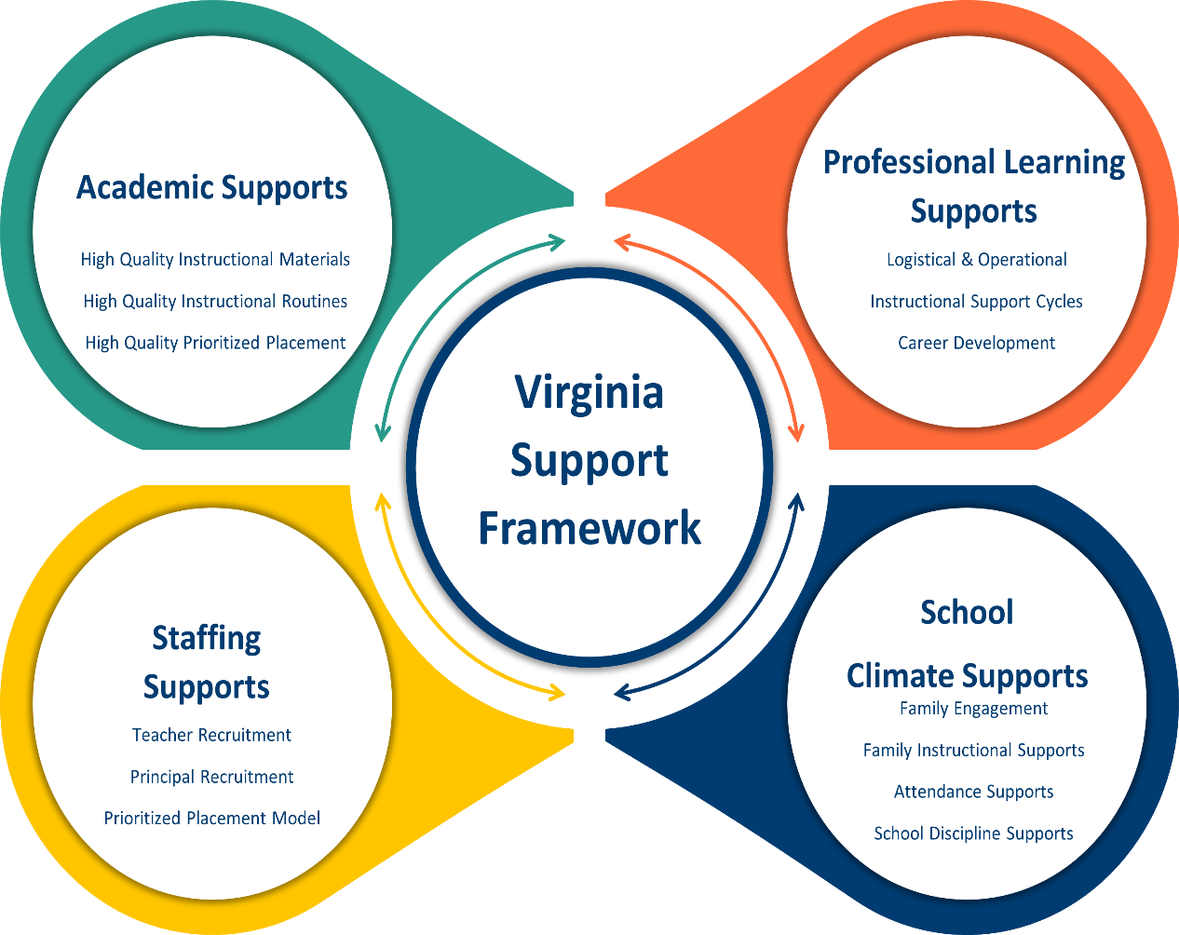

Profile Information
Division: Roanoke City Public Schools | School: William Fleming High School
Principal: Tracey Anderson | Designations (if applicable):
Stakeholder/Family Engagement
Describe how the school will routinely involve internal and external stakeholders in the school improvement process to include conducting the needs assessment; selecting evidence-and research-based strategies; and developing, implementing, monitoring, and evaluating the plan.
Title 1 Parent Nights; Grade Level Student and Parent Meetings; ELL Engagement and Parent Meetings
Domain I: Academic Supports |  |  | Content Area: English
Barrier(s): Parental attendance at events, lack of built in calendar for professional development days, students lack reading stamina, large class sizes, low student participation during after-school tutorials and Saturday school enrichment days.
SMART Goal Statement: By June 2025, students at William Fleming High School will demonstrate an increase of at least 4% from 83% to 87% for the combined pass rate for students in the area of ELA.
- (Evidence-based) Strategy Name: Reading Interventions for 9th graders  - Writing Effectively in Secondary Schools  Tier of Evidence: Strong |  | Description: Provide authentic reading activities to help students read effortlessly while [providing students choice with culturally relevant material. Routinely use a set of comprehension-building practices to help students make sense of the text, including vocabulary development.  Description: Explain appropriate writing strategies using a Model-Practice-Reflect instructional cycle and integrate writing and reading to emphasize key writing features.
Student Measure #1: Student Measure #1: 75% of the students will demonstrate proficiency on quarterly benchmarks |  | Student Measure #2: Students will increase their reading with authentic texts each quarter by increasing reading passages/paragraphs to help build reading stamina while demonstrating text comprehension.
Staff Measure #1: English teachers will ensure students read at least one (1) authentic text individually once a week using the division-provided curriculum to help build their reading stamina. |  | Staff Measure #2: Teachers will implement and monitor research-based instructional strategies and practices aligned with state standards to ensure mastery of content in reading comprehension for students in grades 9-12.
Action Plan
Action Steps  (Describe the step and include who will implement and how often it will be implemented) | Start of Action Step | End of Action Step | Position Responsible for Monitoring | Budget (local, state, federal funds)
Provide professional development for English teachers on teaching practices, lesson planning, and strategies to improve instructional delivery. | October 2024 | May 2025 | Administration, Content Supervisor | Title I
Teachers will participate in ongoing department meetings to build content and instructional capacity. | October 2024 | May 2025 | Teachers, Administration | N/A
Conduct formal and informal walkthrough observations to monitor the alignment of the written, taught, and tested curriculum. | October 2024 | May 2025 | Administration, Content Supervisor | N/A
Build teacher instructional knowledge and confidence by participating in peer observations as needed to support sharing best practices. | October 2024 | May 2025 | Teachers, Administration | N/A
Provide data-informed, guided small group instruction for Tier 2 and 3 students with specific interventions and strategies. | October 2024 | May 2025 | Administration, Content Supervisor | N/A
Local Educational Agency (LEA) Support: Describe how the LEA will support in implementing, monitoring, and evaluating this strategy.
The LEA will support by funding and delivering content-specific professional development opportunities while assisting with monitoring research-based instructional strategies.
Evidence: Based on the action steps, define what measurable evidence would indicate progress towards the long-term goal.
Analysis: Address impact and next steps.
Evidence of Progress (update monthly) |  | Analysis of Progress (update monthly)
Lesson plan feedback.
Instructional walk-throughs and observation feedback.
Required professional development.
Required monthly department meetings to share strategies.
Data reviews after benchmark and SOL assessments.

Domain I: Academic Supports |  |  | Content Area: Science
Barrier(s): Parental attendance at events, lack of built-in calendar for professional development days, teachers learning and adjusting to the new curriculum, low student participation during after-school tutorials, and Saturday school enrichment days.
SMART Goal Statement: By June 2025, students at William Fleming High School will demonstrate an increase of at least 5% from 67% to 72% in the combined pass rate for students in science.
(Evidence-based) Strategy Name: A Best-Evidence Synthesis  Tier of Evidence: Strong |  | Description: Provide science activities to help students understand content using appropriate vocabulary.  Description: Utilize instructional strategies that increase active student participation with gradual release during the lesson.
Student Measure #1: Student Measure #1: 70% of the students will demonstrate proficiency on quarterly benchmarks |  | Student Measure #2: Students will increase their understanding of science concepts and demonstrate this during lab activities.
Staff Measure #1: Science teachers will ensure students read, write, and justify their answers in science classes at least twice weekly. |  | Staff Measure #2: Teachers will implement and monitor research-based instructional strategies and practices aligned with state standards to ensure science content mastery for students in grades 9-12.
Action Plan
Action Steps  (Describe the step and include who will implement and how often it will be implemented) | Start of Action Step | End of Action Step | Position Responsible for Monitoring | Budget (local, state, federal funds)
Provide professional development for science teachers on teaching practices, lesson planning, and strategies to improve instructional delivery. | October 2024 | May 2025 | Administration, Content Supervisor | Title I
Teachers will participate in ongoing department meetings to build content and instructional capacity. | October 2024 | May 2025 | Teachers, Administration | N/A
Conduct formal and informal walkthrough observations to monitor the alignment of the written, taught, and tested curriculum. | October 2024 | May 2025 | Administration, Content Supervisor | N/A
Build teacher instructional knowledge and confidence by participating in peer observations as needed to support sharing best practices. | October 2024 | May 2025 | Teachers, Administration | N/A
Provide data-informed, guided small group instruction for Tier 2 and 3 students with specific interventions and strategies. | October 2024 | May 2025 | Administration, Content Supervisor | N/A
Local Educational Agency (LEA) Support: Describe how the LEA will support in implementing, monitoring, and evaluating this strategy.
The LEA will support by funding and delivering content-specific professional development opportunities while assisting with monitoring research-based instructional strategies.
Evidence: Based on the action steps, define what measurable evidence would indicate progress towards the long-term goal.
Analysis: Address impact and next steps.
Evidence of Progress (update monthly) |  | Analysis of Progress (update monthly)
Lesson plan feedback.
Instructional walk-throughs and observation feedback.
Required professional development.
Required monthly department meetings to share strategies.
Data reviews after benchmark and SOL assessments.

Domain I: Academic Supports |  |  | Content Area: Mathematics
Barrier(s): Lack of built-in calendar for professional development days, teachers learning and adjusting to the new curriculum, low student participation during after-school tutorials and Saturday school enrichment days, lack of foundational math skills, and students missing prerequisite knowledge.
SMART Goal Statement: By June 2025, students at William Fleming High School will demonstrate an increase of at least 5% from 78% to 83% in the combined pass rate for students in mathematics.
- (Evidence-based) Strategy Name: Improving Algebra Knowledge  Tier of Evidence: Strong |  | Description: Provide math activities to help students understand content using appropriate vocabulary. Instruction during the intervention should be explicit and include gradual release. This includes providing models of problem-solving, verbalization of thought processes, guided practice, corrective feedback, and frequent cumulative review. Assist students in monitoring and reflecting on the problem-solving process. Expose students to multiple problem-solving strategies. Help students recognize and articulate mathematical concepts and notation.  Description: Utilize instructional strategies that increase active student participation and engagement.
Student Measure #1: Student Measure #1: 70% of the students will demonstrate proficiency on quarterly benchmarks |  | Student Measure #2: Students will increase their understanding of problem-solving using pictorial representations and DESMOS calculators.
Staff Measure #1: Math teachers will ensure students read, write, and justify their answers in math classes at least twice weekly. Technology, manipulatives and DESMO calculators will be used. |  | Staff Measure #2: Teachers will implement and monitor research-based instructional strategies and practices aligned with state standards to ensure science content mastery for students in grades 9-12.
Action Plan
Action Steps  (Describe the step and include who will implement and how often it will be implemented) | Start of Action Step | End of Action Step | Position Responsible for Monitoring | Budget (local, state, federal funds)
Provide professional development for math teachers on teaching practices, lesson planning, and strategies to improve instructional delivery. | October 2024 | May 2025 | Administration, Content Supervisor | Title I
Teachers will participate in ongoing department meetings to build content and instructional capacity. | October 2024 | May 2025 | Teachers, Administration | N/A
Conduct formal and informal walkthrough observations to monitor the alignment of the written, taught, and tested curriculum. | October 2024 | May 2025 | Administration, Content Supervisor | N/A
Build teacher instructional knowledge and confidence by participating in peer observations as needed to support sharing best practices. | October 2024 | May 2025 | Teachers, Administration | N/A
Provide data-informed, guided small group instruction for Tier 2 and 3 students with specific interventions and strategies. | October 2024 | May 2025 | Administration, Content Supervisor | N/A
Local Educational Agency (LEA) Support: Describe how the LEA will support in implementing, monitoring, and evaluating this strategy.
The LEA will support by funding and delivering content-specific professional development opportunities while assisting with monitoring research-based instructional strategies.
Evidence: Based on the action steps, define what measurable evidence would indicate progress towards the long-term goal.
Analysis: Address impact and next steps.
Evidence of Progress (update monthly) |  | Analysis of Progress (update monthly)
Lesson plan feedback.
Instructional walk-throughs and observation feedback.
Required professional development.
Required monthly department meetings to share strategies.
Data reviews after benchmark and SOL assessments.

Domain of Support
Domain II: Staffing Supports
Barrier(s): Large class sizes and skill level of teachers to deliver Tier 1 instruction that increases rigor and provides differentiation.
SMART Goal Statement: To recruit, hire, and retain certified teachers and provide professional development that improves instruction.
(Evidence-based) Strategy Name: REL (Regional Educational Laboratories) Southwest- Grow Your Own Teacher Programs Ex. iTeach  Tier of Evidence: Promising |  | Description: Recruit individuals from our local communities and nonteaching school staff into the teacher workforce and provide effective professional development that helps them remain in the school system.
Student Measure #1: Increase in student achievement/outcomes. |  | Student Measure #2: Increase student engagement, attendance, and proficiency.
Staff Measure #1: Increase in teacher engagement and efficiency. |  | Staff Measure #2: Increase the number of highly qualified, fully licensed teachers.
Action Plan
Action Steps  (Describe the step and include who will implement and how often it will be implemented) | Start of Action Step | End of Action Step | Position Responsible for Monitoring | Budget (local, state, federal funds)
Provide professional development to help teachers create appropriate, rigorous lesson plans aligned to state standards. | October 2024 | May 2025 | Administration  Content Supervisors/Coaches  HR | Title I  Local
Provide professional development to help teachers understand how to interpret data and implement lessons to support student's needs. | October 2024 | May 2025 | Administration  Content Supervisors/Coaches  HR | Title I  Local
All probationary teachers will participate in the onboarding and division-wide mentoring program. | October 2024 | May 2025 | Administration  Content Supervisors/Coaches  HR | Title I  Local
Local Educational Agency (LEA) Support: Describe how the LEA will support in implementing, monitoring, and evaluating this strategy.
The LEA will update administrators on resources, opportunities, and funding options to support teacher retention programs.
The LEA will focus its recruitment efforts on social media platforms, job fairs, and recruiting events at colleges and universities.

Evidence: Based on the action steps, define what measurable evidence would indicate progress towards the long-term goal.
Analysis: Address impact and next steps.
Evidence of Progress (update monthly) |  | Analysis of Progress (update monthly)
Quarterly status update from HR on provisionally licensed completion progress,

Domain of Support
Domain III: Professional Learning Supports
Barrier(s): 1. Lack of opportunities to provide professional development and coaching, lack of common planning time, experience level of teachers.
SMART Goal Statement: By June 2025, WFHS staff will participate in required professional development activities once per month. We will plan and implement monthly professional development trainings using evidence-based strategies conducted through faculty meetings, department meetings, and division-wide sessions to foster positive changes in teaching practices that impact positive student achievement.
(Evidence-based) Strategy Name: Professional Development with a focus on Reflective Practice  Tier of Evidence: Strong |  | Description: Staff will participate in professional learning that includes reflective practices, including discussions on authentic literacy, lesson plan development, effective instructional strategies, classroom management, culture, and climate.
Student Measure #1: Increase in student engagement and positive student outcomes. |  | Student Measure #2: Increase in student engagement and student goal setting.
Staff Measure #1: Reflection and feedback data from professional development activities. |  | Staff Measure #2: Reflection and feedback data from professional development activities.
Action Plan
Action Steps  (Describe the step and include who will implement and how often it will be implemented) | Start of Action Step | End of Action Step | Position Responsible for Monitoring | Budget (local, state, federal funds)
Plan and organize PD sessions with effective presenters, including VDOE specialists, district specialists, and instructional coaches. | October 2024 | May 2025 | Administration | Title I
Local Educational Agency (LEA) Support: Describe how the LEA will support in implementing, monitoring, and evaluating this strategy.
The LEA will support implementing, monitoring, and evaluating this strategy by providing a division professional development calendar with opportunities for continuous professional growth available to faculty and staff in all content areas throughout the year based on the needs assessment.
Evidence: Based on the action steps, define what measurable evidence would indicate progress towards the long-term goal.
Analysis: Address impact and next steps.
Evidence of Progress (update monthly) | Analysis of Progress (update monthly)
Lesson plan feedback.
Instructional walk-throughs and observation feedback.

Domain IV: School Climate Supports
Barrier(s): Not having the correct/updated telephone and email information to contact parents when a student misses school, parents not attending student support meetings, or students missing days due to vacations or travel.
SMART Goal Statement: By the end of the 2024-2025 school year, chronic absenteeism will decrease by 5% from 36% to 29%.
- (Evidence-based) Strategy Name: Dropout prevention  Tier of Evidence: Promising |  | Description: Weekly meetings with student support specialists and administration are required to review student attendance. Utilize a tiered approach that starts with a meeting with the student, letters mailed home, and parental contacts for students who have missed five days—addition of Tier 2 and Tier 3 support for students missing more than ten days of school.
Student Measure #1: Decrease truancy rate by 2% every nine weeks. |  | Student Measure #2: Decrease out-of-school suspensions and create a reentry plan for suspended students.
Staff Measure #1: Decrease student conduct referrals by providing professional development for teachers and offering student incentives. |  | Staff Measure #2:
Action Plan
Action Steps  (Describe the step and include who will implement and how often it will be implemented) | Start of Action Step | End of Action Step | Position Responsible for Monitoring | Budget (local, state, federal funds)
Identify returning chronically absent students from the 2023 - 2024 school year. | October 2024 | May 2025 |  | N/A
Utilize chronic absenteeism data to make referrals to Communities in Schools, the school social worker, and the school counselor for targeted support and mentoring. | October 2024 | May 2025 |  | N/A
Conduct weekly attendance meetings to monitor student attendance and develop interventions and solutions. | October 2024 | May 2025 |  | N/A
Local Educational Agency (LEA) Support: Describe how the LEA will support in implementing, monitoring, and evaluating this strategy.
The LEA will ensure the school continues to receive daily and monthly attendance updates, assisting the school in remaining focused on attendance.
Evidence: Based on the action steps, define what measurable evidence would indicate progress towards the long-term goal.
Analysis: Address impact and next steps.
Evidence of Progress (update monthly) | Analysis of Progress (update monthly)
Truancy reports.

Number of students receiving incentives.
Discipline reports.

In accordance with the Standards of Quality (SOQ) and Standards of Accreditation (SOA), all schools are to prepare a comprehensive, unified, long-range plan in conjunction with the division long-range comprehensive plan, and make it available to the public (SOQ, § 22.1-253.13:6.; SOA 8VAC20-131-390; 8VAC20-131-400). Under the Every Student Succeeds Act (ESSA), schools identified for comprehensive, targeted, and additional targeted support and improvement are required to develop plans based on a set criteria with state educational agency (SEA), local educational agency (LEA), and school approval (ESSA §1111(d)(1)(B); §1111(d)(2)(B)-(C))

