Virginia’s Comprehensive School Support Plan

Virginia’s comprehensive school support plan (CSSP) integrates findings from Virginia’s needs assessment to help guide schools as they prioritize work, predict and neutralize barriers, and catalyze transformative practices that will improve student outcomes. There are four sections to the comprehensive school support plan, aligned to the Virginia Support Framework:
- Academic Supports
- Staffing Supports
- Professional Learning Supports
- School Climate Supports
High-quality plans support school leaders as they work to allocate human and fiscal resources, establish short-and long-term goals, monitor processes, and scale successes. Specifically, a high-quality plan is:
- Grounded in the continuous improvement process and high expectations for all students;
- Developed and revised through engagement with stakeholders-- including families; and,
- Based on evidence-and research-based strategies aligned to the needs and context of the school.
Effective plans are based on the most important changes needed in the school and demonstrate alignment to federal, state, division, and school priorities by relating goals, measures, strategies, and resources to division plans, federal and state laws and guidance, including Virginia’s Support Framework.
How to use the Virginia Comprehensive School Support Plan:
- Review the Virginia Support Framework domains and the results of the Virginia Support Framework Needs Assessment.
- Become familiar with the explanation and example of the Comprehensive School Support Plan template which includes a description and example for each item.
- Complete the profile information, providing information on designations, School Quality Indicators, Levels, and/or federal identification. An overview of the internal and external stakeholder, including families, that have been engaged in the school improvement process should also be documented.
- Use the results from the needs assessment to develop the plan for each domain and indicator, including barriers from a root-cause analysis establishing SMART goals, the alignment to evidence and research-based strategies, the development and implementation of the plan, and the artifacts to be regularly collected and analyzed for progress monitoring.

Domain of Support | Description
Academic | Providing high-quality instructional materials, routines, and prioritized placement are critical to the successful operation of the school division, and focuses on alignment, engagement, rigor, and organizing staff based on need.
Staffing | Recruiting, allocating, and retaining teachers and principals to address schools and areas with the greatest needs, to include building capacity from those within and the retention of high-quality staff are integral to school division success.
Professional Learning | Managing a school building effectively by providing logistical support to maximize learning through clear calendars and master schedules; and targeting professional learning centered on the instructional cycle with a focus on student outcomes.
School Climate | Engaging with families and providing instructional materials, learning opportunities, and supports to improve attendance creates a welcoming culture. Connecting each student with an adult creates a safe and orderly environment.
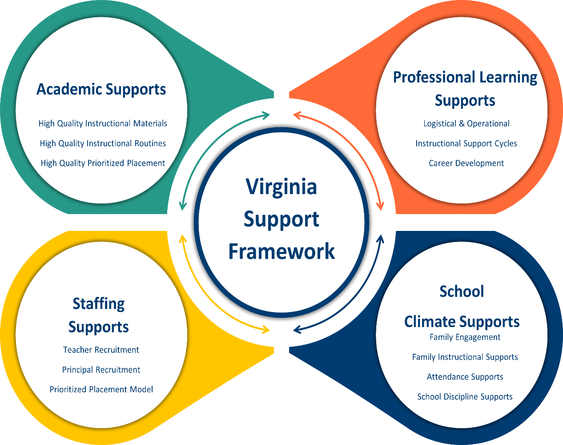

Profile Information
Division: Roanoke City Public Schools | School: Patric Henry High School
Principal: Joseph Booan | Designations (if applicable): Accredited with conditions
Stakeholder/Family Engagement
Describe how the school will routinely involve internal and external stakeholders in the school improvement process to include conducting the needs assessment; selecting evidence-and research-based strategies; and developing, implementing, monitoring, and evaluating the plan.
PH has developed a team of internal and external stakeholders. Stake holders are involved through internal meetings, coordinated after school meetings, robo calls, emails, and announcements. Information exchange will include needs assessment, research based strategies, and plan development/implementation/evaluation.
Domain I: Academic Supports |  |  | Content Area: Mathematics
Barrier(s): Common planning time for all subject teachers, need for full time sped co-teachers in every co-taught class, building level math coach dedicated to the high school, quality/specific professional development, difficulty recruiting quality math instructors,
SMART Goal #1 Statement: By June 2025, PH will increase the percentage of students passing a math SOL from 61.8% to 65.0% or higher.
SMART Goal #2 Statement: By June 2025, PH will increase the percentage of students in subgroup populations (SWD, Black, Eco Dis) passing a Math SOL by at least 5%.
(Evidence-based) Strategy Name: Teach students to intentionally choose from alternative algebraic strategies when solving problems.  Tier of Evidence: Moderate |  | Strategy Description: A strategy involves a general approach for accomplishing a task or solving a problem. Unlike an algorithm, which contains a sequence of steps that are intended to be executed in a particular order, a strategy may require students to make choices based on the specifics of the problem as well as their problem-solving goals. A strategy might also include alternative approaches that consider variations of a problem or unexpected results a student might encounter while implementing the steps of the solution. Strategies are general and broadly applicable, making them useful in solving a variety of problems.  How to carry out this strategy:  - Teach students to recognize and generate strategies for solving problems.  - Encourage students to articulate the reasoning behind their choice of strategy and the mathematical validity of their strategy when solving problems.  - Have students evaluate and compare different strategies for solving problems
Student Measure #1:  65% of the students will receive a 65% or higher on division benchmarks assessed quarterly. |  | Student Measure #2:  Black (50.5%) subgroup will increase to 55%  SWD (42.6%) subgroup to increase to 47%  Eco Disadvantaged (55.2%) subgroup to 60%
Staff Measure #1:  Throughout the 2024-2025 school year, math teachers will demonstrate application of evidence based strategies as observed in lesson plans, walk throughs and formal observations. |  | Staff Measure #2:  During small group and differentiated instruction throughout the 2024-2025 school year, math teachers/special education teachers/co-teachers will demonstrate application of evidence based strategies as observed in lesson plans, walk throughs and formal observations.
Action Plan
Action Steps  (Describe the step and include who will implement and how often it will be implemented) | Start of Action Step | End of Action Step | Position Responsible for Monitoring | Budget (local, state, federal funds)
- Create remedial math classes in Algebra I. Students who failed the Algebra I course and SOL will be placed in a remedial Algebra I class this year. Teacher focus will be on targeted skill sets to increase the probability of a student pass at the end of course. | August 2024 | June 2024 | Principal  Assistant Principal for C&I  School Testing Coordinator | N/A
- Create remedial class for students that passed the Algebra I course but failed the SOL. Students that passed the Algebra I and Geometry course but failed the SOL will be placed in remedial AFDA. Teacher focus will be on target skill set to increase the probability of a student pass in the fall or spring administration of the SOL. | August 2024 | June 2024 | Principal  Assistant Principal for C&I  School Testing Coordinator | N/A
- Geometry: Upper classman who needed to test for Geometry SOL were grouped together. Students who passed Alg I course, but failed the Alg I SOL | August 2024 | June 2024 | Principal  Assistant Principal for C&I  School Testing Coordinator | N/A
- All math department staff and math co-teachers will receive professional development on the implementation and application of evidenced-based differentiated instruction and small group instruction. | October 2024 | December 2024 | Division instructional leadership | N/A
- All math and special education co-teaching teams will receive additional professional development on evidenced-based, effective co-teaching models. | November 2024 | December 2024 | Principal  Assistant Principal for C&I  Special education Coordinator | N/A
- Monthly math department content meetings | August 2024 | June 2024 | Assistant Principal for C&I  School Testing Coordinator | N/A
- Regular data meetings with all math teachers  - review current snapshot and benchmark data  - review cumulative data  - conducted in small groups | October 2024 | June 2024 | Assistant Principal for C&I  School Testing Coordinator | N/A
- Bi-monthly common planning for all Algebra I teachers and co-teachers (when available) | August 2024 | June 2024 | Assistant Principal for C&I  Math Department Lead | N/A
Local Educational Agency (LEA) Support: Describe how the LEA will support in implementing, monitoring, and evaluating this strategy.
Description: The division (Content Supervisor, curriculum and instruction specialists) will provide support by implementing walk through observations (and providing timely feedback) and by providing coordinated professional development as indicated in the action steps above.

Evidence: Based on the action steps, define what measurable evidence would indicate progress towards the long-term goal.
Analysis: Address impact and next steps.
Evidence of Progress (update monthly) |  | Analysis of Progress (update monthly)
Quarterly benchmark assessment data |  | At the end of each quarter, the C&I team will review results from the benchmark and make modifications as needed.
Monthly meeting minutes from content meetings. |  | The AP content leader and the department chair will review assessment data, instructional best practices, small group implantation, and differentiation.
Monthly data meetings. |  | Classroom specific data meetings will be conducted by the AP C&I to assist in the evaluation of each student’s needs.
Lesson plan review following common planning |  | Conducted weekly by each assigned AP and department chair
Snapshot data (every 2-3 weeks) |  | The C&I team will look at data to make modifications every 2-3 weeks
Walk through and observational data |  | Conducted regularly to provide information on instructional practice.

Domain I: Academic Supports |  |  |  |  |  | Content Area: Science
Barrier(s): Common planning time for all subject teachers, need for full time sped co-teachers in every co-taught class, quality/specific professional development, lack of rigorous and aligned common curriculum,
SMART Goal #1 Statement: By June 2025, PH will increase the percentage of students passing a science SOL from 60.8% to 65.0% or higher.
SMART Goal #2 Statement: By June 2025, PH will increase the percentage of students in subgroup populations (SWD, Black, Eco Dis) passing a science SOL by at least 5%.
(Evidence-based)  Strategy Name: Improving Adolescent Literacy: Effective Classroom and Intervention Practices (Provide explicit vocabulary instruction.)  Tier of Evidence: Promising |  |  |  |  | Teachers should provide students with explicit vocabulary instruction both as part of reading and language arts classes and as part of content area classes such as science and social studies. By giving students explicit instruction in vocabulary, teachers help them learn the meaning of new words and strengthen their independent skills of constructing the meaning of text.
Student Measure #1: 65% of the students will receive a 65% or higher on division benchmarks assessed quarterly. |  |  |  |  | Student Measure #2:  (No sub group)
Staff Measure #1: Throughout the 2024-2025 school year, science teachers will demonstrate application of evidence-based strategies as observed in lesson plans, walk throughs and formal observations |  |  |  |  | Staff Measure #2:
Action Plan
Action Steps  (Describe the step and include who will implement and how often it will be implemented) |  |  |  | Start of Action Step | End of Action Step | Position Responsible for Monitoring | Budget (local, state, federal funds)
- Monthly science department content meetings  - Review of lesson plans  - Review best practices | August 2024 | June 2024 | Assistant Principal for C&I  School Testing Coordinator | N/A
- Regular data meetings with all science teachers  - review current snapshot and benchmark data  - review cumulative data  - conducted in small groups | October 2024 | June 2024 | Assistant Principal for C&I  School Testing Coordinator | N/A
Local Educational Agency (LEA) Support: Describe how the LEA will support in implementing, monitoring, and evaluating this strategy.
Description:
LEA will provide support via walk through observation, feedback, and coordinate profession development as needed.
Evidence: Based on the action steps, define what measurable evidence would indicate progress towards the long-term goal.
Analysis: Address impact and next steps.
Evidence of Progress (update monthly) |  |  |  |  | Analysis of Progress (update monthly)
Monthly meeting minutes from content meetings. |  |  |  |  | The AP content leader and the department chair will review assessment data, instructional best practices, small group implantation, and differentiation.
Lesson plan review following common planning |  |  |  |  | Conducted weekly by each assigned AP and department chair
Walk through and observational data |  |  |  |  | Conducted regularly to provide information on instructional practice.

Domain I: Academic Supports |  |  | Content Area: English
Barrier(s): No SPED co-teachers in all classes. SPED co-teachers in grade 11 only (too late), no HS reading specialist at PH.
SMART Goal #1 Statement: Achievement gap for SWD will improve from tier 3 to tier 2
(Evidence-based) Strategy Name: Teaching Secondary Students to Write Effectively (Integrate writing and reading to emphasize key writing features.)  Tier of Evidence: Moderate |  | Strategy Description: Combining reading and writing together in an activity or assignment helps students learn about important text features. For example, asking students to summarize a text they just read signals that well-written texts have a set of main points, that students should understand main points while they read, and that when students write certain types of compositions they should focus on main points. Reading exemplar texts familiarizes students with important features of writing, which they can then emulate.
Student Measure #1 75% of SWD will demonstrate growth on the quarterly in common writing sample in grades 9-11. |  | Student Measure #2: 75% of SWD will demonstrate growth on the IXL diagnostic. Evaluation to be given x3 during 24-25 year.
Staff Measure #1: Teachers will include both reading and writing assignments weekly as evidenced in lesson plans |  | Staff Measure #2:
Action Plan
Action Steps  (Describe the step and include who will implement and how often it will be implemented) | Start of Action Step | End of Action Step | Position Responsible for Monitoring | Budget (local, state, federal funds)
- Review of lesson plans | August 2024 | June 2024 | Assistant Principal for C&I Department Lead
- Review best practices | August 2024 | June 2024
- English department content meetings | August 2024 | June 2024 | Assistant Principal  Department Lead  School Testing Coordinator
Local Educational Agency (LEA) Support: Describe how the LEA will support in implementing, monitoring, and evaluating this strategy.
Description: LEA will provide feedback via walk through observation. LEA professional development on flex days
Evidence: Based on the action steps, define what measurable evidence would indicate progress towards the long-term goal.
Analysis: Address impact and next steps.
Evidence of Progress (update monthly) |  | Analysis of Progress (update monthly)
Monthly meeting minutes from content meetings. | The AP content leader and the department chair will review assessment data, instructional best practices, small group implantation, and differentiation.
Lesson plan review following common planning |  | Conducted weekly by each assigned AP and department chair
Walk through and observational data |  | Conducted regularly to provide information on instructional practice.

Domain of Support
Domain II: Staffing Supports
Barrier(s): Difficulty finding qualified applicants. Difficulty finding qualified applicants who can address student management. Retention of qualified teachers. Staff lack research based practices to deliver tier 1 instruction.
SMART Goal Statement: The math department will be 100% staffed with highly qualified teachers. Teachers will be provided support from administration through direct communication and professional learning.
(Evidence-based) Strategy Name:  Distinguishing Professional Learning from Professional Development REL Pacific Lisa Scherff January 4, 2018  The impact of curriculum-based professional development on science instruction: Results from a cluster-randomized trial. (2011, March)  https://ies.ed.gov/ncee/WWC/Study/81601  Tier of Evidence: Promising |  | Description:  - There is a useful distinction between traditional “professional development” and professional learning, which is intended to result in system-wide changes in student outcomes. Professional development, which “happens to” teachers, is often associated with one-time workshops, seminars, or lectures, and is typically a one-size-fits all approach. In contrast, professional learning, when designed well, is typically interactive, sustained, and customized to teachers' needs. It encourages teachers to take responsibility for their own learning and to practice what they are learning in their own teaching contexts.  - This research is part of a larger, IES-funded study titled: "Measuring the Efficacy and Student Achievement of Research-based Instructional Materials in High School Multidisciplinary Science" (Award # R305K060142). The larger study seeks to use a cluster-randomized trial design, with schools as the unit of assignment, to make causal inferences about the effect of
Student Measure #1: Improving student achievement |  | Student Measure #2: Increase in student engagement
Staff Measure #1: Improve teacher engagement and retention |  | Staff Measure #2: Increase the number of teachers who use research-based instruction. Utilize small group instruction
Action Plan
Action Steps  (Describe the step and include who will implement and how often it will be implemented) | Start of Action Step | End of Action Step | Position Responsible for Monitoring | Budget (local, state, federal funds)
Provide teachers regular communication about instructional practice | September 2024 | June 2025 | Principal of C&I  STC  Principal  Dept Chair  LEA/District professionals  Content Principal | N/A
Provide teachers with updated data on students. Assist teachers in understanding data trends. | September 2024 | June 2025 | Principal of C&I  STC  Principal  Dept Chair  LEA/District professionals  Content Principal | N/A
Provide feedback to teachers on lesson plan alignment | September 2024 | June 2025 | Principal of C&I  STC  Principal  Dept Chair  LEA/District professionals  Content Principal | N/A
Local Educational Agency (LEA) Support: Describe how the LEA will support in implementing, monitoring, and evaluating this strategy.
The LEA will prioritize high need areas of teacher recruitment and begin process for anticipated openings early to secure most qualified teachers.
The LEA will support administration and teachers through regular, evidenced based professional learning opportunities.
Evidence: Based on the action steps, define what measurable evidence would indicate progress towards the long-term goal.
Analysis: Address impact and next steps.
Evidence of Progress (update monthly) |  | Analysis of Progress (update monthly)
Content agendas/mtgs, faculty agendas/mtgs, walk through data, lesson plan data |  | ongoing

Domain of Support
Domain III: Professional Learning Supports
Barrier(s): Time constraints to provide professional learning opportunities, interruptions to scheduled professional learning opportunities.
SMART Goal Statement: Staff will engage in ongoing needs assessment based on regular review of achievement data. This will occur in our multi leveled staff meetings.
(Evidence-based) Strategy Name: Reflective Practice & Coaching: The Path to Instructional Excellence &Equitable Outcomes.  Tier of Evidence: Moderate |  | Description: There are numerous studies in the education field of efficacy of implementing a reflective step in professional learning. Many professional development programs and systems include a step or section on reflective practice where the learner (teacher) deliberately take time to reflect on something that they have learned or observed and adapt to teaching strategies according to reflection in order to improve outcomes.
Student Measure #1: Increase student engagement |  | Student Measure #2:  Increase in student engagement
Staff Measure #1: Analyze and understand data |  | Staff Measure #2:  Walk through data,
Action Plan
Action Steps  (Describe the step and include who will implement and how often it will be implemented) | Start of Action Step | End of Action Step | Position Responsible for Monitoring | Budget (local, state, federal funds)
Organize, plan, and implement effective multi leveled meetings to review data: walk through data, student achievement data | October 2924 | June 2025 | Principal  Principal of C&I  LEA  Dept Chair
Local Educational Agency (LEA) Support: Describe how the LEA will support in implementing, monitoring, and evaluating this strategy.
The LEA will provide professional learning on specific topics of identified need
Evidence: Based on the action steps, define what measurable evidence would indicate progress towards the long-term goal.
Analysis: Address impact and next steps.
Evidence of Progress (update monthly) | Analysis of Progress (update monthly)
Faculty mtgs, agendas, and meeting notes | ongoing
Walkthrough data focusing on the evidence-based strategy discussed during multi leveled mtgs
PD/continuous learning attendance sign in sheets
Domain IV: School Climate Supports
Barrier(s): Lack of cultural leadership, ineffective communication patterns, student/staff attendance/absenteeism, suspensions of students
SMART Goal Statement: Decrease out of school suspensions by 5% of the 2023-2024 school year.
(Evidence-based) Strategy Name: Can Restorative Practices Improve School Climate and Curb Suspensions? An Evaluation of the Impact of Restorative Practices in a Mid-Sized Urban School District. Research Report. RR-2840-DOJ (2018)  Tier of Evidence: Moderate |  | Description: The intervention is a schoolwide restorative practice termed Pursuing Equitable and Restorative Communities (PERC). Pittsburgh Public Schools teamed with International Institute for Restorative Practices (IIRP) to implement the IIRP’s SaferSanerSchools™ Whole-School Change program. The program aims to build a positive school environment and respond constructively to disruptions with the goals of improving attendance and rule adherence, reducing racial disparities in suspensions, reducing juvenile justice involvement, and improving school safety. The program includes 11 essential elements which focus on improving communication among students and between students and school staff, inculcating a sense of responsibility, and welcoming students back into the community after suspensions. The intervention as assessed in the study spanned two school years.
Student Measure #1: 50% of students who receive discipline for significant Relationship Behaviors and Behaviors of a Safety Concern issues will participate in a restorative practice. |  | Student Measure #2: Decrease of student behavior who previously received restorative practice
Staff Measure #1: Decrease in number of student days of suspension |  | Staff Measure #2: Staff will offer restorative practices to all students receiving discipline referrals for significant Relationship Behaviors and Behaviors of a Safety Concern.
Action Plan
Action Steps  (Describe the step and include who will implement and how often it will be implemented) | Start of Action Step | End of Action Step | Position Responsible for Monitoring | Budget (local, state, federal funds)
Design and implement a system to monitor significant student behavior | October 2024 | June 2025 | Principal  Assistant Principals
Apply restorative practice to targeted student behavior. Pre and post discipline. | October 2024 | June 2025 | Principal  Assistant Principals
Admin to receive restorative practices professional development. | October 2024 | June 2025 | Principal  Assistant Principals
Weekly collection of restorative practice data | October 2024 | June 2025 | Administrative Assistant

Local Educational Agency (LEA) Support: Describe how the LEA will support in implementing, monitoring, and evaluating this strategy.
LEA to provide professional development on restorative practice alternatives
Evidence: Based on the action steps, define what measurable evidence would indicate progress towards the long-term goal.
Analysis: Address impact and next steps.
Evidence of Progress (update monthly) | Analysis of Progress (update monthly)
Review discipline data monthly | Data to be compared to 23-24 data
Review restorative practice data monthly

In accordance with the Standards of Quality (SOQ) and Standards of Accreditation (SOA), all schools are to prepare a comprehensive, unified, long-range plan in conjunction with the division long-range comprehensive plan, and make it available to the public (SOQ, § 22.1-253.13:6.; SOA 8VAC20-131-390; 8VAC20-131-400). Under the Every Student Succeeds Act (ESSA), schools identified for comprehensive, targeted, and additional targeted support and improvement are required to develop plans based on a set criteria with state educational agency (SEA), local educational agency (LEA), and school approval (ESSA §1111(d)(1)(B); §1111(d)(2)(B)-(C))

