Virginia’s Comprehensive School Support Plan

Virginia’s comprehensive school support plan (CSSP) integrates findings from Virginia’s needs assessment to help guide schools as they prioritize work, predict and neutralize barriers, and catalyze transformative practices that will improve student outcomes. There are four sections to the comprehensive school support plan, aligned to the Virginia Support Framework:
- Academic Supports
- Staffing Supports
- Professional Learning Supports
- School Climate Supports
High-quality plans support school leaders as they work to allocate human and fiscal resources, establish short-and long-term goals, monitor processes, and scale successes. Specifically, a high-quality plan is:
- Grounded in the continuous improvement process and high expectations for all students;
- Developed and revised through engagement with stakeholders-- including families; and,
- Based on evidence-and research-based strategies aligned to the needs and context of the school.
Effective plans are based on the most important changes needed in the school and demonstrate alignment to federal, state, division, and school priorities by relating goals, measures, strategies, and resources to division plans, federal and state laws and guidance, including Virginia’s Support Framework.
How to use the Virginia Comprehensive School Support Plan:
- Review the Virginia Support Framework domains and the results of the Virginia Support Framework Needs Assessment.
- Become familiar with the explanation and example of the Comprehensive School Support Plan template which includes a description and example for each item.
- Complete the profile information, providing information on designations, School Quality Indicators, Levels, and/or federal identification. An overview of the internal and external stakeholder, including families, that have been engaged in the school improvement process should also be documented.
- Use the results from the needs assessment to develop the plan for each domain and indicator, including barriers from a root-cause analysis establishing SMART goals, the alignment to evidence and research-based strategies, the development and implementation of the plan, and the artifacts to be regularly collected and analyzed for progress monitoring.

Domain of Support | Description
Academic | Providing high-quality instructional materials, routines, and prioritized placement are critical to the successful operation of the school division, and focuses on alignment, engagement, rigor, and organizing staff based on need.
Staffing | Recruiting, allocating, and retaining teachers and principals to address schools and areas with the greatest needs, to include building capacity from those within and the retention of high-quality staff are integral to school division success.
Professional Learning | Managing a school building effectively by providing logistical support to maximize learning through clear calendars and master schedules; and targeting professional learning centered on the instructional cycle with a focus on student outcomes.
School Climate | Engaging with families and providing instructional materials, learning opportunities, and supports to improve attendance creates a welcoming culture. Connecting each student with an adult creates a safe and orderly environment.
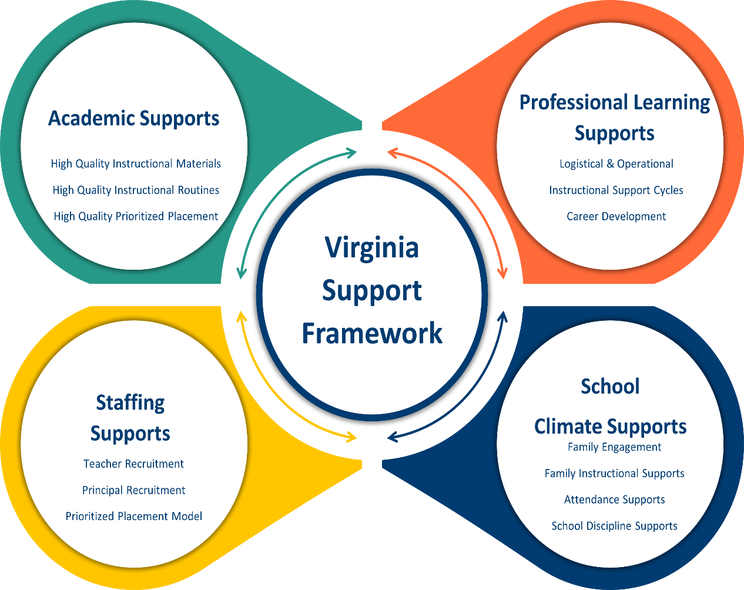

Profile Information
Division: Roanoke City Public Schools | School: Virginia Heights
Principal: Dana Witt | Designations (if applicable):
Stakeholder/Family Engagement
Describe how the school will routinely involve internal and external stakeholders in the school improvement process to include conducting the needs assessment; selecting evidence-and research-based strategies; and developing, implementing, monitoring, and evaluating the plan.
 | Domain I: Academic Supports |  |  | Content Area: English
 | Barrier(s): Some of the barriers that affect teaching and learning include assistance with methodology and limited professional learning opportunities for staff to include trainings needed to implement high-quality instructional materials and differentiate instruction based on assessments.
 | SMART Goal Statement: Increase the percentage of students demonstrating proficiency in reading comprehension by at least 10% by the end of the school year through the implementation of explicit word analysis instruction, comprehension strategy instruction and targeted interventions.
 | (Evidence-based) Strategy Name: Improving Reading Comprehension in Kindergarten through 3rd Grade  Tier of Evidence: Moderate |  | Description: Students who read with understanding at an early age gain access to a broader range of texts, knowledge, and educational opportunities, making early reading comprehension instruction particularly critical. This guide recommends five specific steps that teachers, reading coaches, and principals can take to successfully improve reading comprehension for young readers.
 | Student Measure #1: VAALLS, benchmarks, Reading Playground, MAP assessments |  | Student Measure #2: pre and post assessments
 | Staff Measure #1: walk-throughs and lesson plan feedback |  | Staff Measure #2: student performance reports
 | Action Plan
 | Action Steps  (Describe the step and include who will implement and how often it will be implemented) | Start of Action Step | End of Action Step | Position Responsible for Monitoring | Budget (local, state, federal funds)
 | Develop and monitor lesson plans and collaborative learning team structures to ensure instruction in aligned with Virginia’s SOLs and Curriculum Framework. | October 2024 | June 2025 | Administration | n/a
 | Develop and monitor data meetings to review various data to inform instruction and group students based on their academic needs. | October 2024 | June 2025 | Administration, Reading Specialists, Special Education teachers | n/a
 | Provide feedback to teachers through the observation process to ensure that instruction aligns with the Virginia SOLs and curriculum framework. | October 2024 | June 2025 | Administration | n/a
 | Teachers will participate in ongoing professional development to ensure alignment and consistency of lesson plans to . | October 2024 | June 2025 | Administration, district coaches, reading specialists | n/a
 | Local Educational Agency (LEA) Support: Describe how the LEA will support in implementing, monitoring, and evaluating this strategy.
Evidence: Based on the action steps, define what measurable evidence would indicate progress towards the long-term goal.
Analysis: Address impact and next steps.
 | Evidence of Progress (update monthly) |  | Analysis of Progress (update monthly)
Domain I: Academic Supports |  |  |  | Content Area: Mathematics
Barrier(s): Some of the barriers that affect teaching and learning include assistance with methodology and limited professional learning opportunities for staff to include trainings needed to implement high-quality instructional materials and differentiate instruction based on assessments.
SMART Goal Statement: Improve the computation and estimation skills of students by increasing the percentage of students meeting or exceeding math assessment benchmarks by 10% through intentional practice with number sense and computation.
(Evidence-based) Strategy Name: Assisting Students Struggling with Mathematics: Intervention in the Elementary Grades  Tier of Evidence: Strong |  |  | Description: Provides six comprehensible and practical recommendations that focus on practices and principles underlying effective small group interventions.
Student Measure #1: Benchmarks, MAP assessments, classroom assessments |  |  | Student Measure #2: pre and post assessments
Staff Measure #1: walk-throughs and lesson plan feedback |  |  | Staff Measure #2: student performance reports
Action Plan
Action Steps  (Describe the step and include who will implement and how often it will be implemented) |  | Start of Action Step | End of Action Step | Position Responsible for Monitoring | Budget (local, state, federal funds)
Develop and monitor lesson plans and collaborative learning team structures to ensure instruction in aligned with Virginia’s SOLs and Curriculum Framework. |  | October 2024 | June 2025 | Administration | n/a
Conduct walkthrough and provide feedback to ensure that identified strategies are delivered during instruction |  | October 2024 | June 2025 | Administration, Math Specialists, Special Education teachers | n/a
Provide feedback to teachers through the observation process to ensure that instruction aligns with the Virginia SOLs and curriculum framework. |  | October 2024 | June 2025 | Administration | n/a
Provide intensive, systematic instruction on foundational math skills in small groups to students who score below the benchmark score through utilization of Zearn and other supplemental math resources |  | October 2024 | June 2025 | Administration, district coaches, Math specialist | n/a
Implement and monitor student interventions by including intervention staff in planning, tracking specific student interventions, and evaluating student progress to determine which interventions result in positive student outcomes. |  | October 2024 | June 2025 | Administration, Math specialist
Local Educational Agency (LEA) Support: Describe how the LEA will support in implementing, monitoring, and evaluating this strategy.
Evidence: Based on the action steps, define what measurable evidence would indicate progress towards the long-term goal.
Analysis: Address impact and next steps.
Evidence of Progress (update monthly) |  |  | Analysis of Progress (update monthly)
Domain I: Academic Supports |  |  |  | Content Area: Science
Barrier(s): Implementation of curriculum, professional learning, hands on experiments
SMART Goal Statement: Improve overall student achievement in Science by integrating scientific investigation and hands-on learning activities that promote the application of skills resulting in a 10% increase in student proficiency as indicated on the Science SOL assessment.

(Evidence-based) Strategy Name: Using the 5E model in Science education.  Tier of Evidence: Promising |  |  | Description: An inquiry-focused method gives students a way to connect scientific ideas to their experiences and apply their learning.
Student Measure #1: Benchmarks, classroom assessments, SOL Assessment |  |  | Student Measure #2: Students will have the opportunity to conduct investigations, search for solutions to the problems, ask questions and utilize creative and conceptual thinking
Staff Measure #1: walk-throughs and lesson plan feedback |  |  | Staff Measure #2: student performance reports
Action Plan
Action Steps  (Describe the step and include who will implement and how often it will be implemented) |  | Start of Action Step | End of Action Step | Position Responsible for Monitoring | Budget (local, state, federal funds)
Develop and monitor lesson plans and collaborative learning team structures to ensure instruction in aligned with Virginia’s SOLs and Curriculum Framework. |  | October 2024 | June 2025 | Administration | n/a
Provide feedback to teachers through the observation process to ensure that instruction aligns with the Virginia SOLs and curriculum framework. |  | October 2024 | June 2025 | Administration | n/a
Teachers will participate in ongoing professional development to ensure alignment and consistency. |  | October 2024 | June 2025 | Administration, district science coordinator | n/a
Local Educational Agency (LEA) Support: Describe how the LEA will support in implementing, monitoring, and evaluating this strategy.
Evidence: Based on the action steps, define what measurable evidence would indicate progress towards the long-term goal.
Analysis: Address impact and next steps.
Evidence of Progress (update monthly) |  |  | Analysis of Progress (update monthly)

Domain of Support
Domain II: Staffing Supports
Barrier(s): lack of candidates
SMART Goal Statement: The turnover of support staff impacts student relationships and affects academic progress.
(Evidence-based) Strategy Name: Create a supportive school culture that supports the well-being of the instructional assistant.  Tier of Evidence: Moderate |  | Description: We will engage our support staff by increasing communication and training opportunities.
Student Measure #1: Increase in student engagement and achievement. |  | Student Measure #2: Increase in student attendance due to improved interactions with staff.
Staff Measure #1: Meeting notes |  | Staff Measure #2: Feedback from instructional assistants
Action Plan
Action Steps  (Describe the step and include who will implement and how often it will be implemented) | Start of Action Step | End of Action Step | Position Responsible for Monitoring | Budget (local, state, federal funds)
Encourage a culture of collaboration where teachers share with instructional assistants resources and strategies. | October 2024 | June 2025 | Administration, Teachers | n/a
Establish open lines of communication between IA’s and supervising teacher. | October 2024 | June 2025 | Administration, Teachers | n/a
Provide training to IA’s to understand expectations and guidelines. | October 2024 | June 2025 | Administration, Teachers | n/a
Local Educational Agency (LEA) Support: Describe how the LEA will support in implementing, monitoring, and evaluating this strategy.
Evidence: Based on the action steps, define what measurable evidence would indicate progress towards the long-term goal.
Analysis: Address impact and next steps.
Evidence of Progress (update monthly) |  | Analysis of Progress (update monthly)

Domain of Support
Domain III: Professional Learning Supports
Barrier(s): resistance to change, time constraints
SMART Goal Statement: Teachers are overwhelmed with responsibilities and lack daily access to instructional coaching to implement new strategies.
(Evidence-based) Strategy Name: Reflective practice  Tier of Evidence: Moderate |  | Description: Teachers will implement strategies received from professional development to assist in the development of their teaching styles to understand their role as a teacher. Teachers will critically think about their actions and decisions during their teaching practices through self-observations and evaluations.
Student Measure #1: Assessments |  | Student Measure #2: Student discipline data
Staff Measure #1: Assessment data, self-assessment |  | Staff Measure #2: teacher feedback and data
Action Plan
Action Steps  (Describe the step and include who will implement and how often it will be implemented) | Start of Action Step | End of Action Step | Position Responsible for Monitoring | Budget (local, state, federal funds)
Professional learning opportunities to address new strategies | October 2024 | June 2025 | Administration, Reading Specialists, district coordinators | n/a
Local Educational Agency (LEA) Support: Describe how the LEA will support in implementing, monitoring, and evaluating this strategy.
Evidence: Based on the action steps, define what measurable evidence would indicate progress towards the long-term goal.
Analysis: Address impact and next steps.
Evidence of Progress (update monthly) | Analysis of Progress (update monthly)

Domain IV: School Climate Supports
Barrier(s): transportation, language, stakeholder buy-in
SMART Goal Statement: High rates of chronic absenteeism among students at Virginia Heights Elementary School are negatively impacting academic performance and overall student well-being. Despite efforts to address this issue, many students continue to miss significant amounts of school due to various barriers.
(Evidence-based) Strategy Name: Attendance Works  Tier of Evidence: Strong |  | Description: A variety of approaches, strategies and tools to help address chronic absence. Choose from the list below to find out what you can do to ensure all students succeed in school and in life.
Student Measure #1: Decrease in days absent |  | Student Measure #2: Increase in academic growth
Staff Measure #1: Communication logs |  | Staff Measure #2:
Action Plan
Action Steps  (Describe the step and include who will implement and how often it will be implemented) | Start of Action Step | End of Action Step | Position Responsible for Monitoring | Budget (local, state, federal funds)
Attendance review | October 2024 | June 2025 | Administration, teachers, student support specialist | n/a
Monthly positive attendance celebrations | October 2024 | June 2025 | Administration, teachers | n/a
Attendance letters for students with chronic attendance concerns | October 2024 | June 2025 | Administration, student support specialist, district attendance specialist | n/a
Local Educational Agency (LEA) Support: Describe how the LEA will support in implementing, monitoring, and evaluating this strategy.
Evidence: Based on the action steps, define what measurable evidence would indicate progress towards the long-term goal.
Analysis: Address impact and next steps.
Evidence of Progress (update monthly) | Analysis of Progress (update monthly)

In accordance with the Standards of Quality (SOQ) and Standards of Accreditation (SOA), all schools are to prepare a comprehensive, unified, long-range plan in conjunction with the division long-range comprehensive plan, and make it available to the public (SOQ, § 22.1-253.13:6.; SOA 8VAC20-131-390; 8VAC20-131-400). Under the Every Student Succeeds Act (ESSA), schools identified for comprehensive, targeted, and additional targeted support and improvement are required to develop plans based on a set criteria with state educational agency (SEA), local educational agency (LEA), and school approval (ESSA §1111(d)(1)(B); §1111(d)(2)(B)-(C))

