School Name: John M. Clayton Elementary Submission Date: 07.08.2025
Principal: Allisa Booth School Enrollment: 446
School Mission:
JMC’s mission is to cultivate a culture of compassion, determination, and equity, empowering every student to achieve their goals and make a difference in the world.

School Demographics School Report Card data can be found here.
Provide data for the following in a format/structure of your choosing:
- Student Enrollment Data by Grade Level

Grade | Number of Students
K | 68
1 | 80
2 | 64
3 | 73
4 | 77
5 | 84
Total | 446

- Student Demographic Data
Ethnicity
Ethnicity | Percentage
American Indian  or Alaska Native | 0.67%
Asian American | 0.67%
African American  or Black | 12.33%
Hispanic  or Latino | 31.84%
Multi-racial | 1.79%
White  or Caucasian | 52.69%

Subgroup Identification (i.e. special education, low income, homeless…)
Subgroup | Percentage
English Learners | 30.27%
Low Income | 23.77%
Students with Disabilities | 15.7%

Part I: Comprehensive Needs Assessment (CN7)
A Comprehensive Needs Assessment is a process that is used to identify needs and performance challenges in a school or district, determine their root causes, and set prioritized goals for future action. Schools and districts should use the comprehensive needs assessment to inform improvement planning and budgeting.

A school-wide CNA focuses on the ends (i.e. outcomes and goals) to be attained, rather than the means (i.e. process and action steps). For example, reading achievement is an outcome whereas reading instruction is a means toward that end.

You will find the CNA Priority Form here. You will be forced to make a copy of this document, so be sure to add your school name to the title. Please provide the link to your CNA Priority Form here: JMC 2025.2026 Comprehensive Needs Assessment
JMC 2024.2025 DeSSA Data
JMC 2024.2025 Discipline Data
Once your CNA analysis is complete, please provide a link or copies of your data for those elements you and your team identified as “significant” or “severe” priorities. Your significant and severe priorities should be the ones you plan and budget for in your SSP.
Part II: Data-Driven School Goals and Plan for Improvement
As a district, we are committed to fulfilling our mission, to assure that students attain the knowledge, skills, and attitudes needed to realize their potential, meet the challenges of their life choices, and fulfill their responsibilities as citizens of the State of Delaware, United States and world through a partnership of students, parents, staff, administrators, Board of Education and community.
We commit to doing so while serving as champions of culture and equity by ensuring all students, families, and staff will have adequate tools, training, learning, and experiences needed to be successful in Sussex County, as well as amongst our global and diverse society. We are committed to creating a culturally responsive environment that eliminates barriers that impede student and staff success through the development of a diverse workforce, highly effective leadership, continual professional learning, cutting-edge technology, and extensive related and wrap-around services. In partnership with families and community stakeholders, we will work diligently and collaboratively to promote engagement and inclusivity by practicing effective communication and outreach strategies.
We work to fulfill our commitments by focusing on the four pillars of our 2022-2027 Strategic Plan:
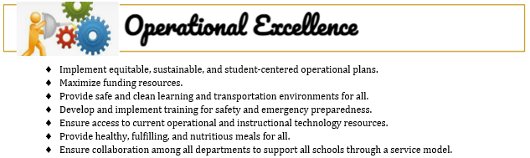
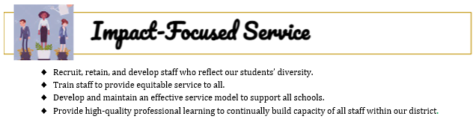
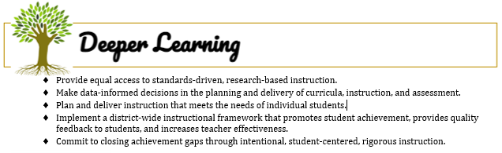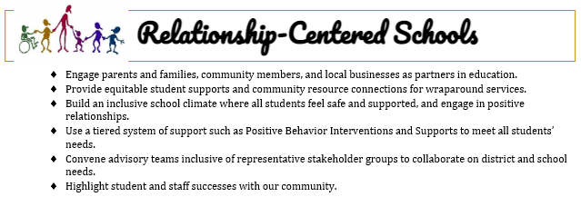
Professional Standards for Educational Leaders, or PSELs, guide us in our work to ensure our practice is productive and beneficial to students, and as a district, we are focusing on the following PSELs to support us in our work:
Component 1: Leadership for Purpose and Improvement | PSEL 10 School Improvement
Component 2: Leadership for Self and Others | PSEL 3 Equity and Cultural Responsiveness
Component 3: Leadership for Student Success | PSEL 4 Curriculum, Instruction, and Assessment  PSEL 5 Community of Student Care and Support
Component 4: Leadership for Learning Community | PSEL 6 Professional Capacity of School Personnel  PSEL 7 Professional Community for Teachers and Staff  PSEL 8 Meaningful Engagement of Families and Community

In considering our district’s strategic plan and the PSELs for administrator growth, complete this action plan to address your significant and severe priorities from your Comprehensive Needs Assessment. Please also ensure you complete the separate required Title I budget form linked here. (Note: you will be required to make a copy of this budget form.)
JMC 2025.2026 Title I Budget
Your School’s Data-Based Goals for 2022-2023 | Root Cause/Data Driving this Goal | Major Action Steps and Activities to Address Goal | Identify the Aligning Strategic Plan Goal(s) | Identify Specific Leadership Actions that will Evidence Progress towards State Appraisal Component(s) and PSEL(s)  (Use numbers to indicate Component and PSEL. For example, 1.10 for Component 1 PSEL10) | If Applicable and Permissible, which Federal Funding will You Use to Support this Work? | CHECKPOINT;  Are Aligned Item(s) on your Title I and/or Opportunity Grant Budget(s) or Perkins Requests Form(s)?  Check if “Yes”
EXAMPLE:  To improve overall school climate for students | School Climate Survey Data from Students  Discipline Data evidencing increase in student referrals for minor classroom-based offenses | - Create a progressive discipline plan to address minor classroom offenses before they result in referrals  Provide training for staff in addressing minor classroom offenses through relationship-building and responsive techniques  Develop grade level team-based PBIS systems that align with our schoolwide PBIS program | Relationship-Centered Schools  Impact- Focused Service | 1.10 Provide hourly rate to grade and team-level staff leaders to meet with school administrators during the summer to create a schoolwide progressive discipline plan and aligning grade/team-based PBIS systems  4.7 Train all staff in minor vs. major behavioral offenses; and in our new Progressive Discipline and PBIS system during Returning Educator Week  1.10 Meet monthly with each team to review referral and Behavioral Intervention Form data and determine next steps  4.7 Include small group counseling session goals, related to discipline data, in our school counseling plan | - Title I  - Opportunity  Grant  - Perkins
Component 1 Goal  Leadership for Purpose and Improvement  To prioritize the intention of standards based planning and strengthen instruction through the use of data analysis to drive and scaffold Tier 1, 2, and 3 instruction. | JMC students in grades 3-5 have consistently declined or shown limited growth in DeSSA scores over the last few years of DESSA data - across the content areas. | Provide substitute coverage for three grade level half day planning sessions during the school year and planning with the IRSD Instructional Coaches and JMC Interventionists for co-planning and co-teaching cycles.  During additional planning time, teams will plan for scaffolded instruction that is incorporated into Tier 1 instructional time - maximizing instructional time. | Deeper Learning  Operational Excellence | 1.10 Administration attends PLCs and Half Day Planning Sessions.  1.10 School Administrators will introduce and use the district-provided PLC framework to improve the structure of school-based PLCs.  4.7 Administration will promote mutual accountability among teachers in PLCs and support staff for each  student’s success.  4.7 Administration will develop and support open, productive, caring, and trusting working relationships  among leaders, faculty, and staff to promote professional capacity and the  improvement of practice. | Title I  Opportunity Grant | Yes
Component 2 Goal  Leadership for Self and Others  To conduct consistent and pervasive data analysis to inform student interventions and target high needs populations. |  | Guarantee all interventionists are supporting each classroom, so that teachers and students feel support and help with students’ individual growth goals. | Deeper Learning  Impact-  focused Services | 2.3 Ensure that cultural responsiveness is embedded in planning for lessons so that all students receive the support they need and deserve.  2.3 Allow students to learn from effective teachers who have been trained to work with students from all backgrounds and promote awareness of and understanding of different populations and programs within the school.  4.6 Develop teachers’ professional knowledge and skills through an international conference, so teachers can empower and motivate their colleagues upon their return. | Title I  Opportunity  Grant | Yes
Component 3 Goal  Leadership for Student Success  (1) Continue work around the two ‘Student- Centered Centered Coaching’ Books read in Summer 2024 with the school’s Administration, Special Education Coordinator, Math Interventionist, ML Interventionist, and Reading Interventionist so the team can further develop a plan to support ALL teachers with planning and co-teaching during the 2025-2026 school year. | (1) With the third year of the district’s ELA Curriculum, CKLA, and the updated Bridges 3 Curriculum, it was determined that teachers need guidance to focus on the standards aligned to the curriculum - not the theme or outside resources. | Continue working with the following two books: Student-Centered Coaching and Student Centered Coaching: The Moves with all Interventionists, Special Education Coordinator, and Administration in preparation of the 2025-2026 school year to further develop a targeted support plan for classrooms/grade levels based on data analysis.  Provide substitutes for staff to conduct peer learning walks in order to observe the co-planning and co-teaching in ‘Student-Centered Coaching’ Classrooms.  Provide specialized professional development through faculty meetings or within PLCs to ensure all students are met - specifically scaffolding needed to meet special education goals.  Provide additional time outside of PLCs (during the school day) for grade-levels or coaching teams to meet, so they can receive extra planning and conduct deep dive data analysis since they are committing to the ‘coaching’ process.  Create small group Counseling sessions to build toolboxes for students who received high numbers of referrals and/or received OSSs during the 2023-2024 school year. | Deeper Learning  Impact-  focused Services  Operational Excellence  Relationship- Centered School | 1.10 Targeting SEL and MTSS intervention planning will allow for students’ individual academic and behavioral growth.  3.5 Support students’ individual emotional and educational needs through SEL curriculum and coaching plans for the school.  4.6 Develop teachers’ professional knowledge and skills through small group book talk, so interventionists can develop a school plan to support teachers and students with individualized learning opportunities. . | Title I  Opportunity  Grant | Yes
Component 4 Goal  Leadership for Learning Community  (1) To streamline PTO events and increase parent and community involvement through school-based activities like Parent Engagement Nights. The goal is to increase parent involvement through strategically assigning grade levels to specific events. | PTO has created a successful calendar of events, but the organization needs more parental and community support, so staff members who are parents do not become accountable for all of the responsibility. | Provide funding for meals during the Parent Engagement Nights.  Work with community partners to educate JMC PTO, parents, and staff on how to strengthen the school’s partnerships within our community - to support our students and families in need with free resources at every event. | Relationship- Centered Schools | 4.8 Administration will work with the newly elected 2025.2026 JMC PTO Board Officers to encourage and train JMC parents and staff to support community partnerships already established with Freeman Arts Advisory Board, Frankford Library, Paws for People, Read to Them (One School, One Book), Read Aloud, Latino Family LIteracy Project, etc. - as well as create new partnerships. | Title I  (Parent Engagement) | Yes

Part III: Parent Engagement
If you have NOT addressed parent engagement in Part II of your School Success Plan (SSP) above, please answer the questions below:
How will you continue working to improve communication and engagement with your families and community this year?
Our PTO recently inducted new officers for the 2025-2026 school year, however, the organization still needs to work on recruiting parents, family members, and community members who are not staff members in an effort to avoid burnout. The school communicates with families through a variety of platforms to ensure we reach as many families as possible. Messages are sent in both English and Spanish through Blackboard Connect emails, Class Dojo, Peachjar, printed hard copies, and social media. For several years, JMC has held multiple Latino Family Literacy Project sessions to support families with both Spanish and English literacy support, so families can help their children at home. We plan to invite more families into school day assembly activities when appropriate.
Please briefly describe your Parent Engagement Event from 2024-2025, and share how you will seek to improve participation this year:
JMC’s PTO invited new JMC parents to a meet and greet at the end of Kinder Camp in August, so parents can meet other parents and students as well as learn about joining the PTO. Our Parent Engagement Nights occur in the fall and the spring. In the fall, we focused on Math Literacy activities at every grade level, S.M.A.R.T. activities, and Spanish Immersion cultural activities for the entire school while the focus was Reading and Writing Literacy in the Spring as well as to showcase the JMC Robotics teams. This past year, we held the first Evening of the Arts which highlighted the JMC Art Show at Seed and Sapling and the Spring Band and Choral Concert was held in the JMC Gym. The event was super successful and we plan to grow the event in 2025-2026 to invite the community at large to attend and highlight a school-wide Spanish Immersion cultural activity as well. JMC’s fall Parent Engagement Night is always crowded but the spring Parent Engagement Night always has fewer families attending due to the increase in sports activities. Our goal is to offer more giveaways for attendance along with the already established free dinner and community clothing closet. Additionally, our counseling team is always present at family events to support families in need as well as provide SEL and community resources.

Part IV: School-wide Planning Information
Please describe the process you used to develop this Strategic Success Plan, including when you met to complete this process:
JMC’s Instructional Leadership Team will meet before the 2025-2026 school on Tuesday, August 5 to review the plan and modify it if needed. The plan has been similar for the past several years as we always determine the use of the upcoming school year’s Title I funding to support as many staff members as possible. JMC’s Instructional Leadership Team, which includes a variety of school stakeholders, will meet with invited parents and community members to agree upon a significant portion of the budget being used for two additional teaching units. In the past, the school team has always decided to replenish outdated technology and support professional development for administration and teachers.
Your planning team should be representative of all stakeholder groups in your school community such as teachers, administration, counseling, support staff and parents/community members. Please provide us with the information regarding your planning team (add additional rows as needed):
Planning Team Member Name | Position/Stakeholder Representation | Signature
Allisa Booth | Principal
Bennett Murray | Assistant Principal
Alison Hill | Kinder
Stephanie Syphard | 1st Grade
Brianna Kelly | 2nd Grade
Haley Donoway | 3rd Grade
Gretchen Viacara | 4th Grade
Sara Powell | 5th Grade
Jaime Swartz | STEM Teacher
Jennifer Pierorazio | Reading Specialist
Khara Bauer | ML Interventionist
Caroline Hevner | Math Interventionist
Matt Redmiles | School Counselor
Allison Bennett | Special Education Coordinator
Cassie Queen | IREA Representative
Parent | Parent
Community Member | Community Member

