Colony Middle School
Student Handbook 2025-26

9250 E Bogard Road ~ Palmer, AK 99645

Phone: 907-761-1500 ~ Fax: 907-761-1592

Mr. John Gardner, Principal
Ms. Brenna Reintsma, Assistant Principal

Colony Middle School is committed to providing an excellent education for all students.


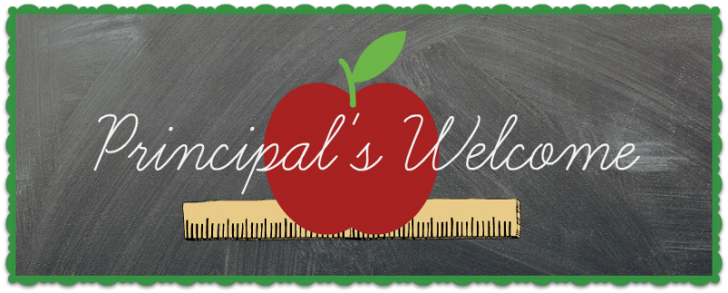

Dear Parents, Guardians and Students,
Welcome to a new school year! It is an honor to work with such bright, curious, and capable students. The education of our students is our highest priority and we are committed to providing all students opportunities to be successful in a safe, supportive and engaging environment. We encourage you to take time to review our school handbook with your child, as it contains important information, expectations, and resources that will help set the tone for a positive and productive year.
We believe that strong partnerships with families are key to a successful school experience and we are excited to partner with you in supporting your child’s growth and success during their middle school journey. We value your involvement and welcome your feedback. Whether it’s a concern, suggestion, or a celebration of success, your voice matters. Please don’t hesitate to reach out or participate in school events and activities throughout the year.
Thank you for entrusting us with your child’s education. We are looking forward to an amazing year filled with learning, growth, and opportunity.
Sincerely,
John Gardner Principal



Colony Middle School Has ONE RULE:

BE KIND AND RESPECTFUL TO EVERYONE AT ALL TIMES

How can you be successful at Colony Middle School? It’s easy! Just follow this simple advice:
Do what is expected and do it the best that you can. This includes:
- Being prepared with all necessary materials (agenda, books, paper, pencil)
- Taking responsibility for your learning by paying attention during class
- Doing your homework
- Getting involved in school activities and athletics
- Asking for support when you need it
- Remember our one rule

School rules exist for the protection of all, but especially to protect each student’s right to an education. The guidelines described in this handbook are not intended to be complete, but to provide a framework for student behavior and responsibilities. School rules reflect Alaska State Law, the policies adopted by the MSBSD and the standards of our community. We encourage all students to aspire toward the ideals shown on the CMS Shield of Success that is displayed in each classroom and hallway.

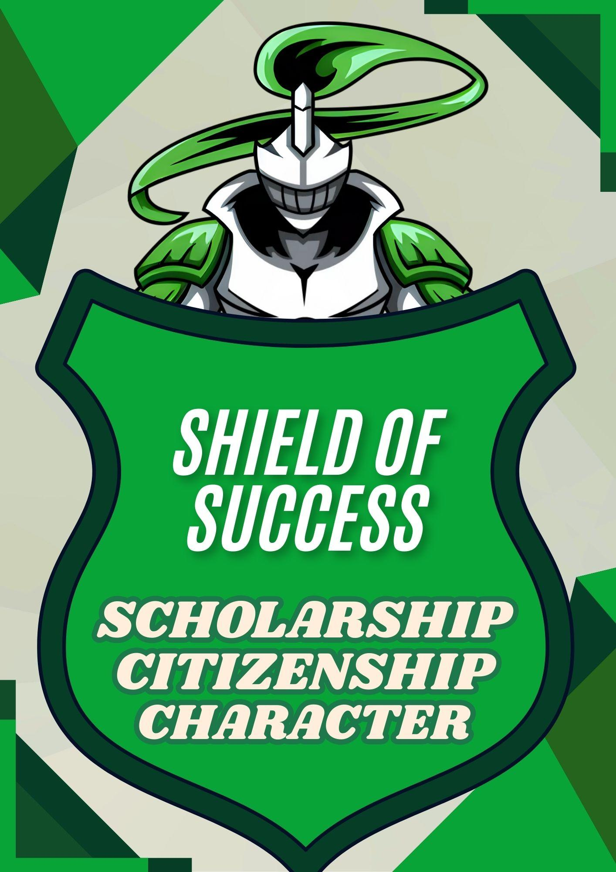

General Information

Building Hours
Students may be in the building from 7:15 AM until 2:30 PM. Students may not be in the building before or after these hours unless they are supervised by staff.
Before school: From 7:15 - 7:30 AM, students will be supervised in the cafeteria or gym. Breakfast is served at 7:15 AM, and students may go to their lockers at 7:30 AM.
After school: Students who do not participate in school sponsored activities must be picked up by 2:25 PM. While your children are encouraged to participate in the activities we offer, it is important that students leave the building when the practice or event is over. Students who have no one supervising them after school may not stay after school. Often, teachers will stay after school to work with students on individual projects. When this is the case, the teacher will notify you of the time your child will need to be picked up.

Office hours: The school office is open from 7:00 AM – 3:30 PM.

Dismissal

All students are expected to remain at school for the entire day. If a student must leave school for an appointment, he/she must be signed out by a parent/guardian at the front office. No student shall be released to siblings who are minors or any other person without the written permission of the student’s parent/guardian.

Buses leave the school promptly at 2:25 PM each afternoon. All transportation changes for the day must be made by 1:45 PM. Please make sure all phone calls and emails are made by this time to avoid confusion and complications. Also, please be aware that between 2:00 PM and 2:30 PM daily, the office will be focused on school dismissal and will be unavailable to answer phones at that time.

Emergency school closure

Should school be closed for bad weather or any emergency, you can find out more information by listening to local radio stations or by checking the district website. MSBSD’s automated messaging system will also call to notify families of any school closure.

Phone Calls Home

Students may make phone calls home from the front office during the school day. They must have permission from their teacher and a hall pass to come to the office. Phone calls should be short so that students do not miss more class than is necessary.

Visitors

Parents and guardians are always welcome at Colony Middle School to see a teacher, counselor, or administrator. To discuss your child’s progress, please contact your child’s teacher. To visit a class while classes are in session, visitors must make prior arrangements with the teacher and an administrator. As a matter of safety when visiting the school, all visitors must sign in and get a visitor’s badge.

Student Expectations

Attendance

Good school attendance is important to a student’s success at CMS. Poor attendance usually results in poor achievement. Students are expected and required by Alaska State Law to attend all class periods of the school day unless other arrangements have been made through the office. Course work missed because of an absence is expected to be completed. The student has time equal to the absence plus one day to complete missed assignments for full credit. It is the student’s responsibility to ask his/her teacher for missed assignments. Parents can call or email their child’s core teachers to request homework due to an absence. Teachers will have 24 hours to fulfill a homework request.

It is also very important that all students arrive at school on time. This includes students on a Boundary Exemption and those families choosing forms of transportation other than the bus. It is equally important that students report to each class period on time and prepared, both for their own learning and so they do not interrupt the learning of others. When a student is late to school/class, he/she will report to the office to record a tardy. The student will only be admitted to class with a tardy slip. The following unexcused tardy consequences are per quarter:

1st-3rd tardy Student warning
4th-9th tardy 1 lunch detention per tardy and parent notification by email.
10th tardy Student referral to CMS Admin for passing period support.
15th tardy Required parent conference

Prearranged absence

Parents and/or students should notify CMS in advance of a planned absence of three or more days. A Prearranged Absence form, available at the front office, should be used for this purpose. For absences up to ten days, teachers may provide work to be completed during the absence. They may also elect to give the student time and opportunity to complete the work upon the student’s return to school. The teacher’s choice will be indicated on the Prearranged Absence form. The form should be signed and returned to the front office prior to the start of the absence.

Excessive absences

Studies have shown that student attendance at school is directly related to student success. Parents, students, and schools need to work together to promote attendance and success. In order to effectuate positive results and good communication, parents can opt to receive daily notifications of absences through the District Student Information System. After three days of absence a telephone call will be made to the parents; a written notice will be mailed to the parents after five days of absence. After nine days of absenteeism, the student’s absences will be considered habitual and another written notice will be mailed to the parents. In cases of habitually truant students, a referral may be made to the Office of Children’s Services. Parents are encouraged to take an active role in student attendance and to alert the school when their child is to be absent. It is the responsibility of the student to make arrangements to keep up with schoolwork when he or she is absent from school.

Truancy/Skipping
Truancy is defined as an “absence from school or class for more than five minutes without the knowledge or consent of the student’s parent, guardian or teacher”. Students who are truant from school or class will be subject to disciplinary action.

Bikes, Boards, Wheels & Blades
Bicycles, which are ridden to school, must be locked to the bike rack in front of the building. The school is not responsible for lost, damaged or stolen bicycles. Bikes may not be ridden around school property unless students are participating in a school sponsored activity or need to ride the bike in order to attend school. Roller blades, skateboards and other similar devices are not permitted on school property whether school is in session or not.
Students may not bring motorized vehicles to CMS, including four wheelers, motorbikes and snowmachines.

Chromebook use
Students will be issued a District Chromebook and charger for school use unless parents elect otherwise. A signed Student/Parent Device agreement (See MSBSD One to One Parent/Student Handbook) and permission to use the internet must be in place. Students are expected to use their Chromebook for school purposes only. Recreational computer use is not permitted. Additionally, students are to follow and abide by all District expectations concerning computer misuse.
Misuse of school computers is defined as “any malicious attempt to physically deface, disable, or destroy computers, peripherals, or other network hardware, to harm or destroy data of another user or any other agency or network that is connected to their system, to gain access or attempt to gain access to unauthorized systems, or to access inappropriate materials from school.” Misuse will result in an SRC referral and may result in the loss of all computer privileges for the remainder of the quarter, semester, or year.

Dress Code

Student dress and general appearance is a shared responsibility among students, parents/guardians, and the school. The Board of Education believes that appropriate dress and grooming contribute to a productive and safe learning environment. The Board expects students to give proper attention to personal cleanliness and to wear clothes that are suitable for the school activities, including industry requirements at the work site, in which they participate. Students have the right to make individual choices from a wide range of clothing and grooming styles, but they must not present a health, safety hazard, or a distraction which would interfere with the educational process. Students wearing prohibited attire will be asked to cover it, change it, or go home until proper attire is worn.

District and/or School Administration may address student dress and appearance trends as necessary through administrative regulation and/or school-based expectations. The following minimum standards will be enforced:

a. Clothing and accessories must be appropriate for school and may not present a substantial disruption in classrooms or common areas.

b. Clothing and accessories, to include but not limited to: Notebooks, patches, tattoos, and jewelry must not display racial or ethnic slurs or symbols, gang affiliations, vulgar, subversive, sexually suggestive, or otherwise inappropriate language or images.

c. Promotion of products that students may not legally buy such as alcohol, tobacco, illegal drugs, or the promotion of establishments that are illegal for students; or anything that promotes harm to another or to oneself is prohibited.

d. Attire, accessories, etc. bearing expression or insignia which is obscene, libelous, or which advocates racial, religious, or other prejudice is prohibited.

e. Clothing that is overly revealing is not allowed. This includes shirts/dresses that are low cut, sleeveless shirts that do not cover undergarments, or that are not long enough to cover the waistband. The midriff/stomach cannot be visible.

f. Pants/shorts/skirts/dresses must cover the legs to mid-thigh. Holes in pants must be below mid-thigh. All undergarments must remain covered. No clothing may be see-through or transparent.

g. Attire that resembles non-human characteristics is prohibited.

h. Students are required to wear shoes at all times.

i. For safety reasons, nothing should obstruct or cover the head or face that would block identification. Items that may conceal a student’s head or face are not allowed during the instructional day without administrative approval.

Reasonable accommodation for a student’s religious beliefs will be made unless the accommodation creates an undue hardship.

Any individual who needs accommodation is encouraged to request it from the administration.

At the discretion of the building administrator, in special circumstances such as spirit days or field trips, exceptions may be made to student dress and appearance standards.
If a student chooses to wear inappropriate clothing, the student will be given an SRC referral and asked to change. If necessary, the student may call a parent to bring an appropriate change of clothes. If a student continually violates the school dress code, the following consequences will occur. First and second offense, an email will be sent to parents. Third and fourth offense, the student will receive 2 lunch detentions. The fifth offense, the student and an administrator will contact parents to discuss the infraction and future consequences.

Electronic devices
Personal electronic devices can be a distraction to the learning environment and a detriment to learning. For this reason, the MSBSD School Board and CMS policy is off and away during the school day including lunch and passing periods. This includes cell phones, tablets, gaming devices, smart watches and all types of wireless headphones. Students are expected to have their electronics turned off and put away from 7:45-2:15. Use of personal electronic devices is allowed before and after school but no photos or recordings of other people are allowed at any time. If a student violates any part of this policy, CMS staff will confiscate any device on sight. Confiscated devices will be turned in to the front office and the following consequences will occur.
1st Offense: Phone call home and student picks up at the end of the day
2nd Offense: Phone call home and parent must come pick up device
3rd Offense and any subsequent offenses: Phone call home, parent picks up device and progressive disciplinary consequences. These consequences may include, but are not limited to, detention, loss of privileges, individual behavior plan, required device check-in, and/or suspension.
Colony Middle School is not responsible for items lost or stolen at school.
Extracurricular activities

Extracurricular activities are part of a large and varied program of activities at CMS. Extracurricular athletics require a fee of $120 per sport, with a maximum of $300 per student each year, and a current physical. All students have a place in our athletic programs. While our 7th and 8th grade competitive programs require try-outs, we also have C-team programs that are all-inclusive. There will be many activities in addition to interscholastic athletics offered throughout the year. These may require a fee. Intramurals and club activities may include, but are not limited to Science Olympiad, Jazz Band, Ski Club, Battle of the Books, Drama, Yearbook, Speech Club, Geography Bee, Chess Club, Spelling Bee and National Junior Honor Society.

Eligibility
Academic eligibility will be monitored on a weekly basis by school staff. In addition to academic eligibility, a student must:

- Have a current physical on file for athletics.
- Register through Bigteams Student Central (formerly PlanetHS).
- Follow attendance guidelines set by coach and approved by administration
- Be responsible for maintaining a passing grade in all subjects. Students that
have two or more “I” grades will be considered not fully eligible for the current week.
- Be in attendance for the full day of school to participate in that day’s
competition.
- Always maintain good conduct and a positive attitude.

Grading

The School Board believes that students and parents have the right to receive course grades that represent an accurate evaluation of the student’s achievement. Teachers shall evaluate a student’s work in relation to standards that apply to all students at his/her grade level. Grades should be based on impartial, consistent observation of the quality of a student’s work and his/her mastery of course content and objectives as demonstrated through classroom participation, homework, and tests. The student’s behavior and effort shall be reported in separate evaluations, not in his/her academic grade. (MSBSD BP 5121)

CMS has four grading periods during the school year. Students will receive report cards at the end of each quarter, as well as progress reports at the middle of each quarter. Grades will be reported for each quarter as follows:
- A - Outstanding 89.5 – 100% 4.0 grade points
- B - Above Average 79.5 – 89.4% 3.0 grade points
- C - Average 69.5 – 79.4% 2.0 grade points
- D - Below Average 59.5 – 69.4% 1.0 grade points
- I- Incomplete 44.5 - 59.4% 0 grade points

*I – Indicates that course requirements were not completed by the student. An I must be made up within the following quarter of when grades are issued to parents/guardians. If an I has not been replaced with a passing grade after one quarter, the I will remain on the student’s record.

- F- Little Achievement 0 - 44.4% 0 grade points

*NG – No Grade indicates that a student was not enrolled in the class for 20 days or more total for the quarter.

Academic Progress
The staff at CMS is committed to academic excellence. We will keep you and your parents informed of how you are doing and offer support if you are not doing well academically. Each quarter, teachers will communicate with parents about their child’s grades through progress reports, and end of quarter report cards. Parents are encouraged to regularly check ParentVUE for academic progress.

Honor Roll
Students with a quarterly GPA of 3.0 or higher and with no incompletes will be on the Honor Roll. CMS recognizes three categories of Honor Roll. A 3.0-3.49 GPA will earn Honor Roll, a 3.5-3.99 GPA will earn High Honor Roll and a 4.0 GPA will earn Distinguished Honor Roll. Students who earn High or Distinguished Honor Roll for the first three quarters will receive the Knights of Academic Excellence Award at the end of the third quarter.

Late work policy
Our school exists for the purpose of high levels of learning. Class assignments are given to provide opportunities for students to be introduced to, practice and eventually master state and district standards. With this in mind, all assignments must be completed. A secondary objective of mastering standards is to learn employability skills, including responsibility, time management, and meeting deadlines. Late assignments will be accepted by all teachers at CMS during a quarter grading period. After quarter/semester grades have posted, late assignments will be accepted for 2 weeks from the time the grades are published. If an assignment is considered late, the earned grade may be reduced by a maximum of 20% at teacher discretion.

Report cards and Progress reports
Report cards are issued at the end of each quarter. Progress reports may be given by a teacher at any time. They designate progress in each subject at that point in time. Mid- quarter progress reports will be uploaded to ParentVue during the fifth week of each quarter.

Student Engagement in the Classroom
Students are encouraged and expected to be engaged in all classroom activities each day, CMS staff support students as they grow academically as well as developing the work traits that help them to be successful in an academic setting.

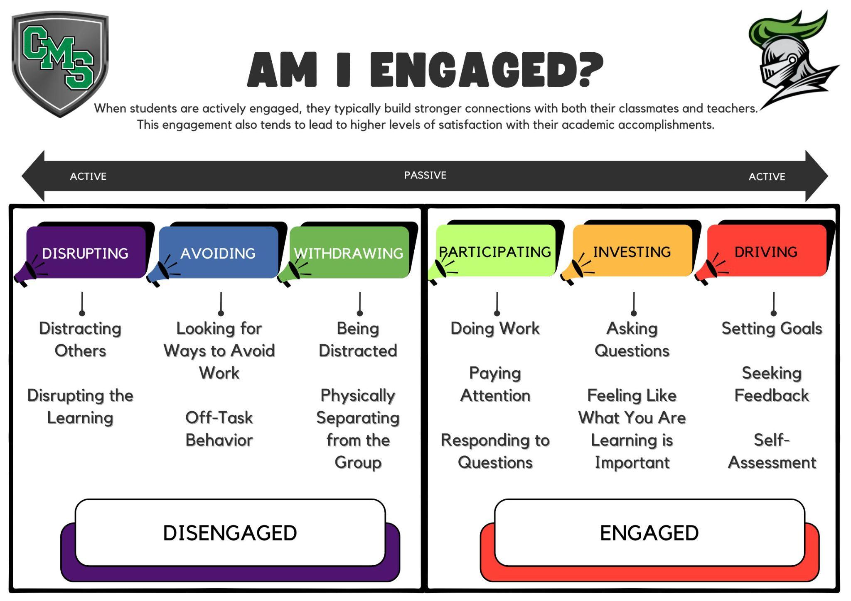

Hallway and common area expectations
Food and Drinks in the Halls
- Open drink containers are not allowed in the halls or common areas. Students arriving to school with open containers, such as coffee drinks, have the option to report to the cafeteria or put the drink in their locker.
- Students with open containers at any other time during the day will be asked to throw it away.
- Food that is in an open container is not allowed at any time in the halls.
- Food, drink, and gum within a teacher’s classroom is allowed at the teacher’s discretion.
Running in the Halls
- Running in the halls is not permitted.
- Students running in the halls will be asked to go back and walk.
- If teacher redirection results in a tardy, then the student will report to the office for an unexcused tardy slip.
- If a student repeatedly violates the “no running” rule, they may earn a tardy for lack of time management and creating a safety issue.

Hall Passes

Hall passes must be requested through the hall pass component of Synergy using the student’s Chromebook. Once the student has requested a pass, the student will be placed in a queue and the teacher will be notified of the request. Students must wait for an available pass as a designated number of passes have been determined for different areas of the school such as the restroom or counselor’s office. If the student is experiencing a restroom emergency and no restroom passes are available at that time, they will be allowed to use the restroom in the nurse’s office instead. For classes such as PE or band where a Chromebook might not be available, the teacher will facilitate the pass through Synergy.
Students should not be in the halls during class time unless they have a pass from a staff member. No passes are issued for the first ten minutes of class. Only one student at a time per classroom will be allowed to leave the room with a pass. If students are in the hall during this time, they will be escorted to the office for a tardy slip. Students that misbehave or abuse hall pass privileges may have their privileges limited or revoked.

Library

We love having students in the library working independently, with a small group, or with their class. Independent and small group use requires a pass and a purpose from classroom teachers.
Checkout/overdue/lost materials policy
Up to six items may be checked out at one time. The checkout period is three weeks and students may renew their books multiple times with library staff provided another student or staff member has not placed a hold on the title. Students with overdue/lost books are responsible for the items and need to communicate with the librarian on how to remedy the situation. Eighth grade students with outstanding charges need to work with the librarian to pay for, replace or come to an agreement, including working in the library prior to leaving CMS.

Printing to the library
- Only school related work may be printed.
- Print only once. If there is a problem, ask for assistance.
CMS students are expected to be aware of and understand the importance of using proper research and documentation techniques to assure that copyright laws are upheld, and plagiarism avoided.

Lunch

School lunch may be purchased daily at CMS or brought from home. Students will be given one-half hour to eat lunch in the school’s cafeteria. A variety of lunch items are available each day. Information on how to pay for meals can be found on the MSBSD website under Nutrition Services.
Everyone at CMS has the right to eat lunch in a clean and safe environment. The lunch monitors oversee maintaining a safe environment and students are expected to follow their direction. Lunchroom procedures are as follows:
- Come down the right-hand side of the stairs quietly.
- While waiting in line for food, remember that “cutting” is not allowed. Also, keep your hands and feet to yourself.
- Once you have your food, be seated at a table to eat your lunch.
- After you have eaten, clean up your own area and take care of your trash.
- You may visit quietly with your friends at the lunch table, go outside, or “walk and talk” clockwise around the stair area.
- Students may not take unwrapped food or open beverage containers out of the cafeteria.

Examples of behaviors that are inappropriate and could result in an SRC referral include:
- Loud or inappropriate language
- Smashing food or beverage containers
- Taking food from other students
- Leaving tables or the floor cluttered with food or litter
- Disrespectful behavior towards lunchroom monitors

Student property
Students are expected to recognize the items that are not consistent with a safe and constructive learning environment and leave them at home. Students are expected to keep all personal items in their lockers. No items other than school supplies should be brought to class unless teachers have requested it. This includes backpacks, bags, coats, and other outside clothing. Here are some specific guidelines:
- Cell phones must be turned off and put away during the instructional day and at any other time directed by school staff.
- Items of distraction such as toys, makeup, etc. should not be brought to school.
- Perfume, cologne, or other fragrant items are not allowed.
- Squeeze water bottles and any beverage containers without a lid should not be brought to school.
- Valuable items and large amounts of cash should not be brought to school.
- Students are not permitted to buy or sell items on school grounds.
- Colony Middle School is not responsible for lost or stolen items.

In addition to disciplinary consequences that may be applied for misconduct, items may be confiscated until the end of the school day. For repeat offenders, parent contact will be made, and the parent may be asked to come to school to claim the item.

Textbooks/Chromebooks

Students will be issued any textbooks that they will need and a District Chromebook with a charger. Students are responsible for the textbooks/Chromebook until they are returned. If you lose or damage any items checked out to you, you will be expected to pay for its replacement.

Student Behavior and Responsibilities

Knights Code of Conduct

At CMS each student is held accountable for our school wide Code of Conduct: Be kind and respectful to everyone at all times; do what is expected; do it the best that you can. Consequences for violating the Knights Code of Conduct are as follows:

Notice 1: If a student is interfering with the learning environment, he/she is privately asked to reflect on their behavior, to process the consequences of his/her chosen behavior and its effect on others. The student may be given a pink Notice 1 slip, as a visual reminder that their behavior has been addressed by the teacher, or the reminder may simply include a signal or verbal notification from the teacher.

Notice 2: If a student continues to interfere with the learning environment, they will be asked to move to a designated location in the classroom to reflect on their disruptive behavior. At this time, the student will be asked to fill out the pink Notice 2 slip to identify and reflect on their disrupting behavior. After two to five minutes, he/she is privately asked to state the behavior that was disruptive and asked if they are ready to return to their seat. If the answer is “yes”, or if the student has completed the Notice 2 Slip, the student is allowed to return to the designated activities, whereas a response of “no” simply indicates that the student needs more time to reflect and/or gather control.

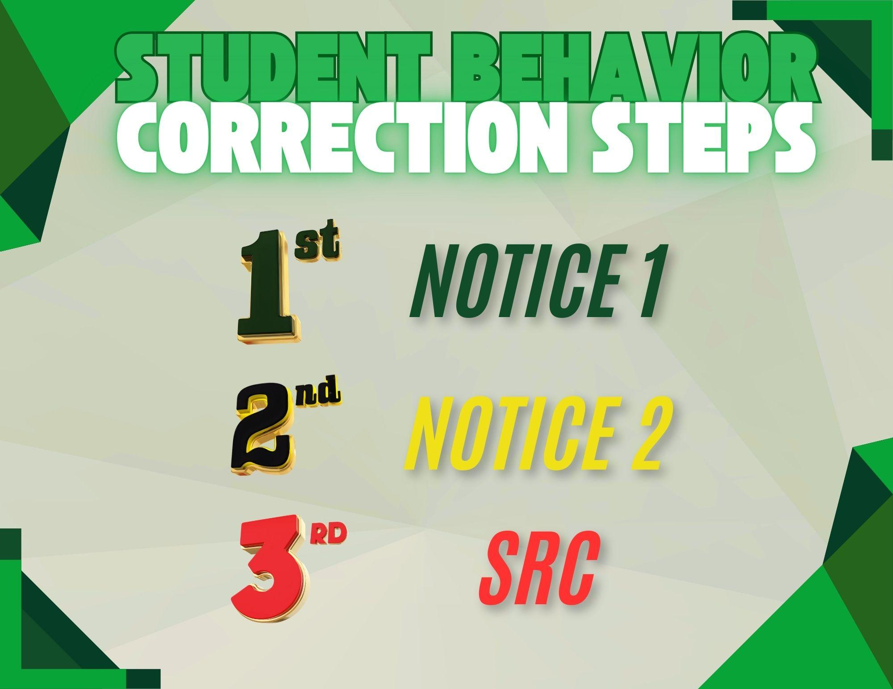

Student Responsibility Classroom (SRC) referral
If a student has already been placed on notice twice in a single class period and continues to disrupt, he/she is sending the message that he/she is choosing an SRC referral. The teacher will fill out an electronic SRC referral at the time the student is sent out of the classroom. The student will go to the SRC room and parent/guardian contact will be made by a staff member. Once parent/guardian contact has been made, the student will begin working on a behavior plan. Students will not return to the class they were referred out of until the next time the class meets. Instead, they will spend the remaining class period in the SRC room working on classwork once their behavior plan is completed. If a student is referred to the SRC room two times in the same day, they will stay in the SRC room for the remainder of the day working on classwork. If a student has received 5 or more SRC referrals during the current school year, they have developed a pattern of disruptive behaviors and a conference with their parent, counselor and an administrator will be required to develop a collaborative plan of support for the student.

To return on the next day to the classroom where the misbehavior took place, the student must:
- Complete the SRC behavior plan
- Discuss the plan with the SRC supervisor or an administrator
- Present the plan to the referring teacher and verbally state their plan for success

Immediate Office Referral

The following behaviors are examples of conduct that will result in a student's removal from class without any prior notice:
- Gross Insubordination
- Fighting or Any Other Significantly Unsafe Behavior
- Harassment That is Severe or Obscene in Nature
- Any Conduct That is Illegal

In addition to the information given in this handbook, violations of district policy and presumptive sanctions are specifically outlined in the MSBSD School Board Policy 5144.01 Student Rights and Responsibilities which is located on the School District website at www.matsuk12.us. Administrative decisions regarding disciplinary action will be made in accordance with MSBSD Board Policy.

Harassment
Harassment is taken very seriously at Colony Middle School. Below are some categories of bullying/harassment that are prohibited:

Physical harassment is repeated, annoying, offensive physical behavior perceived by the recipient or others as having a negative impact on their safety or well-being. Examples are pushing, tripping, poking, kicking, etc.

Sexual harassment is any unwelcome sexual advance, request for sexual favor or other verbal or physical conduct of a sexual nature.

Verbal harassment is defined as using words perceived by the recipient or others as having a negative impact. Some examples are name-calling, put-downs and making threats.

Cyber harassment is defined as repeated, unsolicited, threatening behavior by a person or group using mobile or internet technology with the intent to bother, terrify, intimidate, humiliate, threaten, harass, or stalk someone else.

Hate Speech is defined as any kind of communication in speech, writing, or behavior that attacks or uses derogatory/discriminatory language about a person or group based on who they are. (Religion, ethnicity, nationality, race, color, descent, gender, socio-economic status, sexual orientation, physical appearance, or any other identity factor)

If a student feels that they are being harassed, they should take the following action:
- Say “STOP”. Tell the harasser you do not like the behavior, and you want it to stop.
- Tell someone. Talk to a teacher, counselor, or principal.
- Keep records. If the behavior continues, write it down. Be sure to include dates, times, and names, including witnesses and locations where the harassment occurred.
- Take action. Write a complaint describing your concerns and turn it into the front office.
Consequences of harassment

Listed below are typical steps of progressive discipline for dealing with minor incidents of harassment. Harassment of an extreme or explicit nature will result in more significant consequences without warnings being issued first.
- 1st report – Clarification of the harassment and a warning issued by school staff
- 2nd report – Loss of privileges and/or minor school consequences as appropriate for the violation
- 3rd and subsequent reports – in or out-of-school suspension and/or consequences as appropriate for the violation.

Suspensions of greater duration or expulsion may be applied in serious or continual cases of harassment. Any harassment that would violate state law will be reported to the Palmer Police Department or the Alaska State Troopers.

Respect for Self and Others
Learning respect for yourself and others is a critical component of student success both in and out of the classroom. Students are expected to treat others and themselves with respect at all times.

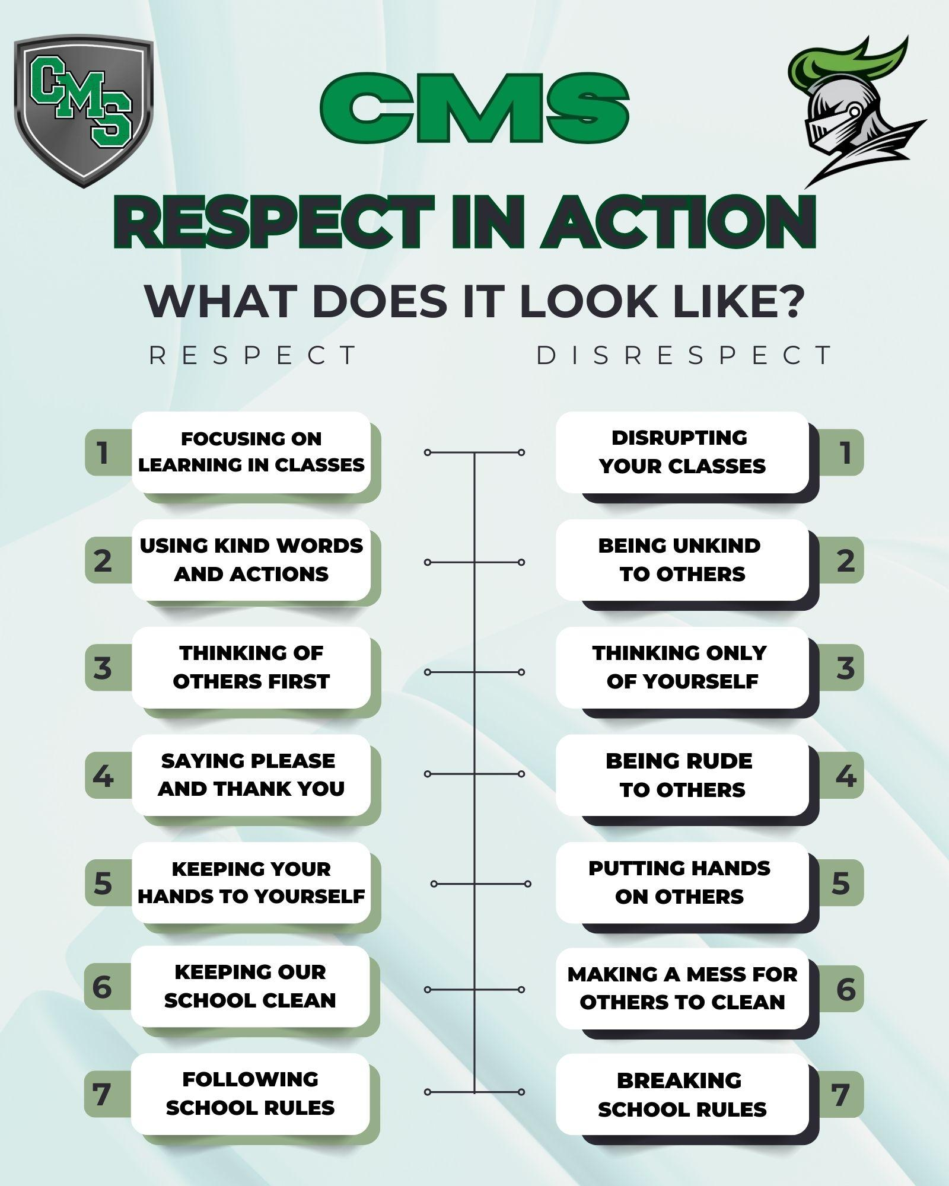

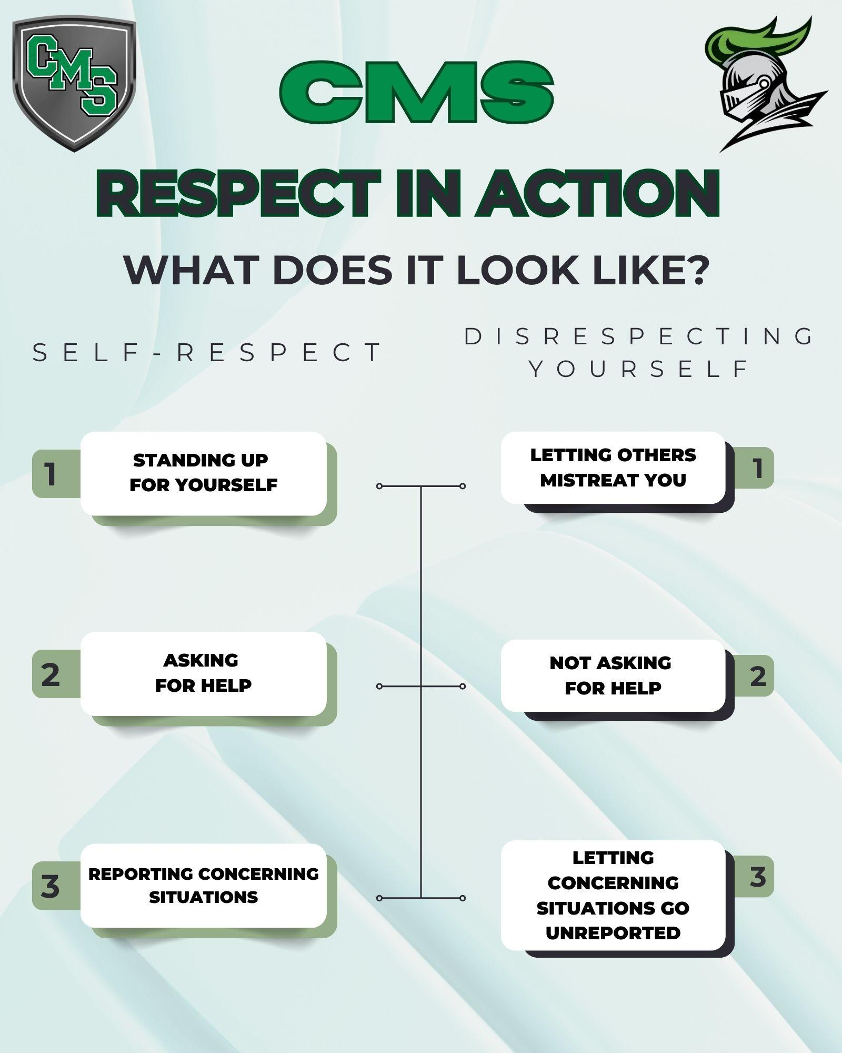

Transportation

Alaska State statutes do not mandate pupil transportation to or from school. School bus transportation is provided as a courtesy and is a privilege, not a right. If a student’s conduct is such that the health, safety, comfort or well-being of others is in jeopardy, a school district official may deny the privilege of riding the bus. The school bus driver oversees the bus and its passengers and has total authority and responsibility. Appropriate school bus conduct is outlined in the MSBSD Student Handbook. Students and parents should take time to review this information. If a student’s behavior on the bus in not appropriate, the following actions will be taken:
- 1st offense – administrator warning
- 2nd offense – student placed on probationary status and parents will receive notification of misbehavior
- 3rd offense – minimum three-day suspension from bus
- 4th offense – suspension of bus privileges pending a conference with the student, parents, principal, and/or transportation department

This procedure may vary depending on the nature and severity of the incident.

Supporting Students

Counseling and guidance

CMS counselors provide many services for students, parents, and school staff. These services include academic guidance, personal and social counseling, career guidance and referrals to outside resources. Parents are encouraged to contact their student’s counselor by visiting, calling, or emailing. Students should feel free to visit the counseling office or fill out the online form to make an appointment to see their counselor. Students with last names beginning with A – J will see Mr. Kleigh Anderton and students with last names K – Z will see Mr. Ryan Parker.

Health services

A student who becomes ill during the school day must get permission from his/her teacher to see the nurse. If it is necessary to go home or to a doctor, the nurse will inform the parent and the student will be released from school. No student should call home to be picked up without checking with the nurse. All students will be expected to participate in health programs sponsored by the school unless special arrangements are made with the principal.

It is the policy of the MSBSD that prescription medication may be dispensed by the school nurse only when the student’s health requires that medication. Parents are required to place all medicine with the nurse at the beginning of a school day to enable students to take the medicine at the nurse’s office at the designated time. Medication to be dispensed at school must be in a properly labeled prescription bottle. Medication that will be dispensed all year will need a Medication Authorization form signed by the child’s physician.

In the interest of keeping CMS DRUG FREE, over-the-counter medications are not to be taken by the student during school hours unless administered by the school nurse with permission from a parent or guardian.

The school nurse will be doing routine health screening for specific grades during the school year. These screenings will include vision, hearing, height, weight, blood pressure and scoliosis. The student will be given a screening report for your information. If a student fails the screening, the school nurse will contact the parent.

Please be sure to contact the CMS nurse about any new disease/illness or accident your student may experience. She will be glad to help with school management and provide care necessary for the recovery of your child. If a physician orders no PE as treatment of an accident or illness, the doctor must provide the school with written documentation as to the length of time the student must be out of class.

The following guidelines will apply:
- The school nurse will notify staff of student injury
- Staff will be notified when the injured student no longer needs assistance
- The injured student will have permission to leave classes two minutes early and be two minutes late to the next class

