Agenda
Zoe Barnum High School
School Site Council
01/21/2025 / 5:00 PM/
Google Meet: Meeting Room
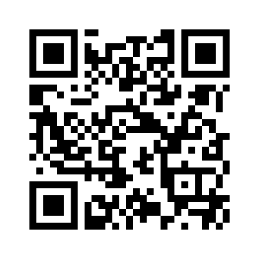
I. Call to Order
Time: 4:50 PM
Adjourned: 4:59 PM
Date: 01/21/2025
By Whom: Adriana West
II. Role Call of members (can be accomplished with a sign-in sheet)
Google Form For Sign In: https://forms.gle/rcauVWu1qSz87MtF7
Those attending in person: Complete the sign in sheet
III. Agenda Calendar Items
- Approval of previous school site council minutes
- Approve of the CSSP Workbook - Link

IV. Changes/additions to the agenda
V. Approval of Minutes: Meeting of Date: 12/17/2024 - Link Here Minutes (12/2024)
Motion to approve: Evan Morden
Second: Nicholas Pelascini
All in Favor: Majority motion to approve
VI. Opportunity for Public Input
There was no public comment.
VII. Committee Reports
- Special committees
- Standing committees
VIII. Unfinished Business

IX. Reports on Meetings Attended
- Principal Report out of school board meeting
- Community Schools Update
X. New Business
- Approve of the CSSP Workbook
  - All members reviewed the CSSP Workbook and information suggested during the public meeting. The team worked together to complete the workbook. The school site council agreed that the action plan met the alignment with the vision and mission statement. School site council voted to approve the workbook.
  - Motion to approve: Kai Lund
  - Second: Evan Morden
  - All in favor: Majority motion to approve
XI. Announcements
- Next meeting 02/04/2025 at 4:30 PM

