Agenda
Zoe Barnum High School
School Site Council
11/19/2024/4:45 PM/
Google Meet: Meeting Room
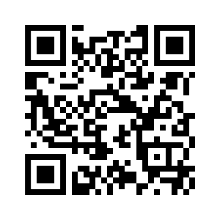
I. Call to Order
Time: 4:46
Adjourned: 5:17
Date: 11/19/2024
By Whom: Adriana West
II. Role Call of members (can be accomplished with a sign-in sheet)
Google Form For Sign In: https://forms.gle/rcauVWu1qSz87MtF7
Those attending in person: Complete the sign in sheet
III. Changes/additions to the agenda
IV. Approval of Minutes: Meeting of Date: 10/09/2024
Motion to approve: Evan Morden
Second: Pete Perata
All in Favor: Majority
V. Opportunity for Public Input
No public comment
VI. Committee Reports
- Special committees
- Standing committees
VII. Unfinished Business
VIII. Agenda Calendar Items
- Approve the 2024/2025 School Site Council Bylaws - 2024/2025 Bylaws
- Vote on member positions
- Meeting dates
IX. Reports on Meetings Attended
- Principal Report out of school board meeting
X. New Business
- Approve the bylaws for School Site Council
  - All members reviewed the agenda
  - Motion to approve: Evan Morden
  - Second: Pete Perata
  - All in favor: Majority
- Vote on member positions
  - Chairperson: Pete Perata
    - Motion to approve: Evan Morden
    - Second: Adriana West
    - Majority: all in favor
  - Vice Chairperson: Evan Morden
    - Motion to approve: Pete Perata
    - Second: Nicholas Pelascini
    - Majority: all in favor
  - Secretary: Adriana West
    - Motion to approve: Evan Morden
    - Second: Nicholas Pelascini
    - Majority: all in favor
- Select Meeting Dates for upcoming meetings
  - December 17, 2024
  - January 21, 2025
  - February 11, 2025
  - March 11, 2025
  - April 15, 2025
  - May 20, 2025
XI. Announcements
- Next meeting

