
English Language Learner Handbook
Hmong College Prep Academy

Table of Contents
Section 1: ELL Identification Criteria and Procedures …………………………….. 4
New Student Enrollment Flowchart ……………………………………………………….. 5
Home Language Questionnaire ………………………………………………………………. 6
Identifying Students as ELL…… ………………………………………………………………. 7
MN Approved Screeners ……… ………………………………………………………………. 8
Directions to Create a New ELL Folder……………………………………………………. 9-10
SLIFE Students…………………………………………... …………………………………………. 11
Immigrant Students……………… ………………………………………………………………. 12
ELL Placement Guides ……………………………………………………………………………. 13-23
NWEA Status Norms (2015) ……………………………………………………………………. 24
English Learner Placement Program (English, Hmong & Karen) …………….. 25-27
Notification of ELL/Bilingual Services (English, Hmong & Karen) ……..……. 28-30
ELL/Bilingual Education Program Description (English, Hmong & Karen) . 31-33
Section 2: ELL Program Amount and Scope of Service…………………………………….. 34-35
Change in Service Level Flowchart ……………………………………………………….....36
General Descriptions of ELL Levels …………………………………………………………. 37-38
ELL Leveling Guide ……………………………………………………………………………….. 39
Recommendation of Instructional Time by Level …………………………………... 40
Recommended Minutes of Direct ELL Instructional Service …………………… 41-42
Instructional Models ……………………………………………………………………………… 43
General Guidelines for Scheduling ELLs …………………………………………………. 44-46
ELL Course Descriptions ………………………………………………………………………… 47-49
Performance Definitions for the Levels of EL Proficiency …………………….... 50
Can Do Descriptions (WIDA) ………………………………………………………………….. 51-53

Section 3: ELL Monitor & Exit Criteria and Procedures ……………………………………..54
Change to Monitor Status or Exit from ELL Flowchart ……………………………… 55
ELL Program Monitor Procedures ……………………………………………………………. 56-57
Parent Notification Letter for ELL Monitor or Exit (English, Hmong& Karen)… 58-60
Elementary ELL Report Card ……………………………………………………………………… 61-62

Section 1: Describe how English Learner identification criteria and procedures are shared with parents and other stakeholders (e.g. teachers, administrators, paraprofessionals, etc.)
HCPA believes it is critical that all teachers, staff, and ELL families have a clear understanding of the ELL identification criteria and procedures.
Communication with Administrators:
The administration team at HCPA works together to review and revise ELL identification criteria and procedures as the need arises (e.g. revisions to the ELL Placement Guide). All documents in the ELL handbook were reviewed and approved by administration before being communicated with teachers, paraprofessionals and families. The ELL Coordinator also works with the school assessment coordinator, counselor, and MARSS coordinator to ensure all students’ official and internal records are kept up to date.
Communication with Teachers and Paraprofessionals:
New students are enrolled following the procedure on page 5 of HCPA’s ELL handbook. Using the ELL placement guide (see pages 17-19 of HCPA’s ELL Handbook), the school assessment coordinator shares assessment results and ELL level information with the counselor, ELL Coordinator and the teachers the student is placed with. A copy of the general description of ELL Learner Levels (see pages 36-37 of HCPA’s ELL Handbook) is attached to the notification. The office staff is instructed to place a note to contact the ELL department for additional information about an individual in each ELL student’s paper cumulative file and electronic PowerSchool record. The ELL department and mainstream teachers monitor the student’s placement and communicate any concerns to the school assessment coordinator and ELL Coordinator.
Communication with Families:
After the ELL Coordinator receives assessment and ELL level information from the school assessment coordinator the department lead sends an ELL notification letter to the student’s guardian(s). When possible, this letter is in the student’s home language (see pages 21-26 of HCPA’s ELL handbook). Parents are provided a description of the program, informed of their rights, provided assessment results and given the option to withdraw their child from receiving ELL service. If a parent declines service an ELL staff member or interpreter calls the guardian(s) to verify the declining of ELL service and to ensure the type of support ELL could offer understood. These signed letters are returned and copied for the ELL student file before being returned to the family.

New Student Enrollment Flow Chart (ELL)

Parent/ student completes application and home language questionnaire (Registrar)

Registrar provides assessment coordinator with HLQ results and transfer records and schedules testing date.

MAP Reading is administered (Assessment Coordinator)
W – APT Screener is administered (Assessment Coordinator)

Assessment coordinator reviews results and recommends class placement to the counselor. Registrar officially enrolls student in PowerSchool. Register enters DOA, if applicable, into PowerSchool.

ELL Teacher continues to monitor the student for 1-2 weeks to ensure student placement is appropriate.
Counselor and/or ELL Teacher match the new student with a “buddy” who can help the student first few days of school.

Counselor places student in classes based on recommendations from the Assessment Coordinator. Assessment results are shared with each teacher the student is placed with. W-APT Screener scores provided to ELL Coordinator to create ELL file and send parent notification letter. ELL Coordinator also reviews placement decisions.

_

Identifying Students as ELL
Determination of the home language, using the Minnesota Language Survey (MNLS), is the first step in identification of an English Learner. Students who understand one or more languages other than English (as reported on the MNLS) then complete an approved English Language Proficiency (ELP) screener. The ELP screener measures the child’s current proficiency level in English in the areas of listening, speaking, reading and writing. Trained district staff score the screener to determine if the student is already proficient in English or conversely, if the student may benefit from ELD instruction. Only students who are not yet proficient in English are identified as English learners. Following initial placement in the district’s LIEP, there is a 45-day grace period in which any errors made in determining a student’s home language or LEP may be corrected. The district will also have a process to determine if students who were not initially identified as English learners may in fact be eligible for EL instruction.
There are three approved ELP screeners in Minnesota: the WIDA Screener, the Kindergarten W-APT and the Kindergarten MODEL.
As mentioned above, the purpose of the screener is to accurately verify if the student has sufficient proficiency in English to meaningfully access the grade-level curriculum in English without English language development (ELD) instruction and other support. The screener also helps identify students who will benefit from a Language Instruction Educational Program. Such a program includes standards-based ELD instruction that is aligned with the grade-level content area standards in order to support growth in the four language domains and full proficiency in social, instructional and academic language across the content areas. The program may also include primary language instruction and support.

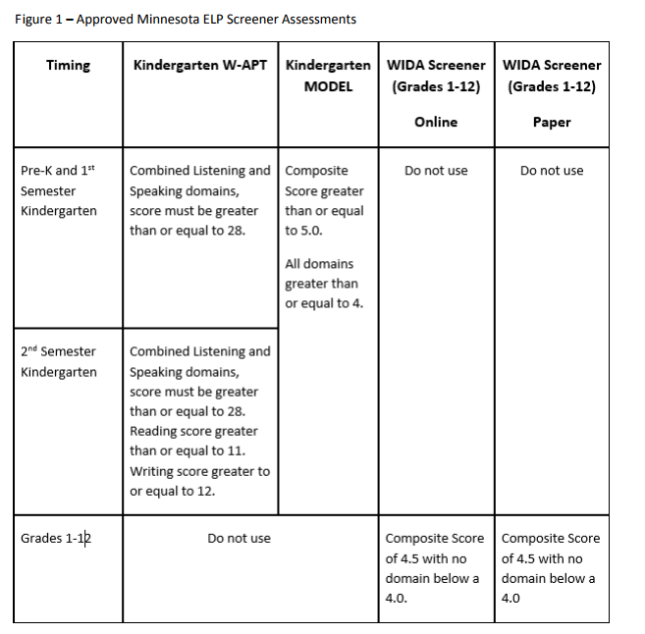

Directions to Create a New ELL Folder:

- Find student’s W-APT Screener Scoring Sheet and test
- Complete Parent Notification form
  - Use student data to complete Parent Notification form:
    - Name of Test: W-APT Screener
    - Speaking and Listening (use Oral Composite Proficiency Level)
    - Reading (use Reading Proficiency level)
    - Writing (use Writing Proficiency Level)
  - Proficiency Levels:
    - Entering
    - Beginning
    - Developing
    - Expanding
    - Bridging
    - Reaching
  - Date of Test: see date W-APT Screener was administered

- Notification of ESL Service form
  - Use W-APT Screener Scoring Sheet to complete Notification of ESL Service
    - Name
    - Date of birth
    - Age
    - Grade

- ESL/Bilingual Program Description
  - Fill in student name and make a copy of:
    - Parent Notification form
    - Notification of ESL Service form
    - ESL/Bilingual Program Description form

- Give copy to the student. Explain what the forms mean.

- Check ELL Folder to make sure it contains the following paperwork:
  - W-APT Screener Scoring Sheet & test
  - Parent Notification form
  - Notification of ESL Service form
  - ESL/Bilingual Program Description form

- Create ELL Folder
    - Write student’s name on the tab on top of the folder.
    - Staple pink ELL label to the outside of the folder.

- File ELL folder in the cumulative file located in the record’s room in the main office.
  - Find student’s grade level
    - File alphabetically by last name

If a student is on the spreadsheet but does not have pink paper or blue sticker, please repeat Steps 1-4.ct

SLIFE Students

At HCPA when a student enrolls one of the questions parents are asked on the intact form is the country of birth and last school attended. The purpose for these questions are to see if the student may qualify as a SLIFE student. The home language questionnaire is also used for this purpose.

The Minnesota Learning English for Academic Proficiency and Success (LEAPS) Act defines SLIFE as an English learner with interrupted formal education who:
- Comes from a home where the language usually spoken is other than English, or who usually speaks a language other than English.
- Enters school in the United States after grade 6.
- Has at least two years less schooling than the English learner’s peers.
- Functions at least two years below expected grade level in reading and mathematics.
- May be preliterate in the English learner’s native language.
(Minn. Stat. § 124D.59, Subd. 2a)

Annually a district representative for HCPA double checks the list of students provided by MDE that are identified as SLIFE. If a student no longer matches the requirements they are no longer marked as a SLIFE student.

Here at HCPA we do not treat SLIFE students differently than our non-SLIFE students. They have access to all electives that any student has access to, and are provided with grade-level content with EL support, as needed. They are provided the same opportunities for after and summer school as well as sports. The graduation progress of these students is closely monitored by administration, counseling and grade level ELL teacher. If it’s determined a student will not be able to graduate before aging-out, then transition services will be provided for the student.

Immigrant Students

At HCPA when a student enrolls one of the questions parents are asked on the intake form what is the country of birth for the student. The purpose for this question to see if they student may qualify as a immigrant student. We also ask what was the student’s previous school. If no school is listed than the student is flagged as a possible immigrant student if the following criteria is applicable.

Immigrant children and youth are defined as individuals who:
a. are aged 3 through 21,
b. were not born in any State; and
c. have not been attending one or more schools in any one or more States for more than 3 full academic years (on a cumulative basis).

Annually a district representative for HCPA double checks the list of students provided by MDE that are identified as Immigrant children. If a student no longer matches the requirements they are no longer marked as a immigrant student.

Here at HCPA we do not treat immigrant students differently than our non-immigrant students. They have access to all electives that a non-immigrant student has access to, and are provided with grade-level content with EL support, as needed. They are provided the same opportunities for after and summer school as well as sports. The graduation progress of these students is closely monitored by administration, counseling and grade level ELL teacher. If it’s determined a student will not be able to graduate before aging-out, then transition services will be provided for the student.

ELL Placement Guide - Grades K.0 - K.4

 | Level 1 | Level 2 | Level 3 | Level 4 | Does Not Qualify
MARSS | LEP – Y | LEP – Y | LEP – Y | LEP –Y | LEP - N
W-APT Kindergarten, Listening and Speaking | 0-6 | 7-12 | 13-19 | 20-27 | >28

Note: Only the W-Apt will be used to determine is a student qualifies for ELL services. A student’s score must be greater than or equal to 28 in order to become DNQ.

STUDENT LEVEL: ____________________
ELL Placement Guide - Grades K.5 - 1.4
 | Level 1 | Level 2 | Level 3 | Level 4 | Does Not Qualify
MARSS | LEP – Y | LEP – Y | LEP – Y | LEP –Y | LEP - N
MAP Reading RIT | ≤133 | 134-139 | 140-149 | 150-159 | ≥160
W-APT Kindergarten, Listening and Speaking | 0-6 | 7-12 | 13-19 | 20-27 | >28
W-APT K test, Literacy-Reading | 0-2 | 3-5 | 6-7 | 8-10 | > 11
W-APT K test, Literacy-Writing | 0-3 | 4-7 | 8-9 | 10-11 | > 12
Point Values for Placement ** | 1 | 2 | 3 | 4 | 5

**Note: Only the W-Apt will be used to determine is a student qualifies for ELL services. A student’s score must be greater than or equal to 28 in listening and speaking, Reading score greater than or equal to 11 and a writing score greater than or equal to 12 in order to become DNQ.
For determining ELL level the W-Apt scores along with the MAP RIT score will be used to determine the level.
Level 1 = 1 point, Level 2 = 2 points, Level 3 = 3 points, Level 4 = 4 points, and Exit/Monitor (Leveling Guide) or Does Not Qualify (Placement Guide) = 5 points.
For example, on the Placement Guide if a 7th grader receives the following scores, the corresponding math will be computed:
RIT: 219 (5 points – Does Not Qualify) W-APT Adjusted overall: 2.2 (3 points – Level 3) Total Points: 7 points; Average: 7/2 = 3.5
Rounded to Level 4. This student would be placed in ELL Level 4

STUDENT LEVEL: ____________________
ELL Placement Guide - Grade 1.5 - 2
 | Level 1 | Level 2 | Level 3 | Level 4 | Does Not Qualify
MARSS | LEP – Y | LEP – Y | LEP – Y | LEP –Y | LEP - N
MAP Reading RIT | ≤144 | 145-154 | 155-164 | 165-174 | ≥175
W-APT Adjusted Overall CPL | ≤1-1.9 | 2.0-2.9 | 3.0-3.9 | 4.0-4.4 | ≥4.5
Point Values for Placement ** | 1 | 2 | 3 | 4 | 5

**Note: Only the W-Apt will be used to determine is a student qualifies for ELL services. A student’s score must be greater than or equal to 4.5 with no domain below a 4.0 in order to become DNQ.
For determining ELL level the W-Apt scores along with the MAP RIT score will be used to determine the level.
Level 1 = 1 point, Level 2 = 2 points, Level 3 = 3 points, Level 4 = 4 points, and Exit/Monitor (Leveling Guide) or Does Not Qualify (Placement Guide) = 5 points.
When a test score overlaps into two levels, the lowest level will be calculated.
For example, on the Placement Guide if a 7th grader receives the following scores, the corresponding math will be computed:
RIT: 219 (5 points – Does Not Qualify)
W-APT Adjusted overall: 2.2 (3 points – Level 3)
Total Points: 7 points; Average: 7/2 = 3.5
Rounded to Level 4. This student would be placed in ELL Level 4

STUDENT LEVEL: ____________________

ELL Placement Guide - Grade 3

 | Level 1 | Level 2 | Level 3 | Level 4 | Does Not Qualify
MARSS | LEP – Y | LEP – Y | LEP – Y | LEP –Y | LEP - N
MAP Reading RIT | ≤157 | 158-160 | 161-167 | 168-175 | ≥176
W-APT Adjusted Overall CPL | ≤1-1.9 | 2.0-2.9 | 3.0-3.9 | 4.0-4.4 | ≥4.5
Point Values for Placement ** | 1 | 2 | 3 | 4 | 5

**Note: Only the W-Apt will be used to determine is a student qualifies for ELL services. A student’s score must be greater than or equal to 4.5 with no domain below a 4.0 in order to become DNQ.
For determining ELL level the W-Apt scores along with the MAP RIT score will be used to determine the level.
Level 1 = 1 point, Level 2 = 2 points, Level 3 = 3 points, Level 4 = 4 points, and Exit/Monitor (Leveling Guide) or Does Not Qualify (Placement Guide) = 5 points.
When a test score overlaps into two levels, the lowest level will be calculated.
For example, on the Placement Guide if a 7th grader receives the following scores, the corresponding math will be computed:
RIT: 219 (5 points – Does Not Qualify)
W-APT Adjusted overall: 2.2 (3 points – Level 3)
Total Points: 7 points; Average: 7/2 = 3.5
Rounded to Level 4. This student would be placed in ELL Level 4

STUDENT LEVEL: ____________________

ELL Placement Guide - Grades 3.5 - 4.4
 | Level 1 | Level 2 | Level 3 | Level 4 | Does Not Qualify
MARSS | LEP – Y | LEP – Y | LEP – Y | LEP –Y | LEP - N
MAP Reading RIT | ≤168 | 169-171 | 172-180 | 181-189 | ≥190
W-APT Adjusted Overall CPL | ≤1-1.9 | 2.0-2.9 | 3.0-3.9 | 4.0-4.4 | ≥4.5
Point Values for Placement ** | 1 | 2 | 3 | 4 | 5

**Note: Only the W-Apt will be used to determine is a student qualifies for ELL services. A student’s score must be greater than or equal to 4.5 with no domain below a 4.0 in order to become DNQ.
For determining ELL level the W-Apt scores along with the MAP RIT score will be used to determine the level.
Level 1 = 1 point, Level 2 = 2 points, Level 3 = 3 points, Level 4 = 4 points, and Exit/Monitor (Leveling Guide) or Does Not Qualify (Placement Guide) = 5 points.
When a test score overlaps into two levels, the lowest level will be calculated.
For example, on the Placement Guide if a 7th grader receives the following scores, the corresponding math will be computed:
RIT: 219 (5 points – Does Not Qualify)
W-APT Adjusted overall: 2.2 (3 points – Level 3)
Total Points: 7 points; Average: 7/2 = 3.5
Rounded to Level 4. This student would be placed in ELL Level 4

STUDENT LEVEL: ____________________

ELL Placement Guide - Grades 4.5 - 5.4

 | Level 1 | Level 2 | Level 3 | Level 4 | Does Not Qualify
MARSS | LEP – Y | LEP – Y | LEP – Y | LEP –Y | LEP - N
MAP Reading RIT | ≤176 | 177-179 | 180-188 | 189-199 | ≥200
W-APT Adjusted Overall CPL | ≤1-1.9 | 2.0-2.9 | 3.0-3.9 | 4.0-4.4 | ≥4.5
Point Values for Placement ** | 1 | 2 | 3 | 4 | 5

**Note: Only the W-Apt will be used to determine is a student qualifies for ELL services. A student’s score must be greater than or equal to 4.5 with no domain below a 4.0 in order to become DNQ.
For determining ELL level the W-Apt scores along with the MAP RIT score will be used to determine the level.
Level 1 = 1 point, Level 2 = 2 points, Level 3 = 3 points, Level 4 = 4 points, and Exit/Monitor (Leveling Guide) or Does Not Qualify (Placement Guide) = 5 points.
When a test score overlaps into two levels, the lowest level will be calculated.
For example, on the Placement Guide if a 7th grader receives the following scores, the corresponding math will be computed:
RIT: 219 (5 points – Does Not Qualify)
W-APT Adjusted overall: 2.2 (3 points – Level 3)
Total Points: 7 points; Average: 7/2 = 3.5
Rounded to Level 4. This student would be placed in ELL Level 4

STUDENT LEVEL: ____________________

ELL Placement Guide - Grades 5.5 - 6.4

 | Level 1 | Level 2 | Level 3 | Level 4 | Does Not Qualify
MARSS | LEP – Y | LEP – Y | LEP – Y | LEP –Y | LEP - N
MAP Reading RIT | ≤181 | 182-183 | 184-193 | 194-206 | ≥207
W-APT Adjusted Overall CPL | ≤1-1.9 | 2.0-2.9 | 3.0-3.9 | 4.0-4.4 | ≥4.5
Point Values for Placement ** | 1 | 2 | 3 | 4 | 5

**Note: Only the W-Apt will be used to determine is a student qualifies for ELL services. A student’s score must be greater than or equal to 4.5 with no domain below a 4.0 in order to become DNQ.
For determining ELL level the W-Apt scores along with the MAP RIT score will be used to determine the level.
Level 1 = 1 point, Level 2 = 2 points, Level 3 = 3 points, Level 4 = 4 points, and Exit/Monitor (Leveling Guide) or Does Not Qualify (Placement Guide) = 5 points.
When a test score overlaps into two levels, the lowest level will be calculated.
For example, on the Placement Guide if a 7th grader receives the following scores, the corresponding math will be computed:
RIT: 219 (5 points – Does Not Qualify)
W-APT Adjusted overall: 2.2 (3 points – Level 3)
Total Points: 7 points; Average: 7/2 = 3.5
Rounded to Level 4. This student would be placed in ELL Level 4

STUDENT LEVEL: ____________________

ELL Placement Guide - Grades 6.5 - 7.4

 | Level 1 | Level 2 | Level 3 | Level 4 | Does Not Qualify
MARSS | LEP – Y | LEP – Y | LEP – Y | LEP –Y | LEP - N
MAP Reading RIT | ≤185 | 186-189 | 190-198 | 199-211 | ≥212
W-APT Adjusted Overall CPL | ≤1-1.9 | 2.0-2.9 | 3.0-3.9 | 4.0-4.4 | ≥4.5
Point Values for Placement ** | 1 | 2 | 3 | 4 | 5

**Note: Only the W-Apt will be used to determine is a student qualifies for ELL services. A student’s score must be greater than or equal to 4.5 with no domain below a 4.0 in order to become DNQ.
For determining ELL level the W-Apt scores along with the MAP RIT score will be used to determine the level.
Level 1 = 1 point, Level 2 = 2 points, Level 3 = 3 points, Level 4 = 4 points, and Exit/Monitor (Leveling Guide) or Does Not Qualify (Placement Guide) = 5 points.
When a test score overlaps into two levels, the lowest level will be calculated.
For example, on the Placement Guide if a 7th grader receives the following scores, the corresponding math will be computed:
RIT: 219 (5 points – Does Not Qualify)
W-APT Adjusted overall: 2.2 (3 points – Level 3)
Total Points: 7 points; Average: 7/2 = 3.5
Rounded to Level 4. This student would be placed in ELL Level 4

STUDENT LEVEL: ____________________

ELL Placement Guide - Grades 7.5 - 8.4
 | Level 1 | Level 2 | Level 3 | Level 4 | Does Not Qualify
MARSS | LEP – Y | LEP – Y | LEP – Y | LEP –Y | LEP - N
MAP Reading RIT | ≤188 | 189-190 | 191-200 | 201-215 | ≥216
W-APT Adjusted Overall CPL | ≤1-1.9 | 2.0-2.9 | 3.0-3.9 | 4.0-4.4 | ≥4.5
Point Values for Placement ** | 1 | 2 | 3 | 4 | 5

**Note: Only the W-Apt will be used to determine is a student qualifies for ELL services. A student’s score must be greater than or equal to 4.5 with no domain below a 4.0 in order to become DNQ.
For determining ELL level the W-Apt scores along with the MAP RIT score will be used to determine the level.
Level 1 = 1 point, Level 2 = 2 points, Level 3 = 3 points, Level 4 = 4 points, and Exit/Monitor (Leveling Guide) or Does Not Qualify (Placement Guide) = 5 points.
When a test score overlaps into two levels, the lowest level will be calculated.
For example, on the Placement Guide if a 7th grader receives the following scores, the corresponding math will be computed:
RIT: 219 (5 points – Does Not Qualify)
W-APT Adjusted overall: 2.2 (3 points – Level 3)
Total Points: 7 points; Average: 7/2 = 3.5
Rounded to Level 4. This student would be placed in ELL Level 4

STUDENT LEVEL: ____________________

ELL Placement Guide - Grades 8.5 - 9.4

 | Level 1 | Level 2 | Level 3 | Level 4 | Does Not Qualify
MARSS | LEP – Y | LEP – Y | LEP – Y | LEP –Y | LEP - N
MAP Reading RIT | ≤189 | 190-191 | 192-202 | 203-218 | ≥219
W-APT Adjusted Overall CPL | ≤1-1.9 | 2.0-2.9 | 3.0-3.9 | 4.0-4.4 | ≥4.5
Point Values for Placement ** | 1 | 2 | 3 | 4 | 5

**Note: Only the W-Apt will be used to determine is a student qualifies for ELL services. A student’s score must be greater than or equal to 4.5 with no domain below a 4.0 in order to become DNQ.
For determining ELL level the W-Apt scores along with the MAP RIT score will be used to determine the level.
Level 1 = 1 point, Level 2 = 2 points, Level 3 = 3 points, Level 4 = 4 points, and Exit/Monitor (Leveling Guide) or Does Not Qualify (Placement Guide) = 5 points.
When a test score overlaps into two levels, the lowest level will be calculated.
For example, on the Placement Guide if a 7th grader receives the following scores, the corresponding math will be computed:
RIT: 219 (5 points – Does Not Qualify)
W-APT Adjusted overall: 2.2 (3 points – Level 3)
Total Points: 7 points; Average: 7/2 = 3.5
Rounded to Level 4. This student would be placed in ELL Level 4

STUDENT LEVEL: ____________________

ELL Placement Guide - Grades 9.5 - 12

 | Level 1 | Level 2 | Level 3 | Level 4 | Does Not Qualify
MARSS | LEP – Y | LEP – Y | LEP – Y | LEP –Y | LEP - N
MAP Reading RIT | ≤190 | 191-193 | 194-204 | 205-220 | ≥221
W-APT Adjusted Overall CPL | ≤1-1.9 | 2.0-2.9 | 3.0-3.9 | 4.0-4.4 | ≥4.5
Point Values for Placement ** | 1 | 2 | 3 | 4 | 5

**Note: Only the W-Apt will be used to determine is a student qualifies for ELL services. A student’s score must be greater than or equal to 4.5 with no domain below a 4.0 in order to become DNQ.
For determining ELL level the W-Apt scores along with the MAP RIT score will be used to determine the level.
Level 1 = 1 point, Level 2 = 2 points, Level 3 = 3 points, Level 4 = 4 points, and Exit/Monitor (Leveling Guide) or Does Not Qualify (Placement Guide) = 5 points.
When a test score overlaps into two levels, the lowest level will be calculated.
For example, on the Placement Guide if a 7th grader receives the following scores, the corresponding math will be computed:
RIT: 219 (5 points – Does Not Qualify)
W-APT Adjusted overall: 2.2 (3 points – Level 3)
Total Points: 7 points; Average: 7/2 = 3.5
Rounded to Level 4. This student would be placed in ELL Level 4

STUDENT LEVEL: ____________________

NWEA STATUS NORMS (RIT VALUES) FOR MULTIPLE SUBJECTS
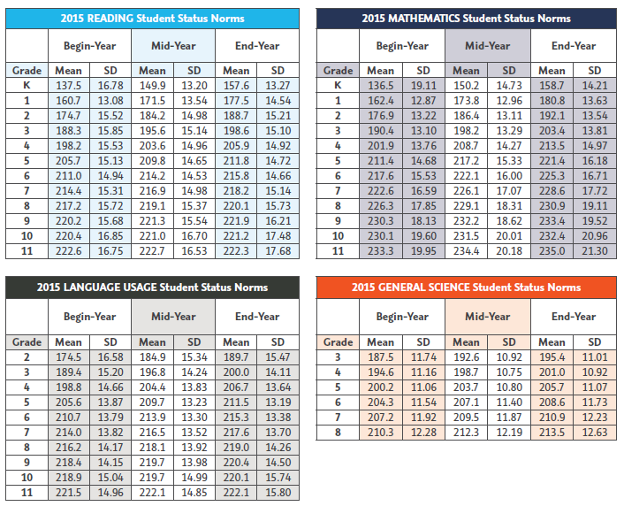

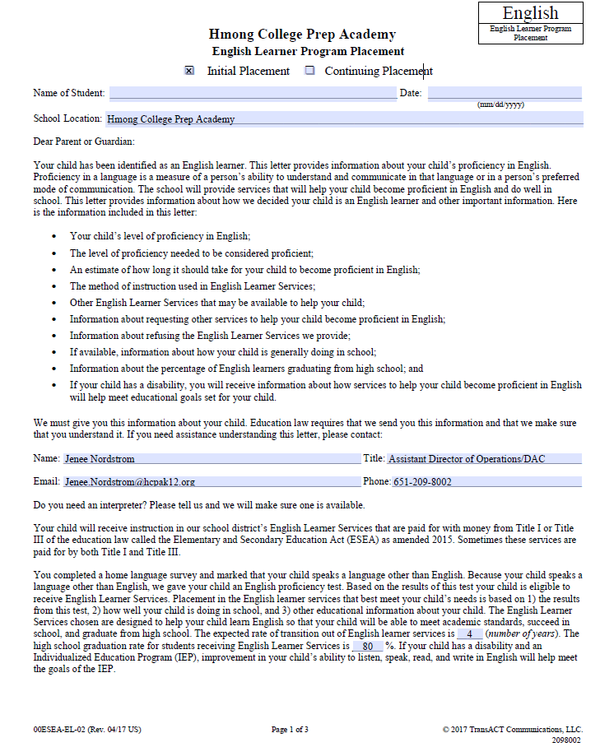
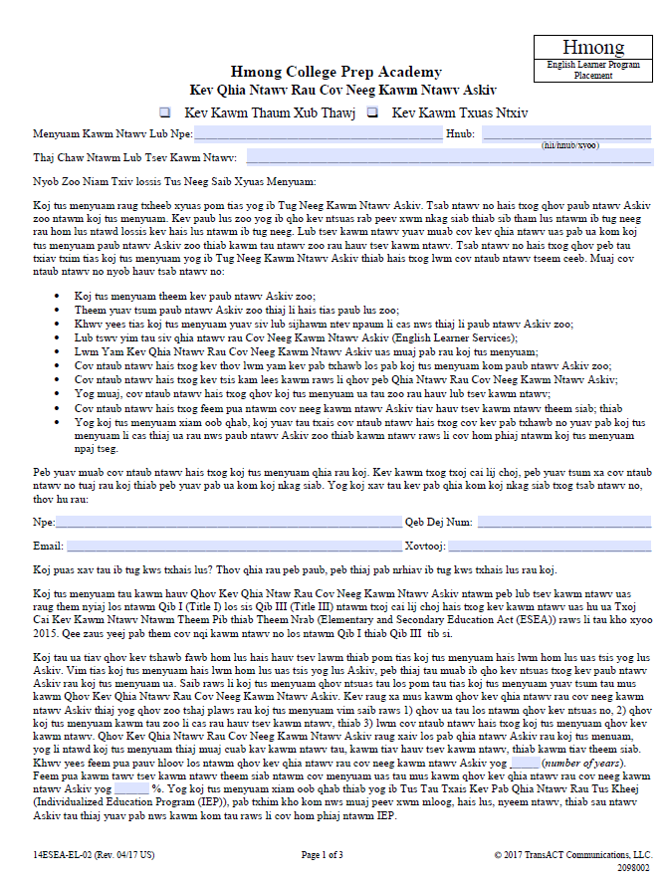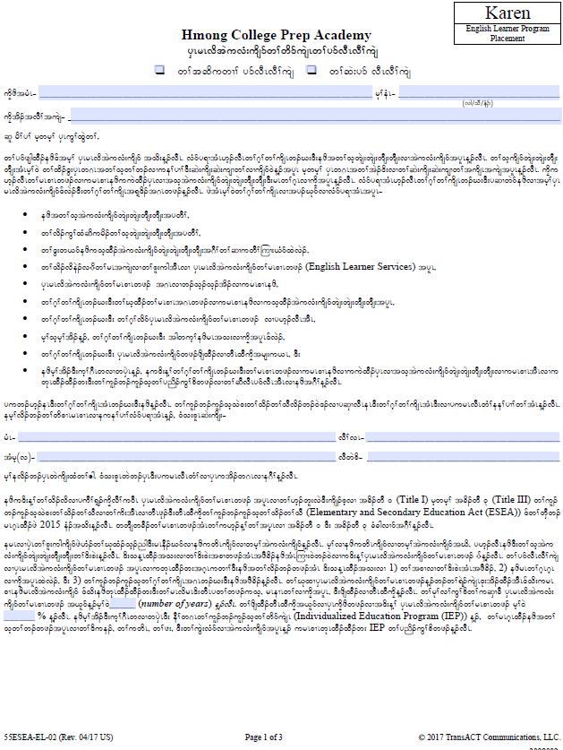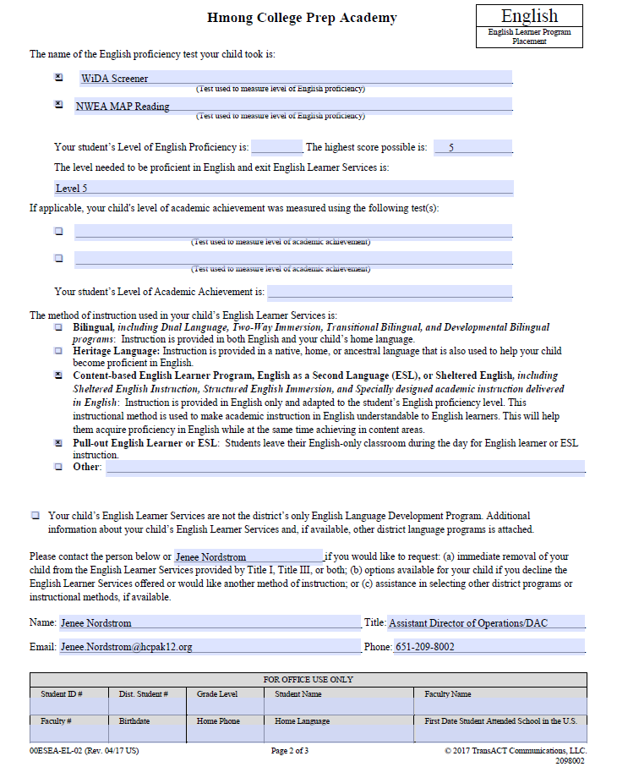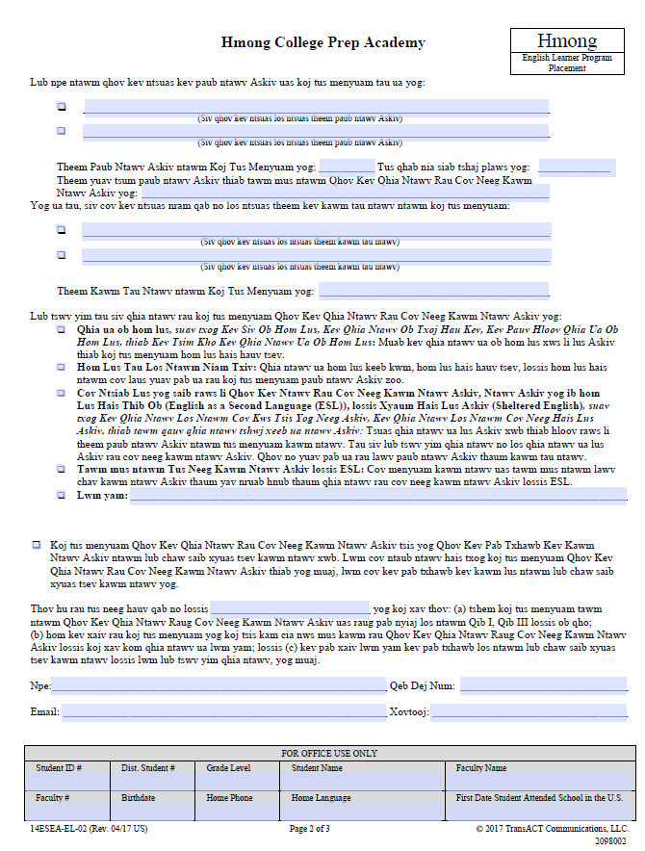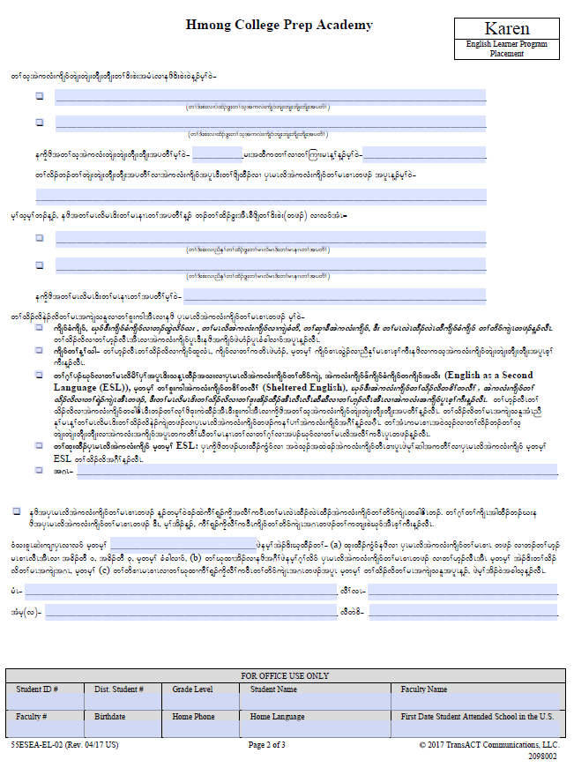

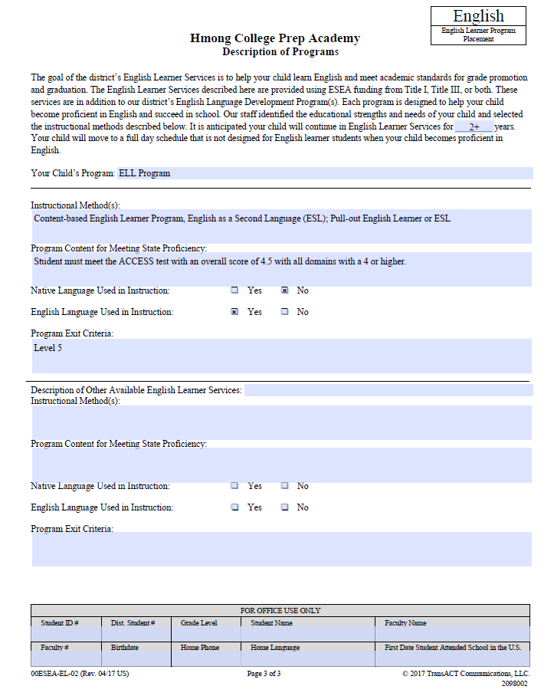

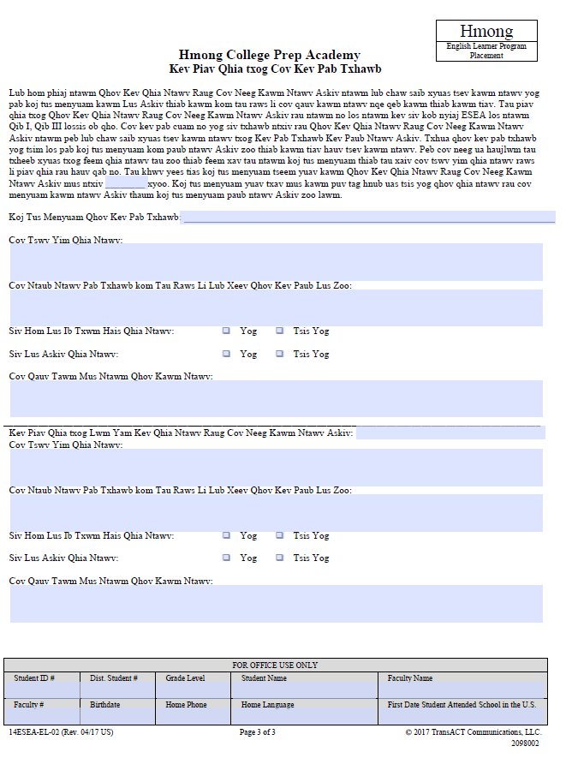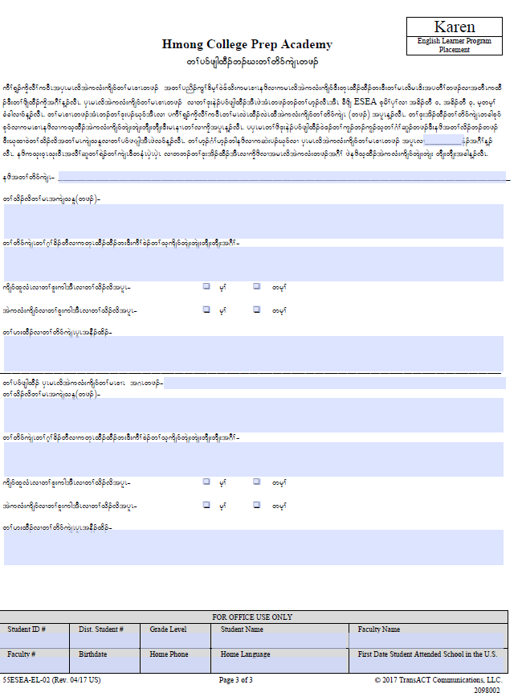
Section 2: Describe how information about English Learner program(s) including the amount and scope of service are shared with parents and other stakeholders (e.g. teachers, administrators, paraprofessionals, etc).

HCPA believes it is critical that all teachers, staff, and ELL families have a solid understanding of the ELL Program and the amount of service that students receive, including which classes are ELL classes, language pull-out, co-taught, or fully mainstreamed.

Communication with Administrators

Each spring members of the ELL department and the School Assessment Coordinator meet with the administrative team to discuss projections for the number of classes and staffing that will be needed for the next school year. In addition, projections for the types of classes, based on students’ grade levels and proficiency levels, are communicated: ELL classes, pull-out, co-teaching, fully mainstreamed. Throughout the summer and early fall this communication continues to ensure that appropriate classes are created.

Communication with Teachers and Paraprofessionals

All staff returns to school at least two weeks before classes begin each fall. During this time, the ELL teachers meet with all teachers and paraprofessionals who will teach and/or support a class that includes ELLs. During this meeting the ELL teachers share the following information: ELL students who will be in that teacher's class, ELL level(s) and what that means, how long the student has been in the country and/or received ELL service, how much ELL service the student will currently be receiving, and modifications that would be appropriate for that student. Throughout the school year teachers and paraprofessionals are encouraged to contact ELL teachers should they have specific concerns about an ELL student or the amount of service that the student is receiving.

When students move from one ELL class level to another, including moving to exit/monitor status, the ELL case manager, data assessment coordinator and counselor work together to make appropriate schedule changes. Teachers are notified of the specific level change, evidence to support the level change, and a description of the language level. See page 43 in HCPAs ELL Handbook for specific details on changes in service level.

Communication with Families

Upon enrollment students and their families are introduced to the school and, if applicable, to the ELL Program from the school's Community Liaisons. The Liaisons explain the different ELL levels at HCPA and the coursework that corresponds to the students' grade level and proficiency level. During the school year families are notified in their native language, when possible, about upcoming parent-teacher conferences. During conferences, a translator is provided so that families are provided with clear and concise communication from their child's teachers. At conferences each class is discussed in detail. In addition, teachers are expected to visit the homes of their students during the school year. If necessary, a translator is also provided for home visits. While visiting a student's home, teachers share information about the child's classes and their performance.

When students move from one ELL level to another, including moving to exit/monitor status, a letter is sent to the student’s guardian(s) notifying them of the change. Included in this letter is evidence to support the level change, a description of the level or exit/monitor status, and a description of the family’s rights. See pages 55-56 in HCPAs ELL Handbook for specific details on changes in service level.

Change in Service Level Flowchart (ELL)

ELL Coordinator reviews student data to determine if a level change is appropriate: state and local assessment results, classroom based assessment results, student participation and motivation in class, student practice and homework results.

If data suggest a level change is appropriate, the ELL Coordinator communicates with the student, School Counselor and Assessment Coordinator to determine appropriate schedule changes (grades 6-12)
A letter is sent to the student’s guardian(s) notifying them of the level change, the evidence to support the change, and a description of the language level.

The student’s teachers are notified of both the schedule change and the level change; along with the evidence to support the change, and a description of the language level.

A copy of the letter to the student’s guardian is placed in the student’s ELL file. All applicable electronic documents are updated.

General Descriptions of ELL Levels

From pages 4 and 5: Minnesota English Language Proficiency Standards for English Language Learners K-12; v. November 2005 (http://www.education.state.mn.us/mdeprod/groups/Englishlang/documents/Report/002212.pdf)

BEGINNING [HCPA ~ Levels 1 and 2]

Beginners range from having no English to demonstrating a minimal understanding and use of English. Their comprehension is limited to simple language containing mostly high-frequency vocabulary and simple grammatical patterns. These learners derive a great deal of meaning from the context and nonverbal cues that accompany any English input, and benefit from repetition, rephrasing and a slower rate of speech. They can express basic personal needs. They tend to communicate about very familiar topics based on personal experience. Errors are frequent, expected and characteristic of language production at this stage. With appropriate instructional strategies and scaffolding of materials, beginning ELLs can learn age-appropriate academic content in English through instruction using sheltered English techniques and/or bilingual education.

INTERMEDIATE [HCPA ~ Level 3]

Intermediate-level learners can comprehend short conversations and simple written narratives in familiar contexts. A limited vocabulary range necessitates frequent repetition and rephrasing for their understanding. They frequently use contextual and visual cues to derive meaning and also rely on guessing. Their production is characterized by simple vocabulary, verb tenses and syntax. Many errors occur, some of which interfere with meaning. With appropriate instructional strategies and scaffolding of materials, intermediate ELLs can learn age-appropriate academic content in English through instruction using sheltered English techniques.

ADVANCED [HCPA ~ Level 4]

Advanced-level learners can understand much of the speech delivered in authentic settings with some repetition or rephrasing. Understanding grammatically complex structures proves problematic but, with support, these learners are able to master some grade-level academic content. Their productive vocabulary, with some circumlocutions, is adequate to accomplish many tasks. They can produce many of the basic and most frequently used grammatical structures, but their errors may become more abundant as they venture into less familiar topics and as they test hypotheses or take risks with more complex language structures. With appropriate instructional strategies and scaffolding of materials, advanced ELLs can learn age-appropriate academic content in English through instruction using sheltered English techniques.

TRANSITIONAL [HCPA ~ Level 5+]

Transitional learners still benefit from ELL support, but they understand most standard speech and writing in a variety of settings. These learners are approaching fluency in speaking and writing in the content areas. They demonstrate an increasing ability to successfully use language to convey their intended message. They do not produce error­free language, but their errors generally do not interfere with meaning. With appropriate instructional strategies and scaffolding of materials, transitional ELLs can learn age-appropriate academic content in English.

Research Regarding Language Acquisition
of Middle and High School Students:

Collier (1989)
…Collier’s findings show that learners who are NOT already literate in their native language or who are 12 years of age and older will take much longer, anywhere from seven to ten years, to reach desired cut-off scores. These learners have a great deal more to learn, both of the language and of content, and it would not be unusual for them to take ten years before their test scores approximated those of native speakers. ELLs who are newcomers in the higher grades AND not literate in their native language usually require even more than ten years to close the gap between themselves and native English-speaking peers.

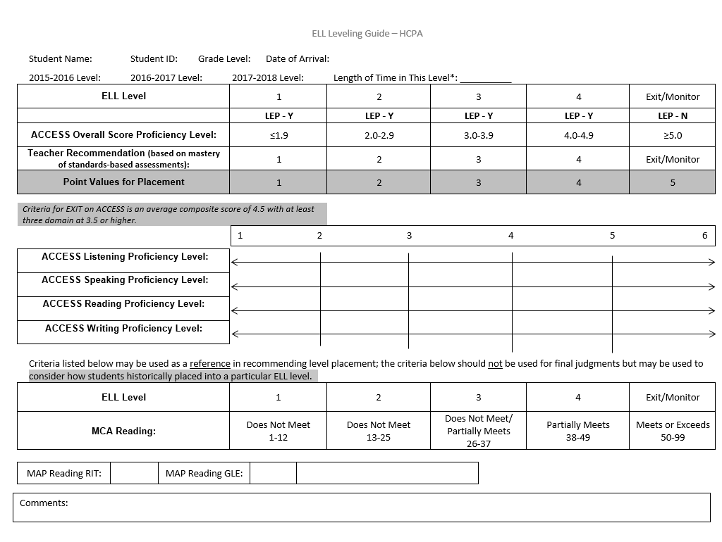
Recommendations of Instructional Time

Rationale:
Amount of direct ELL instructional service should be based on proficiency level, age and grade level. As students' English proficiency level increases, the amount of time teaching direct language should decrease, with more time supporting language learning through content.

Background:
Per Title Ill, Part A, states, districts, and schools have "flexibility to implement language instruction educational programs, based on scientifically based research on teaching limited English proficient (LEP) children, that the agencies believe to be the most effective for teaching English" (http://www2.ed.gov/policy/elsec/leg/esea02/pg40.html). Such programs must demonstrate commitment to best practices and academic achievement of LEP students. The flexibility offered to districts and schools allows them to implement effective programs for the students they serve.

Research:
Although there is little definitive research to show exactly what number of English language service minutes is adequate for LEP students, there is considerable evidence that instruction in English language development is more effective than not providing it (Goldenberg, 2008;Norris & Ortega, 2000). Krashen (1982) proposed that exposure to comprehensible input is critical for the language learning process. Research data show rationale for providing instruction in English language development in amounts that are in alignment with the learner's proficiency level.

References:

Goldenberg, C. {2008). Teaching English language learners: What the research does and does not-say. American Educator, 12{2), 8-22.
Norris, J., & Ortega, L. {2000). Effectiveness of L2 instruction: A research synthesis and quantitative meta-analysis. Language Learning, 50, 417-528.
Krashen,S. 1982. Principles and Practice in Second Language Acquisition. New York: Pergamon Press.
US Department of Education, http://www2.ed.gov/policy/elsec/leg/esea02/pg40.html

Grades K-5
Recommended Minutes of Direct ELL Instructional Service
English Language Service Level 1
 | Guidelines for ELL Instruction
How Much? | At least 30 minutes
How Often? | Daily

English Language Service Level 2
 | Guidelines for ELL Instruction
How Much? | At least 30 minutes
How Often? | At least 3 times per week

English Language Service Level 3
 | Guidelines for ELL Instruction
How Much? | At least 30 minutes
How Often? | At least 2 times per week

English Language Service Level 4
 | Guidelines for ELL Instruction
How Much? | At least 30 minutes
How Often? | Once per week

Grades 6 – 12
Recommended Minutes of Direct ELL Instructional Service

English Language Service Level 1

 | Guidelines for ELL Instruction
How Much? | At least 160 minutes
How Often? | Daily

English Language Service Level 2

 | Guidelines for ELL Instruction
How Much? | At least 160 minutes
How Often? | Daily

English Language Service Level 3

 | Guidelines for ELL Instruction
How Much? | 80 minutes
How Often? | Daily

English Language Service Level 4

 | Guidelines for ELL Instruction
How Much? | 80 minutes
How Often? | Daily

Recommendation of Instructional Models

Rationale:
No two language learners are alike, and therefore instruction for different language learners cannot be "one size fits all". HCPA acknowledges the uniqueness of each language learner and strives to create an environment in which all teachers and staff take responsibility for the language development of our students. Students' age, grade level, proficiency level, student numbers and school resources impact the type of instructional delivery for our school's English learners.

Background:
Many English learners at Hmong College Prep Academy receive a significant amount of their instruction in the general education classroom. However, English learners receive language support in a variety of formats: ESL class instruction, pull-out, and sheltered content classes. Teacher Assistants and Community Liaisons who speak Hmong and Karen provide native language support as necessary.

Research:
According to McKeon {1987) ESL programs accommodate learners of different languages since the primary mode of instruction is done in English.

ESL Class (secondary)
Students are provided English language instruction in an environment with other language learners of similar proficiency. Cummins (1992) recognized the difference between Basic Interpersonal Communication Skills {BICS) and Cognitive Academic Language Proficiency {CALP). BICS can take anywhere from two to three years to develop, whereas CALP can take at least five years to master. The instruction in an ESL class is delivered by an ELL teacher who provides both English language proficiency standards and mainstream English language arts standards in order to develop the CALP that is necessary to successfully transition to mainstream classes.

Pull-Out (elementary)
Students are provided English language instruction in an environment with other language learners of similar proficiency. Students are pulled from their grade-level content class to receive direct English instruction from an ELL teacher who can provide the scaffolding necessary to develop oral proficiency and literacy in English. Instruction with a focus on oral and literacy skills are effective instructional practices for ELs (August & Shanahan, 2006).

Collaboration/Sheltered Mainstream Class (elementary and secondary)
Classroom and ELL teachers collaborate on instruction designed to meet content and language objectives for ELLs in the mainstream (Echevarria, Vogt and Short. 2008).

A General Guide for Scheduling English Language Learners:
Elementary School, K-5
Exit/Monitor
- Mainstream for all courses
- Eligible for Title 1 Reading
- Eligible for Title 1 Math

- Co-taught ELL Level 4 English
- Eligible for Title 1 Reading
- Eligible for Title 1 Math
- Mainstream for all other courses
ELL
Level 4
- Co-taught ELL Level 3 English
- Eligible for Title 1 Reading
- Eligible for Title 1 Math
- Mainstream for all other courses
ELL
Level 3
- Co-taught ELL Level 2 English
- Eligible for Title 1 Reading
- Eligible for Title 1 Math
- Mainstream for all other courses
ELL
Level 2
- ELL Level 1 English pull-out
- Eligible for Title 1 Math
- Mainstream for all other courses
ELL
Level 1

A General Guide for Scheduling English Language Learners:
Middle School, 6-8
Exit/Monitor
- Mainstream for all courses

- ELL Level 4 English
- ELL Level 4 English Lab
- All other classes are mainstream content

ELL
Level 4
- ELL Level 3 English
- ELL Level 3 English Lab
- Eligible for Foundations of Math I, II & III
- All other classes are mainstream content
ELL
Level 3
- ELL Level 2 English
- ELL Level 2 English Lab
- Eligible for Foundations of Math I, II & III
- ELL Level 2 Social Studies
- ELL Level 2 Science
- ELL Level 2 Language Lab
- Mainstream for Art, Music Phy Ed, Technology, Languages
ELL
Level 2
- ELL Level 1 English
- ELL Level 1 English Lab
- Eligible for Foundations of Math I, II & III
- ELL Level 1 Social Studies
- ELL Level 1 Science
- ELL Level 1 Language Lab
- Mainstream for Art, Music Phy Ed, Technology, Languages

ELL
Level 1

A General Guide for Scheduling English Language Learners:
High School, 9-12
Exit/Monitor
- Mainstream for all courses **

- ELL Level 4 English **
- ELL Level 4 English Lab
- Eligible for Foundations of Math I, II & III
- All other classes are mainstream for content credit **
ELL
Level 4
- ELL Level 3 English **
- ELL Level 3 English Lab
- Eligible for Foundations of Math I, II & III
- All other classes are mainstream for content credit **
ELL
Level 3
- ELL Level 2 English
- ELL Level 2 English Lab
- ELL Level 2 Social Studies **
- ELL Level 2 Science **
- Eligible for Foundations of Math I, II & III
- ELL Level 2 Language Lab
- Mainstream for Art, Music, Phy Ed, Technology, Languages & Math
ELL
Level 2
- ELL Level 1 English
- ELL Level 1 English Lab
- Eligible for Foundations of Math I, II & III
- ELL Level 1 Social Studies
- ELL Level 1 Science
- ELL Level 1 Language Lab
- Mainstream for Art, Music, Phy Ed, Technology, Languages
ELL
Level 1

** indicates content credit offered when taught by a highly qualified teacher in that content area. Elective credit offered when NOT taught by a highly qualified teacher in that content area.

Course # | Course Name | Course Description
EL100 | ELL 1 English | This is an introduction to the fundamentals of English; listening, speaking, reading, and writing with the emphasis of basic vocabulary, grammar and pronunciation. Instruction focuses on vocabulary and phrases, reading/decoding, simple sentence writing, study skills and social language. Elective credit is offered for this course.
EL105 | ELL 1 Social Studies | This course is designed for students to be exposed to learning map skills, world geography, and basic historical events in the United States. This course will focus on skills in reading, writing, discussing, and critical thinking. Elective credit is offered for this course.
EL110 | ELL 1 Science | This course combines life skills and academic science in order for students to make appropriate life choices. Students are introduced to very basic topics and terminology used in Earth Science, Physical Science, and Life Science. This course focuses on developing students’ use of English reading, writing, listening, and speaking skills. Appropriately writing and discussing scientific descriptions, particularly using adjectives, is emphasized. Topics may include, but are not limited to, names of human body parts and how to use appropriate English with medical professionals, the concept of cycles (lifecycle of plants & animals and the water cycle), landforms, weather, animals’ habitats, and making wise choices for the Earth. Elective credit is offered for this course.
EL200 | ELL 2 English | This course expands on students’ skills and strategies in English listening, speaking, reading and writing. Reading fluency and strategies are developed through different forms of literature, including fiction and non-fiction books, short stories, plays, poetry, and newspapers. Grammar is strengthened through writing practice from sentence to paragraph levels. This course focuses on learning and spelling new vocabulary words. Students’ spoken English is practiced in small and large group academic and social activities. Research skills are introduced and practiced by the students in this course. Elective credit is offered for this course.
EL205 | ELL 2 Social Studies | This course introduces students to the themes of Geography. Students are introduced to major events and terminology in Ancient History, World History, and American History. Appropriately writing about and discussing historical events is emphasized. Interpreting and creating visual materials, such as diagrams, is practiced. Specific topics may include, but are not limited to, Early Civilizations, the Classical World, the Middle Ages, the Renaissance, the creation of the United States, and modern U.S. History. This course focuses on skills in English reading, writing, listening, and speaking. Content credit is offered when taught by a highly qualified teacher in that content area. Elective credit offered when NOT taught by a highly qualified teacher in that content area.
EL210 | ELL 2 Science | This course introduces students to experimentation and the scientific method. Students are introduced to basic principles and terminology in Earth Science, Physical Science, and Life Science. Appropriately writing and discussing scientific descriptions is emphasized. Using visual materials, such as diagrams, is practiced. Specific topics may include, but are not limited to, the concept of cycles (lifecycle of plants & animals, the water cycle, and the rock cycle), the Earth’s layers and their relationship with natural disasters, and taking care of the human body through exercise and nutrition. This course focuses on skills in English reading, writing, listening, and speaking. Content credit is offered when taught by a highly qualified teacher in that content area. Elective credit offered when NOT taught by a highly qualified teacher in that content area.
EL300 | ELL 3 English | This course continues to expand on students’ skills in English listening, speaking, reading and writing. Reading fluency, comprehension and strategies are developed through different forms of literature, including fiction and non-fiction books and stories. Grammar is strengthened through writing practice from the paragraph to the essay level. This course focuses on learning and spelling new vocabulary words and word parts. Students’ spoken English is practiced in small and large group academic and social activities. This level focuses on developing conversational oral skills. Basic research skills are covered. Content credit is offered when taught by a highly qualified teacher in that content area. Elective credit offered when NOT taught by a highly qualified teacher in that content area.
EL400 | ELL 4 English | Academic and conversational English are emphasized through activities in listening, speaking, reading and writing. Emphasis is placed on preparing students for grade-level content courses by integrating different genres of literature and different forms of writing, with special attention on essay writing. Critical thinking skills are built through reading, writing, research activities and conversational debate. Students continue to build study skills that can be applied across classes. Content credit is offered when taught by a highly qualified teacher in that content area. Elective credit offered when NOT taught by a highly qualified teacher in that content area.
EL350 | Language Lab | The ELL Language Lab is an online program designed for English Language Learners to learn new vocabulary and language structures in order to develop immediate communication in English as well as to progressively develop skills for increasingly difficult reading. The online activities allow students to work independently and to repeat activities as often as needed until they understand the concepts and learn the vocabulary. Each lesson addresses skills in listening, speaking, reading, and writing and is connected with state standards.
MA110 | Foundations for High School Math Level 1 | Basic foundations of mathematics needed to be successful in higher level mathematics. Students will learn and apply basic skills involving number sense, algebra, and geometry and data analysis. Administrative placement is required. Pre-requisite: Basic Mathematics Placement Test
MA120 | Foundations for High School Math Level 2 | Equivalent to Pre-Algebra. Administrative placement is required. Pre-requisite: Successful completion of Foundations 1 or Mathematics Placement Test.
MA130 | Foundations for High School Math Level 3 | Foundations 3 cover the basic operations on integers, fractions, decimals, and percent as well as solving both equations and inequalities in various forms. The course explores linear functions, including slope and graphing equations.

Table 4: Performance Definitions for the Levels of English Language Proficiency
At the given level of English language proficiency, English language learners process, understand, produce or use:

6 – Reaching | - specialized or technical language reflective of the content area at grade level  - a variety of sentence lengths of varying linguistic complexity in extended oral or written discourse as required by the specified grade level  - oral or written communication in English comparable to proficient English peers
5 – Bridging | - specialized or technical language of the content areas  - a variety of sentence lengths of varying linguistic complexity in extended oral or written discourse, including stories, essays, or reports  - oral or written language approaching comparability to that of English-proficient peers when presented with grade-level material
4 – Expanding | - specific and some technical language of the content areas  - a variety of sentence lengths of varying linguistic complexity in oral discourse or multiple, related sentences or paragraphs  - oral or written language with minimal phonological, syntactic, or semantic errors that do not impede the overall meaning of the communication when presented with oral or written connected discourse with sensory, graphic, or interactive support
3 – Developing | - general and some specific language of the content areas  - expanded sentences in oral interaction or written paragraphs  - oral or written language with phonological, syntactic, or semantic errors that may impede the communication, but retain much of its meaning, when presented with oral or written, narrative, or expository descriptions with sensory, graphic, or interactive support
2 – Beginning | - general language related to the content areas  - phrases or short sentences  - oral or written language with phonological, syntactic, or semantic errors that often impede the meaning of the communication when presented with one to multiple-step commands, directions, questions, or a series statements with sensory, graphic, or interactive support
1 – Entering | - pictorial or graphic representation of the language of the content areas  - words, phrases, or chunks of language when presented with one-step commands, directions, WH-, choice, or yes/no questions, or statements with sensory, graphic, or interactive support  - oral language with phonological, syntactic, or semantic errors that often impede meaning when presented with basic oral commands, direct questions, or simple statement with sensory, graphic or interactive support

CAN DO Descriptors for the Levels of English Language Proficiency

The CAN DO Descriptors are an extension of the Performance Definitions for the ELP standards. The Descriptors inform the use of ACCESS for ELLs scores as they may assist teachers and administrators in interpreting the meaning of the score reports as well as sharing them with students and their families.

The CAN DO Descriptors offer teachers and administrators working with ELLs a range of expectations for student performance within a designated ELP level of the WIDA ELP Standards. The PreK-12 CAN DO Descriptors are included in score reports returned to schools and are duplicated here. The CAN DO Descriptors are also available by grade level cluster (PreK-K, 1-2, 3-5, 6-8, 9-12) in the Standards section of the WIDA website (www.wida.us).

The CAN DO Descriptors are broad in nature, focusing on language functions generally found in the school setting, rather than language skills related to specific academic topics. Indistinguishing feature of these Descriptors, although not explicitly mentioned, is the presence of sensory, graphic, or interactive supports that enable ELLs to access the language and content required for success in school. Given the broad nature of these Descriptors, educators need to keep in mind the variability of students' cognitive development, age and grade level differences, and their diversity of educational experiences.

The Descriptors are not instructional or assessment strategies, per se. They are samples of what ELLs may do to demonstrate comprehension in listening and reading as well as production in speaking and writing within a school setting. Unlike the strands of model perfom1ance indicators within the standards matrix, the Descriptors do not fom1 a developmental strand encompassing a shared topic or theme. Rather, each ELP level is to be viewed as an independent set of Descriptors.

The CAN DO Descriptors do not constitute a comprehensive list of students’ abilities at each language proficiency level. Teachers are encouraged to supplement these bulleted points with additional ones from their classroom experience. In that way, educators will have a more complete understanding of what ELLs "can do" as they move along the stages or levels of second language acquisition.

The Descriptors are presented in matrix format similar to the ELP standards across the language domains for the five levels of English language proficiency. ELP level 6, Reaching, is reserved for those students who have completed the continuum of English language proficiency development.

The WIDA ELP Standards and Resource Guide, PreKindergarten-Grade 12 (2007) and the Overview Document (2004) as well as the CAN DO Descriptors in Spanish located within the Resource Guide can be found on the WIDA Consortium website at www.wida.us.

Section 3: Describe how English Learner exit criteria and reclassification procedures are shared with stakeholders (e.g. teachers, administrators, paraprofessionals, etc.)
HCPA believes it is crucial that all teachers, staff, and ELL families have a clear understanding of the ELL exit criteria and reclassification procedures. Students are monitored for two academic years.
Communication with Administrators:
The ELL department notifies the school assessment coordinator and counselor when a student has met the exit criteria set forth by the state. See page 65 in HCPA’s ELL Handbook for exit criteria. The school assessment coordinator works with the MARSS coordinator to update official and internal electronic records and requests the counselor remove the ELL flag from PowerSchool. The counselor meets with the student to revise the student’s class schedule as needed (for grades 6-12).
Communication with Teachers and Paraprofessionals:
Every quarter, ELL teachers meet with the K-6 student and his/her mainstream teacher(s) to review academic performance and provide an opportunity for teacher(s) and student to voice any concerns or questions. The ELL teacher also provides grades specific to the program and updates through the quarterly report card (see page 68 of HCPA’s ELL Handbook). The notes from this meeting are logged in PowerSchool for teachers and administrators to access later if desired and the student’s quarter grades are copied and put in the ELL student file. Every HCPA student in grades 6-12 has a teacher advisor through our CP program. Once a week that advisor meets with the student and discusses the student’s academic progress. When a student has moved to exit/monitor status, the ELL case manger notifies all of the student’s teachers via email.
Communication with Families:
When a student has been exited/monitored by the ELL department a letter (in home language when possible) is sent home that must be signed by the guardian to confirm their agreement with this ELL status change or to open the avenue for further communication. As needed, an ELL staff member and/or interpreter will follow up over the phone or in person and a log of the conversation with the guardian is added to PowerSchool. Parents must return the letter signed to indicate their agreement of the student being exited from ELL. This letter is then placed in the ELL student file.

Change to Exit/Monitor Status from ELL Flowchart
ELL Case Manager reviews student data to determine if exit/monitor status from ELL is appropriate: state and local assessment results – Students must score an overall composite score of 4.5 with at least three domains over 3.5 on the Access test. If a student has one domain under 3.5 the student can still be exited but additional criteria must be used and documented in order to exit the student.

If data suggest exit/monitor status from ELL is appropriate, the ELL Case Manager communicates with the student, School Counselor and Assessment Coordinator to determine appropriate schedule changes (grades 6-12)
A letter is sent to the student’s guardian(s) notifying them of the change to exit/monitor status from ELL, and evidence to support the change.

The student’s teachers are notified of both the schedule change and the status change; along with the evidence to support the change.

A copy of the letter to the student’s guardian is placed in the student’s ELL file. All applicable electronic documents are updated. The MARSS Coordinator updates LEP status the year after a student is exited from ELL Services (MARSS status is not updated mid-year to prevent funding issues and flagging for ACCESS)

*See Monitor Procedure if reclassification is needed

K-5 ELL Program Monitor Procedure

ELL Leveling Guide
ELL teachers will review students' progress on an ongoing basis. The ELL department notifies the school assessment coordinator and counselor when a student has met the exit criteria set forth by the state.

ELL Exit/Monitor Letter
After student is placed on Exit/Monitor status, an ELL Exit/Monitor Letter is sent home. Guardians must sign the ELL Exit/Monitor Letter and return to the school. Upon receipt of the letter, it is placed in student's ELL file. If the guardian indicates that they have questions about their child being placed on exit/monitor status, an ELL staff member or interpreter will follow up with a phone call as well as indicate the outcome of the phone call as a log entry in PowerSchool. Guardians must sign the ELL Exit/Monitor Letter and return to the school. Upon receipt of the letter, District Assessment Coordinator will be notified and student will be marked as LEP-No in school records and MARSS database the year after exit from ELL Services (MARSS status is not updated mid-year to prevent funding issues and flagging for ACCESS).

Ongoing Monitoring
In addition, if teachers have questions or concerns about a student on exit/monitor status, the ELL department will meet with the student and the appropriate teachers on an as-needed basis. If it is determined that a student needs to return to receiving ELL services, an ELL teacher will meet with students' content teachers to discuss and determine possible reassignment to ELL. If applicable, ELL teacher will meet with school counselor to revise student's schedule to include ELL services. The ELL teacher will notify District Assessment Coordinator and student will be marked as LEP-No in school records and MARSS database the year after exit from ELL Services (MARSS status is not updated mid-year to prevent funding issues and flagging for ACCESS).

Quarterly Meetings and Grades
Once a quarter, an ELL teacher will meet with the student and their mainstream teacher to review students' academic performance as well as submit a log entry of this meeting in PowerSchool. In addition, the ELL teacher will make a copy of student's quarter grades and place in his/her ELL file.

Final Steps
Students will continue to be monitored for two academic years. If a student is successful in mainstream classes, completes two years of academic monitoring, and based on teacher recommendation, the student will no longer be monitored by the ELL department.

6 - 12 ELL Program Monitor Procedure

ELL Leveling Guide
ELL teachers will review students' progress on an ongoing basis. The ELL department notifies the school assessment coordinator and counselor when a student has met the exit criteria set forth by the state.

ELL Exit/Monitor Letter
After student is placed on Exit/Monitor status, an ELL Exit/Monitor Letter is sent home. Guardians must sign the ELL Exit/Monitor Letter and return to the school. Upon receipt of the letter, it is placed in student's ELL file. If the guardian indicates that they have questions about their child being placed on monitor status, an ELL staff member or interpreter will follow up with a phone call as well as indicate the outcome of the phone call as a log entry in PowerSchool. Guardians must sign the ELL Exit/Monitor Letter and return to the school. Upon receipt of the letter, District Assessment Coordinator will be notified and student will be marked as LEP-No in school records and MARSS database the year after exit from ELL Services (MARSS status is not updated mid-year to prevent funding issues and flagging for ACCESS).

Academic Check-in
Upon enrollment, students are placed in a College Prep {CP) class according to grade level. Once a week in CP class, students will review their course grades with their CP teacher during Academic Check-in.

In addition, if teachers have questions or concerns about a student on exit/monitor status, the ELL department will meet with the student and the appropriate teachers on an as-needed basis. If it is determined that a student needs to return to receiving ELL services, an ELL teacher will meet with students' core content teachers to discuss and determine possible reassignment to ELL. If applicable, ELL teacher will meet with school counselor to revise student's schedule to include ELL services. The ELL teacher will notify District Assessment Coordinator and student will be marked as LEP-No in school records and MARSS database the year after exit from ELL Services (MARSS status is not updated mid-year to prevent funding issues and flagging for ACCESS).

Quarterly Meetings
Once a quarter, an ELL teacher will meet with the student and their corresponding CP teacher to review and discuss students' academic performance as well as submit a log entry of this meeting in PowerSchool. An ELL teacher will also make a copy of student's quarter grades and place in his/her ELL file.

Final Steps
Students will continue to be monitored for two academic years. If a student is successful in mainstream classes, completes two years of academic monitoring, and based on teacher recommendation, the student will no longer be monitored by the ELL department.

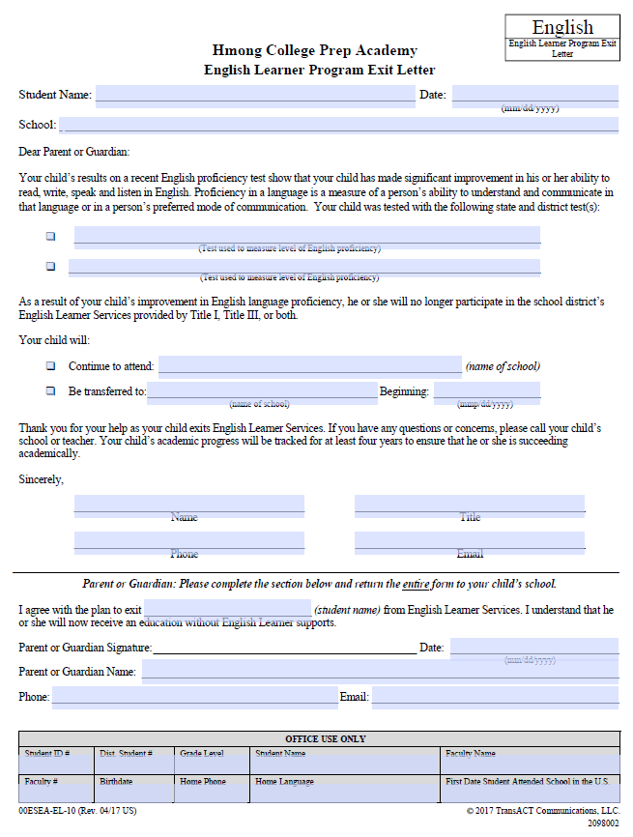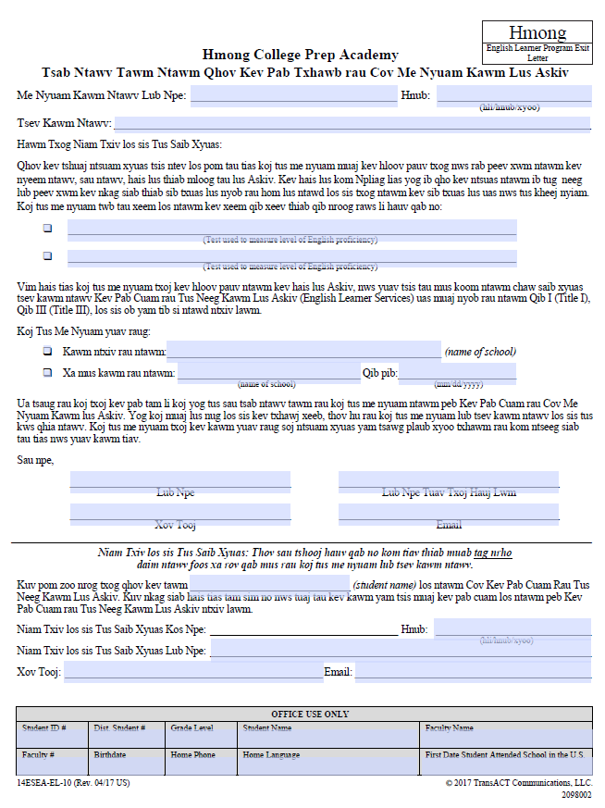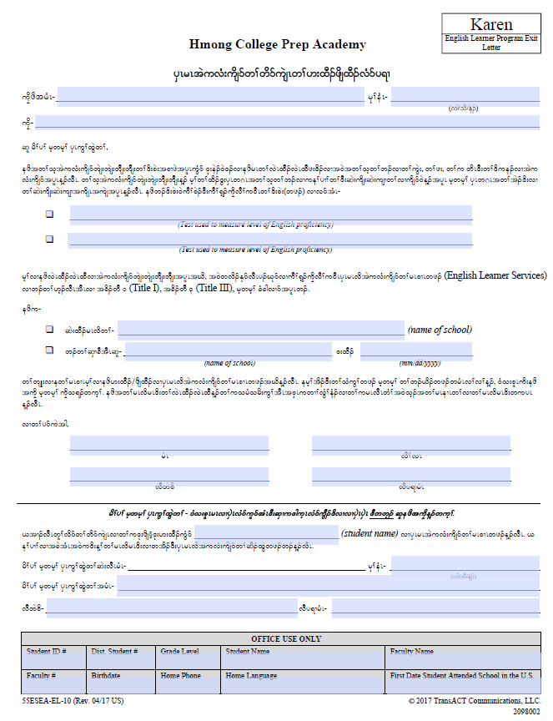

English Language Learner Report Card – Grades K – 5

