
Mrs. Lawson’s Classroom Overview
Grading Scale:
Grades 3-12
10-point Grading Scale
A- 90 - 100
B - 80 - 89
C - 70 - 79
D - 60 - 69
F - Below 60

Classroom Expectation: Ms. Lawson’s 4th Grade Classroom is a responsive classroom that fosters academic excellence and exploration. We will focus on engaging lessons and expanding our learning. Students will participate in interactive Math lessons that will challenge them. Students will also be exposed to a wide variety of strategies that are tailored to their individual needs. Throughout the year students will work to develop a lifelong love for learning.

Supplies and Materials:
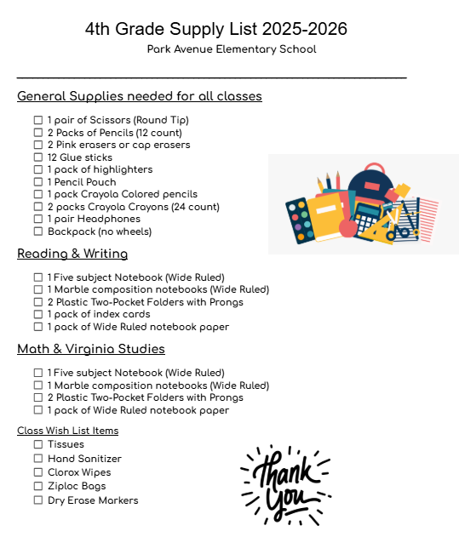

DPS Homework Policy: Please click on the highlighted link to view the homework policy. Homework will be sent home each Monday, or the 1st day of the school week and will be due on Friday or the last day of the school week. Homework will be posted on the website as well as sent home paper and pencil.

Extra Help: Students will engage in intervention and enrichment activities throughout the year based on their needs. Please reach out if you have any questions or need help with additional resources.
Contact Information: I can be reached through ClassDojo until 3:30 or by contacting the school at 434-799-6452 during school hours.

