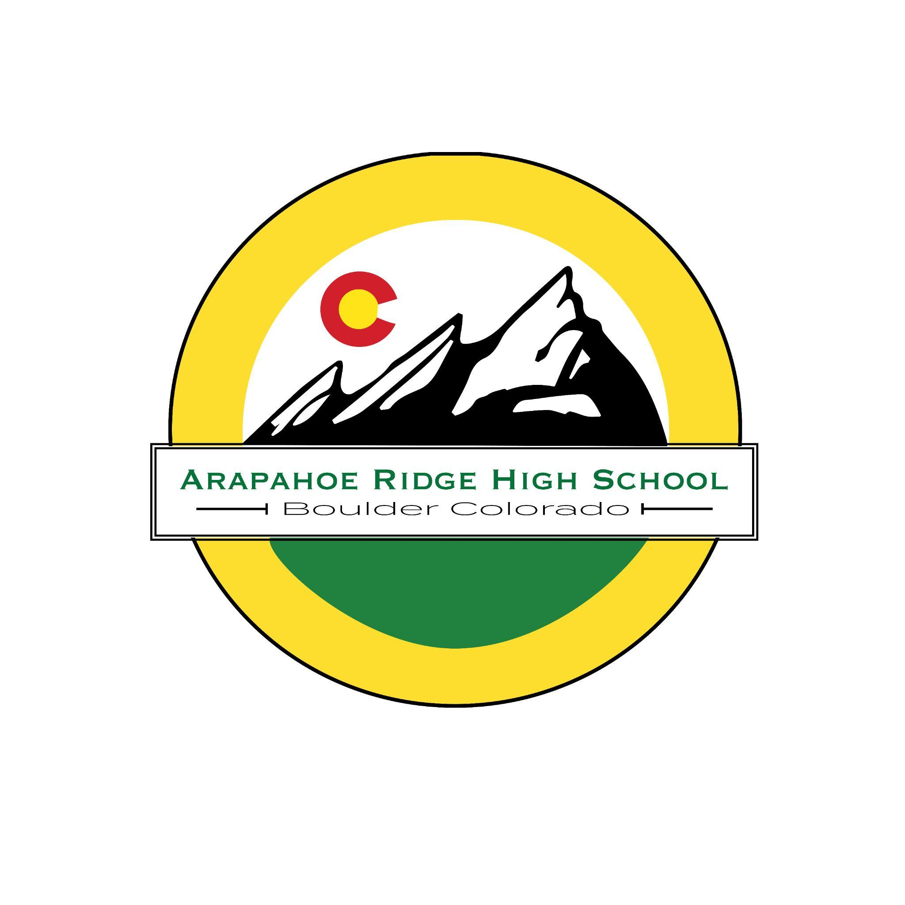
Arapahoe Ridge WBL Bell Schedule 2025-2026
AM SESSION

 | Mon | Tues | Wed | Thur | Fri
1 | 8:55 - 9:47 | 8:55 - 9:47 | 10:00 - 10:30 | 8:55 - 9:47 | 8:55 - 9:47
2 | 9:52 - 10:44 | 9:52 - 10:44 | 10:35 - 11:05 | 9:52 - 10:44 | 9:52 - 10:44
3 | 10:49 - 11:41 | 10:49 - 11:41 | 11:10-11:41 | 10:49 - 11:41 | 10:49 - 11:41
4* | 11:41  WBL | 11:41  WBL | 11:41  WBL | 11:41  WBL | 11:41  WBL
5* | WBL | WBL | WBL | WBL | WBL
6* | 3:36  WBL | 3:36  WBL | 3:36  WBL | 3:36  WBL | 3:36  WBL

Arapahoe Ridge WBL Bell Schedule 2025-2026
PM SESSION

 | Mon | Tues | Wed | Thur | Fri
1 * | 8:45  WBL | 8:45  WBL | 8:45  WBL | 8:45  WBL | 8:45  WBL
2* | WBL | WBL | WBL | WBL | WBL
3* | 12:40  WBL | 12:40  WBL | 12:40  WBL | 12:40  WBL | 12:40  WBL
4 | 12:40 - 1:32 | 12:40 - 1:32 | 1:45 - 2:15 | 12:40 - 1:32 | 12:40 - 1:32
5 | 1:37 - 2:29 | 1:37 - 2:29 | 2:20 - 2:50 | 1:37 - 2:29 | 1:37 - 2:29
6 | 2:34 - 3:26 | 2:34 - 3:26 | 2:55 - 3:26 | 2:34 - 3:26 | 2:34 - 3:26

*Work Based Learning (WBL)

To ensure WORK CREDIT : You MUST complete the following no later than September 26, 2025
1. Upload paystubs or volunteer forms
2. Complete ICAP Surveys
3. Respond to feedback questions.
Optional 4. Portfolio for GRAD + with Jodi Bennett
In-Person Conferences : 4:30-7:00 PM
Pizza & Salad Served
Qu 1: September 4
Qu 2: November 6
Qu 3: January 29
Qu 4: April 23

Every 9 weeks (Quarter)

12 hrs = 1 Credit

9 weeks x 20 hrs = 180 hrs

180 hrs = 15 credits

