DELAWARE VALLEY MIDDLE SCHOOL
"Where Dreams Become Reality"

THANK YOU, SERVICE MEMBERS: Twenty-four veterans were celebrated in true fashion on Friday, November 8, 2024. The morning began with a welcoming meet and greet continental breakfast held in the Warrior Café. Veterans were then treated to a rockstar introduction as they entered a full auditorium of supporters. The students completed a video tribute to members of our nation’s Armed Forces and one kind veteran offered a speech inclusive of his experiences. So many commented afterwards on their appreciation for such a special event! Mr. Morley did an outstanding job coordinating the activities. A special thanks goes to the students and staff in the Warrior Café for hosting our guests.
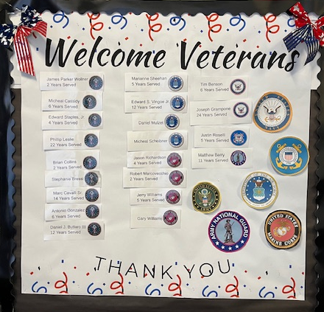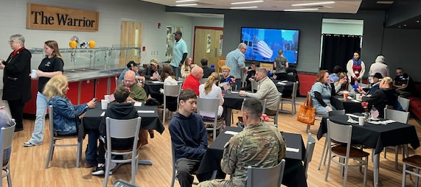
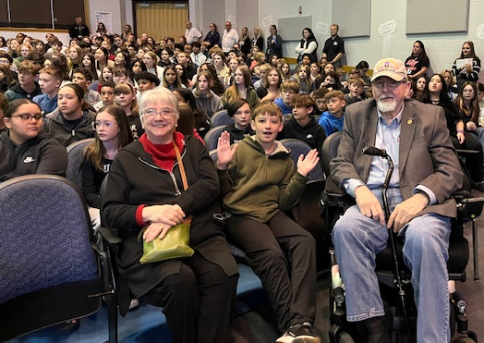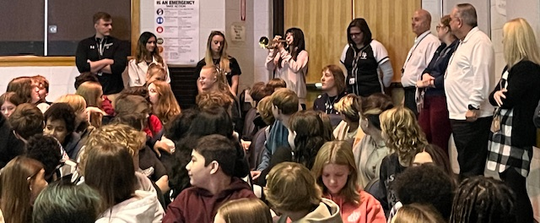
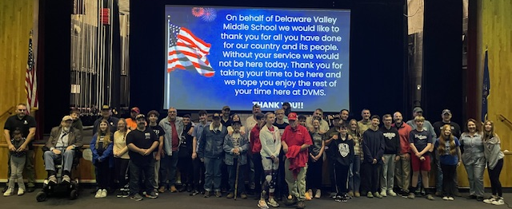
CONGRATULATIONS & THANK YOU VETERANS
WELL-ROUNDED EXCELLENCE: The National Junior Honor Society held their induction ceremony on the evening of Wednesday, November 20, 2024. This prestigious organization added an additional 28 new members to the group. This year there are a total of 38 National Junior Honor Society members. Delaware Valley Middle School Art Teacher and NJHS Advisor, Tara Gandolfo, was the guest speaker. She offered inspirational words of wisdom, while also sharing that this would be her final year before retirement. Congratulations to the students and the parents on such an outstanding accomplishment.
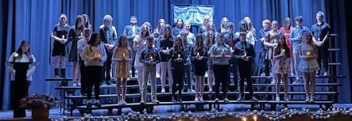
CONGRATULATIONS NJHS 2024-25 INDUCTED MEMBERS

OUT OF THE BOTTLE! The cast and crew shifted gears quickly as opening day was snowed out. However, two outstanding performances were held on Saturday and another on Sunday of Aladin Jr. The stage and pit music crews created an outstanding environment for our talented actors and actresses. Congratulations to Ms. Tallo, director, Mrs. Sudano, assistant director, and pit band leader, Mrs. Reece, for a wonderful production. This was exceptionally done, and the audience was thrilled!
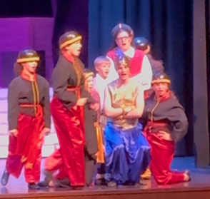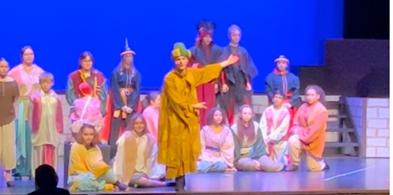
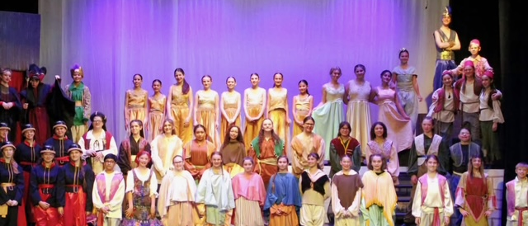
DVMS DRAMA PRODUCTION PERFORMS ALADIN, JR.
CONTRIBUTING TO THE CAUSE: Delaware Valley Middle School students and staff participated in the annual Thanksgiving food drive. We were able to provide local families with some support hoping to make their Thanksgiving holiday a bit more enjoyable.

DVMS WAS FULL OF PEP: The DVMS Teachers defeated the DVMS Girls & Boys Basketball Team by 14 points in the return of the pep rally! All clubs and sports were recognized and several students and staff had opportunities for half-court shots, which would have earned gift certificates. Sadly, no shots were made. This was a fun-filled event for all. A special thank you to Mr. Bell for initiating the request for the return of this fun event. He did a great job gathering staff support to make this a great afternoon.
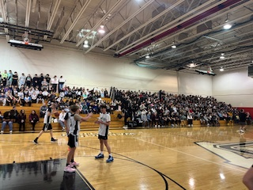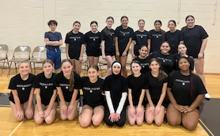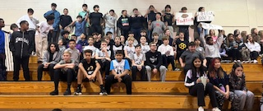
DVMS WINTER PEP RALLY

MEETING OUR PARENTS: A combination of parent/teacher conferences was held in the afternoon and early evening of November 26, 2024. During the afternoon session, parents and teachers met virtually to discuss how each child is doing in class and to address any potential concerns. During the evening sessions, parents came to the school to meet directly with teachers for discussions. Many parents took the time to express their appreciation for the work the teachers are doing with the children.

THE GRANDEST DAY OF ALL: Grandparents Day at DVMS was another extraordinarily successful day! November 27, 2024, marked the 16th year for this incredible event. 150 grandparents came to celebrate with 79 students. The cafeteria was decorated with table-centerpieces created by Mrs. Gandolfo and her art students. Guests were greeted by our student ambassadors, and upon entering the cafeteria were serenaded by piano players and songs from our chorus. A continental breakfast was provided by the food service staff and the Warrior Café’. Grandparents and students also each received a photo together reminding them of how special the morning was. This was an outstanding job by everyone involved and remains the best day of the year!
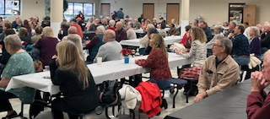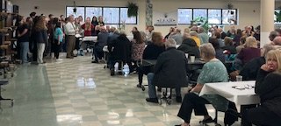
GRANDPARENTS DAY

MUSIC NEWS: The DVMS Band, Chorus, and Orchestra continue to work in preparation for their upcoming concerts. The 7th & 8th Grade Concert will be held on December 9th with a snow date of December 16th. The 6th Grade Concert will be held on December 11th with a snow date of December 18th. The free concerts will be held in the DVHS Auditorium at 6:30PM.
Also, thank you DVMS Chorus for singing a few songs for the grandparents during Grandparents Day.

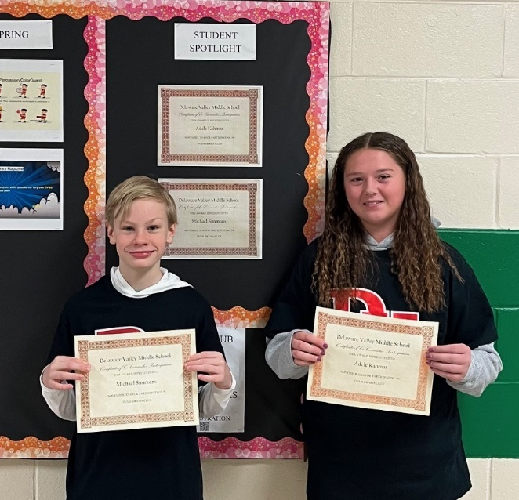
Michael Simmons and Adele Kahmar Co-Curricular

NEW TEACHER HIGHLIGHTS
Mrs. Boonyam

What made you decide to become a teacher?
I was an instructor for a high school summer enrichment program while I was a college student, and it sparked my passion and love for teaching!

What do you love most about teaching?
I love to connect with my students and learn about their interests. Another thing that I love about teaching is helping students to work through problems and find strategies that help them succeed in math.
What do you enjoy doing in your leisure time?
I enjoy spending time with family, going outside to hike the beautiful trails in our area, and I also enjoy baking!

Who is your best role model and why?
I have been extremely privileged to be working with so many great teachers here at DVMS, and I am learning from each of them every day. As a new teacher, it has been extremely valuable to me to have such a supportive community in this school!
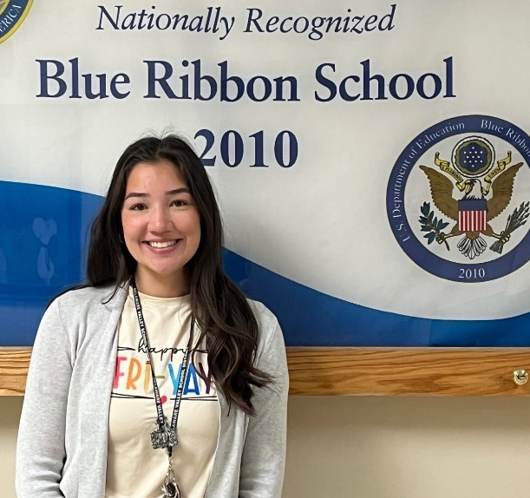
Mrs. Boonyam, Math Teacher

NOVEMBER STAFF MEMBER OF THE MONTH

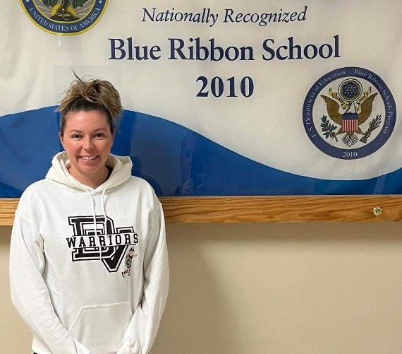
Mrs. Gonzalez, Math Teacher

NOVEMBER STUDENTS OF THE MONTH NOMINEES

Alice Aguirre Dylan Aguirre Isabella Baily Myah Amici
Anastasia Baisheva Sydney Dutkus William Hoar Blake Mady
Wyatt Malenczak Ayla Martine Keston Monahan Jace Thiele
Darendra Ramnauth Mikhei Rosario Hrithik Udeshi Maxx Weber
Stephanie Williams Lydia Boronow Aiden Contreras
NOVEMBER STUDENTS OF THE MONTH

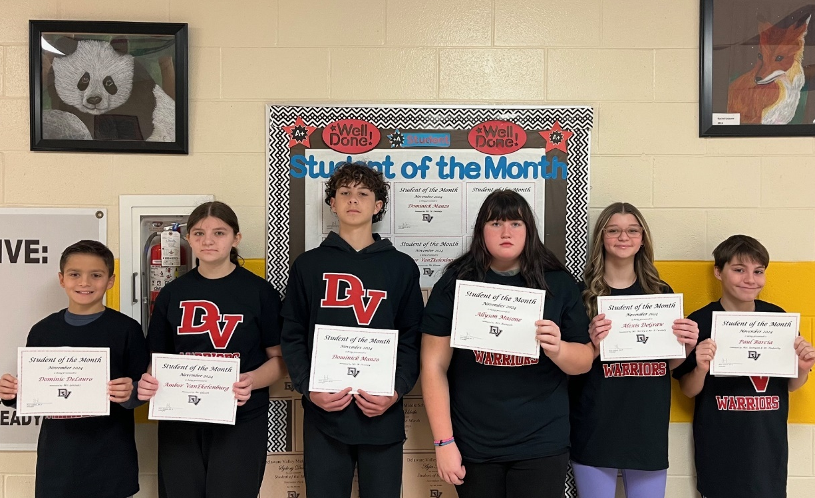
Dominic DeLauro, Amber VanEkelenburg, Dominik Manzo, Allyson Masone, Alexis DeGraw, Paul Barcia

DECEMBER HAPPENINGS

December 9 Grades 7 & 8 Band, Chorus, Orchestra Concert, HS Auditorium 6:30PM (Snow Date, December 16)
December 11 Grade 6 Band, Chorus, Orchestra Concert, HS Auditorium 6:30PM
(Snow Date, December 18)
December 23 – January 1 Schools Closed, “Winter Recess”
**Please be reminded that school will resume on THURSDAY, JANUARY 2, 2025**

The holiday season is upon us! As we move through December, let us hope for nice weather so we may get as many school days in as possible before our long winter break. While still in school, please make every effort to achieve your best academically. Continue working hard and plan to attend after school tutoring as necessary. Good luck to all our coaches and club advisors as we begin the winter season. Parents, please encourage your children to get involved.

I would like to extend a very happy and healthy holiday season to all! Enjoy the time off with your family and friends! It is very well-deserved!

Sincerely,

Pete Ioppolo, Ed. D.
Principal

