DELAWARE VALLEY MIDDLE SCHOOL
"Where Dreams Become Reality"

HITTING THE TRIFECTA: Triple congratulations to our three Odyssey of the Mind teams for their exceptional performances at the NEPA Odyssey of the Mind Regional Tournament which was held on February 22nd at the Pocono Mountain West High School. Ms. Orgitano's Structure team held an incredible 920 pounds and came in first place; Mrs. Lockwood's technical team sailed into first place, and Mrs. Nielsen and Mrs. Monahan's vehicle team raced into second place. All three teams will be advancing to the State Finals competition at Pocono Mountain East High School on April 5th. Way to go OMers and good luck at States!
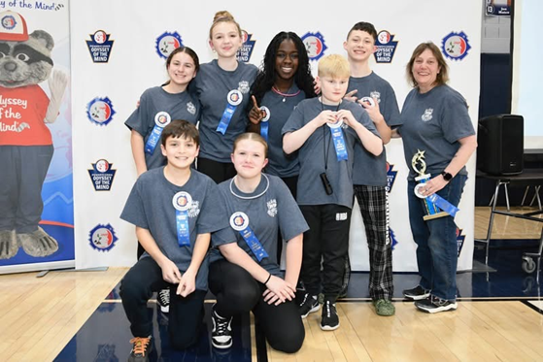
(Structure team photo: rear, L to R: Mia Pavinich, Jovey Thiele, Sekai Jones, Connor Stewart, Gabriel O'Sullivan, Coach Karen Orgitano. Front, L to R: Dominic DeLauro and Taryn Kaylor)

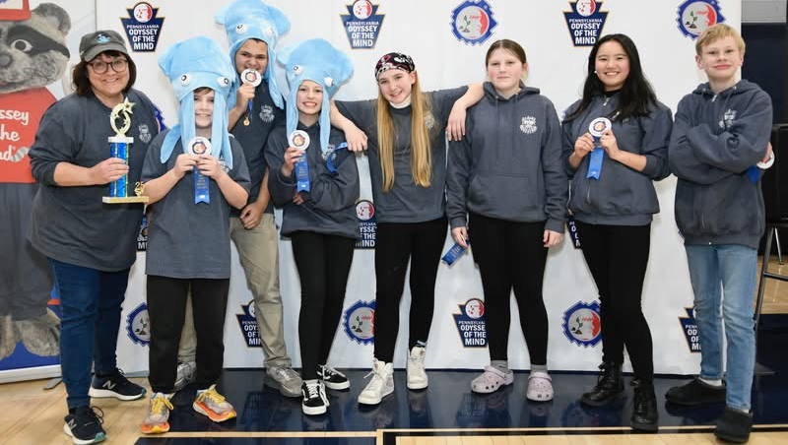
(Technical team photo, L to R: Coach Lauren Lockwood, Keston Monahan, Christopher Miller, Adelyn Gamer, Ariel Weyant, Jojo Nielsen, Patty Chen, and Michael Simmons.)
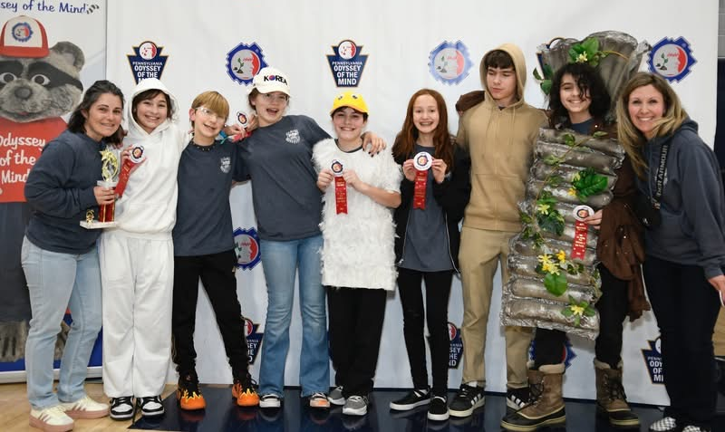
(Vehicle team photo, L to R: Coach Cheryl Nielsen, Maeve Kaiser, Bradley Gaa, Mackenzie DiMarsico, Paul Barcia, Maryah Nuhn, Calder Laubin, Jake Bischoff, and Coach Ashley Monahan.)
DVMS 2025 KING & QUEEN OF KINDNESS: February is Random Acts of Kindness Month. DVMS hosts King and Queen of Kindness where students are nominated by teachers and voted on by students to showcase those who emulate our school culture that includes positive choices, good citizenship and caring about others and our school. Our 2025 King is Patrick Tamplin and Queen is Aubrey Kirwan.
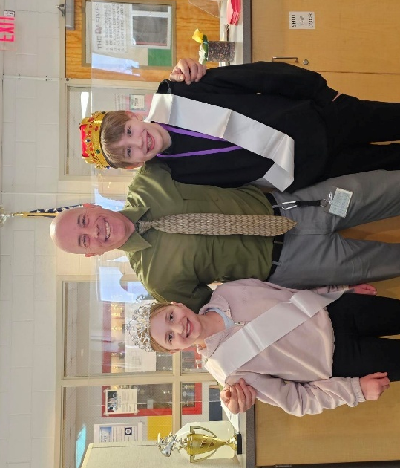
Aubrey Kirwan & Patrick Tamplin

THEY CAME, THEY DANCED: Over 115 students attended the Student Council Valentine’s Day dance held on Thursday, February 13, 2025. The PTA provided refreshments, and the DJ kept our feet moving to some new and old-time favorites. Thank you to many of our staff that stayed after school to chaperone the event. They also appeared to have a great time!
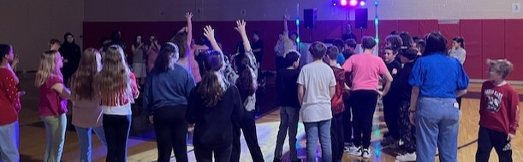
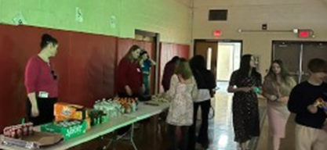
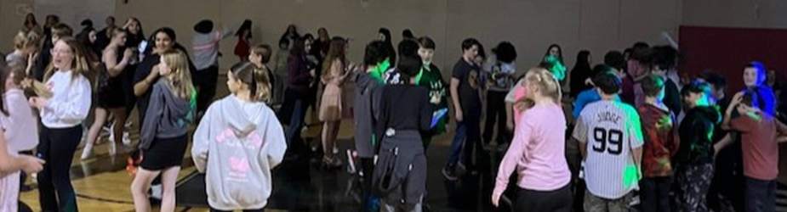
FEBRUARY CO-CURRICULAR STUDENTS OF THE MONTH

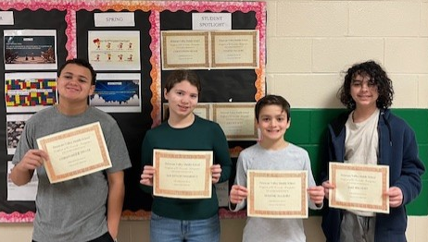
Christopher Miller, Mackenzie DiMarsico, Dominic DeLauro, McKenzie, Jake Bischoff
DVMS OM TEAM MEMBERS

FEBRUARY TEACHER OF THE MONTH

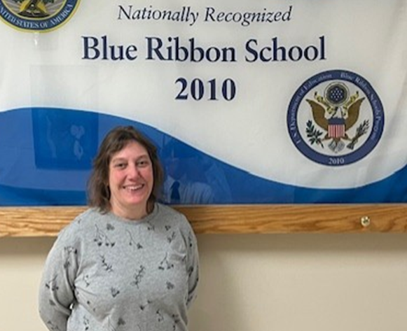
Mrs. Orgitano

FEBRUARY STUDENTS OF THE MONTH NOMINEES

Taryla Adaria Anastasia Baisheva Aliya Bates Jake Biscoff
Jordon Delahoz Mackensie DeMarisco Jeremey Jesualdo Sekai Jones
Renato Diaz-Phelp Alycia Jacinto-Norton Maxyne Jahrling Colton Judd
Adele Kahmar Jacob Kutschera Mackenzie Lee Zoey Loomis
Maeve McGoey Gabriel O’Sullivan Jasmine Sevek Tajae Redick
Edward Vingoe
FEBRUARY STUDENTS OF THE MONTH

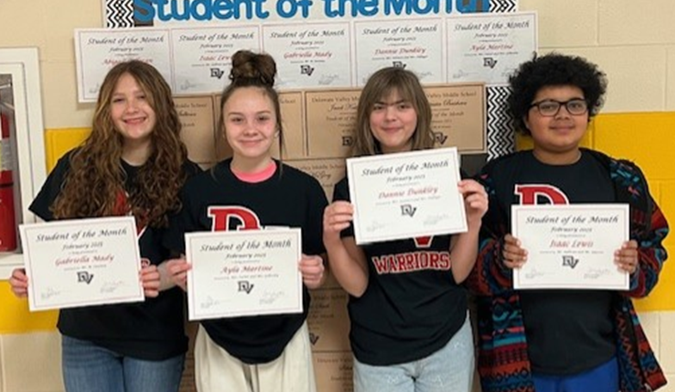
Gabriella Mady, Ayla Martine, Danni Dunkley, Isaac Lewis, Abigail Colleran

MARCH HAPPENINGS

March 21 In-Service Day/No School for Students

While spring is on the way, the third marking period is well-underway. There is still ample time to identify strengths and weaknesses within your classes and to seek additional assistance as determined. Additionally, our academic data indicates that many students can benefit mathematically from focusing in on constructed responses, commonly known as “word problems.” Also, the ability to analyze and identify what is being asked within the question does require practice. For example, in ELA, students complete TDAs to increase their reading comprehension skills and writing.

To provide support, tutoring continues to run after school. As we get closer to the state assessments, an even more focused after school tutoring opportunity will be available for students that receive invitations in relation to ELA, math, and for those students in grade 8 taking the Keystone Algebra exam.

Spring sports are getting underway, and I wish all our athletes and teams a great season. Thank you for your commitment to getting our student athletes and entertainers to all practices and events as needed. Bring on the sun! Please enjoy a wonderful month.

Sincerely,
Pete Ioppolo, Ed. D.
Principal

