Using your Lexile Score to help you find a book
Step 1: Go to Destiny Library Catalog
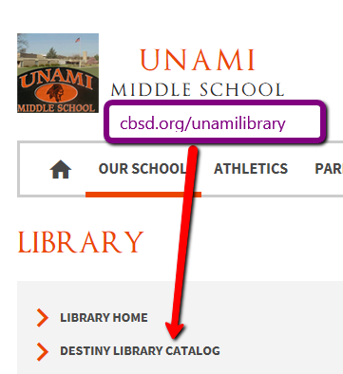
Step 2: LOGIN to the Catalog
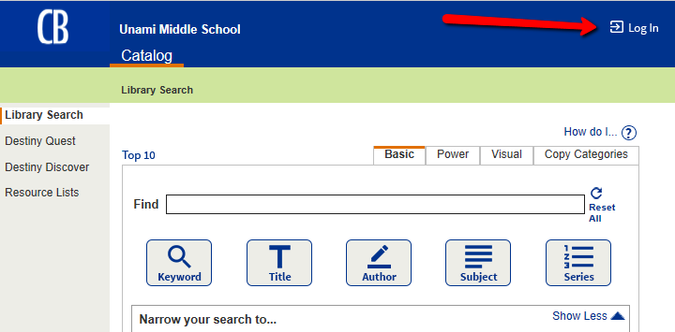
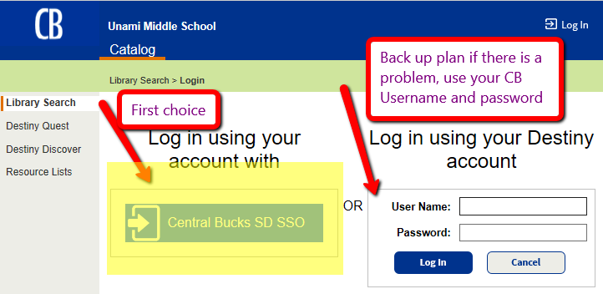

Step 3: Do a keyword/subject matter search combined with a Lexile range search.
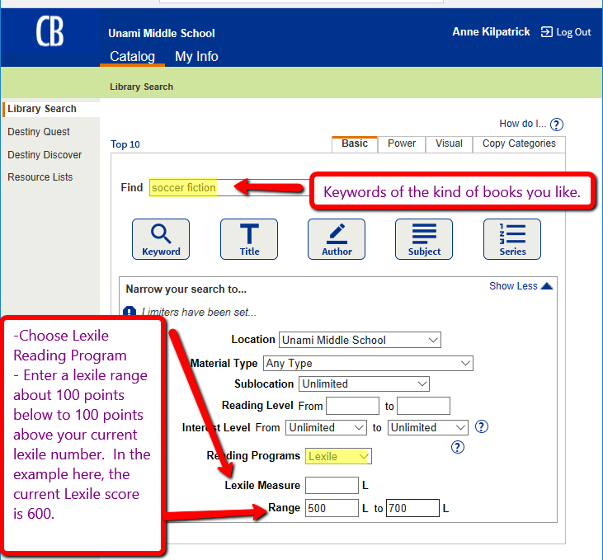
Step 4: Explore the results
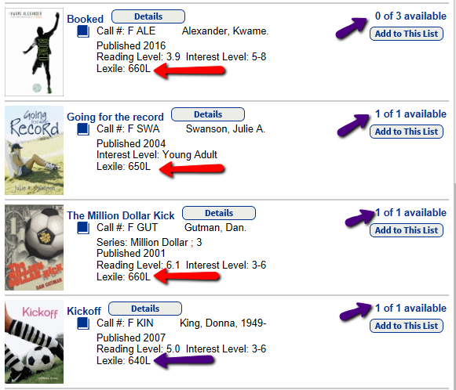

Step 5: Pick a book or two for now and add others you may like to your NEXT LIST in Destiny
