THIRD GRADE SUPPLIES
- Pencil box big enough to hold all supplies
- Scissors
- Headphones in a labeled Ziploc bag
- Box of tissues
- 1 notebook
- 2 two-pocket plastic folders-red and green
- Whiteboard
- Whiteboard eraser/sock
- 4 Expo dry erase markers
- Optional: math flashcards
- Optional Classroom Donation: gallon or sandwich sized Ziploc bags

FOURTH GRADE SUPPLIES
- Small pencil sharpener
- Scissors
- Zippered pencil case that will fit all supplies
- 4 spiral notebooks
- 5 folders with pockets
- Headphones in labeled plastic bag
- 2 packages of cleaning (Clorox) wipes
- 1 container of hand sanitizer
- 1 Box of tissues

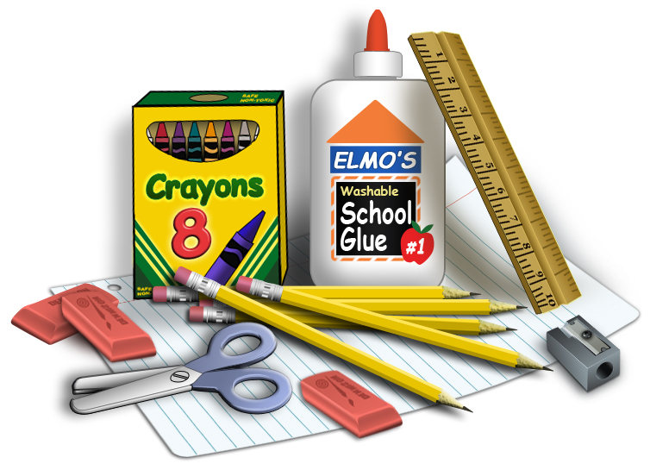

KINDERGARTEN SUPPLIES
- 1 box of tissues
- 1 Two-pocket folder, heavy-duty w/name
- Headphones in a Ziploc bag, labeled with your child’s name (no earbuds please)
- 1 pack (4 count) Play-Doh
- 2 Lysol or Clorox wipes

FIRST GRADE SUPPLIES
- 1 plastic supply box
- 5 plastic pocket folders with prongs- one each of red, yellow, green, blue, and orange
- 4 black Expo markers
- 1 white board eraser
- Headphones in a Ziploc bag, labeled with your child’s name
- 1 reusable water bottle (leak proof)
- 1 container of disinfecting wipes
- 2 boxes of tissues

SECOND GRADE SUPPLIES
- Pencil case/box big enough to hold all supplies
- 1 handheld pencil sharpener
- scissors
- 1 marble composition book
- 1 red two-pocket plastic folder
- 1 blue two-pocket plastic folder
- Whiteboard eraser/sock
- 2 boxes of tissues
- Headphones in a Ziploc bag, labeled with your child’s name
- 1 container of Clorox wipes

KUTZ ELEMENTARY SCHOOL RECOMMENDED SCHOOL SUPPLIES 2024-2025

Thank you for your assistance in providing the necessary materials for your child’s school experience. Please let us know if the purchase of such is in any way a hardship as we will work with you to ensure your children have the materials they need.
FIFTH GRADE SUPPLIES
- Headphones or earbuds
- Laptop case (you received with your district laptop)
- 1 composition book (not spiral)
- 4 plastic folders - red, blue, green, yellow, or a variety (hole-punched if possible)
- Individual hand-held pencil sharpener
- Pencil case (not box) that can be closed securely to hold supplies provided by school
- 2 boxes of tissues
- Clorox or disinfecting wipes
- Hand Sanitizer

SIXTH GRADE SUPPLIES
- 4 marble composition books
- 4 pocket folders
- Pencils
- Pencil case
- Glue stick (optional)
- Black Sharpie (optional)
- Scissors
- Crayons or colored pencils (optional)
- 2 containers of anti-bacterial wipes, if possible
- 2 boxes of tissues
- Headphones

