Sixth Grade Supply List

2025-2026

Necessary Items:

Three marble-covered composition books
- Six 2-pocket folders
- Two dozen #2 pencils
- Highlighter(s)
- Colored pencils (no more than a 24-pack)

Headphones or earbuds
- Four or more thin-tipped dry erase markers
- Whiteboard eraser (or old sock)
- Two glue sticks
- Two large boxes of tissues (to be shared with class)

---------------------------------------------------------------------------

Helpful Optional Items:
- Kid-safe scissors
- Black fine-point permanent marker
- TI-34 II calculator
- Pencil pouch
- Container of antibacterial wipes

Thanking you,
Our Appreciative Sixth Grade Team

Parents and Guardians:
Thank you in advance for weathering yet another back-to-school shopping experience. As parents and teachers, we feel your pain. If anything is unclear, please just send us an email.
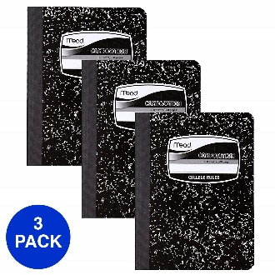  3 sewn-bound composition books | 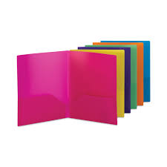  Six 2-Pocket Folders | 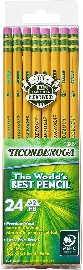  Two Dozen #2 pencils
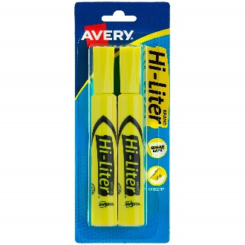  Two highlighters | 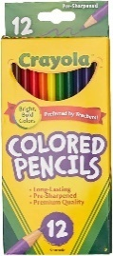  Colored Pencils  (24 or less) | 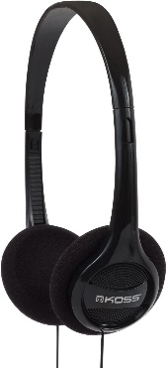  Headphones
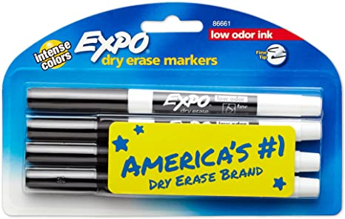  Four thin-tipped dry erase markers | 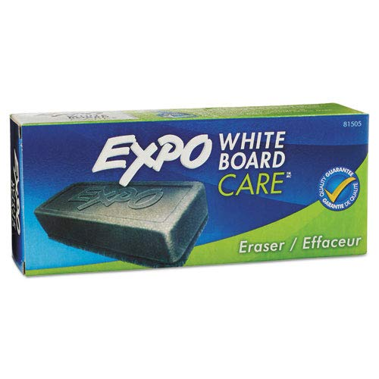  White board eraser or clean sock | 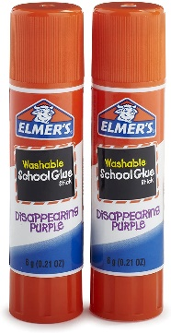  Two glue sticks
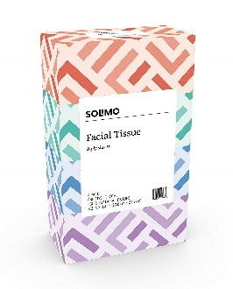  Two boxes of tissues | Optional:  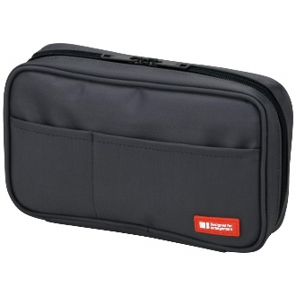  Soft Pencil Case | Optional:  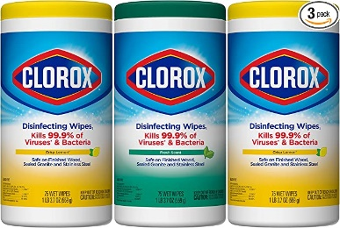  Clorox Wipes

