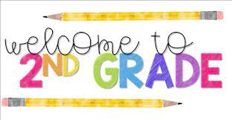  
**Supply List**  
2025-2026 School Year

***Needed for in school:***

* 1 rectangular (5”X 8”) school supply box
* 24 #2 ***sharpened*** pencils (Ticonderoga brand if possible)
* 5 dry erase markers
* 2 boxes of crayons (24 or less)
* 5 glue sticks (no liquid glue)
* 1 pair of student scissors
* 1 folder (pockets at the bottom)
* 1 set of headphones in a zip lock bag (labeled with name)
* A reusable water bottle (labeled with name)

***OPTIONAL items to bring:***   
-Washable Markers    
-Clorox Wipes   
-Zip lock bags (sandwich and gallon bags)    
-More pencils: #2 ***sharpened*** pencils (Ticonderoga brand if possible