Somerset County Vocational and Technical Schools

Career & Technical Education
Course Catalog 2025-2026

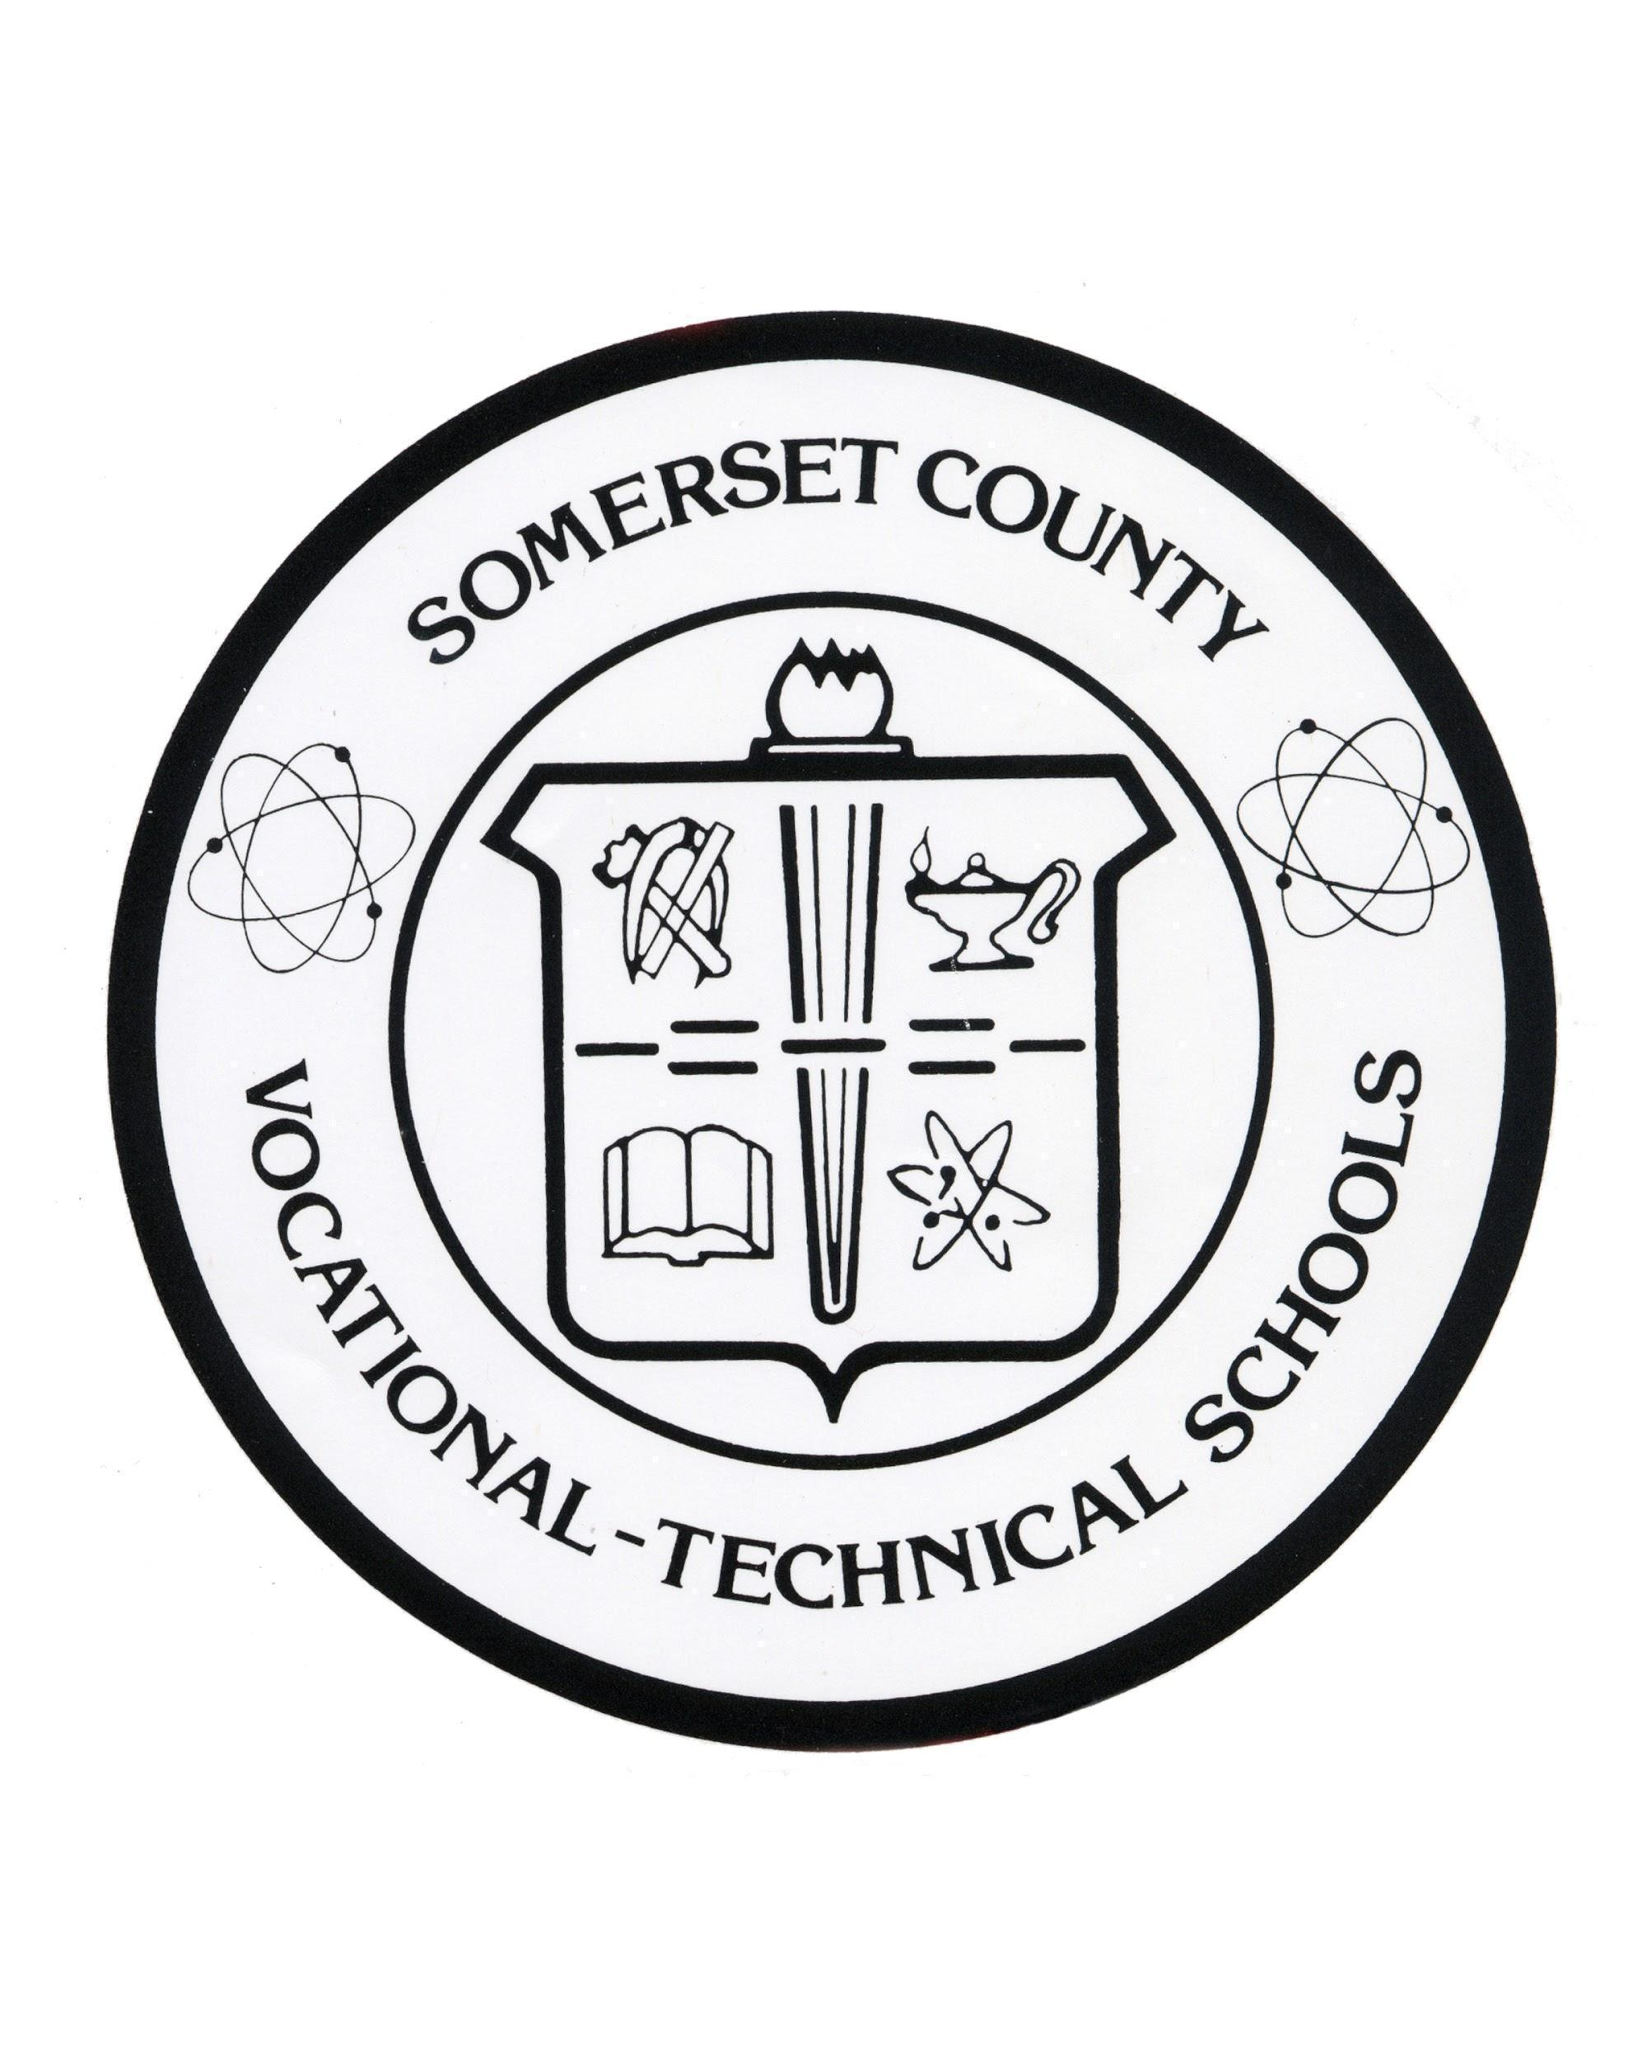

14 Vogt Drive
Bridgewater, NJ 08807
908-526-8900
www.scvths.org

Somerset County Vocational Technical School fully complies with Title II: 35.107(a), Title IX CFR106.8 and Section 504:34 CFR 104.7(a). This includes race, color, national origin, sex and disability status. For any inquiries regarding Title II and Title IX, please contact Patrick Pelliccia (ppelliccia@scvts.net) at 1.908.526.8900 x 7121, 14 Vogt Drive, Bridgewater, NJ 08807. For inquiries regarding Section 504, please contact Maria Johnson (mjohnson@scvts.net) at 1.908.526.8900 x 7155, 14 Vogt Drive, Bridgewater, NJ 08807.

TABLE OF CONTENTS

AGRICULTURE, FOOD AND NATURAL RESOURCES
- Agricultural Science ……………………………………………………………………………………………….………….. 4

ARCHITECTURE AND CONSTRUCTION
- Carpentry ………………………………………………………………………………………………………….……………….. 6
- Electrical Construction …………………………………………………………………………………….…………………. 7
- Plumbing Technology ……………………………………………………………………………………….……………...… 9
- Welding Technology ………………………………………………………………………………………………………….. 10
- HVAC…………………………………………………………………………………………………………………...Coming Soon

ARTS, A/V TECHNOLOGY, AND COMMUNICATIONS
Gifted and Talented Performing Arts
- Dance Program ………………………………………………………………………………………………………………….. 12
- Theater Arts ………………………………………………………………………………………………………….…………… 13
- Graphic Communications …………………………………………………………………………………….……………. 15

BUSINESS AND FINANCE
- Business Entrepreneurship and Management (BE&M) …………………………………………………….. 17
- Finance………………………………………………………………………………………………………………….Coming Soon
- Global Business……………………………………………………………………………………………………..Coming Soon

HEALTH SCIENCE
- Health Occupations …………………………………………………………………………………………….……………… 19
- Biomedical……………………………………………………………………………………………………………………………20

HOSPITALITY AND TOURISM
- Culinary Arts ………………………………………………………………………………………………………….…..……… 22

HUMAN SERVICES
- Cosmetology ...………………………………………………………………………………………………….………………. 25

INFORMATION TECHNOLOGY
- Computer Science ………………………………………………………………………………………….……….………… 27

LAW, PUBLIC SAFETY, CORRECTIONS AND SECURITY
- Law and Public Safety ……………………………………………………………………….……………….……………… 29

ENGINEERING & MANUFACTURING
- Mechatronics, Engineering, and Advanced Manufacturing (MEAM) ………….…………………….. 31

TRANSPORTATION, DISTRIBUTION AND LOGISTICS
- Auto Body .………………………………………………………………………………………………………………….……. 34
- Automotive/Diesel Technology .…………………………………………………………………………….…………. 36
- Mechanics and Repair ..………………………………………………………………………………………………….…. 38

Agriculture, Food and Natural Resources

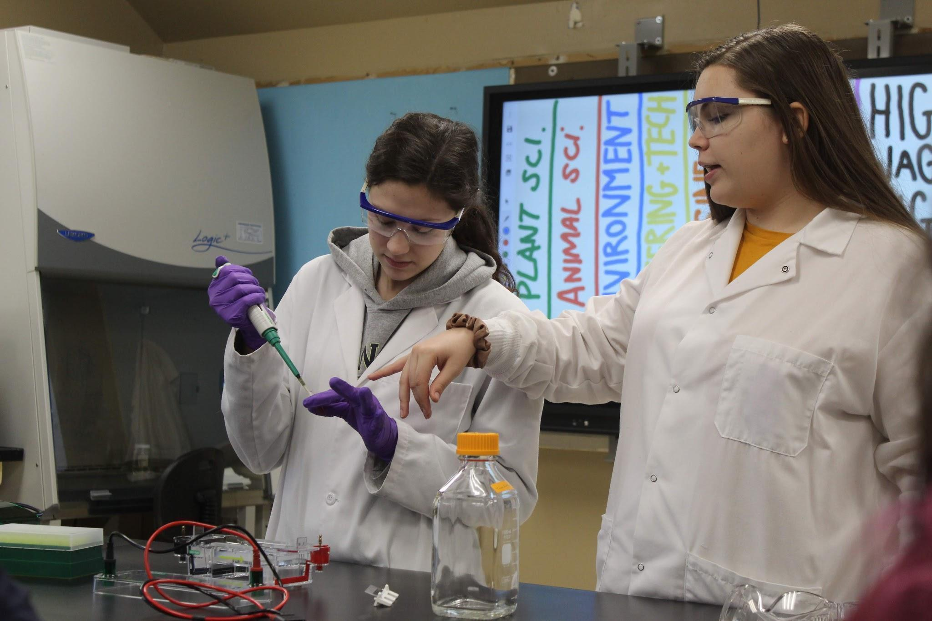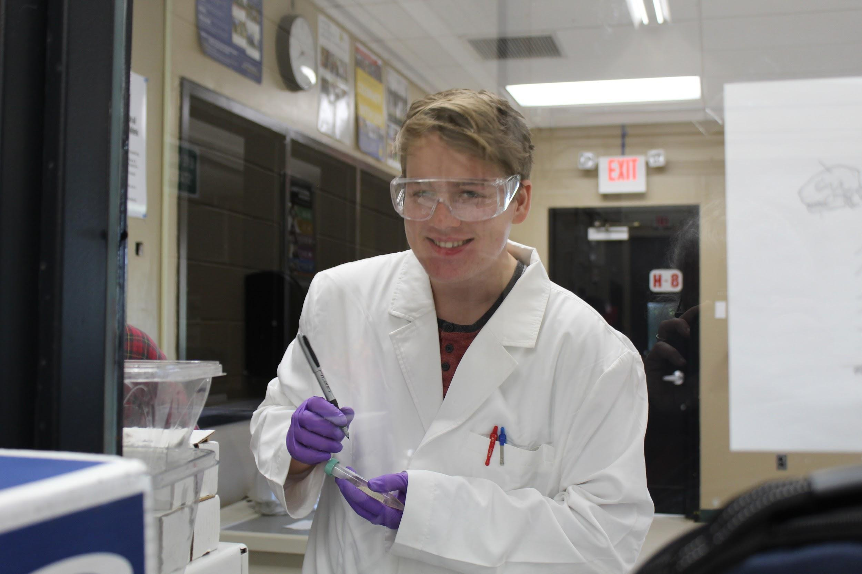

Agricultural Science

Year 1: Introduction to Agriculture, Food, and Natural Resources
Course Description: Introduction to Agriculture, Food, and Natural Resources (AFNR) is the introductory course in the CASE sequence of courses. It is designed to introduce students to the pathways in the AFNR career cluster and the opportunities that will be available to them. Students participating in the Introduction to Agriculture, Food, and Natural Resources course will experience exciting “hands-on” activities, projects, and problems. Student experiences will involve the study of communication, the science of agriculture, plants, animals, natural resources, and agricultural mechanics. While surveying the opportunities available in agriculture and natural resources, students will learn to solve problems, conduct research, analyze data, work in teams, and take responsibility for their work, actions, and learning. For example, students will work in groups to determine the efficiency and environmental impacts of fuel sources in a practical learning exercise. Students experiences will include the study of plant and animal anatomy and physiology, classification, and investigate, experiment, and learn about documenting a project, solving problems, and communicating their solutions to their peers and members of the professional community.
Year 2: Principles of Agricultural Science- Plant
Course Description: The Principles of Agricultural Science – Plant™ course is intended to serve as a foundation course within the CASE™ sequence. The course is structured to enable all students to have a variety of experiences that will provide an overview of the field of agricultural science with a foundation in plant science so that students may continue through a sequence of courses through high school. Students will work in teams, exploring hands-on projects and activities, to learn the characteristics of plant science and work on major projects and problems similar to those that plant science specialists, such as horticulturalists, agronomists, greenhouse and nursery managers and producers, and plant research specialists face in their respective careers. This knowledge and these skills will be used in future courses within the CASE™ program.
In addition, students will understand specific connections between the Plant Science lessons and Supervised Agricultural Experience, FFA, and Life Knowledge components that are important for the development of an informed agricultural education student. Students will investigate, experiment, and learn about documenting a project, solving problems, and communicating their solutions to their peers and members of the professional community.

Year 3: Animal and Plant Biotechnology
Course Description: Animal and Plant Biotechnology is a course in the CASE Program of Study which provides a rigorous instruction to students in the field of biotechnology. Students will complete hands-on activities, projects, and problems designed to build content knowledge and technical skills in the field of biotechnology. Students are expected to become proficient at projects involving micropipetting, bacterial cultures and transformations, electrophoresis, and polymerase chain reaction. Research and experimental design will be highlighted as students develop and conduct industry appropriate investigations. Students investigate, experiment and learn about documenting a project, solving problems, and communicating their solutions to their peers and members of the professional community.
Year 4: Agricultural Research and Development
Course Description: Agricultural Research and Development is the capstone course designed to culminate students’ experiences in agriculture. Woven throughout the course are projects and problems based on practical applications and designed to develop and improve the employability skills of students. Students will further enhance critical thinking and teamwork skills as they expand on their content knowledge from previous CASE courses. In this course students will learn to: solve complex real-world problems, conduct research, analyze data, work in teams, and develop new products. Returning fourth year students will be challenged with projects and materials designed to prepare them for scientific research. Subject areas include: designing, conducting and reporting research.

Architecture and Construction

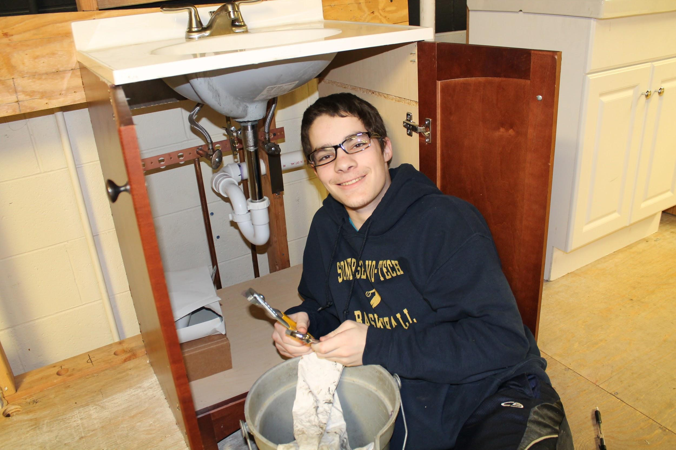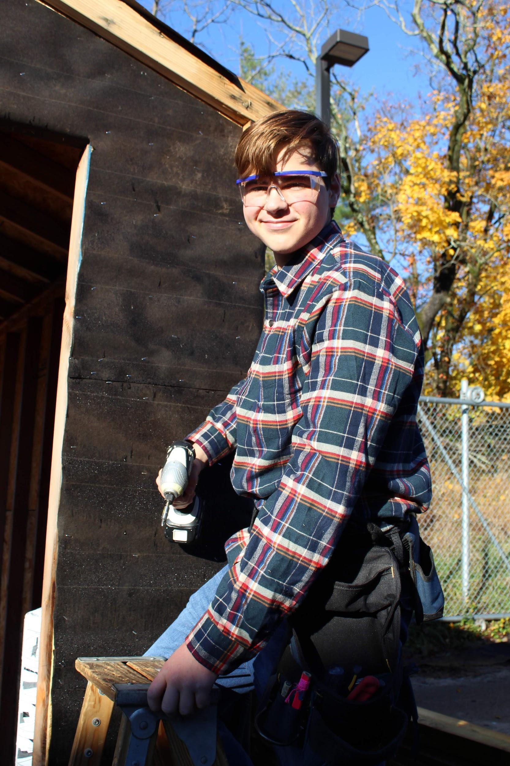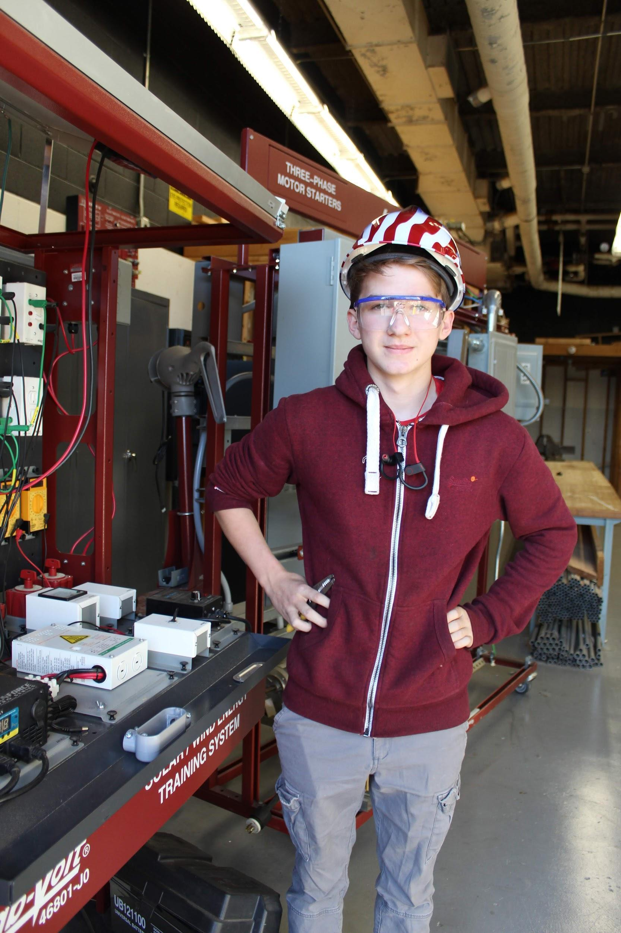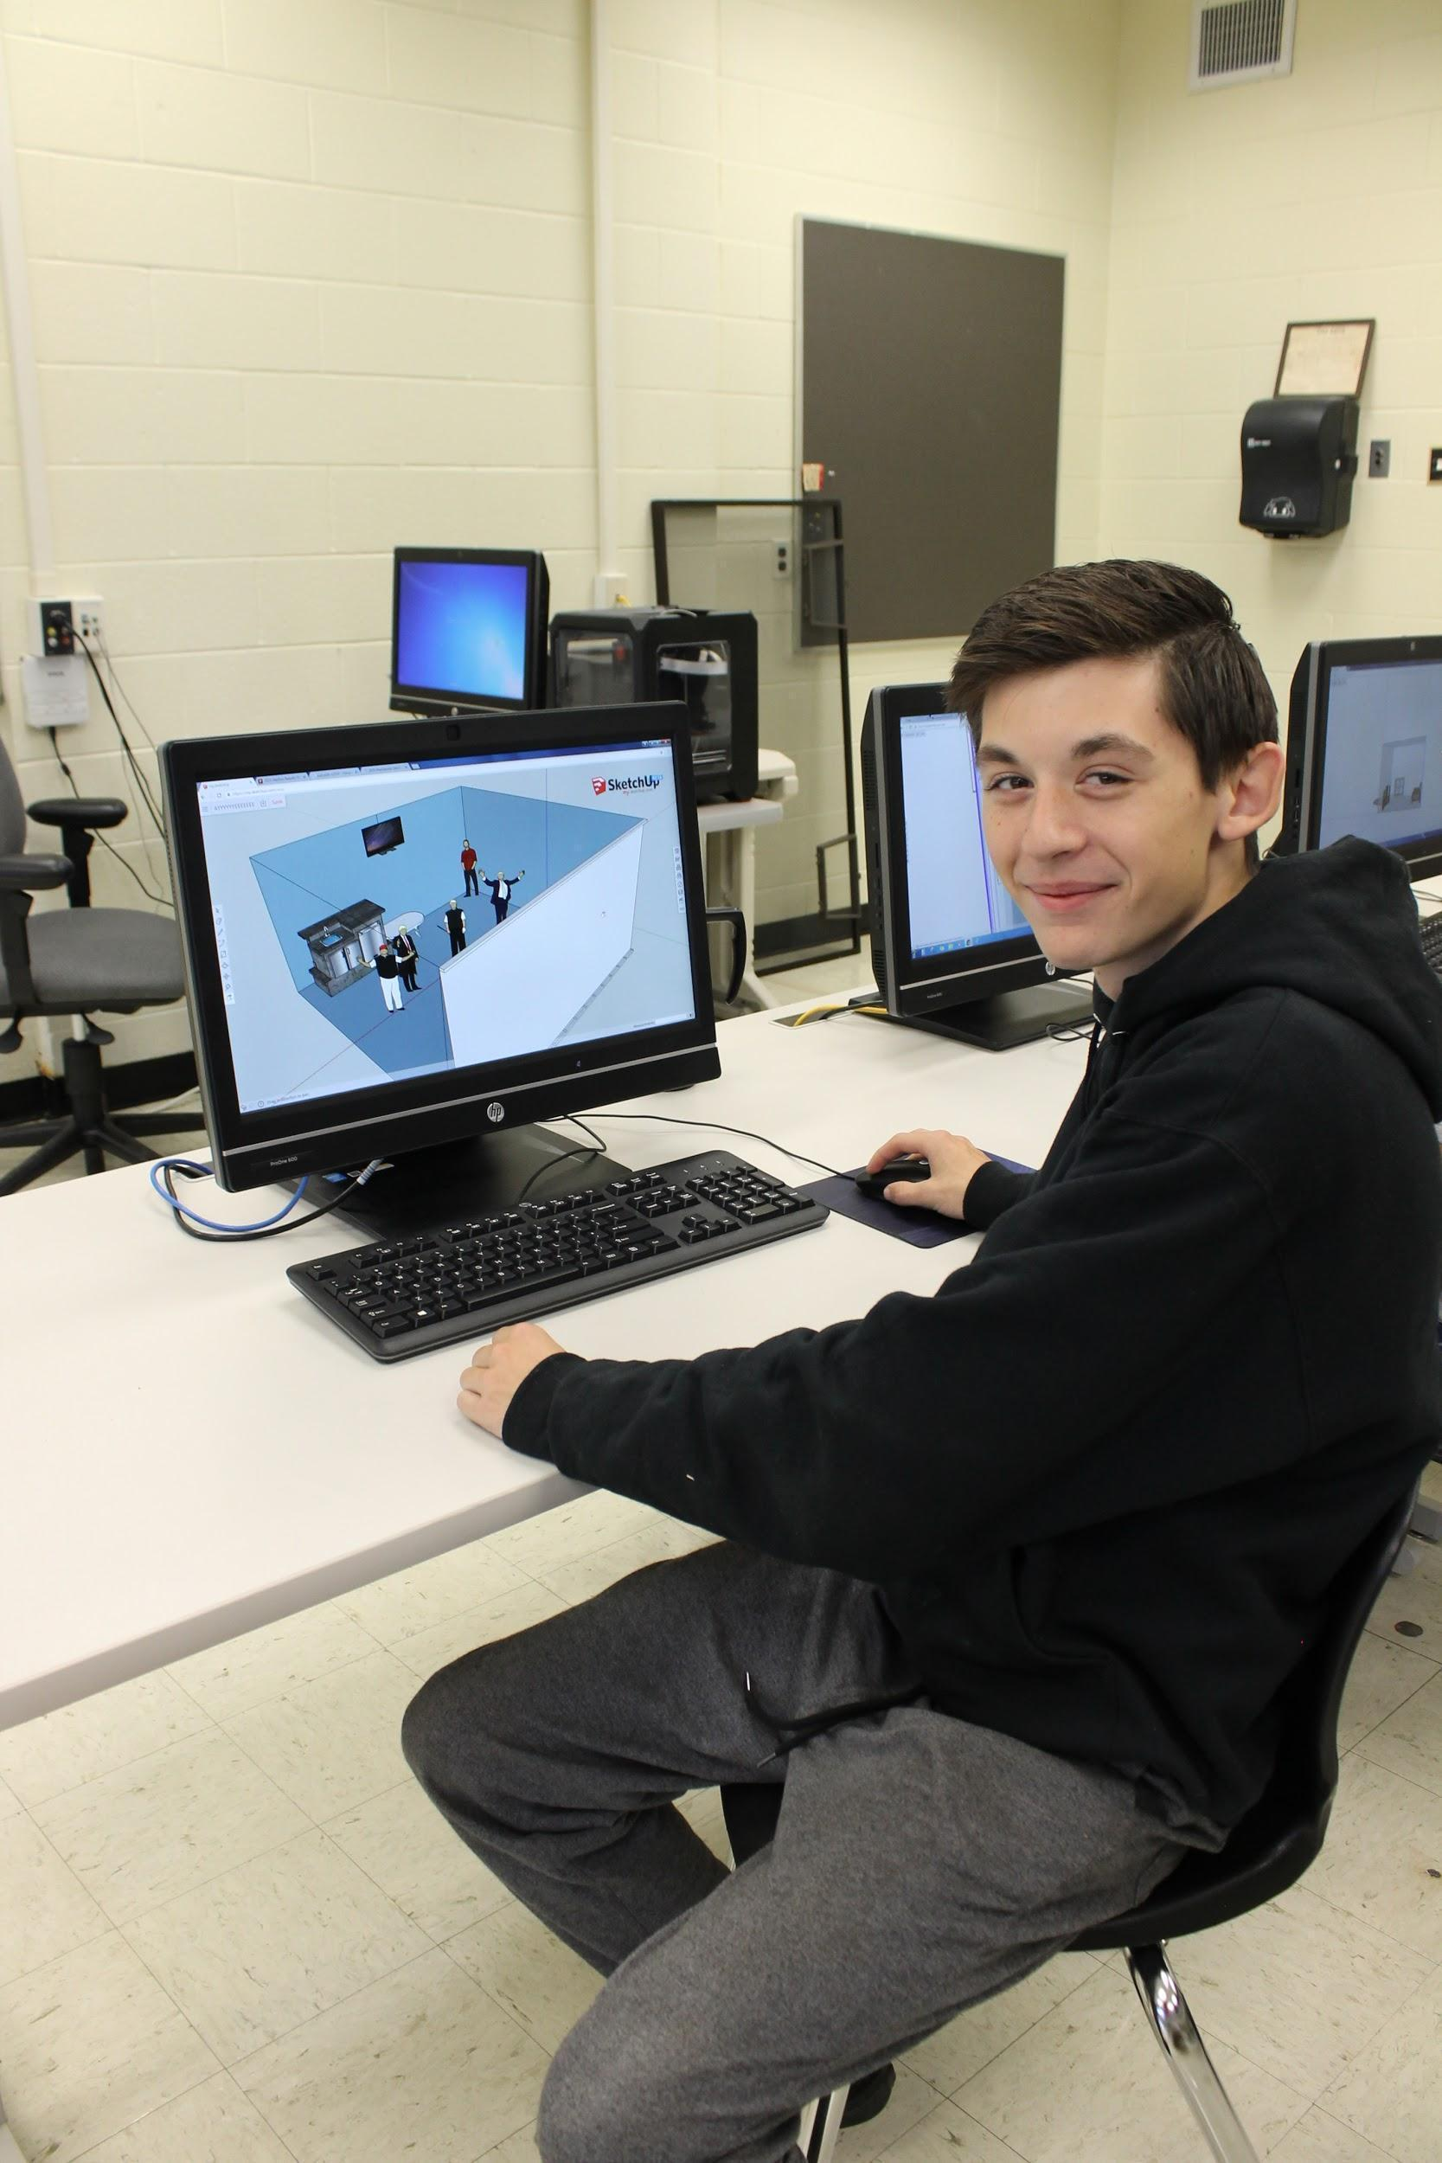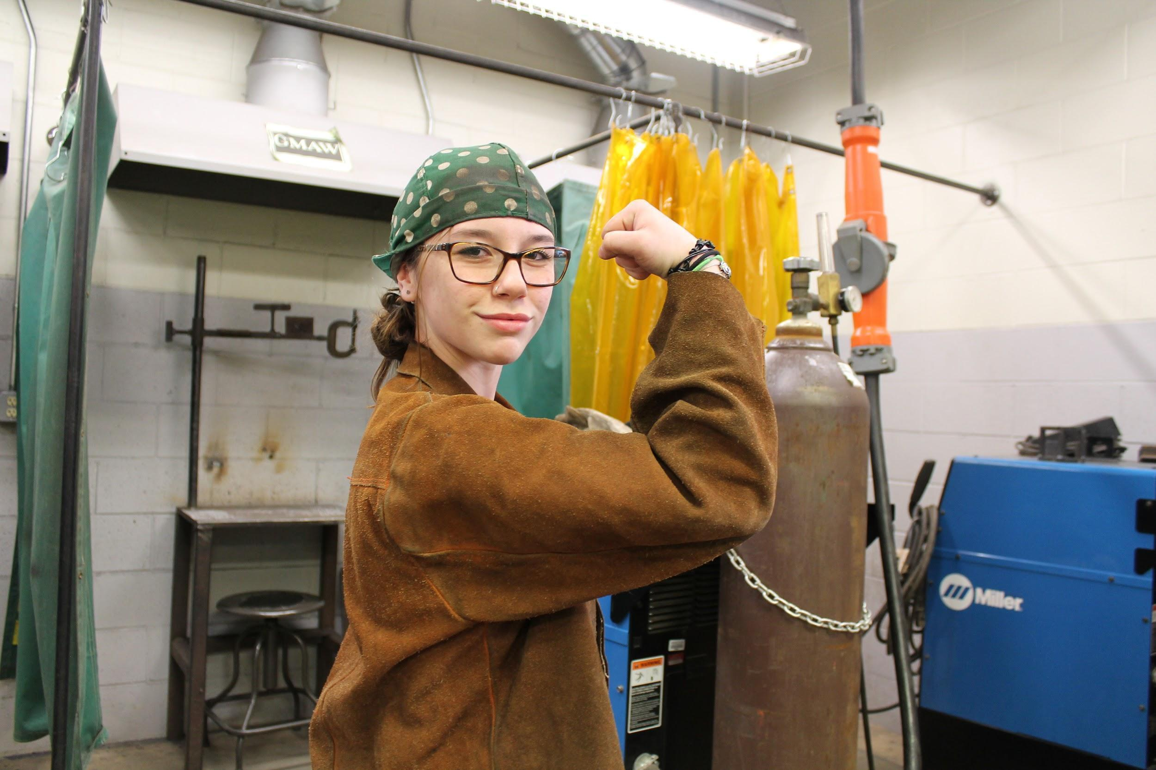

Carpentry

Year 1: Introduction to Carpentry & Building Trades

Course Description: Carpentry I is an introductory course in which students will begin to develop the basic skills needed to seek employment in this field. The first half of the year will be focused on teaching the students proper use of tools and shop safety precautions in order to construct a scale model of a house. As the year progresses the students will be involved in basic electrical circuits, basic cabinet work and basic masonry terms and techniques.

Year 2: Foundations of Carpentry & Building Trades

Course Description: As a second year course students will be expected to expand upon and perfect the skills that they learned in Introduction to Building Trades/Carpentry. Second year students will begin the year by reviewing safety techniques and then receive a set of plans for a four foot by five foot shed. Development of this shed to completion should take the students half way through the school year. The second half of the school year will be spent building interior walls, sheathing them and then installing drywall and taping them. The students will learn the correct method for installing windows and doors during the construction of these walls. By completing these different projects the students will be exposed to and develop a multitude of skills required in the industry.

Year 3: Carpentry & Building Trades – Advanced Concepts

Course Description: Third year students will begin the school year by showing mastery of the topics covered in the first two years of the course. In the first half of the school year students will develop more complex projects such as larger sheds, facility maintenance and other specialty tasks. As the year progresses the students will work with more advanced tools and materials in preparation for their impending employment.

Year 4: Carpentry & Building Trades – Advanced Concepts

Course Description: Fourth year students will be expected to seek employment in the field in coordination with our CIE department. If the student opts to attend his or her shop in the fourth year, they will expand upon and perfect the skills that they have learned in the previous three years. The students that stay in the program will be called upon to do advanced work and would be responsible for completion of these projects while acting in a lead position working with the younger students to assist them at the tasks required.

Electrical Construction

Year 1:
Electrical 1: First Semester: Electrical Fundamentals
Course Description: This program provides students with instruction in three core areas; safety, tools for the electrician, and electrical energy fundamentals. Topics covered in this course include working safely, workplace accidents and the causes, accident prevention and responses to an accident, and hazardous environments. Also includes electricity principles, basic electrical quantities, basic concepts of electricity, and industry mathematic principles and applications. Students demonstrate proper use of hand, power, and various measuring tools. Students perform low voltage electrical installations, proper wire connections, and related skills. Students practice all skills in a lab setting workstation on a workbench.

Electrical 1: Second Semester: Residential Electrical Installations
Course Description: This program provides students with instruction in various electrical installations and related skills, safety standards, tools and instrumentation, and terminology. Topics covered in this course include wiring systems, conductors, box assemblies, device wiring, overcurrent protection, and grounding. Also includes introduction to the National Electrical Codebook (NEC). Students perform standard single pole switch, three way switch, four way switch, duplex grounding receptacle, and lighting fixture installation. Installations are completed from rough in to trim out. Students practice all skills in a lab setting on a simulated residential sectional structure.

Year 2:
Electrical 2: First Semester: Alternating Current (AC) and Direct Current (DC) Principles
Course Description: This program provides students with instruction in the fundamentals of electricity. Topics covered in this course include voltage sources, resistance, Ohm’s and Watt’s law, AC/DC series and parallel circuits. Students perform various lighting and fan installations. Lighting fixtures include fluorescent, recessed, and suspended lighting fixtures. Fan installations include exhaust, paddle, and independently supported fan/light combination. Students also perform residential electrical work on existing structures (old work). This includes fishing wires through concealed walls, and mounting or replacing recessed boxes and fixtures. Also includes cutting, patching (tape and spackle), sanding, and painting sheetrock. Students practice all skills in a lab setting on a simulated residential sectional structure.

Electrical 2: Second Semester: Electrical Prints and Planning
Course Description: This program provides students with instruction in electrical print interpretation, specification, and layout. Topics covered in this course include various prints electricians may read, recognizing and using standard electrical symbols, branch circuits, feeders, and how to draw a circuit layout on a floor plan. Also includes implementation of NEC to construct circuit layout, maintenance, and troubleshooting circuits. Students perform various receptacle installations such as ground fault circuit interrupters (GFCI), switched duplex receptacles, split duplex receptacles, twenty ampere receptacles and special purpose receptacles. Also performed are fire protection system installations. Students practice all skills in a lab setting on a simulated residential full size structure.

Year 3:

Electrical 3: First Semester: Advanced Residential Electrical installations
Course Description: This program provides students with instruction in electrical calculation, planning, and installation of full residential circuits and related skills, safety standards, tools and instrumentation, and terminology. Topics in this course will cover National Fire Protection Agency (NFPA), Occupational Safety and Health Administration (OSHA), International association of Electrical Inspectors (IAEI), and various testing agencies. Also includes electrical theory, industry mathematics, interpretation and implementation of the NEC, electrical prints, and schematics, calculating and balancing service loads, and skills to produce a quality job estimate or quote. Students perform installation of meter pan and service panel, construct and install circuit layouts for kitchen, bathroom, and other various full room circuits. Students practice all skills in a lab setting on a simulated residential full size structure.
Electrical 3: Second Semester: Commercial Appliances
Course Description: This program provides students with instruction in various commercial wiring installations. Topics include commercial methods of safety, tools and terminology, wiring methods, conductors, box assemblies, conduit bodies, and overcurrent protection. Also includes transformers (single and three phase), delta and wye connections, and grounding methods. Students perform complex switch and lighting circuit installations using metallic armored cable systems (BX/MC), Polyvinyl Chloride (PVC) and Electrical Metallic Tubing (EMT) bending (using hot boxes and hand benders), Rigid Metal Conduit (RMC) bending (using a hydraulic bender). Students practice all skills in a lab setting on a simulated commercial full size structure or commercial trainer.

Year 4:

Electrical 4: First Semester: Industrial Applications
Course Description: This program provides students with instruction in industrial electrical installations. Topics include motors (single phase and three phase), emergency and standby systems, magnetic motor starters, and motor control systems. Also includes advanced electrical theory (complex and inductive-resistive-capacitive circuits), interpretation of line and ladder diagrams, control logic and devices, Programmable Controllers (PLC). Students perform various motor control installations using NEMA magnetic motor starters and control devices. Students practice all skills in a lab setting on a simulated industrial trainer.
Electrical 4: Second Semester: Self Directed Learning Format
Course Description: This program provides students with the primary responsibility for planning, implementing, and evaluating their learning process. Students choose a topic or combination of topics, either not covered previously or not covered in depth during the course, and explores the topic thoroughly. Topics may include entrepreneurship (economic systems and starting a business), alternative energy, utility work, media or communications, career or continued education exploration, portfolio development, or any other desired electrical trades related area. Students research their topic and develop a project designed to enhance and demonstrate their knowledge of the subject (example: build a functioning windmill). Students practice all skills in a lab setting in a career simulated area.

Plumbing Technology

Year 1: Introduction to Plumbing

Course Description: Plumbing 1 is an introductory class in which students will begin to learn the basic skills that they can apply to become plumbers. First year plumbing students will begin by learning about plumbing history, tool names and purposes, possible career paths, and shop safety. As the school year develops, students will develop competencies and proficiencies in making pipe measurements, pipe threading, cutting pipe, reamers and soldering.

Year 2: Foundations of Plumbing
Course Description: As a second year course students will be expected to expand upon and perfect the skills that they learned in Introduction to Plumbing. Second year students will begin the year by learning about proper tool care and maintenance, how to choose the right tools and materials for a job, and the use of pipe machines. As the school year develops, students will develop competencies and proficiencies in working with copper, steel, cast iron, a variety of plastic pipe and fittings, flaring, bending pipe, caulking, pipe layout, fabrication, and pipe and fitting installation.
Year 3: Plumbing – Advanced Concepts
Course Description: Third year students will begin the school year by showing mastery of the topics covered in the first two years of the course. Third year students will begin the year learning the plumbing systems including portable water, sanitary drainage waste & vents, and storm drainage systems. Students will also work on tankless on demand gas fired domestic water heaters and sealed combustion residential gas fired domestic hot water heaters. As the school year develops, students will develop competencies and proficiencies in installing plumbing fixtures and appliances in kitchens and bathrooms along with gaining basic knowledge of heating, ventilation, and air conditioning systems.

Year 4: Plumbing - Advanced Theory and Independent Study

Course Description: Fourth year students will be expected to expand upon and perfect the skills that they have learned in the previous three years. As the school year develops, students will develop competencies and proficiencies in repair work, soil and waste system installation, private disposal system installation, gas fired hot water heating boilers, gas fired steam heating boilers and the National Standard Plumbing Code. Students will also be provided with more practical and theoretical knowledge of what they have learned by going to work at local companies within the surrounding community, heating ventilation, and air conditioning systems. In addition, the CIE (Cooperative Industrial Education) program provides students with opportunities to leave the classroom and put into practice what they learned.

STUDENTS WILL BE REQUIRED TO :
Follow multi-step directions
Perform basic math operations
Calculate precise measurements using fractions and decimals
Initiate tasks independently
Work collaboratively
Welding Technology

Year 1: Introduction to Welding
Course Description: Welding 1 is an introductory class in which students will learn the basic skills that they can apply to become welders. First year students will begin the course by learning about the history of welding and program safety regulations (AWS safety in welding and cutting). Next, students will learn the basics of electrical current (as it applies to welding) and the AWS designated Shielded Metal Arc Welding Electrode identification method. They will learn the when’s, where’s, and why’s of Electrode selection, and how to use them. As the school year progresses, students will develop competencies and proficiencies in basic Shielded Metal Arc welding(SMAW in Flat, horizontal, and vertical positions) oxy-acetylene and plasma cutting, Gas Metal Arc Welding(flat, horizontal, and vertical positions) in a variety of metals(carbon steel, aluminum, and stainless steel). They will also learn the “Five Basic Joints”, the basics of welder’s math, weld symbols, rudimentary metallurgy, and basic blueprint reading. First year students will also be exposed to, and encouraged to join, the American Welding Society.

Year 2: Foundations of Welding I
Course Description: In the course of their second year, students will be expected to expand upon and perfect the skills that they learned in their first year. The second year introduces more difficult tasks such as vertical up welding with the SMAW and GMAW processes. Also students will learn the more challenging tasks of: overhead welding with four different types of SMAW electrodes and overhead welding with GMAW in a variety of wires. They will then learn the basics of GTAW (formerly known as TIG), first on aluminum, then carbon steel, and finally on stainless steel in various joint configurations. Second year students are now ready to compete in welding contests. Their first competition will be the Somerset County in-house Skills USA Welding contest. The winner will go onto compete at the state level in May. Students will also learn basic metal fabricating techniques, how to do a basic job breakdown, cut lists, and beginning cost estimation of metal products.

Year 3: Foundations of Welding II and Career Exploration:
Course Description: Third year students will begin the year in review of the previous two years experiences and then proceed to the more difficult and challenging aspects of welding, welding theory, and fabrication. They will begin to pay more attention to job possibilities and career opportunities, both local and afar, and give consideration to specializing in one of the various processes with an eye to a particular industry. Students will go on field trips to potential employers, schools such as the Divers Academy, and various Trade Union Training centers, such as the Ironworkers, Pipefitters, Operating Engineers, and Sheet Metal Workers. They will learn intermediate fabrication techniques and the set up and operation of all the shops fabricating machinery and tools. Students will be expected to hone their welding skills in the various processes, materials, positions, and joints. The welding of thin material (less than 1/8”) will be emphasized on all materials and processes, and they will be introduced to pipe welding in the 1G and 2G positions on carbon steel.

Year 4: Advanced Welding Concepts:
Course Description: Fourth year students will be expected to be able to interpret all technical sketches brought to them, to troubleshoot and facilitate most welding repairs brought into the vocational setting on any material, and to determine the “best practice” for any repair or fabrication. They will learn “mass production” techniques, jig and fixture making, and “tricks of the trade” to speed up and/or improve their productivity. In addition, fourth year students will work in conjunction with outside agencies by completing public service projects within our local communities, working on their competencies and proficiencies, and fine tuning the welding processes already learned. Students in Advanced Welding Concepts will practice the very difficult 3G plate weld, and 5G and 6G pipe weld test joints on steel and aluminum using the SMAW, GMAW, and GTAW processes. The welding of Cast Iron with Ni-rod (SMAW) and Oxy-Fuel Brazing will also be demonstrated and practiced.

Arts, A/V Technology, and Communications

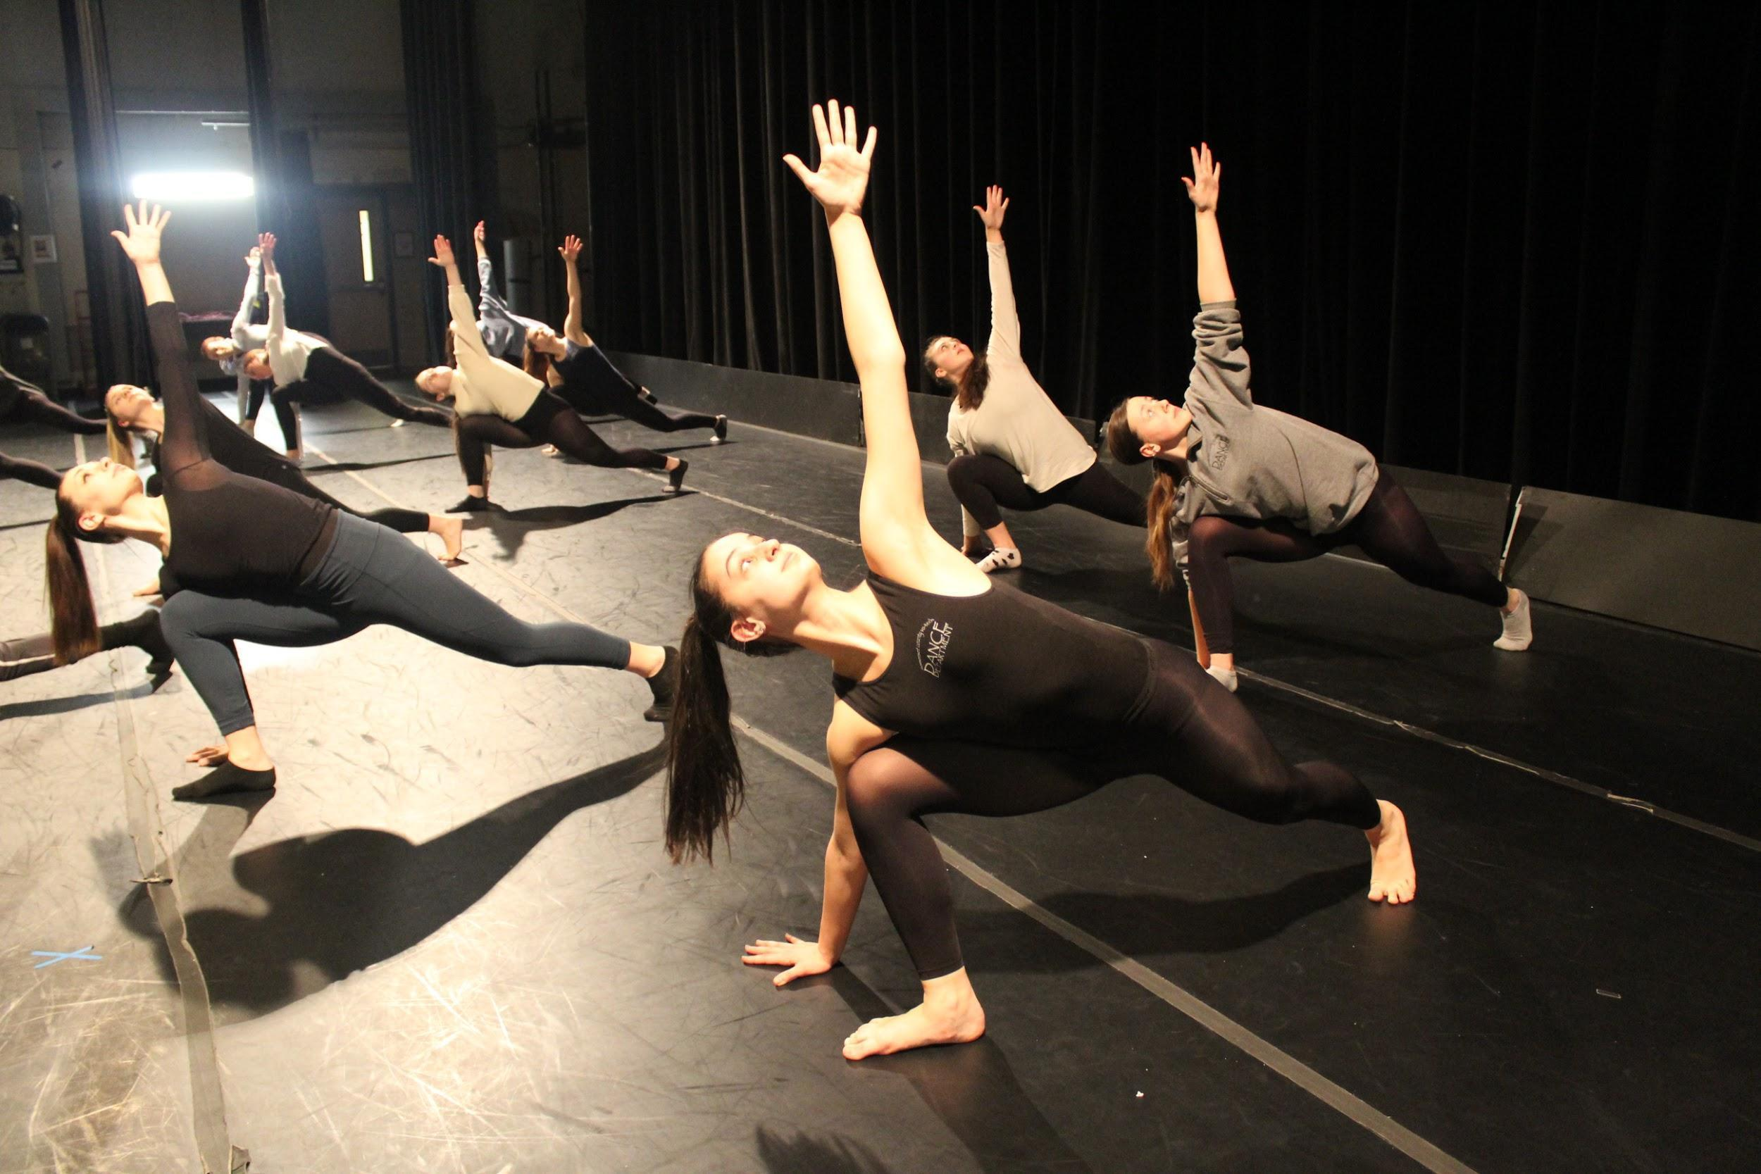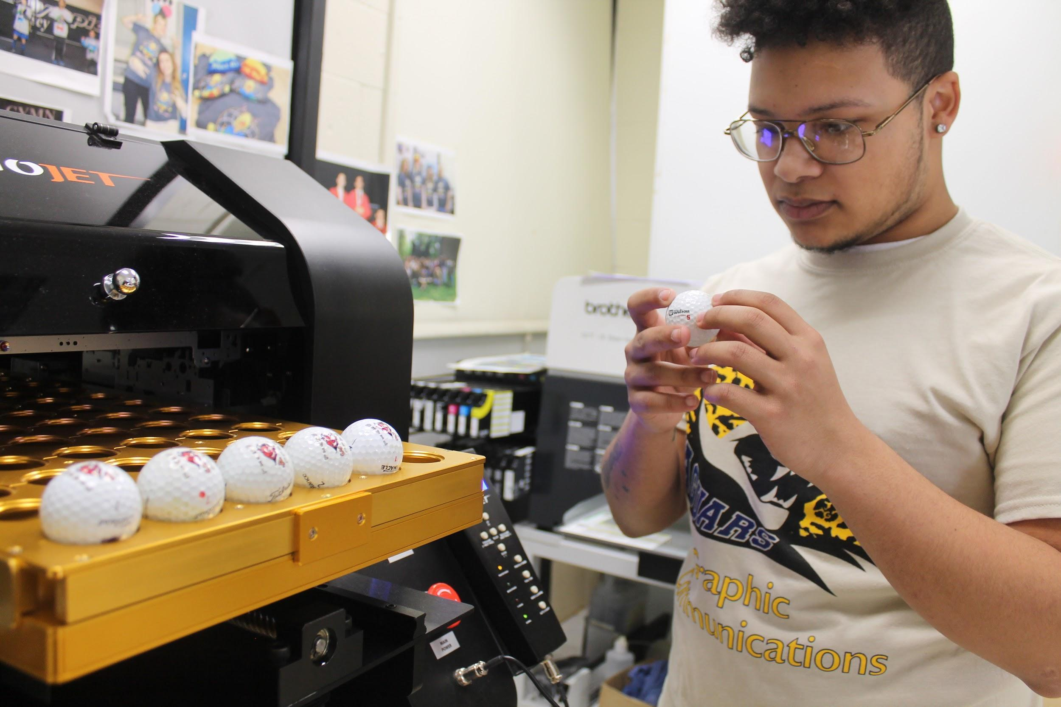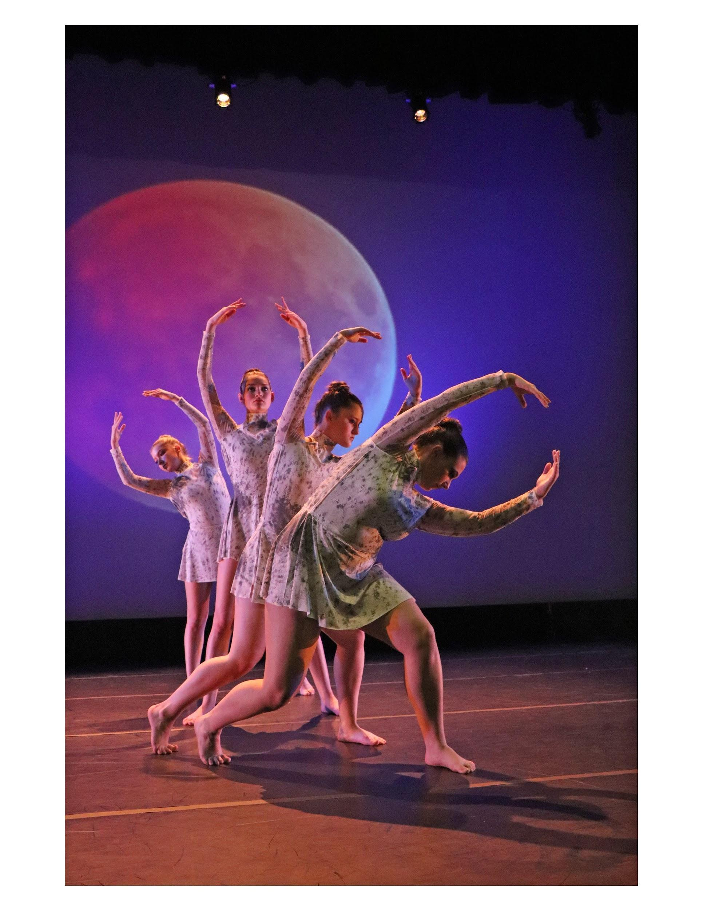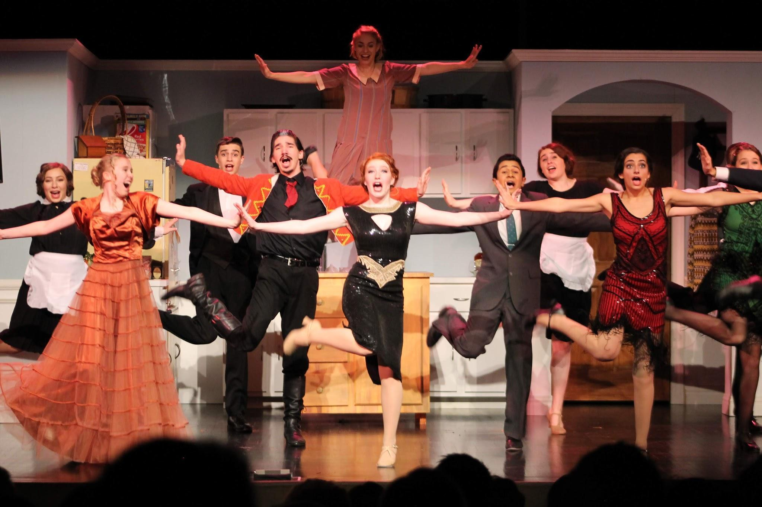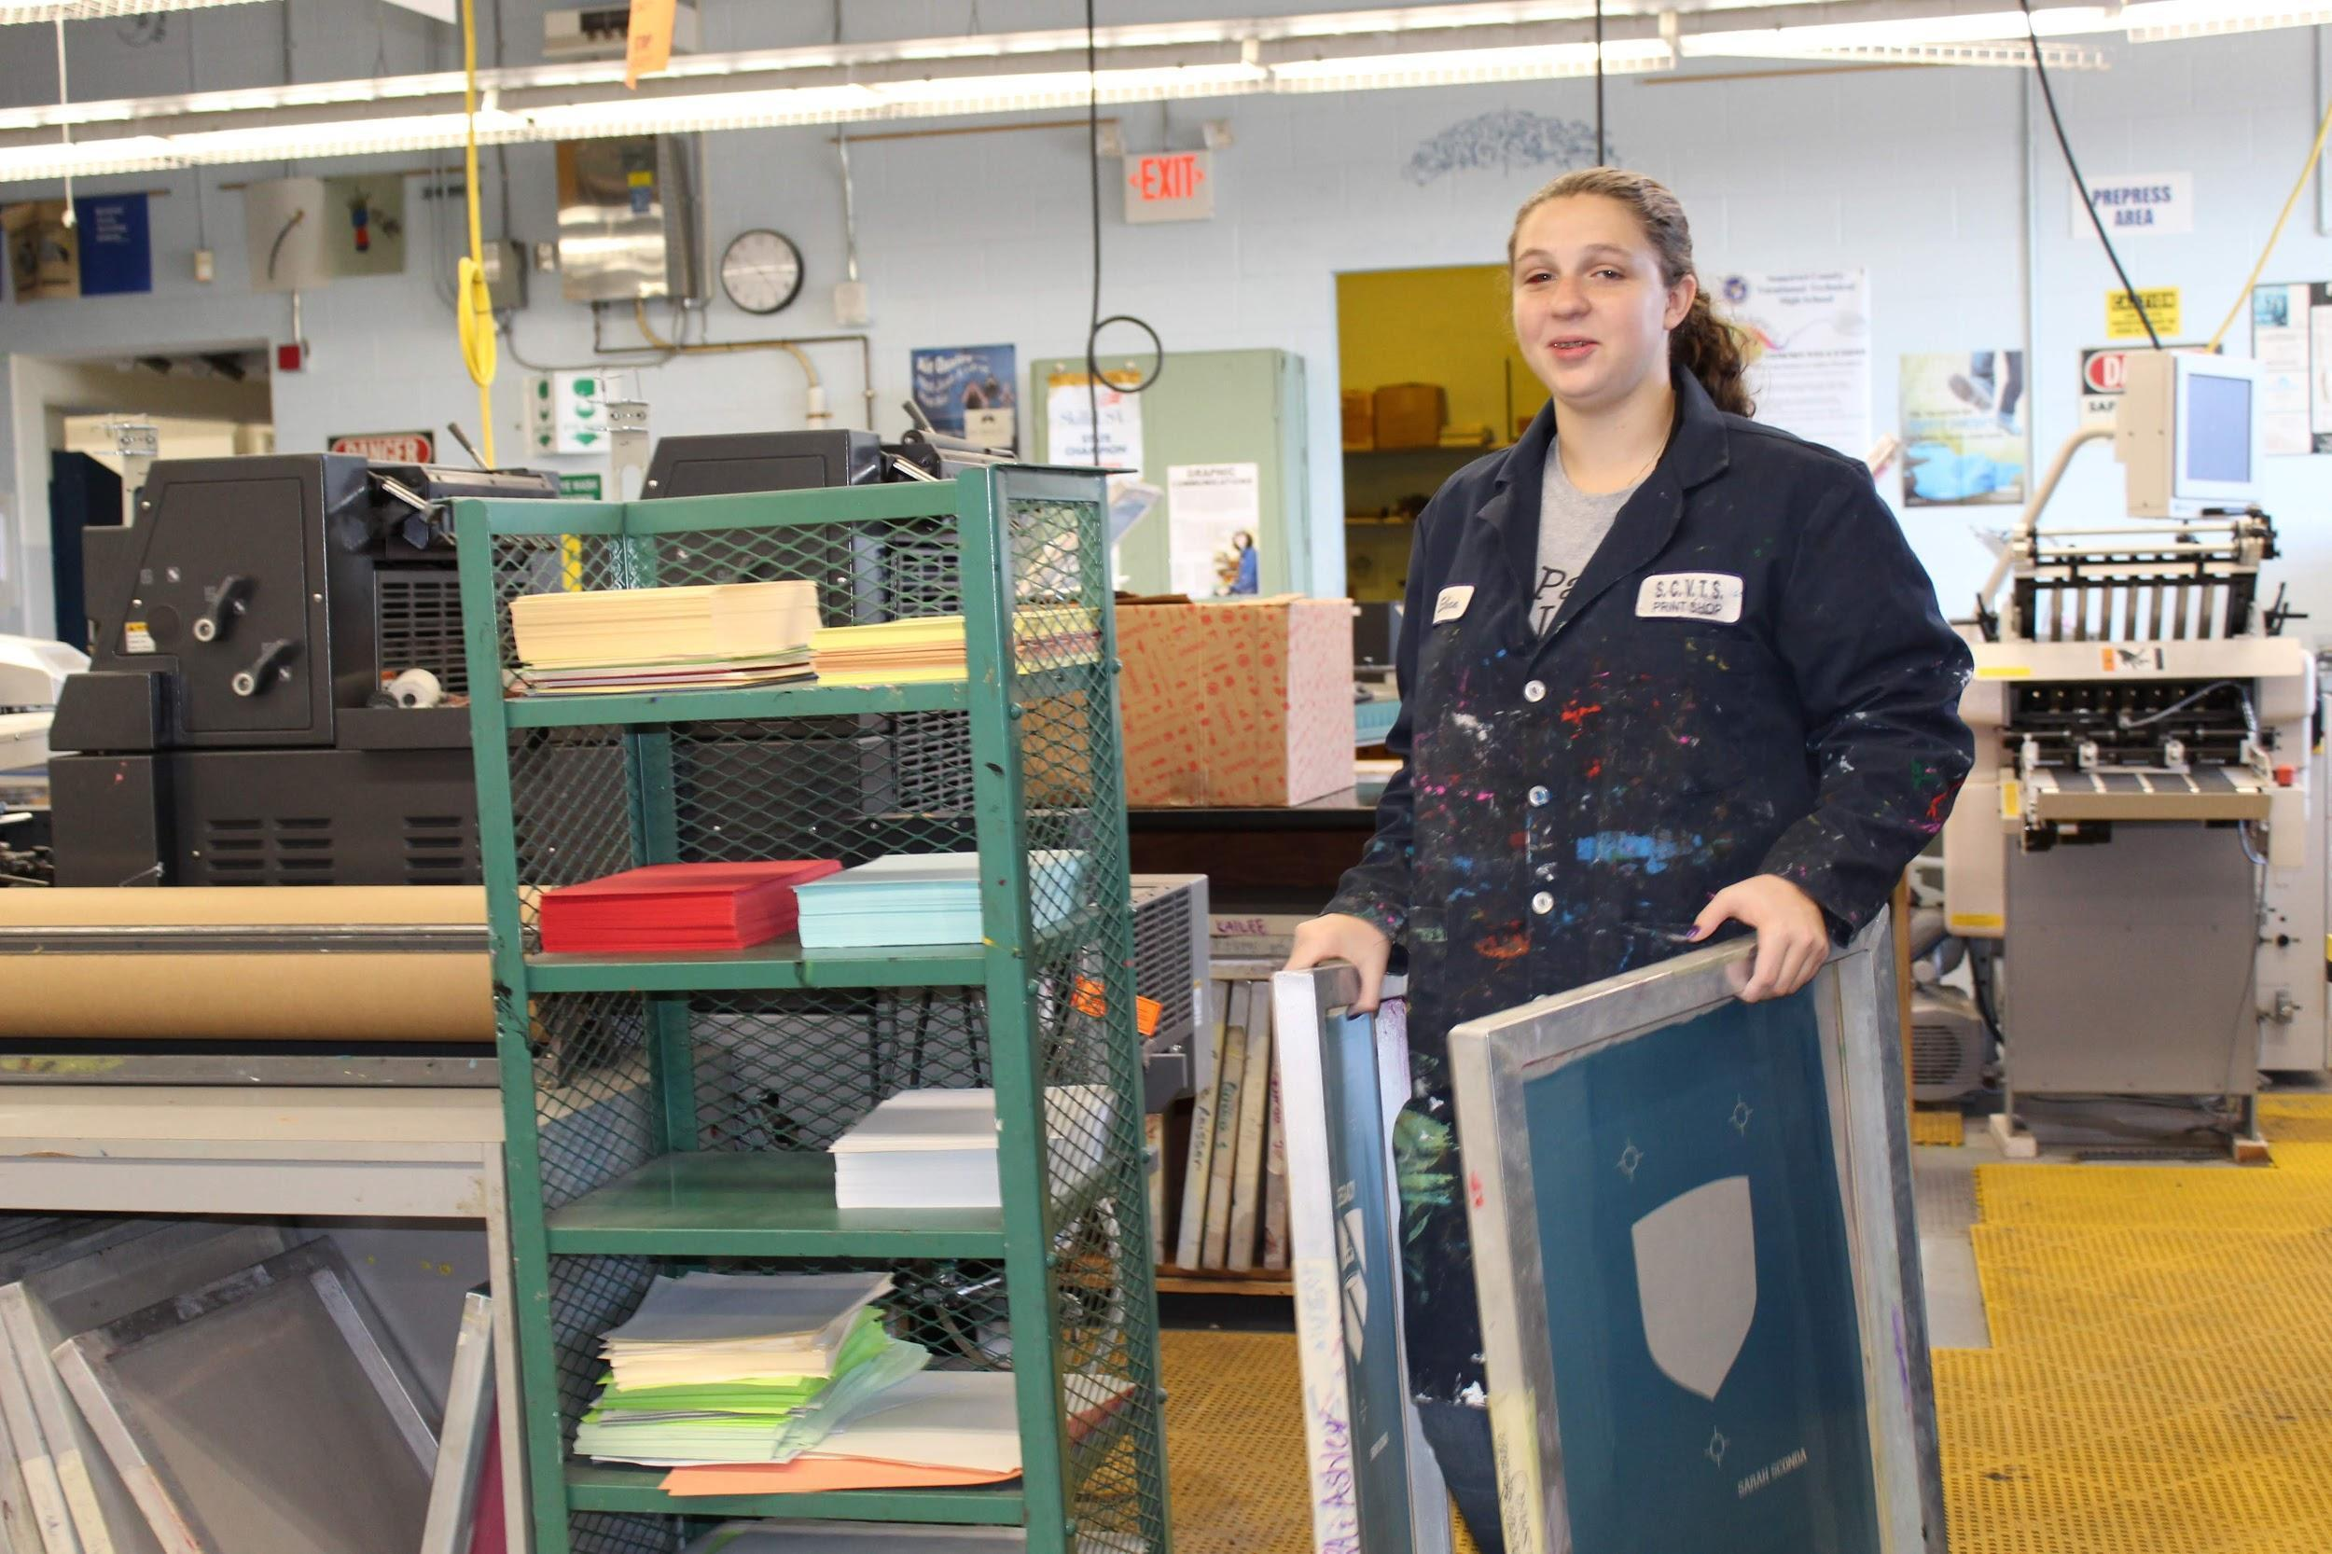

GIFTED AND TALENTED PERFORMING ARTS DEPARTMENT

Dance Program
12.25 Honors Credit 3.75 Physical Education Credit 1.25 Health Credit

Year 1: Fundamental Development of Dance Technique

Course Description: Beginning level classes focusing on creating a foundation of dance technique. First year students will be introduced to dance fundamentals such as basic terminology, correct alignment, time, space, energy/force and shape. As the year progresses, students will develop fundamental competencies and proficiencies in the basic techniques of Ballet, Modern, Tap, and Jazz dance. First year students take supporting classes in, Improvisation, Rhythm, World Dance, Introduction to Anatomy, and Technical Theater.
- The Health component: Virtual Health I 1.25 credits

Year 2: Integration of Dance Technique

Course Description: The second year of training is a continuation of dance training in Ballet, Modern, Tap and Jazz dance technique. Second year students will also be introduced to the dance pedagogy. As the year progresses, students will develop a strong technical foundation beginner/intermediate Ballet, Modern, Tap, and Jazz techniques. Second year students who are in Level II have the opportunity to study Teaching Methods and participate in an in house internship called Little Steps. Teaching methods will be integrated into their technique classes to assist the students to prepare for a possible career in teaching dance. Second year students take supporting classes in Improvisation, Rhythm, Ballet History, and Composition I.
- Drivers Education is offered as the Health component for 1.25 credits.

Year 3: Expression and Dance Technique

Course Description: In the third year, dance classes focus building on the strong technical foundation that has been built from the two previous years and the exploration of expression and artistic voice into the students work. The third year student is expected to be able to focus on developing the individual artistic voice and perform with clear phrasing and accurate sequencing. Students are expected to continue to perfect the technical skills that they learned in the first two years. Third year students develop their creativity and imagination in the Composition and Choreography units.
Third year students take supporting classes in Improvisation, Ballet and Modern Dance History and Composition II, Lighting and Choreography.
- The Health component: Virtual Health III for 1.25 credits.

Year 4: Emerging Artist Training and Career Development

The fourth year dance student is expected to have mastered the Level II dance technique requirements and have a clear understanding of executing movement with dynamic alignment, correct technique and artistic interpretation. Fourth year students develop their creativity and imagination in the Composition and Choreography units. Fourth year students take supporting classes in Improvisation, Ballet and Modern Dance History and Composition II, Lighting and Choreography. All senior students are advised in BFA or BA dance programs in universities.
The Health component: Virtual Health IV for 1.25 credits.

GIFTED AND TALENTED PERFORMING ARTS DEPARTMENT

12.25 HONORS ARTS CREDITS ANNUALLY 3.75 Physical Education Credits Annually 1.25 Health Credit (online course)
Theater Arts

Year 1: Foundations of Theater
12.25 HONORS ARTS CREDITS ANNUALLY (7.25 for 21st Century Skills and 5 for Fine Arts)
3.75 Physical Education Credits Annually
1.25 Health Credit (online course)
Course Description: First-year students begin to develop the skills and abilities needed for a successful career in the performing arts, including the varied acting styles of improvisation and ensemble work, and an introduction to the more specific techniques of Chekhov and Meisner. Students also experience essential elements of voice & diction, movement, script analysis, theater history, theater criticism, and technical theater. As the year progresses, students will develop competencies and proficiencies in using the entire “actor’s Instrument” of body, voice, and emotional life while challenging each student to discover the nuances of compelling creative expression. Select students who track with a vocal music emphasis also experience elements of dance, as well as the application of the correct vocal production elements, including posture, breath, placement, and care of the singing voice. First-year students serve on the tech crew for the November mainstage production and in June perform in a one-night informal demonstration of classwork in progress.

The Health I online class is a separate component, which receives 1.25 credits.

Year 2: Intermediate Applications and Technique
12.25 HONORS ARTS CREDIT ANNUALLY
3.75 Physical Education Credits Annually
1.25 Health Credit (online course)

Course Description: Second-year students will expand upon the skills they learned in Foundations of Theater, developing intermediate to advanced techniques in crafting, emotional preparation, and analysis. As the year progresses, students will develop competencies and proficiencies in characterization, projection, articulation, and truthful stage behavior.
Students continue to experience essential elements of voice & diction, movement, script analysis, theater history, theater criticism, and technical theater. Students will further develop competencies and proficiencies in using the entire actor’s instrument of the body, voice, and emotional life while challenged to discover the nuances of compelling creative expression. Students will begin to comprehend concepts of character portrayal, presence on stage, rhythm, shape, space, and motion as it pertains to the actor. Students further develop elements of voice & diction, movement, script analysis, theater history, theater criticism, and technical theater. Select students who track with a vocal music emphasis also experience elements of dance, as well as the application of the correct vocal production elements, including posture, breath, placement, and care of the singing voice. Second-year students may perform in the November main-stage production or serve on the tech crew if selected.

An on-site drivers education class is a separate Health II component, which receives an additional 1.25 credits.

Year 3: Introduction to Performance
12.25 HONORS ARTS CREDIT ANNUALLY
3.75 Physical Education Credits Annually
1.25 Health Credit (online course)

Course Description: Third-year students will expand upon and hone the skills they learned in the previous two years and develop advanced techniques in crafting, emotional preparation, and analysis. As the year progresses, students will develop competencies and proficiencies in characterization, projection, articulation, and truthful stage behavior. Students further develop elements of voice & diction, movement, script analysis, theater history, theater criticism, and technical theater. Also, they will be introduced to concepts of playwriting, directing, and audition techniques. Students will work on methods for further enhancing their projection, breath control, and articulation. As the school year progresses, students will develop competencies and proficiencies in character portrayal, presence on stage, and understanding rhythm, shape, space, and motion as it pertains to the actor. Select students who track with a vocal music emphasis also experience elements of dance, as well as the application of the correct vocal production elements, including posture, breath, placement, and care of the singing voice. Additional opportunities exist for interested students to explore independent projects in stage management, assistant director, and other related areas of performance. Third-year students may perform in the November main-stage production or serve on the tech crew if selected.

The Health III online class is a separate component that receives 1.25 credits.

Year 4: Advanced Performance and Audition Preparation
12.25 HONORS ARTS CREDIT ANNUALLY (12.25 for 21st Century Skills)
3.75 Physical Education Credits Annually
1.25 Health Credit (online course)

Course Description: Fourth-year students will expand upon and polish the skills they have learned in the previous three years and demonstrate advanced techniques in crafting, emotional preparation, and analysis. Students will also demonstrate competencies and proficiencies in characterization, projection, articulation, and truthful stage behavior finely attuned to elements of voice & diction and movement. They will further develop proficiency in music vocals, playwriting, and directing, with a particular emphasis on developing advanced skill in audition technique in preparation for the required monologue, cold reading and writing portions of the senior exit exam required by the New Jersey Department of Education as well as college entrance audition requirements for those choosing to pursue a bachelor of fine arts degree in acting. Select students who track with a vocal music emphasis also experience elements of dance, as well as the application of the correct vocal production elements, including posture, breath, placement, and care of the singing voice. Additional opportunities exist for interested students to explore independent projects in stage management, assistant director, and other related areas of performance. Fourth-year students may perform in the November mainstage production or serve on the tech crew if selected.

The Health III online class is a separate component that receives 1.25 credits.

Graphic Communications

This is a four-year program, which combines Graphic Design and Printing skills. Students obtain skills in both the Graphic Design and the Print Shop classroom. The goal of the program is for students to gain the skills to do live work in the PawPrints production shop and or go out to work their senior year. Students who also go through this program for the four years gain 5 credits for Visual and Performing Arts mandated by the state. Safety is included in ALL 4 years.

Year 1: Foundations of Graphic Communications
Course Description: First year students will learn about the history of the graphic communication industry, safety issues associated with this career and possible career paths. Students will learn how to use Adobe Illustrator and Photoshop and will be able to apply basic color information to the print area. A concentration on color separations, CMYK, and spot colors are highlighted. Students will also learn basic typography and design elements, the color wheel, primary, secondary and tertiary colors. Students will be able to demonstrate competencies and proficiencies in basic screen printing, digital press, computer skills and color registration techniques.

Year 2: Graphic Communications -Design & Printing
Course Description: Students are educated in the use of programs Adobe Illustrator, Photoshop and InDesign. An emphasis is placed on learning file formats. Students are introduced to Adobe InDesign page layout techniques and concepts. Basic design rules are created in logo design, package design, and t-shirt design. Students apply these skills to the print areas by developing basic proficiencies in digital color output, press operations, press maintenance, computer to film technology, bindery and finishing operations. Students are introduced to large format printing & sublimation printing.

Year 3: Graphic Communications -Design & Printing
Course Description: Students will develop advanced skills in Adobe Illustrator, Photoshop and InDesign. Students create booklets, pamphlets, editorial spreads, invitations and other layout and design projects. Students will apply these skills to the print areas by developing advanced competencies in automatic screen, offset, and sublimation skills, 2-4 color spot & process printing, ink mixing, press maintenance, digital color output, bindery and finishing operations. A production unit is embedded within the course that allows students to learn how to log work in, manage the workflow, meet with clients, and develop estimating and employment skills. Students begin training and working in the PawPrints shop which allows them to work with clients and school staff along with local businesses.

Year 4: Advanced Graphic Communication Concepts
Course Description: Fourth year students will be expected to expand upon and perfect the skills they have learned in the previous three years. Students work only within the shop of PawPrints. Students work individually creating designs & printing designs on T-Shirts, banners, signs, brochures, posters, sublimation products, tickets as assigned. Students will be expected to apply all of the skills that they have learned in a production shop. They will meet with clients to produce a product from the beginning design process through the printing process while working on their employment and customer service skills. Students also learn about time management, billing and record keeping as needed in a live shop. Students also will be able to create both a digital and hard copy portfolio in which they can present their skills for college admission.

Business, Entrepreneurship and Management

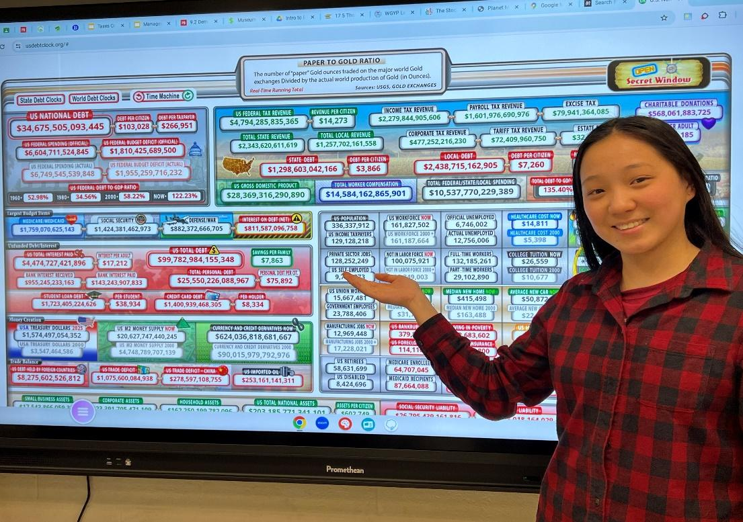

Business Entrepreneurship and Management

Years 1 and 2: Principles of Marketing and Principles of Management
Course Description – Principles of Marketing: examines the process involved in creating goods and services to satisfy consumer wants and needs, including planning, pricing, promotion, and distribution of goods and services. It relates marketing to the larger environment and covers a range of topics including consumer behavior, global marketing, and ethics/social responsibility.
Students are eligible to take the College Board’s College-Level Examination Program® (CLEP) Principles of Marketing exam. More information on the exam can be found here.
Course Description – Principles of Management: This course is a study of the basic theories and concepts of management and their application. The course content is organized around the functions of management; planning, organizing, leading, and controlling. The course is designed to prepare students to successfully manage in a changing business environment.
Students are eligible to take the College Board’s College-Level Examination Program® (CLEP) Principles of Management exam. More information on the exam can be found here.

Years 3 and 4: Introduction to Business and Small Business Management
Course Description – Introduction to Business: Intro to Business examines the fundamental aspects of the business community. Emphasis is placed on business functions as they apply to current business practices. Current events comprise the framework for topic development and class assignments.
Intro to Business is a foundation course. This course provides students with a broad business background covering economics, accounting, finance, marketing, and management, within a global context. As such it sets the foundation for all advanced study of business principles. It is offered as a dual enrollment course with Raritan Valley Community College (RVCC).
Intro to Business includes elements from the Financial Literacy course, which satisfies the Financial Literacy course requirements needed for graduation.
Course Description – Small Business Management: This course is designed to acquaint the enterprising individual with the education and tools necessary to operate and manage a small business. The course material will include such topics as management functions with emphasis on the control function. Methodologies in such functional areas as finance, marketing and management will be discussed and will constitute the parameters of the course. It is offered as a dual enrollment course with Raritan Valley Community College (RVCC).

Health Science

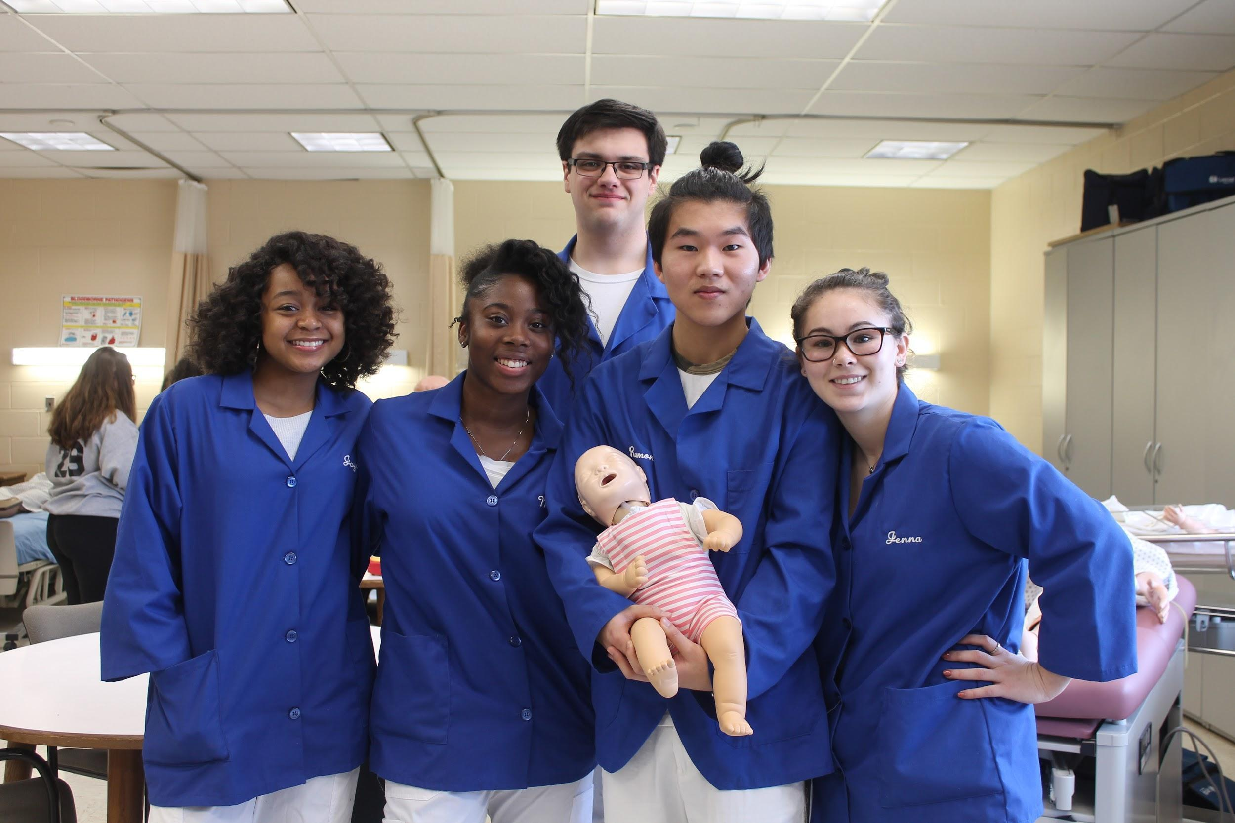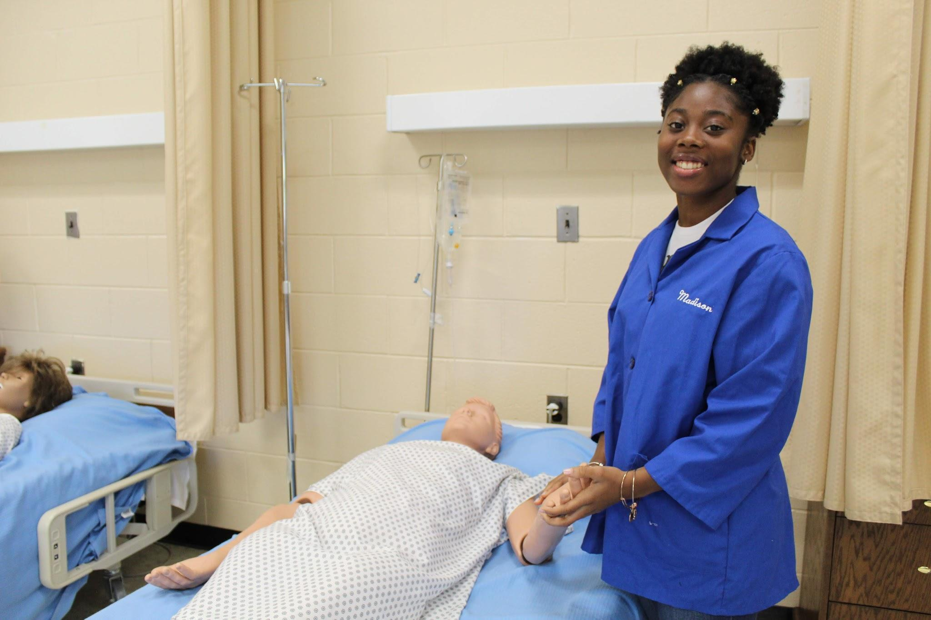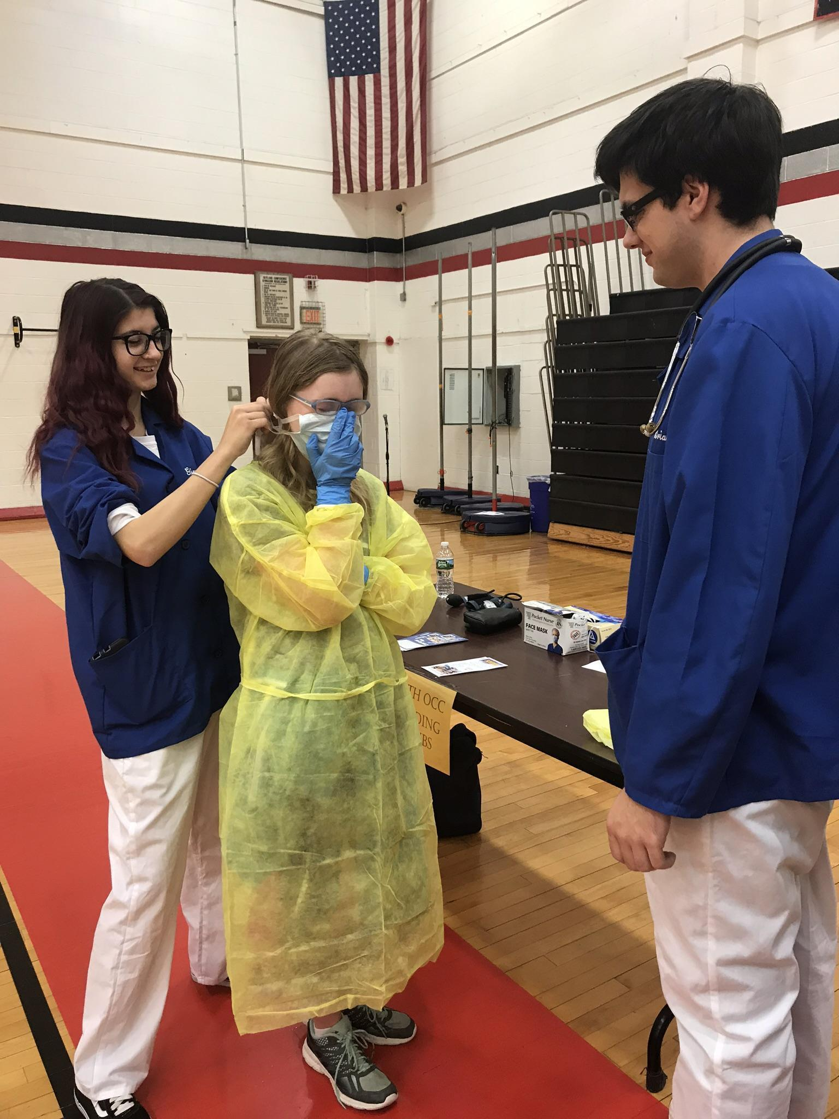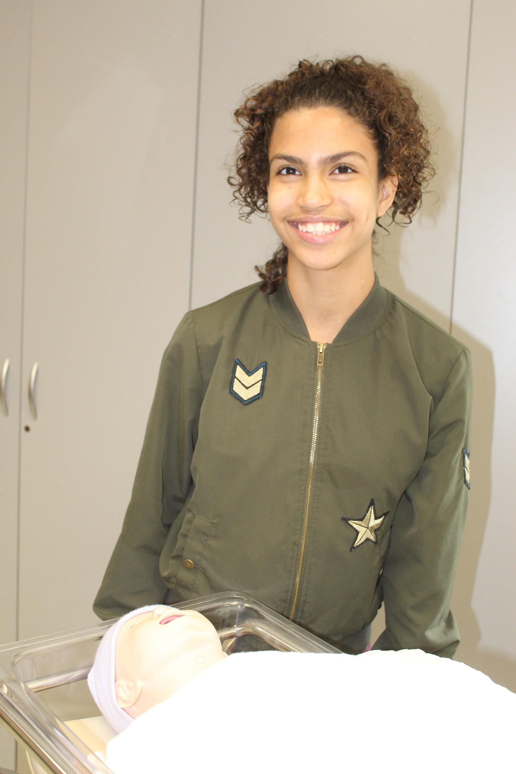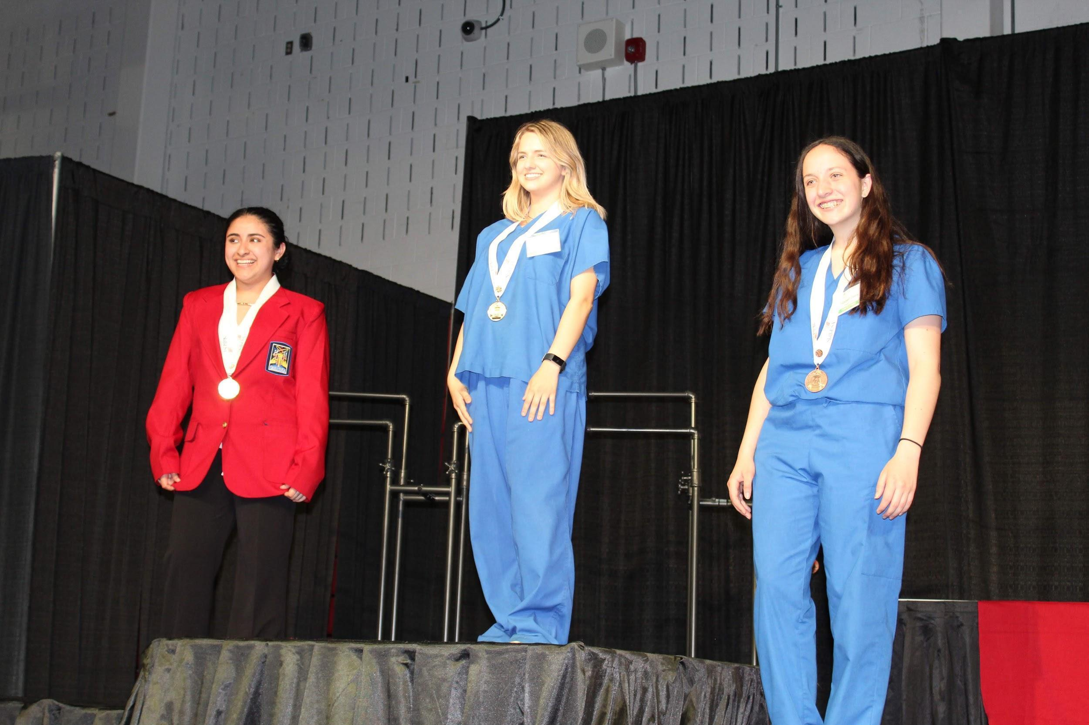

Health Occupations

Year 1: Introduction to Allied Health and Clinical Skills
Course Description: Introduction to Health Care Theory and Practice is an introductory course designed to expose students to the many opportunities available to them in the healthcare industry. Basic health assisting skills are taught in the classroom lab including infection control practices, universal precautions, proper body mechanics, lifting and moving patients, assessing vital signs (temperature, pulse, blood pressure and respirations), measuring height and weight, and the use of medical equipment. Emphasis is placed on learning about the various health careers and understanding their professional responsibilities and educational requirements. Using this process, students will identify personal career interests and fields of study they may wish to pursue. All first year Health Occupation students will receive training and certification in first aid and CPR by an American Heart Association instructor. Health Occupations students will have the opportunity to participate in Skills USA health related competitions.

Year 2: Advanced Allied Health and Emergency Skills
Course Description: Second year Health Occupation students continue to build on previously learned health care skills. Sophomores learn to perform basic patient care tasks and complete a physical and psychological evaluation including assessing vital signs, mental status, breath sounds, circulatory status, and the musculoskeletal system. Students learn to critically assess a patient’s condition and discern between routine medical problems and those that require emergency intervention. Sophomores study advanced aspects of health care including nutrition, death and dying, human growth and development, and the psychology of mental illness. Students will visit a senior citizen center and conduct hypertension screenings. Students may be given the opportunity to participate in other field experiences to practice skills learned in the classroom. A Humanistic approach when interacting with patients and people in the community is stressed. All students receive First Responder Training. Health Occupation students will also have the opportunity to participate in Skills USA health related competitions. Students who meet certain requirements may also participate in EMT Training at Somerset Vo-tech offered during the summer. This additional training qualifies students to volunteer on their local rescue squad as emergency medical technicians.

Year 3: Health Occupations III/ Rutgers University- Dynamics of Health Care IDST-2250 Dual Credit

Course Description: Third year students will be expected to expand upon and perfect the skills they have learned in the previous two years. Students will participate in clinical field visits to a long term care facility and a child care center. Third year students will learn advanced health care skills and recognize pathological conditions involving the cardiovascular system, musculoskeletal system, respiratory system, and endocrine system. All students will be enrolled in a college level course, Healthcare Organizations and Interprofessional Practice, given in conjunction with Rutgers University, Health Science Career Program. Dynamics of Health Care provides an orientation to health care services and their delivery. It presents an interdisciplinary perspective focusing on processing skills such as critical thinking, ethical reasoning, effective communication, and ways to continue independent learning throughout life. The professional competency stressed applies to general issues and topics common to all health care providers. Students examine important topics relating to health care including the evolution and complexities of the health care delivery system, social and legal issues associated with biomedical technical technologies, concepts of wellness and disease, and analyzing factors which impact health status. Emphasis is placed on the role of the health care practitioner as both provider and consumer of health care services. For students that enter our program as Freshmen, college credit will be awarded upon successfully passing the Rutgers University course credit exam. Juniors and seniors are eligible to take the Nursing Assistant certification course and/or phlebotomy certification course through Prestige Medical Center. Students will also receive OHA training and certification in Healthcare Safety

Year 4: Health Occupations IV/ Rutgers University- Medical Terminology IDST-1000 Dual credit
Course Description: Fourth year students will be expected to expand upon and perfect the skills they have learned in the previous three years. Students will participate in clinical field visits to a long term care facility, an acute care hospital, a child care center, the school health office, and be responsible for organizing and running Somerset Vo-Tech’s school wide blood drive. Fourth year students will learn advanced health care skills and recognize pathological conditions involving the nervous system, gastrointestinal system, urinary system, and reproductive system as well as learning how to care for the obstetrical patient. All students will be enrolled in a college level course, Medical Terminology, given in conjunction with the Rutgers University, Health Science Career Program. Medical Terminology is the study of words that pertain to body systems, anatomy, physiology, medical processes and procedures and a variety of diseases. It provides specialized language for the health care team, enabling health care workers to communicate in an accurate, articulate, and concise manner. This course is designed to give students a comprehensive knowledge of word construction, definition, and the use of terms related to medical science. The course includes but is not limited to terms related to anatomy of the human body, functions of health and disease, and the use of language in processing medical records and claim forms. For students that enter our program as Freshmen, college credit will be awarded upon successfully passing the Rutgers University course credit exam. Seniors are eligible to take a Nursing Assistant Certification course and/or phlebotomy certification course through Prestige Medical Center. Students are also eligible to take Anatomy & Physiology I course through Raritan Valley Community College and ear three college credits.

Biomedical
Biomedical Program Year 1:

Principles of Biomedical Science (PBS) is a full-year high school course in the PLTW Biomedical Science Program.
This course serves to provide foundational knowledge and skills in fields such as biology, anatomy & physiology,
genetics, microbiology, and epidemiology as well as engage students in how this content can be applied to real-
world situations, cases, and problems.
Through both individual and collaborative team activities, projects, and problems, students will tackle real-world
challenges faced by biomedical professionals in the field. They will work with the same tools and equipment
used in hospitals and labs as they engage in relevant hands-on work. Students will develop skill in technical
documentation to represent and communicate experimental findings and solutions to problems. In addition,
students will explore how connections to other disciplines such as computer science and engineering shape the
future of medicine and practice collaboration techniques that will help them connect with professionals across
any field.

Hospitality and Tourism

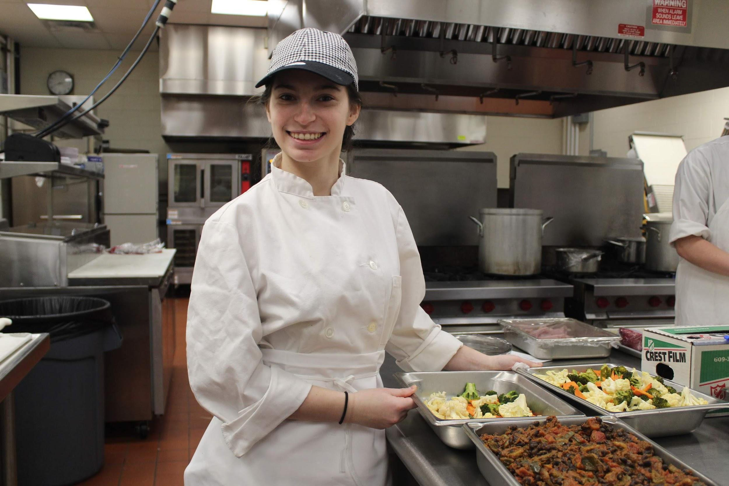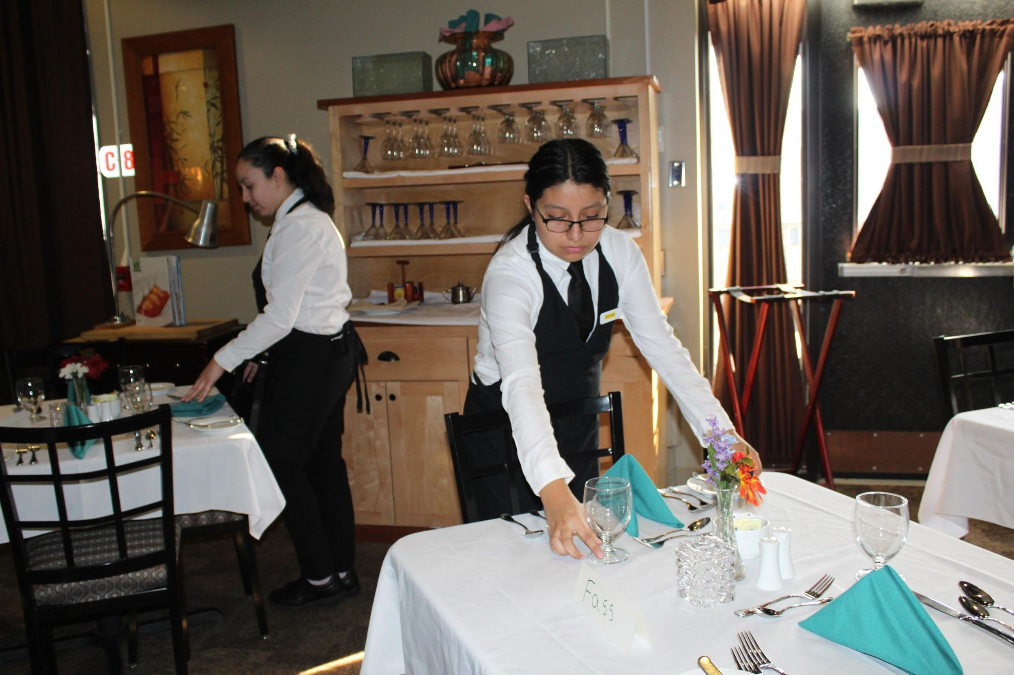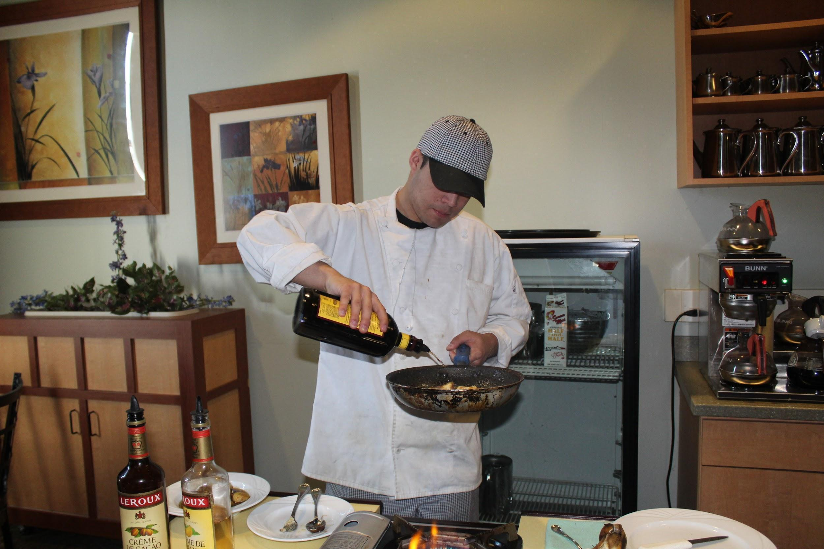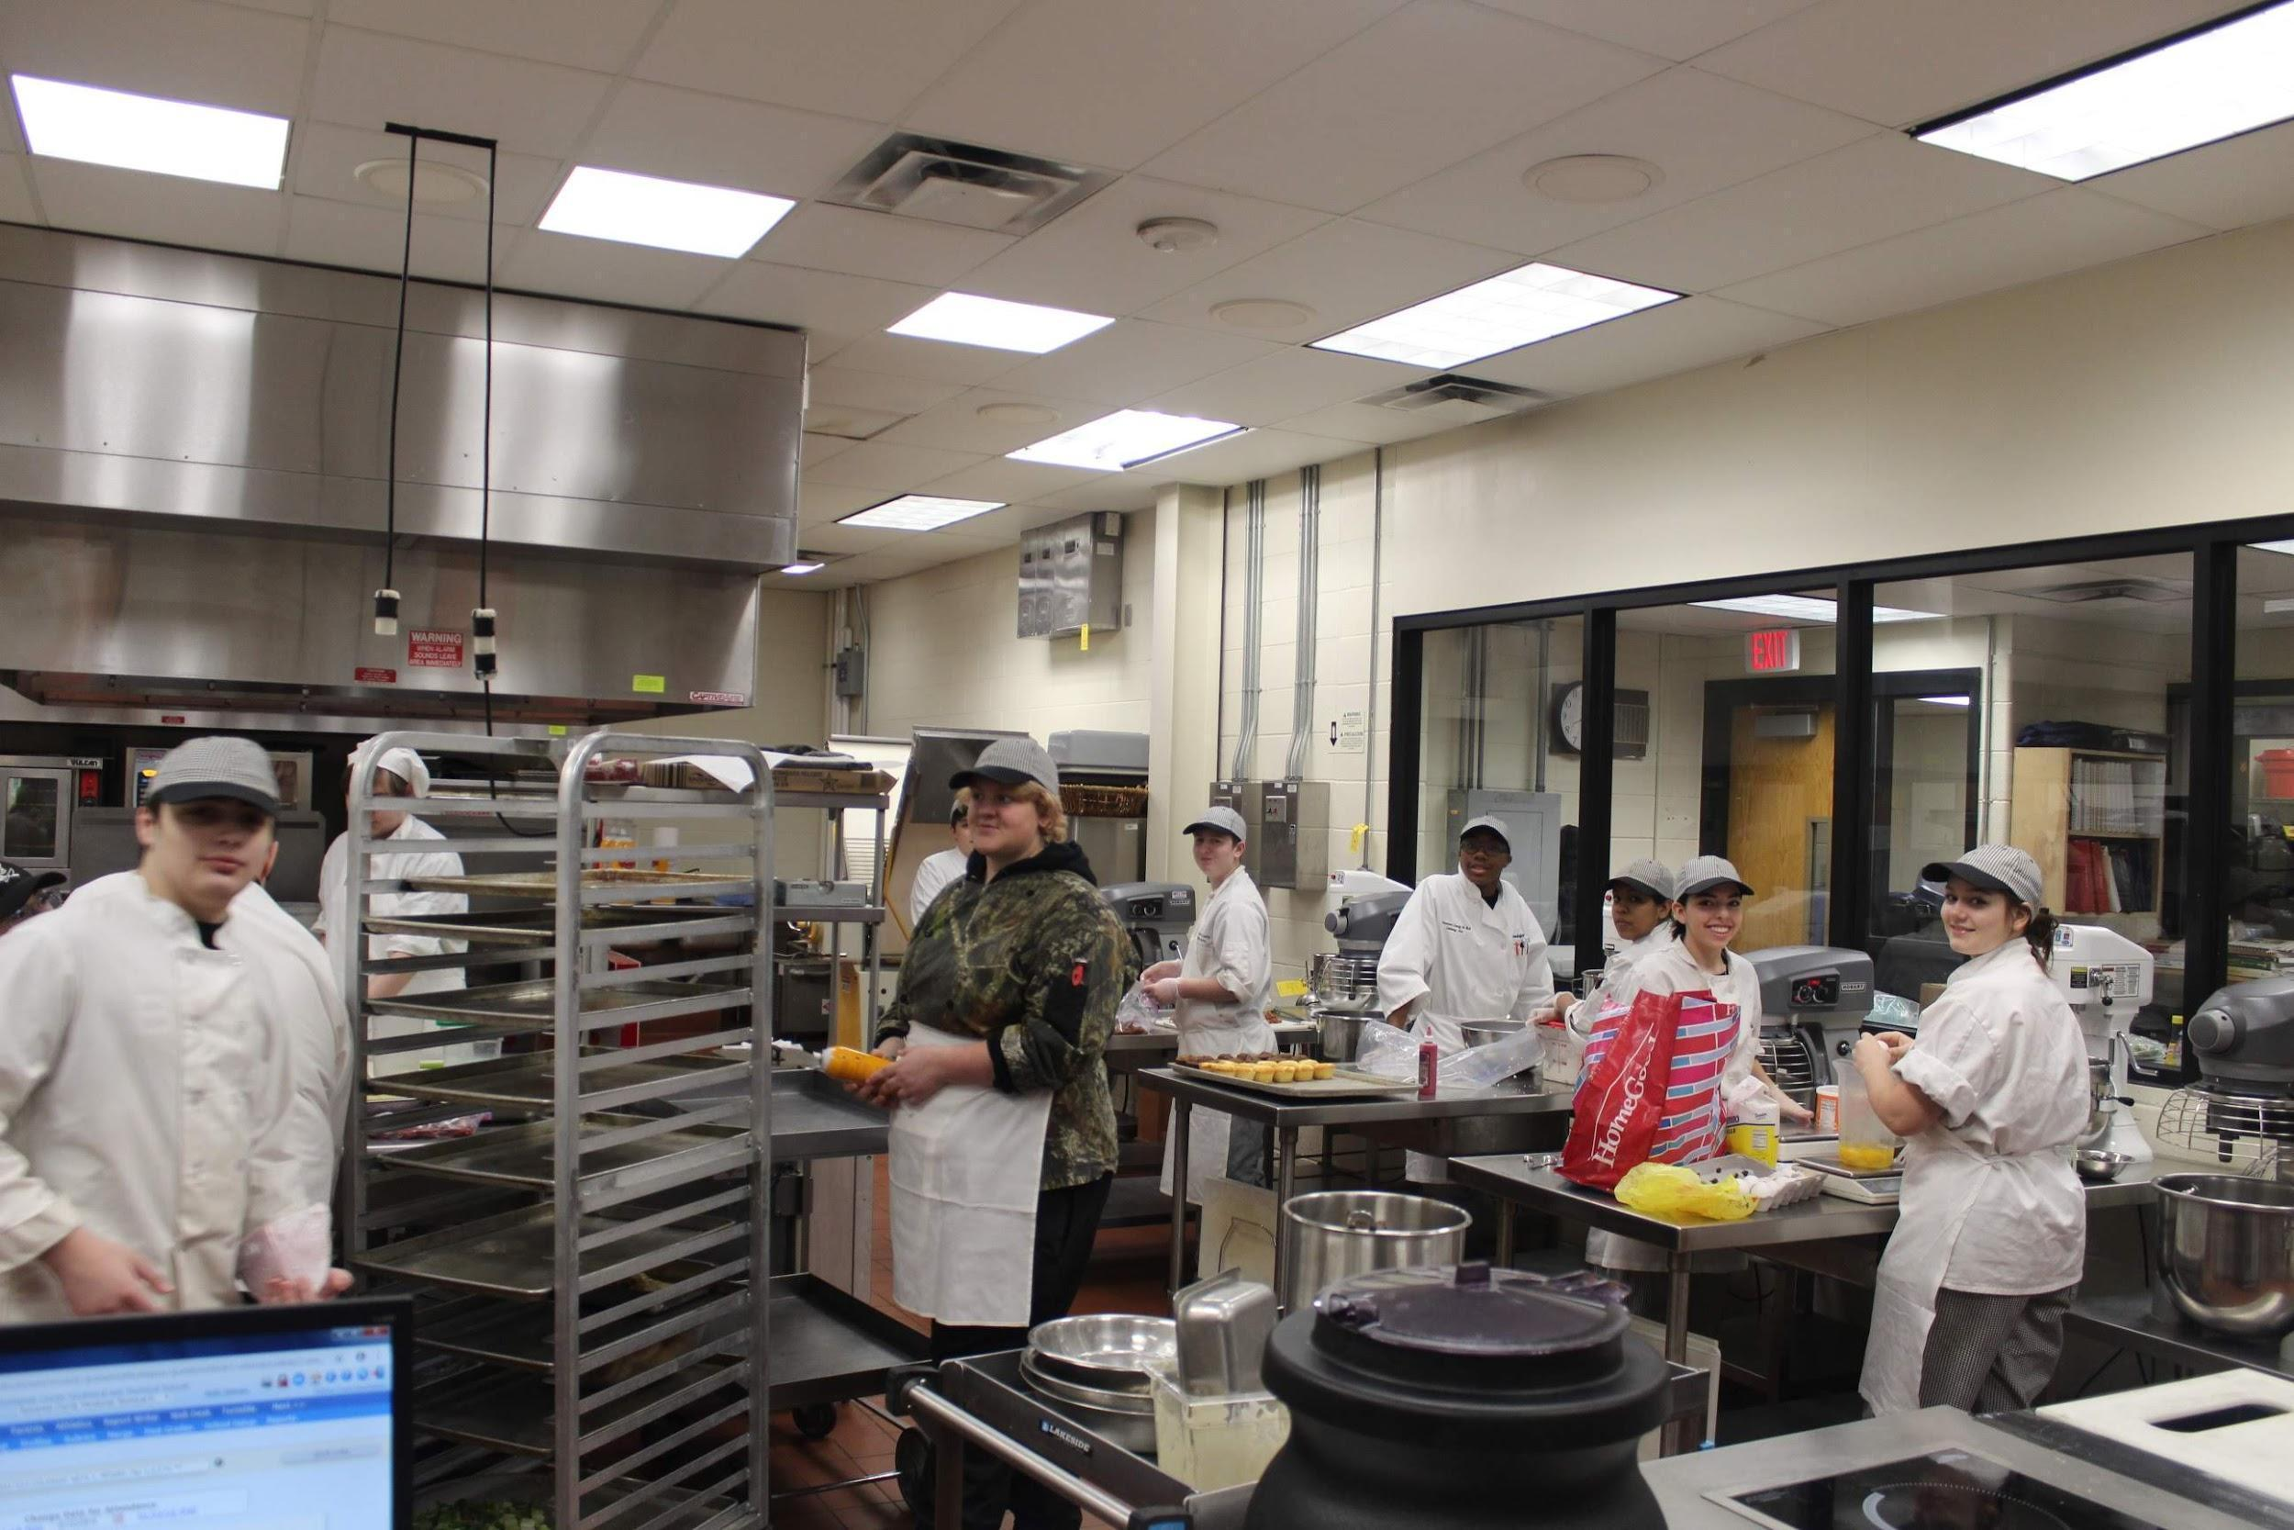

Culinary Arts

Year 1 - Introduction to Culinary Arts and Dining Room Fundamentals
Course Description: Year 1 is designed to introduce students to the basics of the service/hospitality industry. At the start of the year, students will learn proper cleaning, safety and sanitation regulations, equipment operation, and restaurant terminology. As the school year progresses, students will begin to develop their skills in baking and pastry, food preparation, and basic cooking methods and techniques. Students will also be introduced to the following concepts of hospitality and aspects of the dining room: professionalism, service standards, service ware identification, equipment identification and usage, and table service.
Year 2 - Intermediate Culinary Arts and Dining Room Skills
Course description: Year 2 is a class, which is designed to expand upon and improve the skills that students learned in Year 1. Students will focus on culinary and dining room related math. They practice and improve knife skills, and demonstrate cooking meats, poultry, fish, and eggs. They will continue to build on their basic baking and pastry skills. Students will also assume more of the responsibilities of each position within both the kitchen and dining room brigade systems. They will enhance both verbal and non-verbal communication skills by taking food service orders and speaking clearly and respectfully with guests and fellow workers, making eye contact with guests, maintaining straight posture, and displaying a friendly and pleasant disposition. Students will also learn the POS system by entering menu items, modifiers, guests’ orders, and processing guest checks.
Year 3 - Advanced Culinary Arts and Dining Room Principles
Course Description: Year 3 is a class, which is designed to expand upon and improve the skills learned in Years 1 and 2. Students will engage in activities related to running a restaurant/catering hall. They will continue to demonstrate and develop proficiencies in various cooking and baking methods and techniques. They will be introduced to international cuisines. Students will also practice tableside services such as flambéing and cooking/preparing dishes in front of guests. As they are placed in higher positions in the brigade systems, they will assume more responsibilities in the following areas: menu planning and ordering.
Year 4 - Culinary Arts and Dining Room Management
Course Description: Year 4 is a class designed to expand upon and improve the skills learned in Years 1, 2, and 3. Students will assume the highest positions in both the kitchen and dining room brigade systems. They will learn how to run both the “front end” (dining room) and back end” (kitchen) of a restaurant/banquet facility. They will oversee full operations of the kitchen stations during service times as executive chefs, expeditors, and line chefs. They will also manage all dining room affairs such as taking reservations, booking parties, and delegating work and assigning responsibilities to servers. They will act as mentors to underclassmen as they reinforce what they have learned over the last 3 years by training them, which will allow them to gain the skills that it takes to be an effective and efficient executive chef and dining room manager.
The curriculum will additionally focus on the following topics relate to the art of dining:
- Appreciating and recognizing dining as an art form, capable of forming many wonderful emotions within those who are engaged in the experience.
- Gaining perspectives of proper and improper dining etiquette and manners from the host’s, guest’s, and server’s roles (conduct becoming a host, guest, and server).
- Defining civility and graciousness and understanding how they affect the overall dining experience.
- Exploring and embracing cultural dining by understanding its history and how it relates to modern fusion cuisine and multicultural dining.
- Practicing and demonstrating event-planning skills, with a purpose of focusing on incorporating the proper etiquette that corresponds to the culture and/or theme of the event.

Human Services

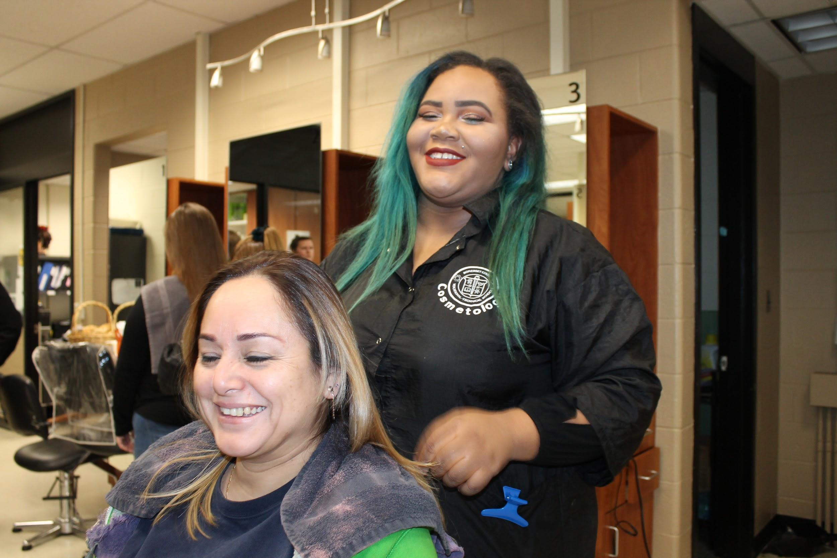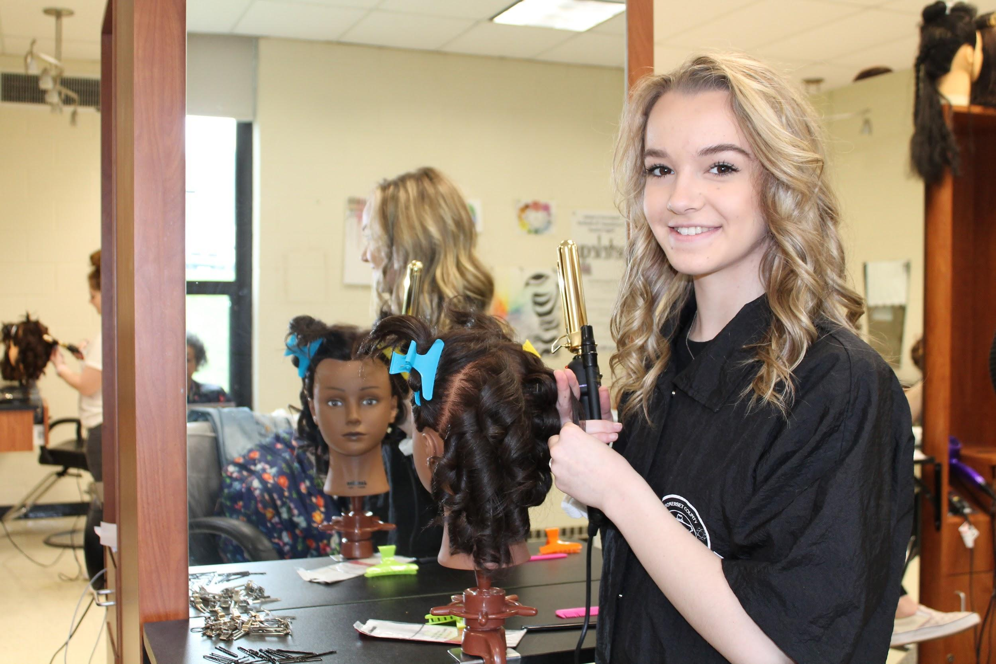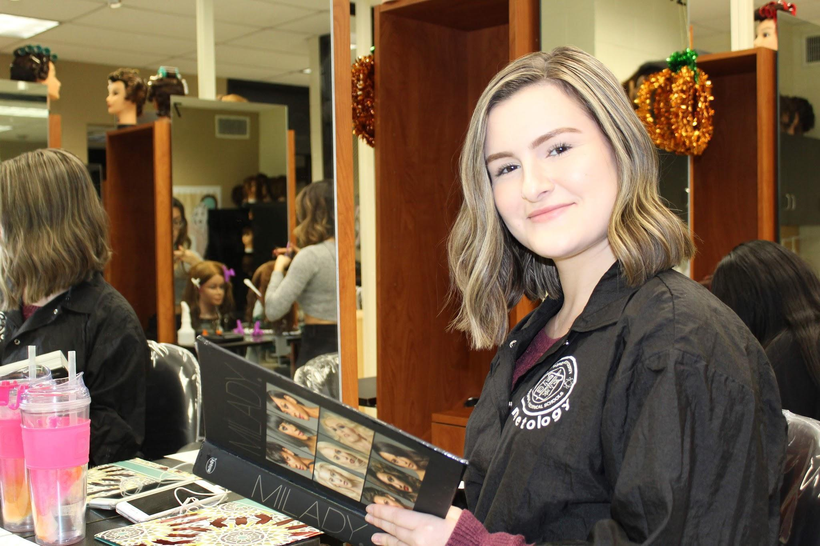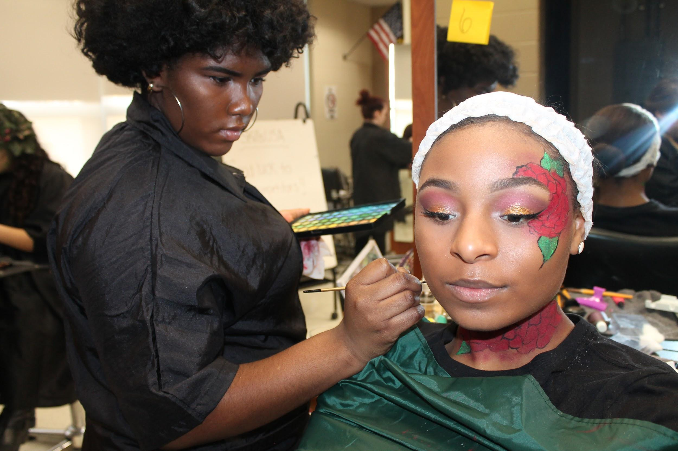

Cosmetology
Year 1: Foundations of Cosmetology
Course Description: Foundations of Cosmetology is an introductory class in which students will learn the basic skills that they can apply to become cosmetologists. First year students will begin the course by learning about shop safety and responsibilities, sanitation and sterilization, career paths and basic life skills. As the school year progresses students will develop necessary skills in all aspects of wet and dry hairstyling, hair removal, and all natural nail services. Class trips are used to explore careers opportunities and to extend classroom learning by including real world experiences.

Year 2: Fundamentals of Cosmetology
Course Description: As a second year student you will expand and perfect the skills that are learned in Foundations of Cosmetology. Second year students will develop necessary skills and techniques in haircutting, make-up and skin care. They will also gain knowledge of communication skills by booking appointments and learning how a salon environment operates. Class trips are used to explore careers opportunities and an on-site clinic is conducted throughout the school year to extend classroom learning by including real world salon experiences.

Year 3: Chemistry of Cosmetology

Course Description: Third year students will expand and perfect the skills learned in Foundations and Fundamentals of Cosmetology. During this year they will have the necessary skills and hours to obtain their student permit and begin working in clinic to gain professional experience. Third year students will develop necessary competencies and proficiencies in all aspects of chemical services including; hair coloring, hair lightening, permanent waving and hair straightening, as well as nail enhancement services (gel, acrylic and powder/glue). Class trips are used to explore careers opportunities and an on-site clinic is conducted throughout the school year to extend classroom learning by including real world experiences.
Year 4: Professional Development of Cosmetology
Course Description: Fourth year students will review and continue to perfect skills learned in previous years. They will learn about the laws that govern this occupation, resume building, business operations and seeking employment. Fourth year students will also develop necessary skills to perform a professional shave. Class trips are used to explore careers opportunities and an on-site clinic is conducted throughout the school year to extend classroom learning by including real world experiences. Also, students who have acquired the mandatory State hours will be eligible to take their State Board Exam.
(Year 3/4) Summer Semester At RVCC (July-December) : Advanced Cosmetology
Course Description: During this semester 575 hours will be transferred over to RVCC where students will attend school and they will obtain their student permits to begin working in clinic two days a week to gain professional experience. Summer semester students at RVCC will expand and perfect the skills learned in Foundations and Fundamentals of Cosmetology. Students will expand upon previous years of study and develop necessary competencies and proficiencies in all aspects of chemical services including; hair coloring, hair lightening, permanent waving and hair straightening, as well as nail enhancement services (gel, acrylic and powder/glue). Additionally, students will learn about the laws that govern this occupation, resume building, business operations and seeking employment as well as learn about barbering and shaving. Workshops are used to explore careers opportunities and an on-site clinic is a mandatory component of the program. Upon completion of the college semester, students will select an employer and gain additional experience through a 100 hour practicum. Students in this program will graduate with 1,200 hours.

Information Technology

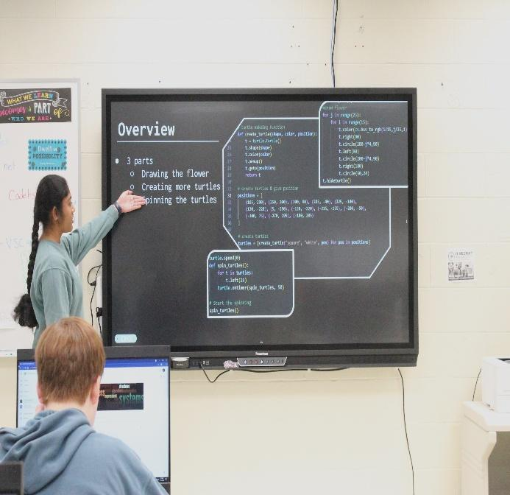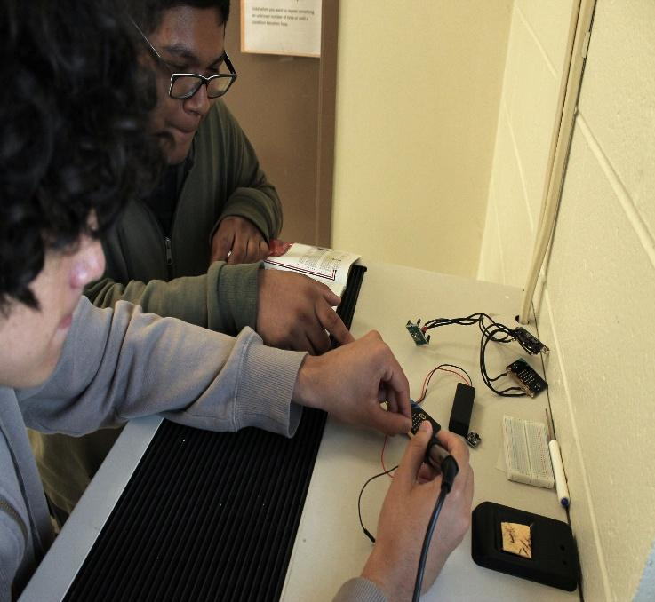
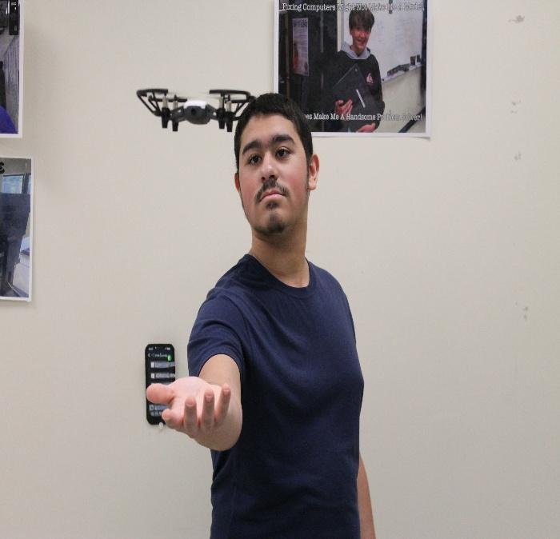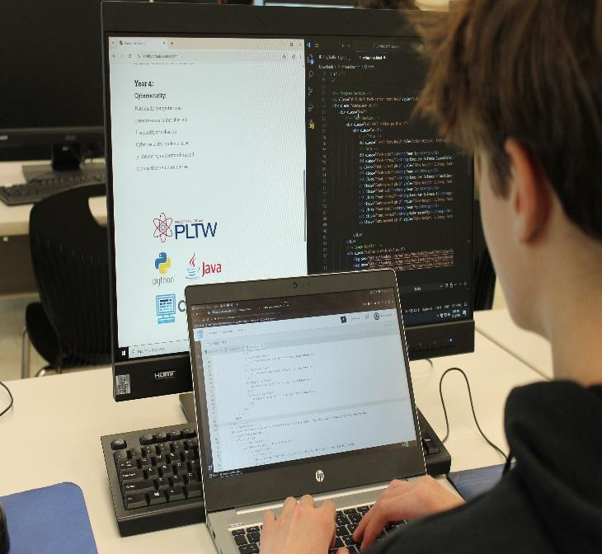

Computer Science

Year 1: Computer Science Essentials

Course Description: With emphasis on computational thinking and collaboration, this year-long course provides an excellent entry point for students to begin the PLTW Computer Science PreK-12 experience. Computer Science Essentials will expose students to a diverse set of computational thinking concepts, fundamentals, and tools, allowing them to gain understanding and build confidence. In Computer Science Essentials, students will use visual, block-based programming and seamlessly transition to text-based programming with languages such as Python to create apps and develop websites, and learn how to make computers work together to put their design into practice. They’ll apply computational thinking practices, build their vocabulary, and collaborate just as computing professionals do to create products that address topics and problems important to them. Computer Science Essentials helps students create a strong foundation to advance to Computer Science Principles, Computer Science A, and beyond.

Year 2: Computer Science Principles

Course Description: Using Python® as a primary tool, students learn the fundamentals of coding, data processing, data security, and task automation, while learning to contribute to an inclusive, safe, and ethical computing culture. The course promotes computational thinking and coding fundamentals and introduces computational tools that foster creativity. Computer Science Principles helps students develop programming expertise and explore the workings of the Internet. Projects and problems include app development, visualization of data, cybersecurity, and simulation.

Year 3: Computer Science A

Course Description: Throughout the Computer Science A course experience, students cultivate their understanding of coding through analyzing, writing, and testing code as they explore concepts like modularity, variables, and control structures. Fundamental topics in this course include the design of solutions to problems, the use of data structures to organize large sets of data, the development and implementation of algorithms to process data and discover new information, the analysis of potential solutions, and the ethical and social implications of computing systems. The course emphasizes object-oriented programming and design using the Java programming language.

Year 4: Cybersecurity

Course Description: Cybersecurity introduces the tools and concepts of cybersecurity and encourages students to create solutions that allow people to share computing resources while protecting privacy. Nationally, computational resources are vulnerable and frequently attacked; in Cybersecurity, students solve problems by understanding and closing these vulnerabilities. This course raises students’ knowledge of and commitment to ethical computing behavior. It also aims to develop students’ skills as consumers, friends, citizens, and employees who can effectively contribute to communities with a dependable cyber-infrastructure that moves and processes information safely.

Law, Public Safety, Corrections and Security
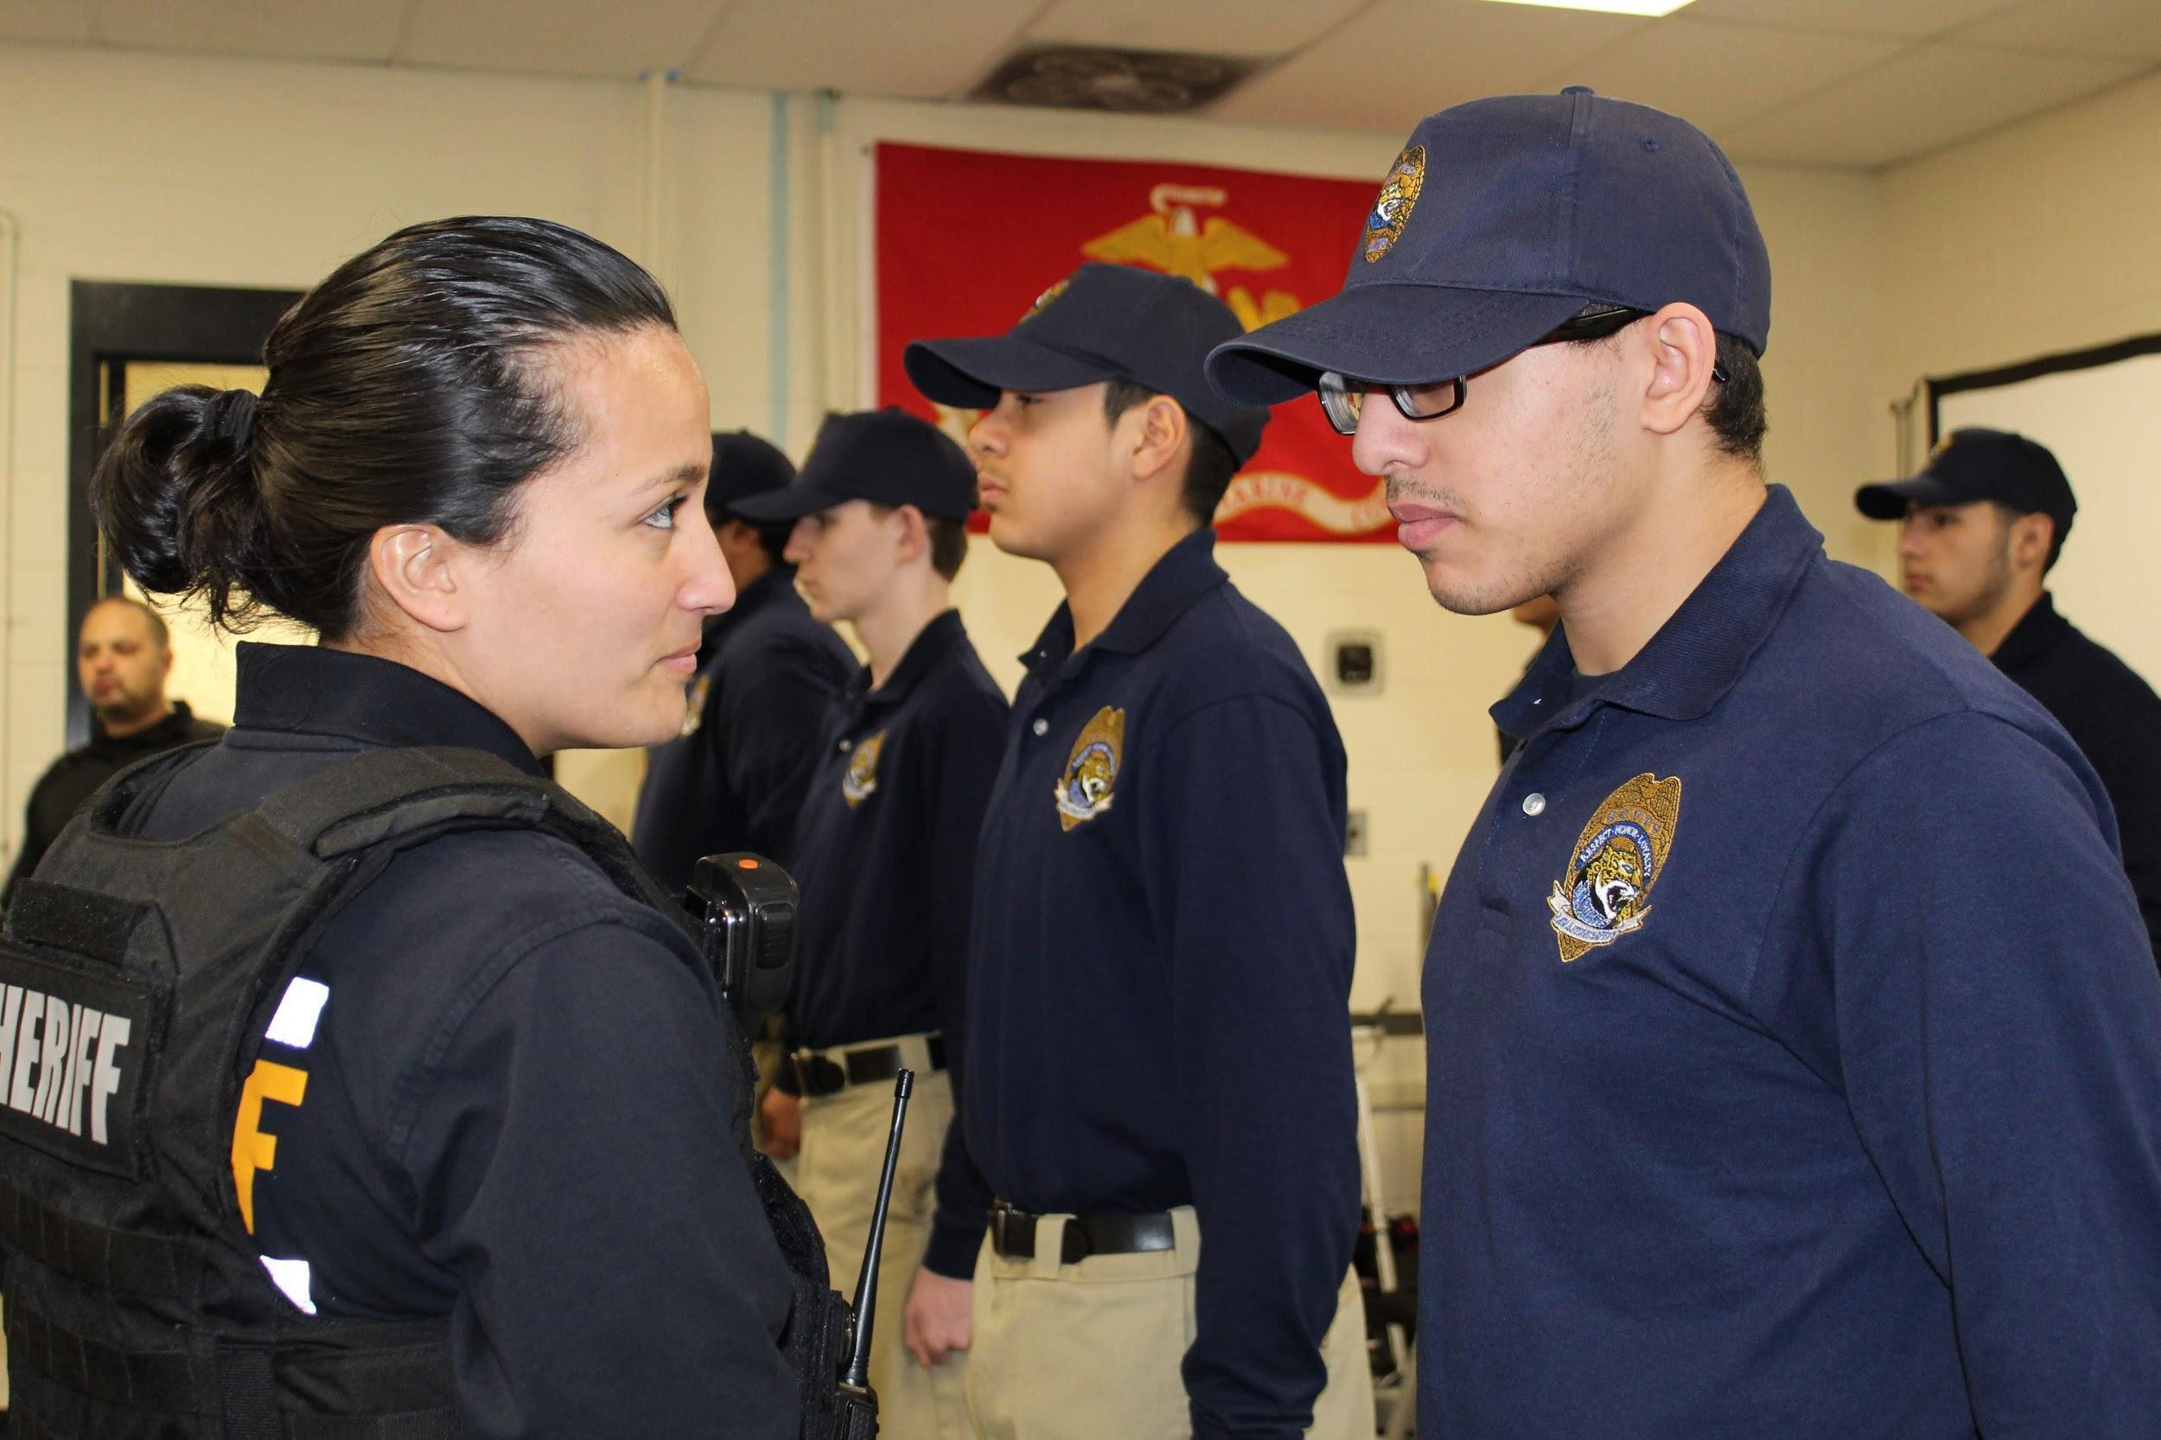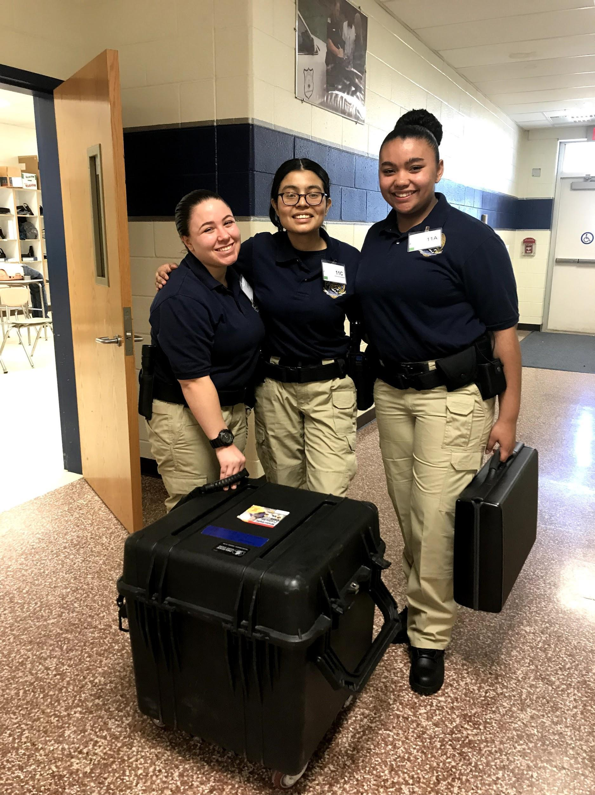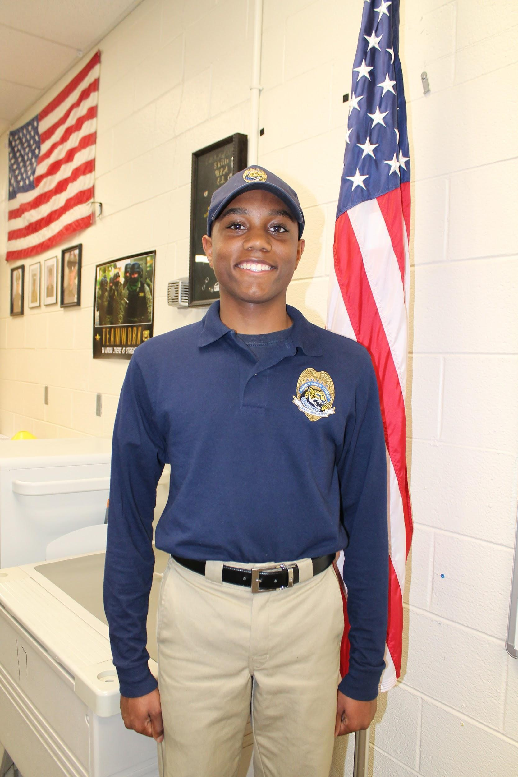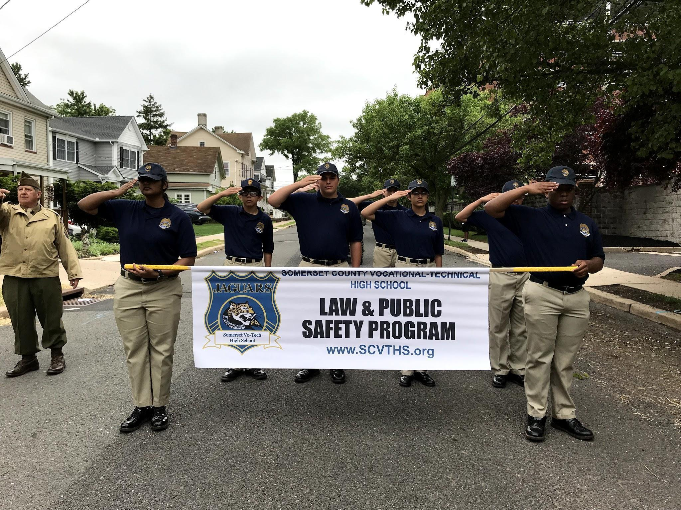

Law and Public Safety

Year 1: Introduction to Law and Public Safety
Course Description: Law and Public Safety I is an introductory class in which students will learn the basic skills that they can apply to work in the criminal justice field. First year students will begin the program by participating in a First Responder course taught by instructors from Somerset Medical Center. Upon completion of this course, students will have obtained a basic knowledge in emergency first aid care and will receive a First Responder certificate acknowledging the completion of the course. Subsequent to the First Responder course, students will learn about the historical development of the criminal justice system, develop competencies and proficiencies in their knowledge of the Constitution, as well as become engaged in several other topics revolving around the American justice system. Students must also participate in physical training (PT) and are required to perform community service.

Year 2: Criminal Justice I
Course Description: As a second year course, students will be expected to expand upon and perfect the skills that they learned in Law and Public Safety I. Second year students will begin the year by learning about the equipment and technology that police officers use to perform their duties. As the school year progresses students will develop competencies and proficiencies in identifying the different types of infractions/offenses people can commit, NJ traffic laws, types of organized crime, and how to write a traffic accident report. In addition to field trips, regular guest lecturers are used to provide students with real world experiences from people working in the field of Law and Public Safety.

Year 3: Criminal Justice II
Course Description: Third year students will be expected to expand upon and perfect the skills that they have learned in the two previous years. They will also be introduced to the ETC-1, 9-1-1 Dispatch Course. A national 9-1-1 dispatcher certification will be given upon completion of this program. Students will also learn about and be able to differentiate between civil law and criminal law. As the school year progresses students will develop competencies and proficiencies in police interrogation techniques, investigating a crime scene, search and seizure techniques, processing evidence, and basic forensic science.

Year 4: Careers in Law Enforcement, Public Safety, Corrections, and Security
Course Description: Fourth year students will be expected to expand upon and perfect the skills they have learned in the previous three years. As the school year progresses students will develop competencies and proficiencies in communicating with the public, identifying the different types of illegal drugs in the United States, and will understand the concepts and purposes of the United States criminal correction system. Through classroom lectures and hands on instruction, taught by former law enforcement officers and the Somerset County Sheriff’s Office, students will learn the New Jersey Attorney General Guidelines for the Use of Force continuum and will apply the knowledge and skills obtained in real-life law enforcement scenarios.

Engineering & Manufacturing

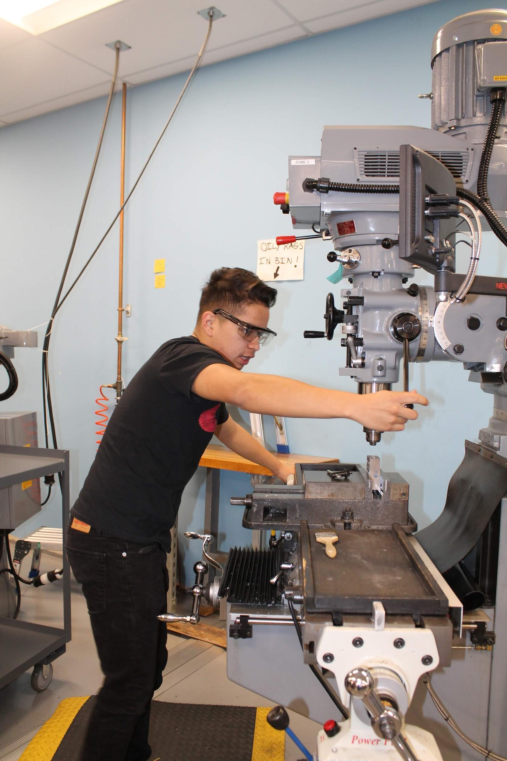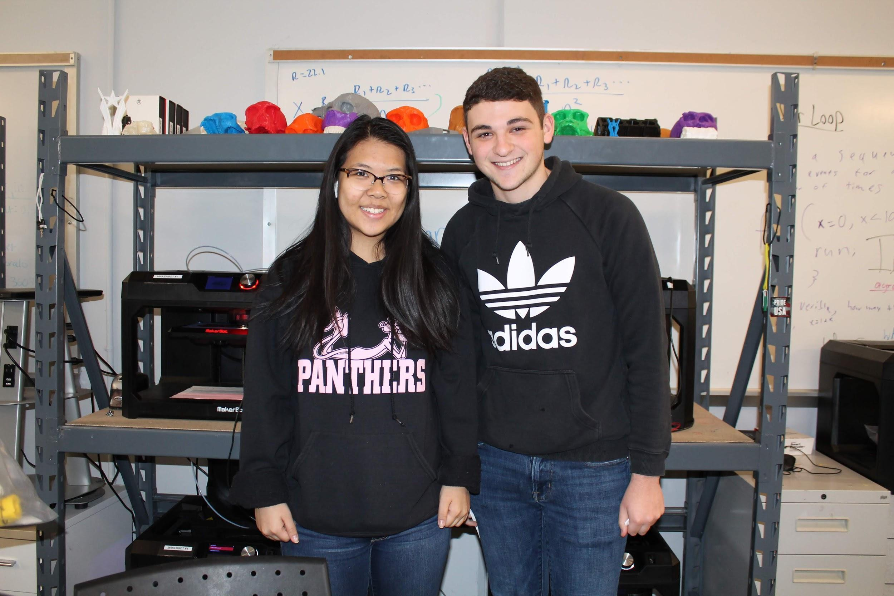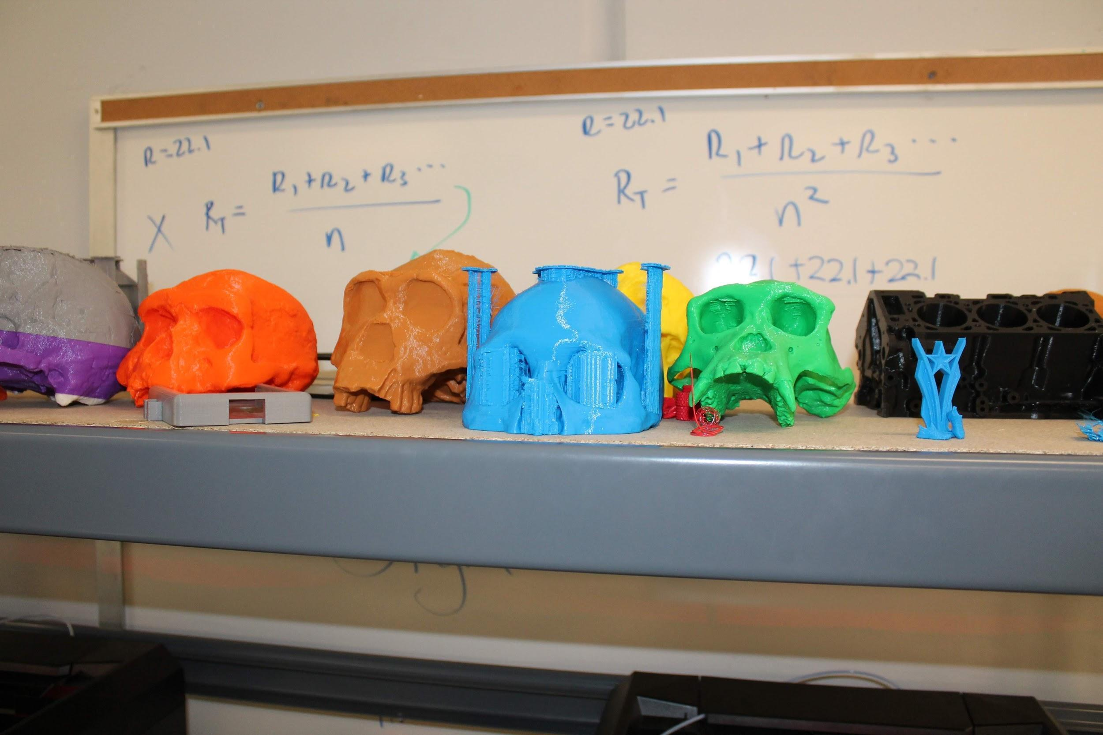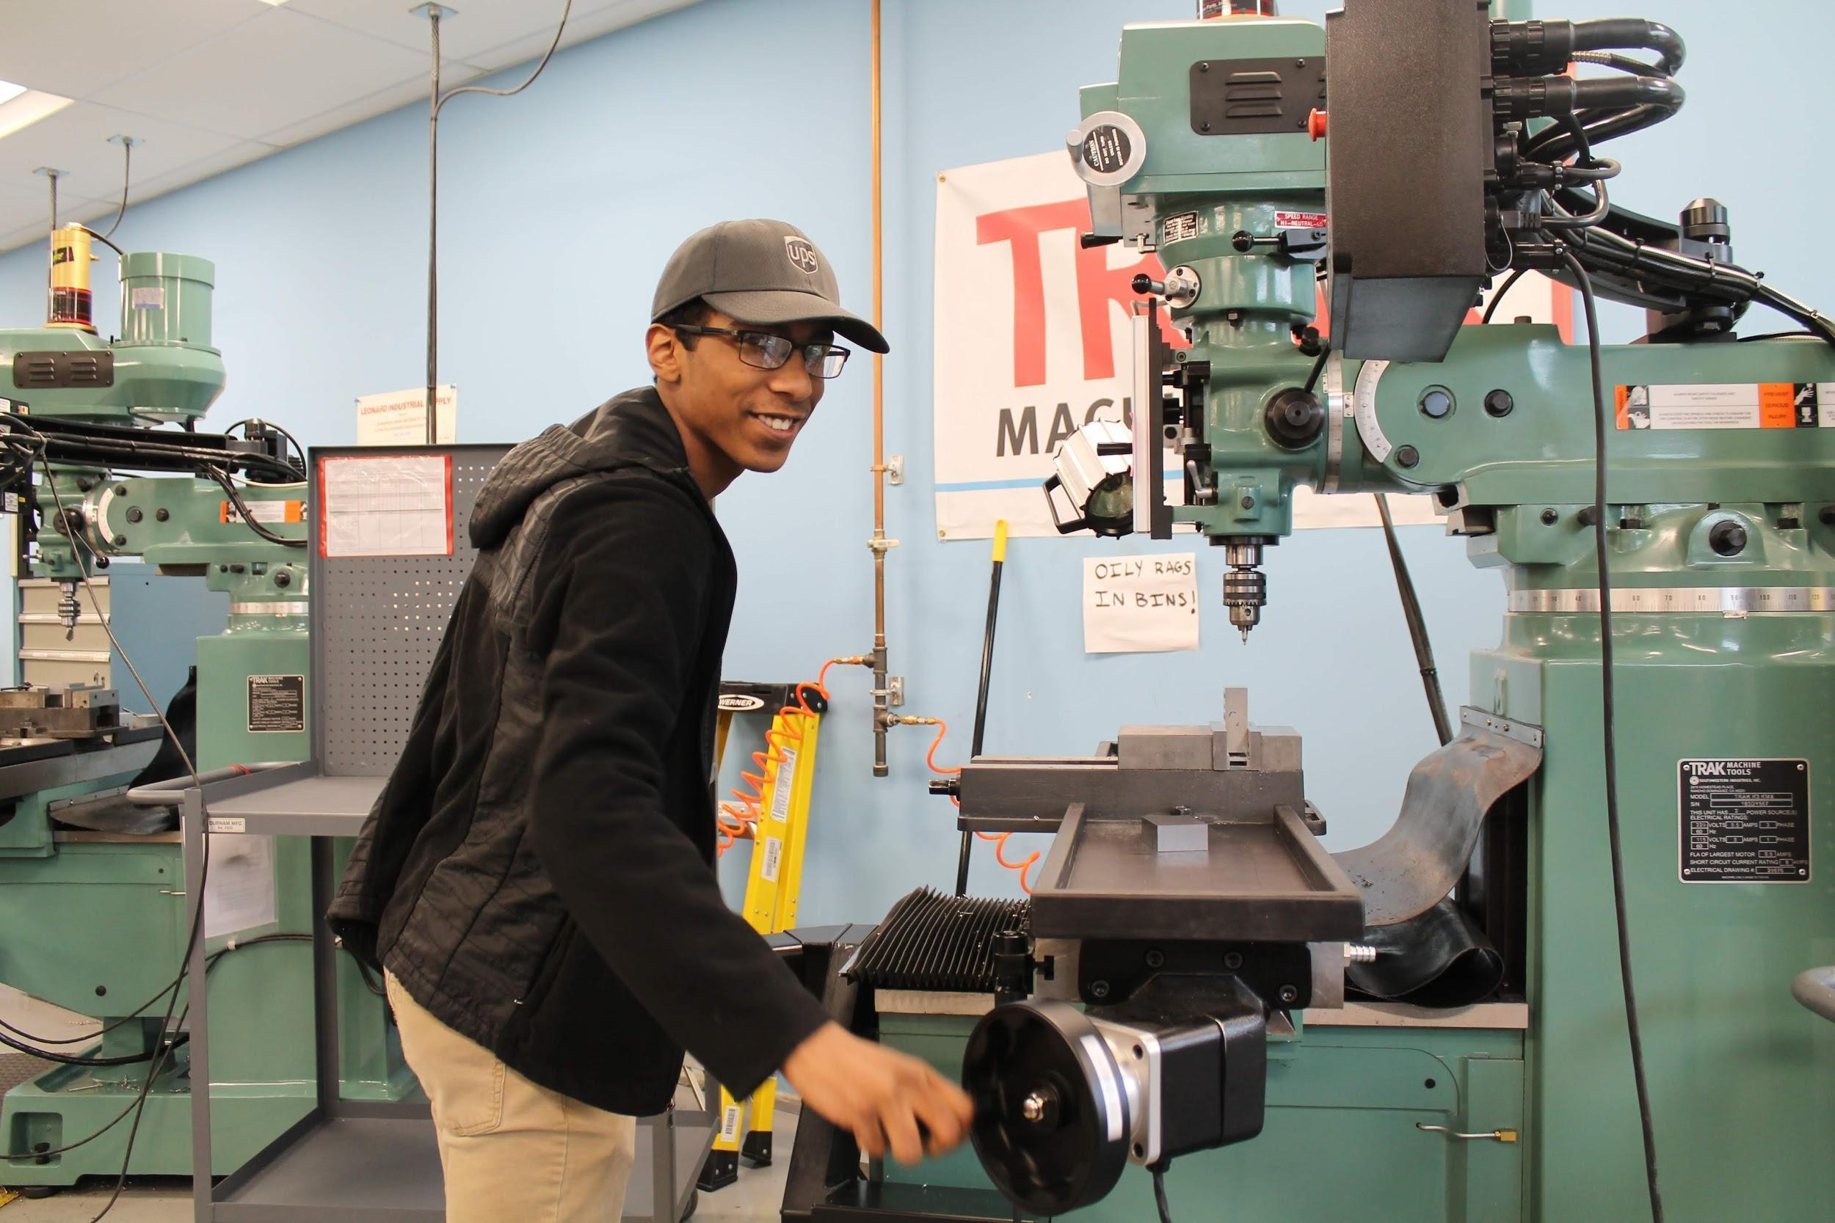

Mechatronics, Engineering, and Advanced Manufacturing (MEAM)

Year 1: SCVTHS Robotics and Engineering

Located at SCVTHS’s Robot Lab, in this project based course students build and program their own robot using VEX robotics systems. Students will use their robot to study fundamentals of engineering, robotics, and introduction to programming (using EasyC and Cortex Controllers). Students will also begin to develop their skills using CAD mainly using Fusion 360 and Onshape, bringing their designs to life via 3D printing and CNC machining.
Year 2: SCVTHS Industrial Mechatronics

RVCC College Course: EMET 105 (2 Credits) - Applied Computer Aided Design

Working at SCVTHS’s Robot Lab, students will refine their knowledge and skills in design, construction, troubleshooting, and repair of FESTO / Allen Bradley industrial mechatronics systems. These systems include MecLab desktop mechatronics systems, MPS203 advanced mechatronics systems and Pneumatics Troubleshooting systems. Students will learn to program and operate these systems using Ladder Logic with some structured text included. Software will include free packages such as OpenPLC and Codesys as well as proprietary software such as Rockwell Automation Studio5000 / RSLogix. Students will continue developing their CAD skills and start working with CAM, turning their CAD designs into GCODE and programming CNC machines to manufacture these designs.
Year 3: RVCC Advanced Manufacturing: Year 3 is conducted in a CNC machine shop environment at the RVCC Campus. Students will be bused back and forth from the high school to the college.
RVCC College Course: EMET 151 (3 Credits) – Conventional Machining Operations I
The Conventional Machining Operations I course is the first of four courses designed to prepare students to develop the requisite skills to become a Certified Level 1 Machinist in accordance with the National Institute for Metalworking Skills training and performance criteria (NIMS – Machining Level 1) and serves as a Technical Elective for the RVCC Mechanical Engineering Technology program. The course training includes the fundamentals of blueprint reading, fundamentals of calibration, geometric dimensioning and tolerancing, materials, machine shop safety, job planning, benchwork & layout, and grinding skills, and drill press skills. Classes are conducted in a fully functional machine shop environment located on the RVCC Campus equipped with manual and CNC mills and lathes, virtual machining centers, precision measurement equipment, and all basic machine shop tools.

RVCC College Course: EMET 152 (3 credits) – Conventional Machining Operations II
The Conventional Machining Operations II course is the second of four courses designed to prepare students to develop the requisite skills to become a Certified Level 1 Machinist in accordance with the National Institute for Metalworking Skills training and performance criteria (NIMS – Machining Level 1) and serves as a Technical Elective for the RVCC Mechanical Engineering Technology program. The course training includes the fundamentals of calibration, geometric dimensioning and tolerancing, theory, set-up, and operation of the Engine Lathe and Manual Milling machines. Classes are conducted in a fully functional machine shop environment located on the RVCC Campus equipped with manual and CNC mills and lathes, virtual machining centers, precision measurement equipment, and all basic machine shop tools.

Year 4: RVCC Advanced Manufacturing: Year 4 is conducted in a CNC machine shop environment at the RVCC Campus. Students will be bused back and forth from the high school to the college.
RVCC College Course: EMET 253 (3 credits) – CNC Machining Center
The Computer Numerical Controlled (CNC) Machining center course is the third of four courses designed to prepare students to develop the requisite skills to become a Certified Level 1 Machinist in accordance with the National Institute for Metalworking Skills training and performance criteria (NIMS – Machining Level 1) and serves as a Technical Elective for the RVCC Mechanical Engineering Technology program. The course training includes the fundamentals of calibration, geometric dimensioning and tolerancing, understanding of materials, mechanical systems, and metal cutting, CNC turning and milling operations and programming. Classes are conducted in a fully functional machine shop environment located on the RVCC Campus equipped with manual and CNC mills and lathes, virtual machining centers, precision measurement equipment, and all basic machine shop tools.

RVCC College Course: EMET 254 (3 credits) – CNC Lathe Operations
The Computer Numerical Controlled (CNC) Programming course is the fourth of four courses designed to prepare students to develop the requisite skills to become a Certified Level 1 Machinist in accordance with the National Institute for Metalworking Skills training and performance criteria (NIMS – Machining Level 1) and serves as a Technical Elective for the RVCC Mechanical Engineering Technology program. The course training includes the fundamentals of the theory, set-up, and operation of the CNC Swiss-Type and Haas mill and lathes, and Lean Manufacturing and Statistical Process Control (SPC) principles. Classes are conducted in a fully functional machine shop environment located on the RVCC Campus equipped with manual and CNC mills and lathes, virtual machining centers, precision measurement equipment, and all basic machine shop t

Transportation, Distribution and Logistics
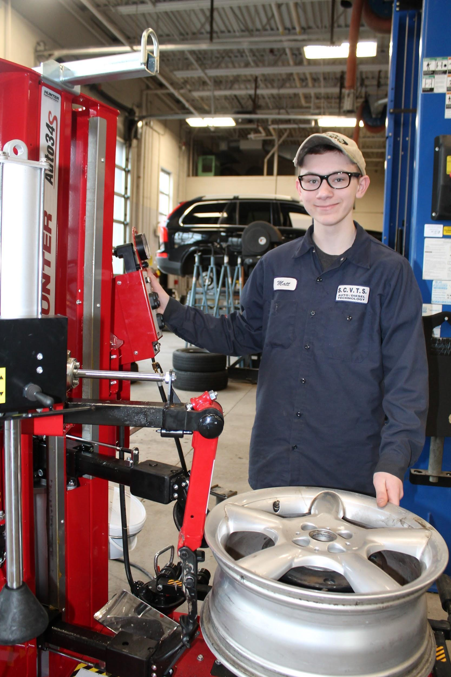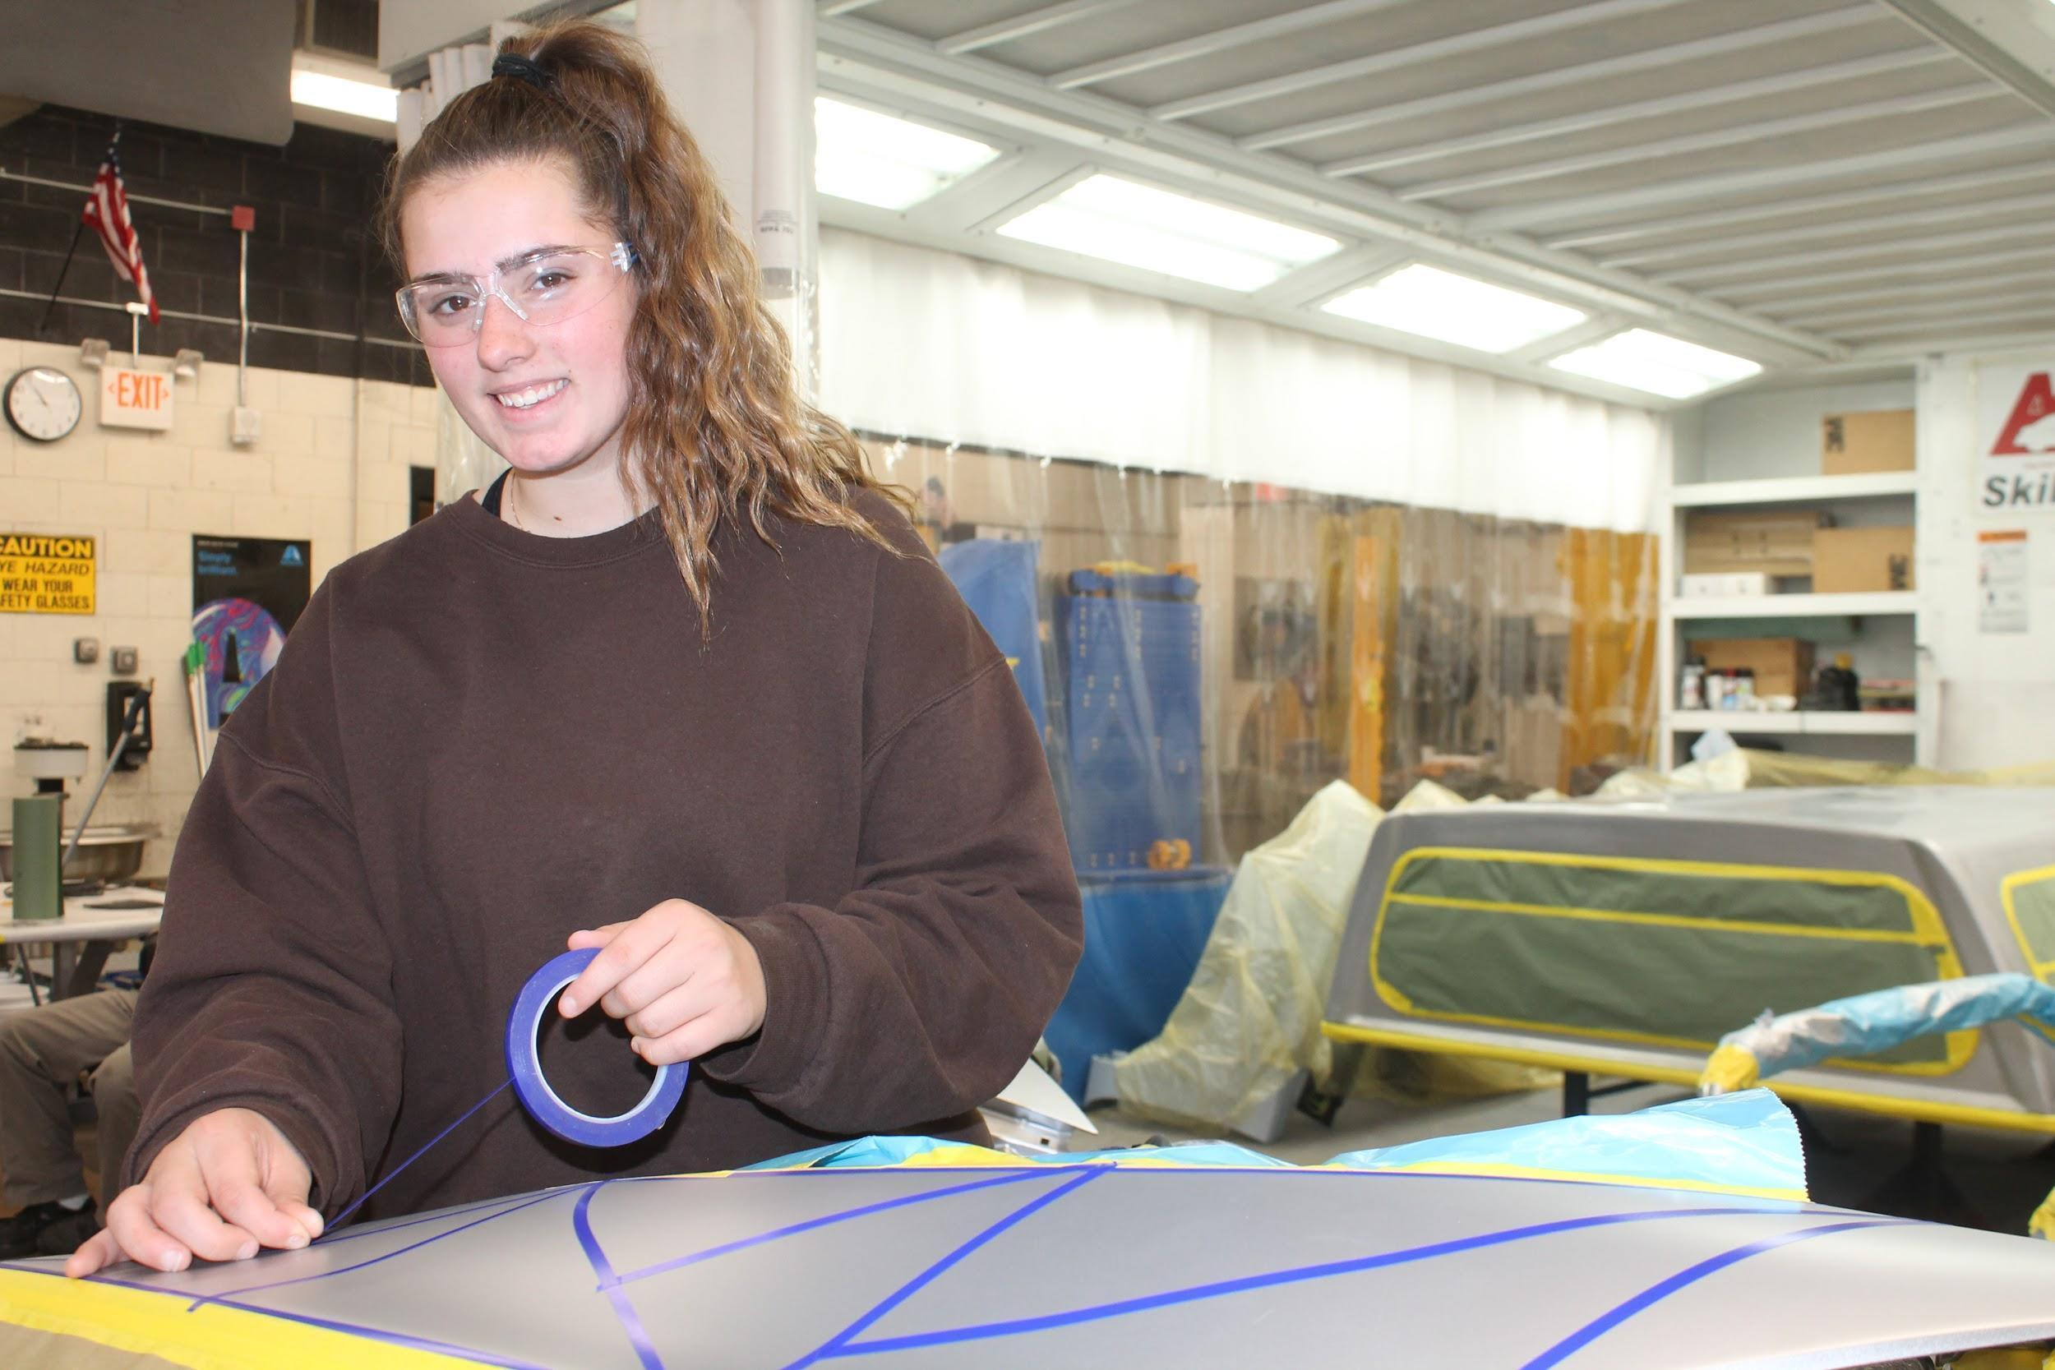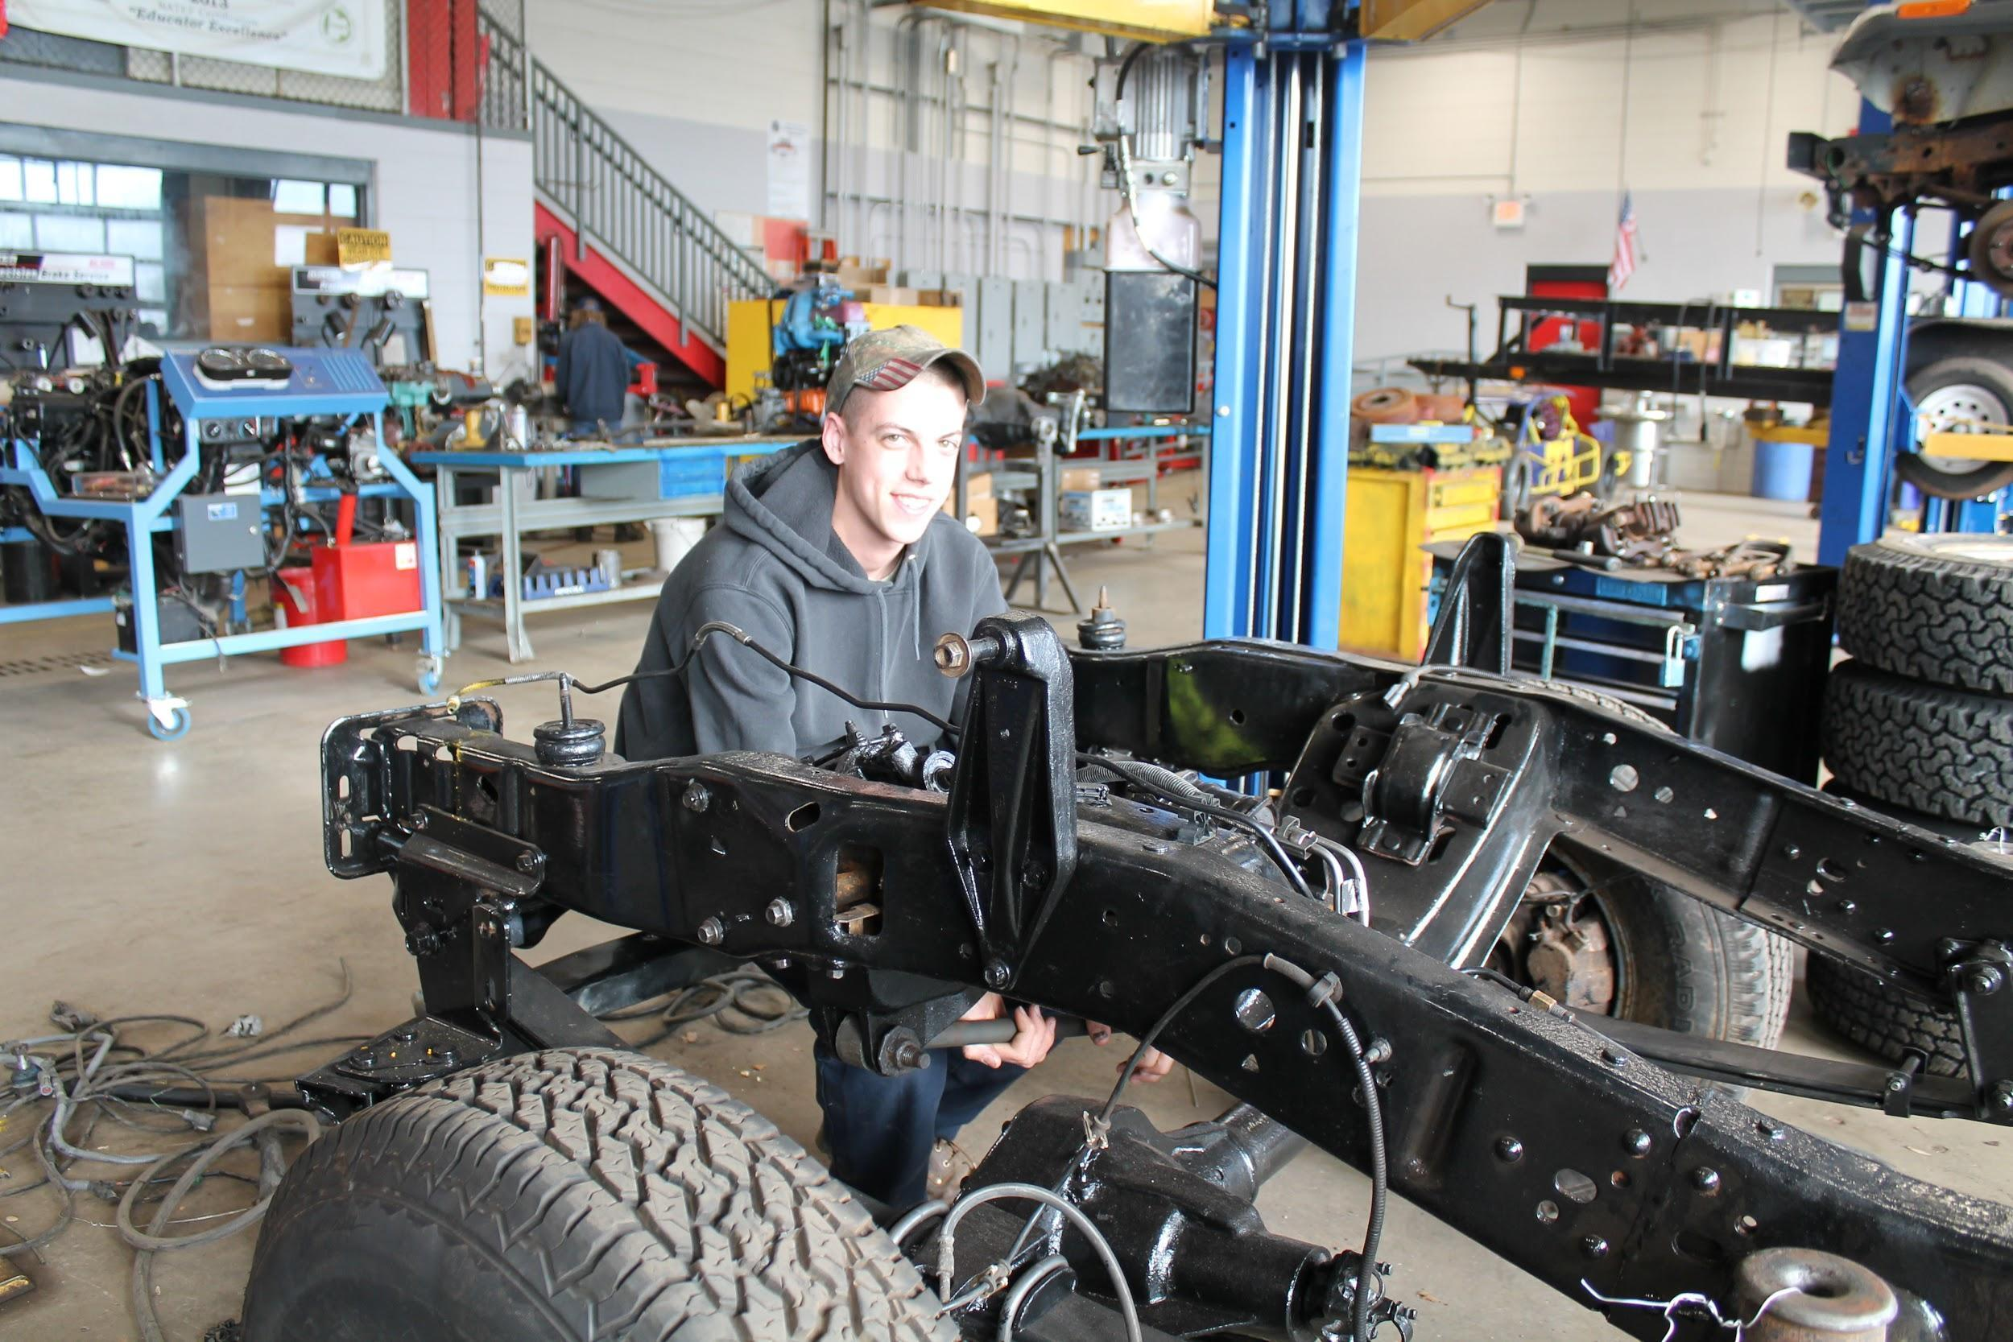
Auto Body

Year 1: Introduction to Auto Body
Course Description: Auto Body 1 is an introductory class in which students will learn the basic skills that they can apply to become auto body/collision specialists. First year students will begin the course by learning about possible career opportunities, shop safety, and how to choose the appropriate hand and power tools for a job. As the school year progresses, students will develop competencies and proficiencies performing basic live work; including power washing, use of pneumatic tools, creating repair plans and invoicing through the PPG paint system. During this time, students will be signed up for the I-Car academy curriculum which includes the following badge; Collision Fundamentals. Categories of certification are shown below.

- Vehicle Repair Information
- Repair Facility Safety
- Power Tools
- Personal Safety
- Sanding
- Vehicle Construction & Protection
- Heat Application for Vehicle Repairs and Corrosion Protection
- Vehicle Construction and safety Systems

Year 2: Foundations of Auto Body
Course Description: As a second year, course students will be expected to expand upon and perfect the skills that they learned in Introduction to Auto Body. Second year students will begin the year by learning about and developing basic welding skills and applying basic metalworking and collision repair techniques. As the school year progresses, students will develop competencies and proficiencies in proper masking for undercoat applications, the use of fillers,
Understanding surface preparation procedures and products, and the proper application of topcoats. Students are expected to test out of these foundational skills through the use of the I-car hands on welding certification administered by the instructor. In addition, students are expected to continue their I-car academy curriculum through the badge: Disassembly and Reassembly. Categories of certification are shown below.

- Hand Tools
- Vehicle Drop Off Considerations
- Interior Trim and Movable Panels
- Exterior Part Removal and Installation
- Movable Panel Removal and Installation
- Interior Trim Removal and Installation

Year 3: Auto Body Advanced Concepts
Course Description: Third year students will be expected to expand upon and perfect the skills that they learned in the two previous years. Third year students will begin the school year by learning how to identify different types of advanced abrasives and how they are used and performing plastic repair procedures. As the school year progresses, students will develop competencies and proficiencies in advanced topcoat applications, bolt on panel replacements and alignments, as well as basic mechanical principles. Students are expected to test out of these advanced skills through the use of the I-car hands on plastic nitrogen welding certification administered by the instructor. In addition, students are expected to continue their I-car academy curriculum through the badge: Plastic Repair. Categories of certification are shown below.

- Damage Analysis and Initial Repairs
- Plastic Adhesive Repair
- Plastic Welding Repair/Airless repair
- Metal Working Tools and PDR (paintless dent repair)
- Steel Panel Dent Removal and Fillers

Year 4: Auto Body Advanced Theory and Independent Study
Course Description: Fourth year students will be expected to expand upon and perfect the skills they have learned in the previous three years. Fourth year students will begin the school year by learning how to identify different types of vehicle construction and the damage to them along with creating an estimate of a damaged vehicle using state of the art equipment and Original Equipment Manufacturer (OEM) repair procedures. As the school year develops, students will develop competencies and proficiencies in welded and bonded panels using Pro-Spot SP2 MIG welder, Polyvance Nitrogen Plastic Welding, PPG envirobase and OMNI plus paint system, and Vehicle Construction Designs and trends. Upon completion of these hands-on certification requirements, fourth year students will be given the opportunity to seek employment in the field in coordination with our CIE department. In addition, students are expected to finalize their I-car academy curriculum through the badge: Preparation for Refinishing. Categories of certification are shown below.

- Introduction to Refinishing & Breathing air systems
- Surface Preparation and Refinishing using OMNI plus paint system
- Refinish Equipment/Accudraft & PPG Envirobase color match camera and invoicing
- Primer & Clear Coat Mixing and Application, Tinting and Advance Blending Techniques
- Basic Mechanical and Steering and Suspension Damage Analysis

Automotive-Diesel Technology

1st Year: Automotive Foundation and Safety
Engine Repair and Theory
Automotive Electricity and Electronics I
Manual Driveline and Axles
The first part of the year is spent with basic personal and shop safety, as well as tools, fasteners and precision measuring equipment. This is followed by the basic operation of the various automotive systems with emphasis placed on engine, lubrication and cooling systems. The second part of the year starts with basic electrical theory and working with battery, starting and charging system diagnosis and repair. Next students are introduced to manual drive lines and the concept of power transmission. All classes are designed to prepare students for careers in the Automotive Industry and include theory, as well as practical hands-on experience in our lab.

Skill areas include:
▪ Safety and Hybrid/EV Safety ▪ Precision Measurement & Fasteners
▪ Tools & Shop Equipment ▪ Electronics & Electricity -Level I
▪ Engine Theory, Design ▪ Preventative Maintenance Service
& Basic Diagnostics ▪ Manual Driveline
▪ Hybrid/EV Intro ▪ Vocabulary – Industry Related

2nd Year: Automotive Electricity and Electronics II
Engine Performance
Automatic Transmissions/Transaxles
The year begins with a review of electricity and electronics I, followed by all the other systems which will include lighting, comfort, security, warning devices, etc. The second part of the year is spent learning the basics of computer controls and the use of scan tools to diagnose and repair drivability problems, with an emphasis on fuel and ignition systems. The students will be introduced to the various emissions systems and the equipment necessary to diagnose and repair them. The students also will be given an overview of diesel engine operation and fuel management as well as turbo and supercharger systems. The students will also be introduced to the concepts of automatic transmissions systems and their maintenance, diagnosis and repair. All classes are designed to prepare students for careers in the Automotive Industry and include theory, as well as practical hands-on experience in our lab. An emphasis is placed on the math, science and reading skills necessary for success in the transportation industry.

Skill areas include:
▪ Electronics & Electricity -Level II ▪ Basic Light Duty Diesel Engine Management
▪ Engine Performance: Computer Controls and Turbo/Supercharger Systems
& Diagnosis, Emissions Systems ▪ Automatic Transmissions/Transaxle
▪ Vocabulary – Industry Related ▪ Hybrid and EV Driveline

3rd Year: Automotive Steering, Suspension and Alignment
Automotive Brake Systems
Automotive Heating and Air Conditioning Systems

The first part of the year is spent identifying, diagnosing and repairing various types of suspension and steering systems. Vehicle alignments complete the repair process. Next students learn mounting and dismounting of tires, and balancing the assembly. The second part of the year is dedicated to brake systems, their operation, diagnosis and repair procedures, including drum, disc, ABS, TCS, ESC and related subsystems. The final unit is heating and air conditioning systems diagnose, repair, and the environmental rules necessary to be compliant. All classes are designed to prepare students for careers in the Automotive Industry and include theory, as well as practical hands-on experience in our lab. An emphasis is placed on the math, science and reading skills necessary for success in the transportation industry.

Skill areas include:
▪ Steering Systems ▪ Brake systems, Hydraulics, ABS, TCS, ESC
▪ Suspension Systems ▪ Air Conditioning & Heating Systems
▪ Wheel Alignments ▪ Hybrid/EV Refrigerant Handling
▪ Tire Mounting and Balancing ▪ Vocabulary – Industry Related

4th Year: Advanced and Independent Study

The returning fourth year students will be challenged with projects and material geared to increase both their proficiency and depth of understanding of previous areas of study. In addition they will have the opportunity to explore material not cover with the general population during the first three years of study.
Students may work on a curriculum appropriate personal projects with instructor approval.
Eligible students may participate in the Work Study Program, also known as, Cooperative Education (CE). The CE Program offers placement for students at local businesses and industries in the surrounding area. Students participating in the Cooperative Education program will receive academic instruction during the morning at SCVTHS, then spend the remainder of the day working at a paid experience in a supervised jobsite environment.

Mechanics and Repair

Mechanics and Repair Technology is a two-year course offered to upperclassmen starting in their junior year. Students in the Mechanics and Repair Technology Program learn the fundamentals of maintaining, repairing, and servicing outdoor power equipment, small engines and power sports equipment. Students discuss how to properly diagnose customer concerns, as well how to properly, professionally, and effectively communicate with customers. Students are introduced to basic automotive theories and service and repair fundamentals.
Year 1: Introduction to The Fundamentals of Mechanics and Repair
Course Description: First year students will learn the basic skills that are necessary to become outdoor power equipment technicians. The course begins with possible career opportunities, shop safety, and proper hand tool / power tool identification and use. Students will complete basic maintenance and repair procedures. As the school year progresses, students will learn about four stroke engines and operation theory, as well as fuel systems, including carburetion theory, service and repair.
Year 2: Advanced Repairs and Introduction to Automotive Service and Repair
Course Description: Second year students will be expected to expand upon and perfect the skills learned in their first year. Fuel and emission control systems are reviewed at the beginning of the year. Winter outdoor power equipment operation, maintenance and repair is introduced for machinery such as snow throwers and snow plows. Ignition systems, lubrication systems, starting / charging systems, and cooling systems are then discussed. Students will learn about precision measurement equipment and how to perform precision engine measurements. This is followed by basic operation, diagnosis, and repair of the various automotive systems, with emphasis placed on engine, lubrication, braking, and suspension systems.

