Date

Letter of Direction

Dear Mr. Employee,

The purpose of this letter of direction is summarize the most recent incident regarding your interactions with a student, review past concerns and provide clear directions for improvement and future conduct.

# Incident September 27, 2017

On September 30, 2017, I received an email from a parent stating her daughter was physically grabbed by you. The student, a sixth grader, wrote in her journal when she got home, “My teacher is mean.” Two teachers also observed the interaction and described your tone as harsh. The teachers said you grabbed her backpack and said, “Do you want to go to the office?”

In a meeting on October 14, 2017, we discussed this incident. You described the incident with the student. You said there was a lot of activity in the classroom. You were walking around asking the students to pay attention. You remember that she was out of her seat, but do not recall grabbing her arm or backpack.

# Previous Incidents

We met last year to discuss a similar concern. A student reported that you yelled at him because he was not paying attention in class. You described your voice and tone as firm, but you denied yelling. You received a summary memo with specific expectations related to your interactions with students.

**Summary and Future Conduct**

# Interactions with Students

Governing Board policies and teaching standards outline the expectations for communication and interactions with students. Pertinent portions are outlined below:

Policy GBEA

The school employee:

* Makes the well-being of students the fundamental value of all decision-making and actions.
* Maintains just, courteous, and proper relationships with students, parents, staff members, and others.

Policy GBEBB

* All personnel employed by the District are expected to relate to students of the District in a manner that maintains social and moral patterns of behavior consistent with community standards and acceptable professional conduct.
* Staff/student relationships shall reflect mutual respect between staff members and students and shall support the dignity of the entire profession and educational process.

Teacher Evaluation 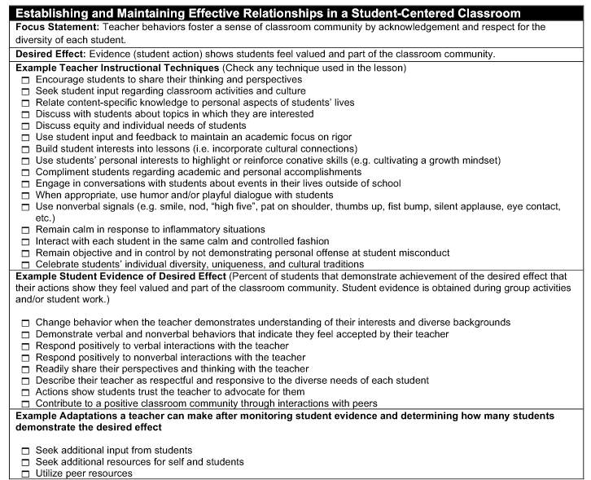

We discussed a number of instructional strategies to improve in this area including:

1. Video yourself and view to assess your volume, tone, and content. Have your principal and/or another teacher view and critique with you.
2. Immediately lower the volume of your voice.
3. Ensure your tone is respectful.
4. Use high fives, etc. to maintain positive rapport.

# Directives for Future Conduct

In addition to the strategies for improvement, you are directed to:

* Refrain from grabbing, holding, or any physical contact with a student.
* Communicate student redirection in an appropriate, respectful manner.

I am in receipt of this letter of direction and understand that failure to follow the above-mentioned directives and/or incorporate instructional strategies may result in disciplinary action.

______________________________________ _______________________

Name of Employee Date

_____________________________________ _______________________

Name of Administrator Date

Cc: Personnel File