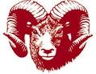
HIGHLANDS SCHOOL DISTRICT
UNPACKING THE STANDARDS Template
Standard:

Knowledge (Nouns)
Skills (Verbs)

Key Understandings/Big ideas (Purpose/Rationale)

Learning Intention(s) with DOK Level(s)

Essential Questions

