3rd, 4th and 5th grade SELF

Supply List

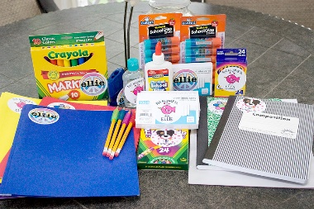

Please send the following items to school with your child: (Please label all supplies with your child’s name)

* A pair of headphones or earbuds for Chromebook (NOT wireless please, they should plug in)
* 2 bottom pocket folders-one labeled “Homework” and one labeled “Classwork”
* A 4-pack of dry erase markers
* 1 marble notebook
* 1 box of tissues
* A plastic supply box to hold the following:
  + A box of pencils (preferably pre-sharpened)
  + A box of crayons
  + A box of markers
  + A pair of safe scissors
  + A package of glue sticks