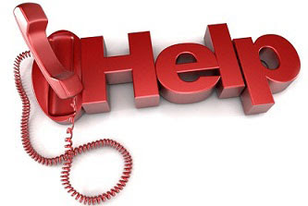

Life Line:
Call 211 or 585-275-5151

NYS Project Hope Emotional Support:
1-844-863-9314

Crisis Text Line:
TEXT GOT5 to 741741

National Suicide Prevention Lifeline:
1-800-223-TALK (8255)

Trevor Lifeline:
1-866-488-7386

Trevor Text:
Text START to 678678

NYS Office of Mental Health Customer Relations:
1-800-597-8481

