KINDERGARTEN
- 1 pack index cards
- 1 backpack, labeled with student’s name
- 12 #2 pencils
- 12 small glue sticks
- 1 pack of 4 Dry Erase Markers
- 2 boxes of 24 crayons
- Clorox wipes
- 1 pair of headphones/earbuds
- 1 gallon and sandwich-sized Ziploc bags
- 2 boxes of facial tissue/Kleenex

GRADE 1
- 2 boxes of 24 crayons
- 24 #2 sharpened pencils with erasers
- 2 pink pearl erasers
- 1 pair of headphones
- 3 Plastic Poly Folders: red, blue, green
- 1 black and white composition notebook
- 1 pack of 4 Dry Erase Markers
- 1 box of gallon size Ziploc bags
- 1 plastic pencil box (optional)
- 1 backpack, labeled with student’s name
- 2 boxes facial tissue/Kleenex
- 3 Packs of 100 Index Cards
- 5 Pack of 3x3 Post It Notes

GRADE 2
- 2 boxes of 24 crayons
- 24 #2 sharpened pencils with erasers
- 1 backpack
- 1 package of Glue Sticks
- 2 boxes facial tissue/Kleenex
- 1 box of thin-tipped colored markers
- 1 two-pocket folder
- 1 box of colored pencils
- 1 pair of headphones

GRADE 3
- 1 box of thin-tipped colored markers
- 1 box of colored pencils
- 24 #2 sharpened pencils with erasers
- 1 box of crayons
- 2 boxes of highlighters
- 1 large pink eraser
- 3 two-pocket folders
- 1 pair of headphones/earbuds
- 5 spiral notebooks: blue, green, yellow, black, red
- 1 two-inch binder
- 3 large boxes facial tissue/Kleenex
- 1 one-gallon zipper bag

GRADE 4
- 1 box thin-tipped colored markers
- 1 box colored pencils
- 24 #2 sharpened pencils
- 1 box crayons
- 1 one-gallon zipper bags
- 1 large box facial tissues/Kleenex
- 5 two-pocket folders: blue, green, yellow, black, red
- 1 pack filler notebook paper
- 4 spiral notebooks: blue, green, yellow, red
- 2 pink pearl erasers
- 1 box of highlighters
- 1 4-pack dry erase markers

GRADE 5
- 1 box thin-tipped markers
- 2 packs of filler notebook paper
- 1 box of colored pencils
- 24 #2 sharpened pencils with erasers
- 1 pink pearl eraser
- Eraser tops for pencils
- 1 pair of headphones or earbuds
- Dictionary
- 1 large box facial tissues/Kleenex
- Post-It notes

Grade 6
- 6 Two--pocket folders: yellow, blue, green, red, purple, black
- 6 spiral notebooks: yellow, blue, green, red, purple, black
- 1 box facial tissues/Kleenex
- Hand sanitizer
- # 2 pencils (5 packs of 12)
- Pens (1 pack)
- Colored pencils (1 pack of 12)
- Clorox Wipes (2)
- Highlighters (4 pack)
- Ear Buds or Headphones
- 2 composition notebooks
- Dry Erase Markers (4 pack)

GRADE 7 & 8
- Dry Erase Markers (4 Pack)
- Hand Sanitizer
- Pencils (5 packs of 12)
- Pens (2 pack)
- Clorox Wipes (canister)
- Highlighters (4 pack)
- Ear Buds or Headphones
- Colored Pencils (1pack of 12)
- 2 spiral notebooks (blue for 7th grade, green for 8th grade)
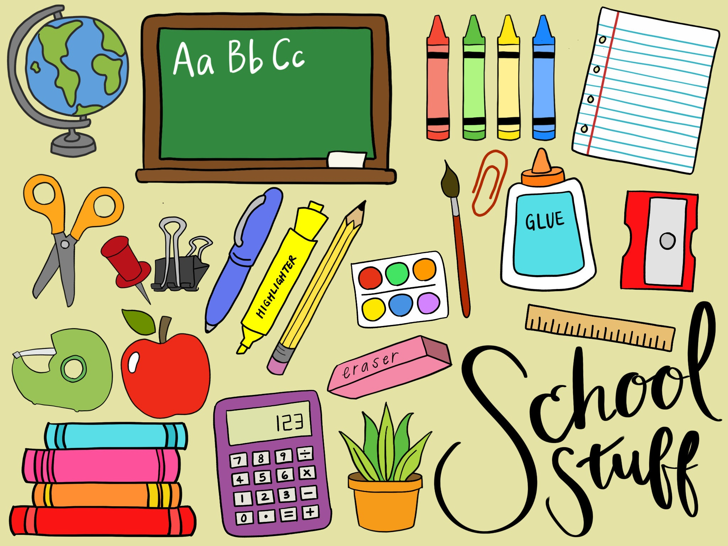

MARY MCLEOD BETHUNE SCHOOL NO. 45
2023-2024 SCHOOL SUPPLY CHECKLIST

