Unit 1 Investigation 4
Name: ____________________________

Period: _____
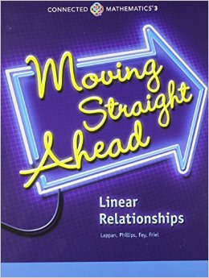

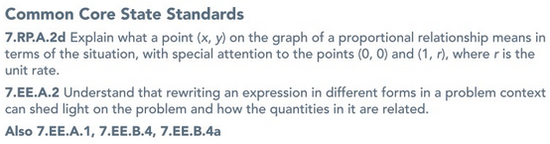

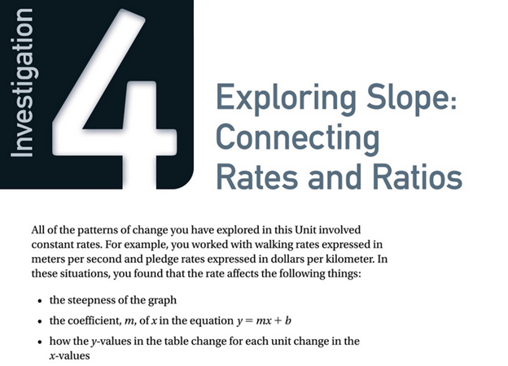
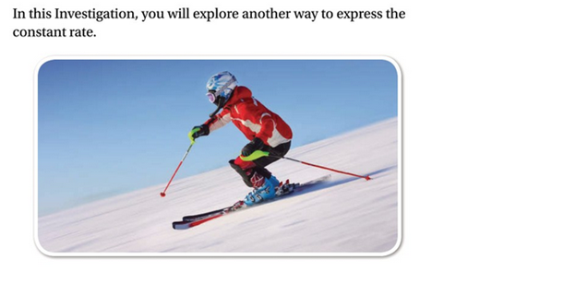
Investigation 4 Focus Questions:

Problem 4.1 – How is the steepness of a set of stairs related to a straight-line graph?
Problem 4.2 – How can you find the y-intercept and the slope of a line from data in a table, graph, or equation?
Problem 4.3 – How can you predict if two lines are parallel or perpendicular from their equations?
Problem 4.4 – What information do you need to write an equation for a linear relationship? Is the expression for the dependent variable always the same?
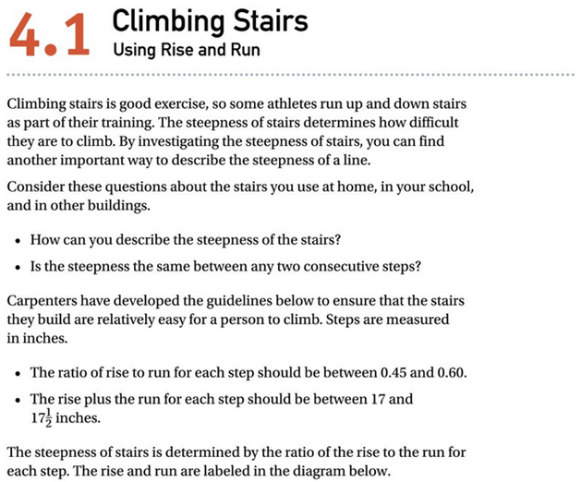
Investigation 4.1 Notes
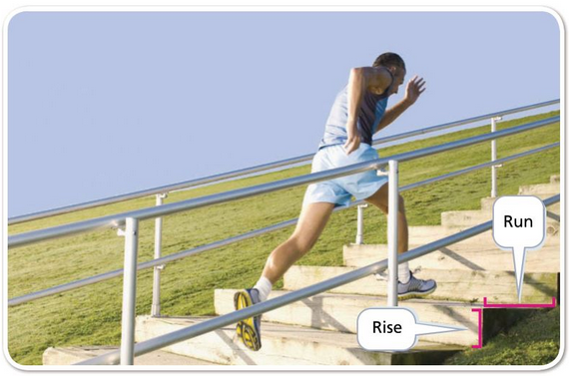

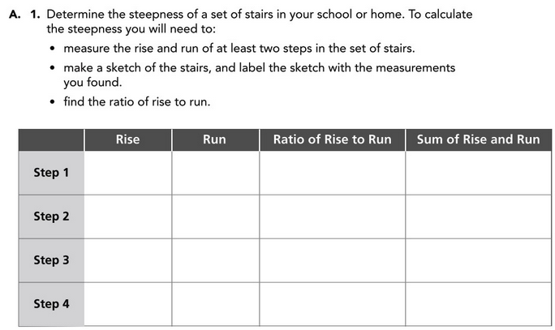

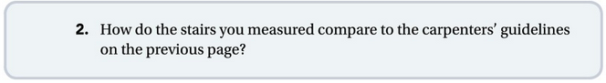

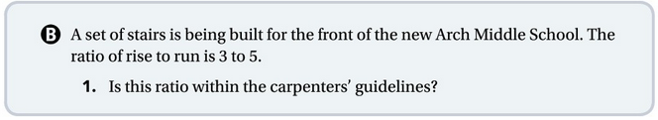

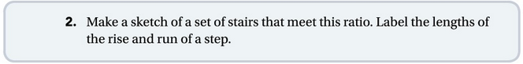


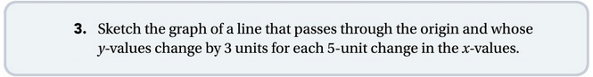







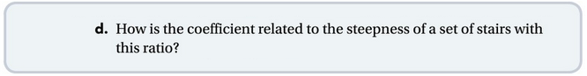

Investigation 4.2 Notes
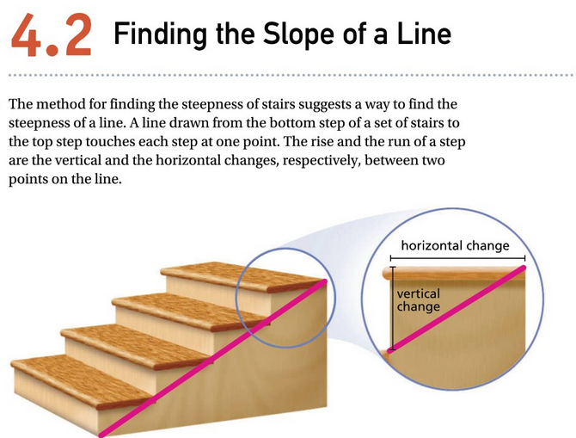
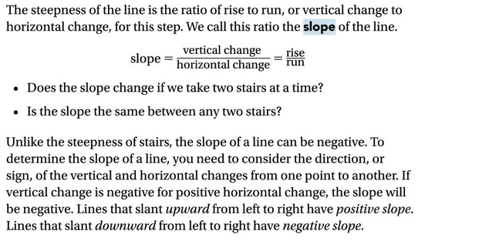
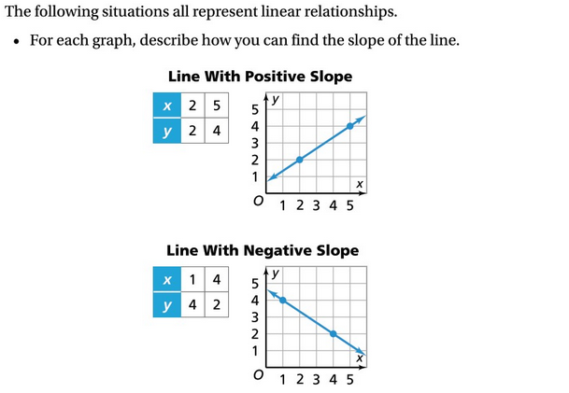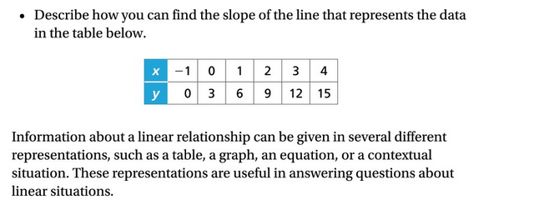
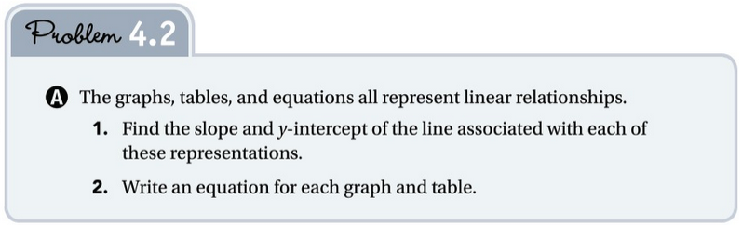
(on next page)
Given Representation | Slope | $y$-Intercept | Equation
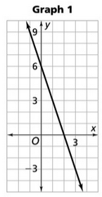
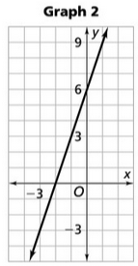
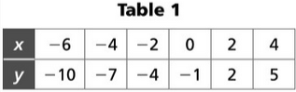
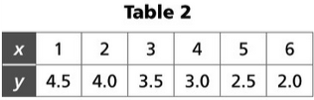
Equation 1  $$y=2.5x+5$$ |  |  | $$y=2.5x+5$$
Equation 2  $$y=20-3x$$ |  |  | $$y=20-3x$$
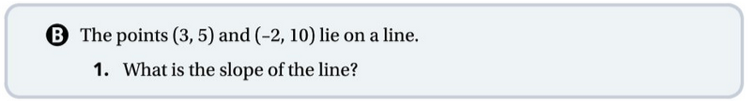



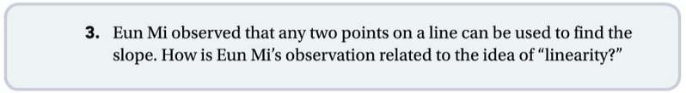

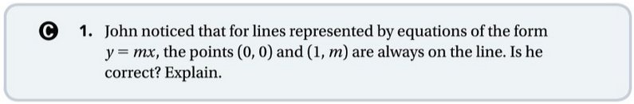

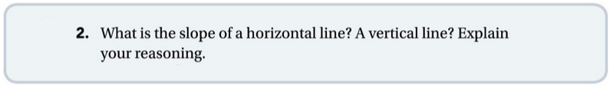

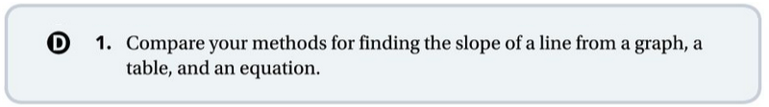

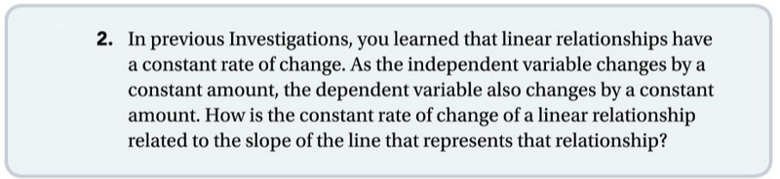

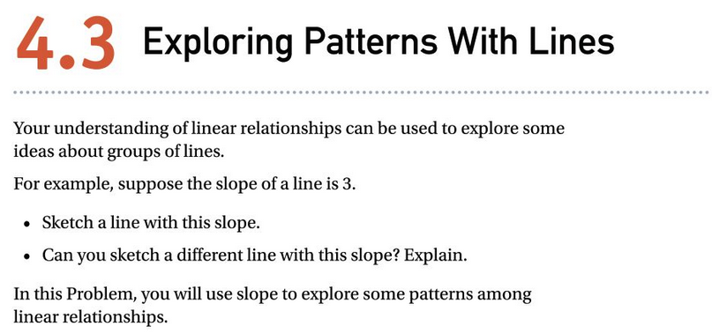
Investigation 4.3 Notes

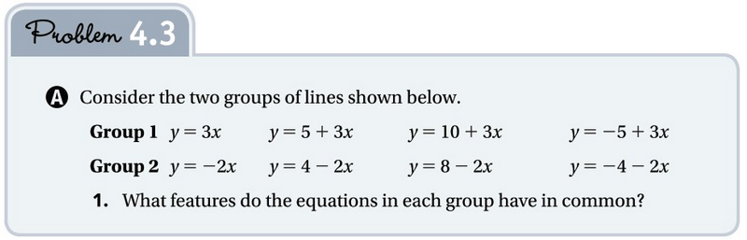
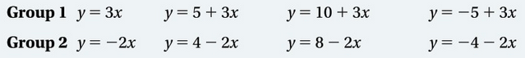
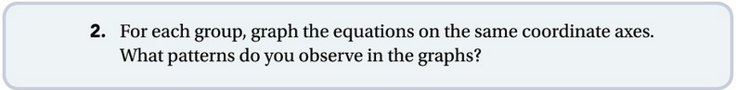

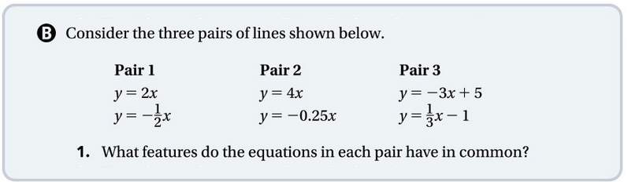

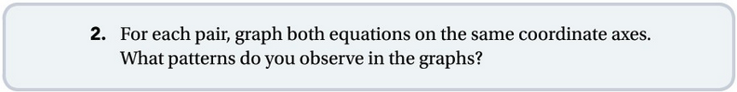


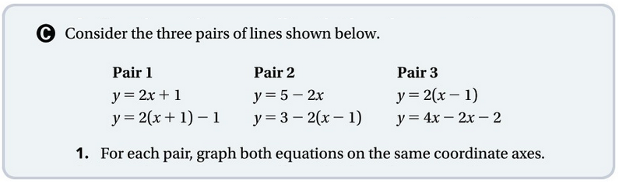

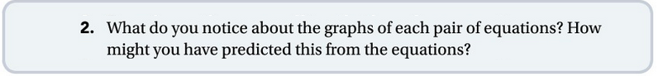

Investigation 4.4 Notes
