Unit 1 Investigation 3

Name: ____________________________

Period: _____
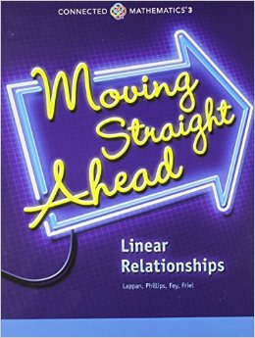

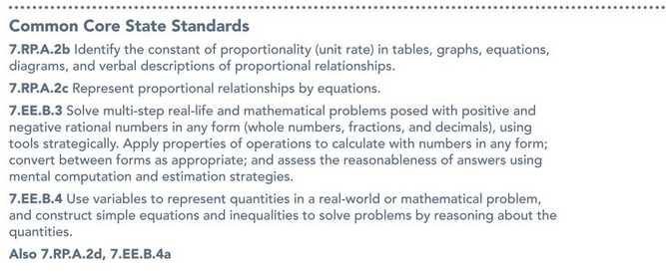
Investigation 3.1 Notes:
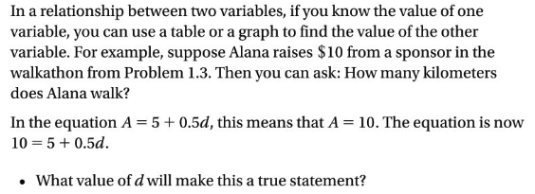

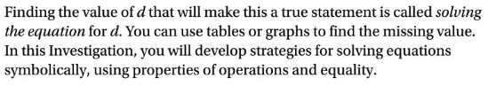

Problem 3.1:
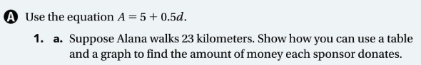

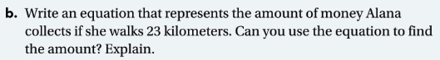

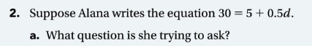

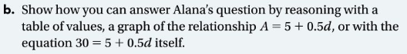

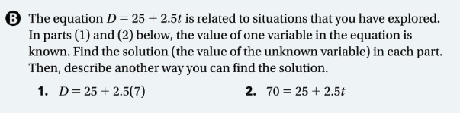

Investigation 3.2 Notes:
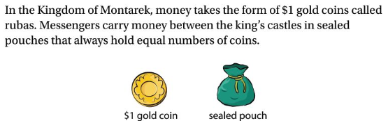

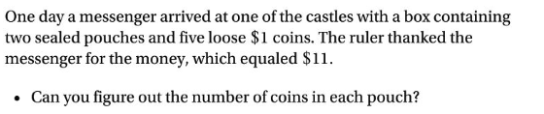

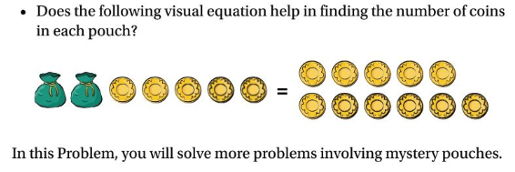

Problem 3.2:

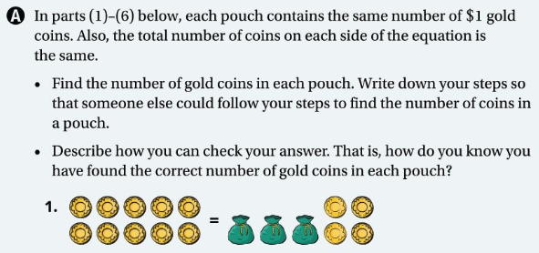

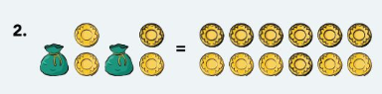

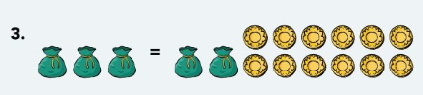

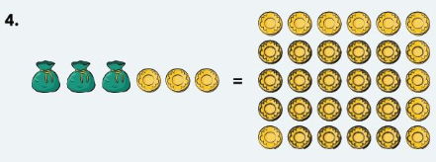

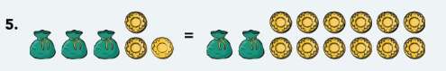

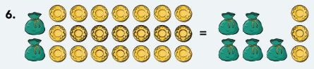

Problem 3.3:

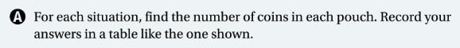

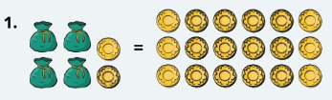

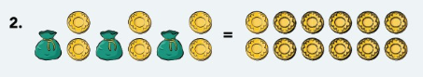

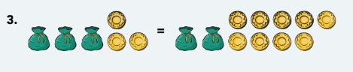

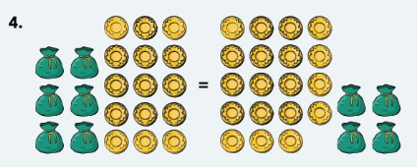

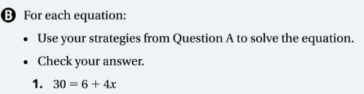

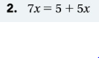

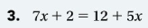

Investigation 3.4 Notes

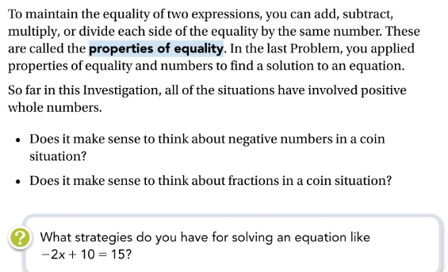

Problem 3.4

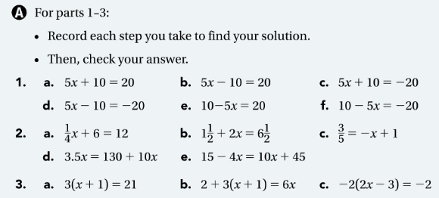

Choose 2 Equations from each row to solve on the next page

Row 1. Equation: Equation:

Row 2. Equation: Equation:

Row 3. Equation: Equation:

Row 4. Equation: Equation:

Row 5. Equation: Equation:

