Scientific Revolution

Background
The Scientific Revolution develops as an offshoot of the Renaissance. The same spirit of inquiry that fueled the Renaissance, led scientists to question traditional beliefs about the workings of the universe. One of the main ideas to come out of the Scientific Revolution was the use of the Scientific Method. The Scientific Method uses observation and experimentation to explain theories on how the universe works.
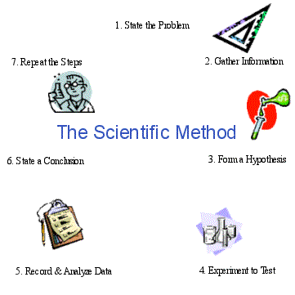
Copernicus
Nicolaus Copernicus developed the heliocentric model of the universe. This states that the sun is the center, and that the earth revolves around it. Despite his calculations, many scholars disagree with his theories and continue to believe in the geocentric model proposed by the ancient Greek Ptolemy 1500 years earlier.
Galileo
Galileo continues Copernicus' work by observing the skies with a homemade telescope. Although he was able to prove Copernicus correct, his work was rejected by the Church and he was forced to recant (take back) or face execution.
Newton
Isaac Newton built upon the earlier work of Copernicus and Galileo and used mathematics to describe gravity as the force that keeps planets revolving around the sun. He also explained that this same force is what causes objects to fall to earth.

