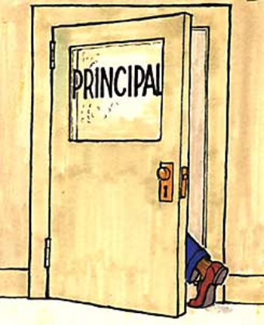
Mentor-Intern-Administrator Scenarios
Breakout Room Instructions 1 March 18, 2024
- Read over the scenarios below, and also think about challenges that as a Mentor you have encountered with Administrators.
- Come to consensus about one or two scenarios to discuss in your Breakout Room (can be from those described below, or provided by a mentor in the Breakout Room). Select additional scenarios to discuss if you have time.
- Identify the core issues in each scenario and discuss how a Mentor might address those issues.
- Generate sentence stems that Mentors might use if faced with this scenario, and add them to our CIT Mentor Padlet:

https://rcsdk12.padlet.org/1266650/CITMENTORADMIN.
- Be sure to give everyone an opportunity to speak and to listen.
- Only share what you feel comfortable sharing,
you always have the option to pass.
- Please respect the privacy of the others in your Breakout Room.
- You are welcome to leave the Breakout Room to return to the main room at any time.
Scenarios (or choose your own):
The vast majority of our Mentor interactions with Administrators are respectful and constructive. Based on actual Mentor experiences, below are some scenarios where they were not . . .

SCENARIO A: “FIX YOUR INTERN!”  Your Intern’s supervisor stops you in the hallway to complain that your Intern keeps sending kids out of the classroom and has a very negative attitude. The Administrator asks you, “What are you going to do about it?!” | SCENARIO B: ABSENTEE ADMINISTRATOR  No administrator has responded to your monthly communication via email, the administrator has not been available when you have visited the school. Your Intern has not received any feedback from the administrator and has no idea what the administrator thinks about the Intern’s performance.
SCENARIO C: ARE WE TALKING ABOUT THE SAME INTERN?  The Intern’s supervisor rates the Intern much higher than you do. You have serious concerns about your Intern’s performance, but the Administrator is oblivious that the Intern is struggling. | SCENARIO D: ADMINISTRATOR SHARING  The Principal calls you into the office. “Staff members are coming to me with complaints about your Intern. They say she smells like weed and is dozing off in grade-level meetings. I’m concerned.”
More on next page
SCENARIO E: MISUSE OF INTERN  The Principal asks your Intern to “babysit” students who were sent to the office. Or . . .  Principal asks Intern to cover classes during prep time or in place of lessons or counseling sessions every week, sometimes several times per week. | SCENARIO F: TARGETED INTERN  The Principal provides only negative, harsh feedback, and only visits the Intern’s most challenging class (and does so almost weekly). The Principal suggests to you that the Intern should transfer to another school. You and your Intern are seeing growth, but your Intern feels dismissed and silenced by the Principal.
SCENARIO G: INVESTIGATION  The Intern calls to tell you that they are being sent home and they are not supposed to return to work until notified pending an investigation. They are supposed to report to the Principal’s office before leaving, and the Intern wants you to accompany them to this meeting. | SCENARIO H: COLLABORATING WITH ADMIN  The Principal stops you in the hallway on your way in to visit your Intern and shares detailed concerns about your Intern’s instruction. “Please let me know what strategies you are working on so I can support you in your efforts to help your Intern improve.”
Or Use One of Your Own!

