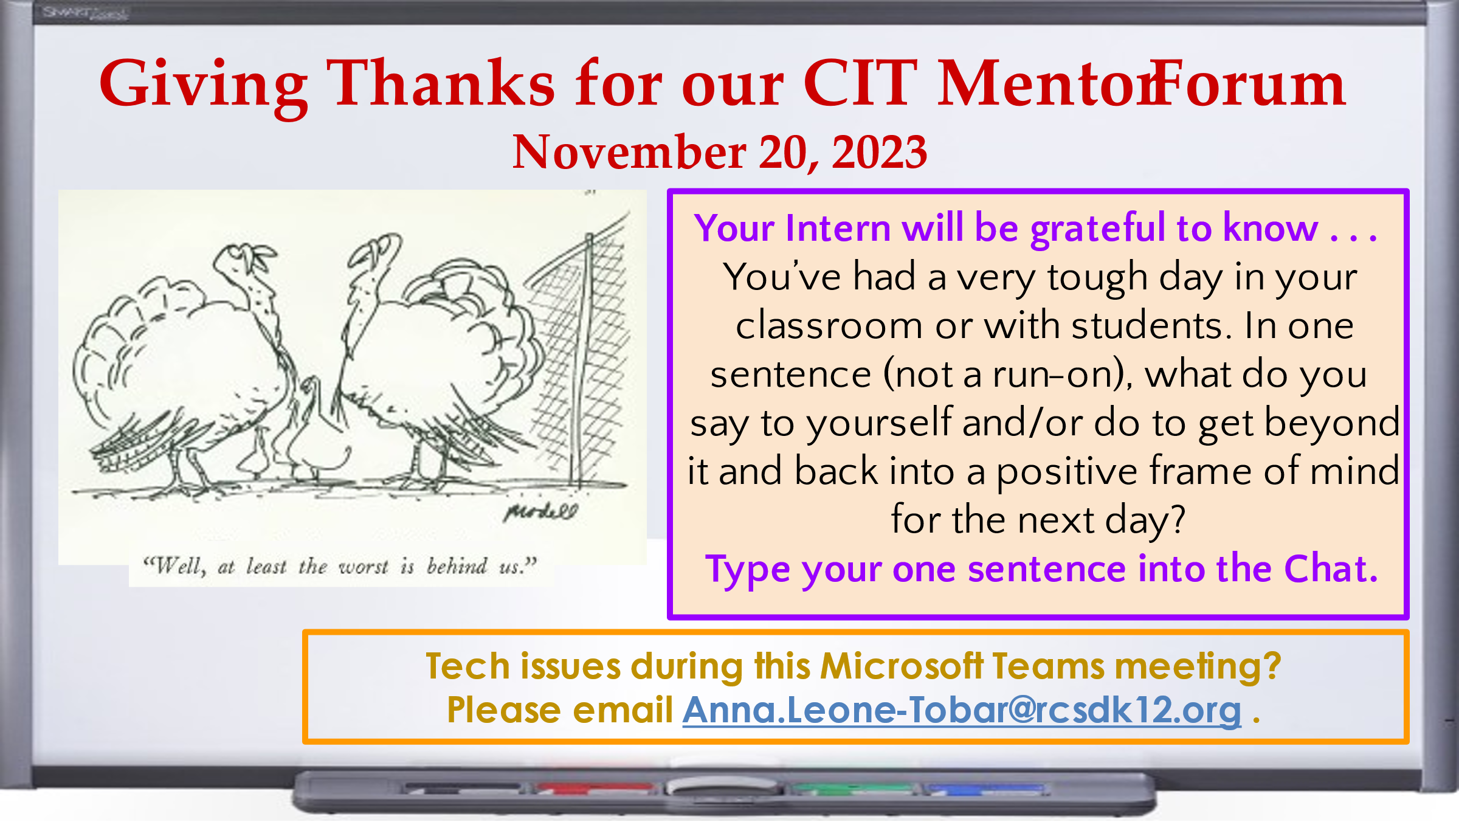

CIT Mentor Forum, November 20. 2023
How Teachers Get Beyond Tough Days in the Classroom
By Larry Ferlazzo — October 22, 2023
See https://www.edweek.org/teaching-learning/opinion-how-teachers-get-beyond-tough-days-in-the-classroom/2023/10

Advice from our CIT Mentors in tonight’s Chat:

This too shall pass.
Today may not have gone as I hoped or expected, but tomorrow is a new day!
Tomorrow is a new day
Tomorrow is another day!
Tomorrow is a new day
Tomorrow is a new day
I email/visit my intern.
Most days are great; there are always bumps in the road!
Just Breath
tomorrow is another day and another fresh start
Tomorrow is a new day
The worst in life can't take the best of me
Tomorrow is a new day.
This too shall pass
What am I going to do tonight to take care of myself?
When I walk out at the day's end I shake my hands like they are wet. Feels like letting go.
Go for a long walk.
I am here for the kids
This isn't easy work, but it is worth it.
Take a deep breath!
Keep breathing
Tomorrow is a brand new day and a fresh start- a re-do
Treat each day as a fresh start. One day isn't the be all, end all.
Try again tomorrow
One day doesn't cancel out a bunch of good days
Tomorrow is a brand new day!
Go to bed early tonight and start fresh tomorrow
Go for a long walk
Fresh start tomorrow
I go home and relax
This is normal!
I'll do better tomorrow
We'll try again tomorrow.
Tomorrow is a new day!
Tomorrow is a new day.
No one wants to be in middle school again. Try again tomorrow.
Be kind to yourself and take a break tonight, tomorrow is a new day.
Breathe and know tomorrow you can try again
Also see:
https://www.edweek.org/teaching-learning/how-to-shake-the-october-blues-and-rediscover-the-joy-in-teaching/2022/10

