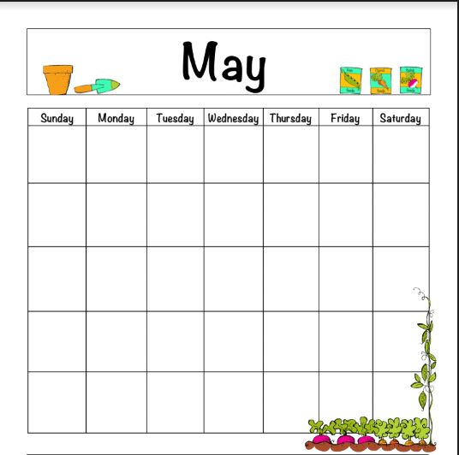
Please write in the title of the book & minutes read each night!

Total Minutes Read in May _____________

