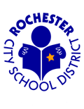
MATCH CHEAT SHEET FOR PSYCHOLOGISTS FOR 504s
Medical Management and Assistive Technology for Children
MATCHTeam@rcsdk12.org

REFERRALS
- General education students may be referred for AT evaluations, but without a documented learning disability qualifying them for a 504, equipment cannot be provided by the MATCH Team. ***The equipment recommendation should NOT drive the 504!
- Assistive Technology should be considered for any student with a disability-no referral is necessary to consider Tier 1-2 supports.

When considering a referral to the Assistive Technology team:
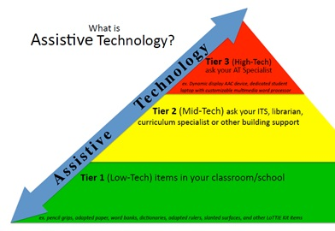
Tier 3 includes laptop, word processor, tablet, augmentative communication device—high tech equipment. It also MAY include service recommendation.
Tier 2 supports could be book on CD, school owned Chromebooks/tablets, pencil grips, special paper, visual schedules.
Tier 1 supports should be tried PRIOR to referral and results documented on the referral form.

MEETINGS
- List equipment under ASSISTIVE TECHNOLOGY DEVICES
- RCSD policy: laptops, computers, word processors, tablets (high tech devices) MUST have a MATCH recommendation to be added to a 504. ** “ACCESS to” one of these devices CAN be added without MATCH and indicates THE BUILDING provides/has this access (Tier 1-2).

MATCH provides BUILDING provides

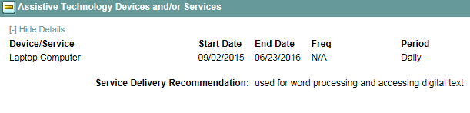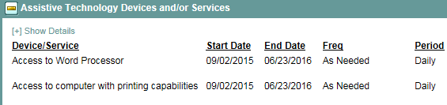

- RCSD policy: AT Service or AT Consultation MUST have a MATCH recommendation to be added to a 504. This service should be listed under Support to Staff on Behalf of the Student.
- If the student has a device already on a 504, please use the Assistive Technology Device Review form to note whether a device will be continued or discontinued. NOTE IN SUMMARY IF REMOVED!
All forms are found on MATCH website: http://www.rcsdk12.org >Departments> MATCH

