
Quick Reference: Assistive Technology for Students with an IEP
Medical Management and Assistive Technology for Children
MATCHTeam@rcsdk12.org

REFERRALS
When considering a referral to the Assistive Technology team:
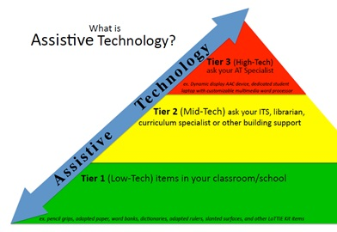
Tier 3 includes laptop, word processor, tablet, augmentative communication device—high tech equipment. It also MAY include service recommendation.
Tier 2 supports could be book on CD, school owned Chromebooks/tablets, pencil grips, special paper, visual schedules.
Tier 1 supports should be tried PRIOR to referral and results documented on the referral form.

CSE MEETINGS
- Assistive Technology should be considered at all meetings (per IDEA)-no referral is necessary to consider Tier 1-2 supports.
- If building team has tried Tier 1-2 supports and HAS DOCUMENTATION that there is a difference in quality/quantity of work with the use of school equipment, please follow guidelines for adding equipment.
- EXISTING assistive technology on the IEP should be reviewed! Please use the Assistive Technology Device Review form to note whether a device will be continued or discontinued. NOTE IN SUMMARY IF REMOVED! Forward a copy to MATCH email.

When adding equipment/assistive technology to the IEP
- Use GENERIC terms (e.g. word processor). DO NOT list specific equipment (e.g. Chromebook, iPad). See list of generic terms in current use.
- List equipment under ASSISTIVE TECHNOLOGY DEVICES.
- RCSD policy: laptops, computers, word processors, tablets (high tech devices) MUST have a MATCH recommendation to be added to the IEP. ** “ACCESS to” a device CAN be added without MATCH and indicates THE BUILDING provides/has this access (Tier 1-2).

MATCH provides BUILDING provides

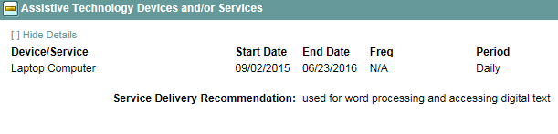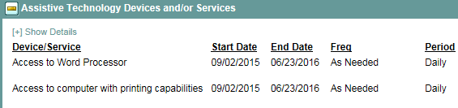

- RCSD policy: AT Service or AT Consultation MUST have a MATCH recommendation to be added to the IEP. This service should be listed under Support to Staff on Behalf of the Student.
- If you get a temp placement with assistive technology equipment or service please NOTIFY MATCH before holding the final meeting.

Generic Terms for assistive technology currently in use (most frequently used):
- Word processor
- Communication device
- Picture symbols
- Digital text (note, this is NOT a device, rather the format of the text allowing for audio support)
**if you have a question about how to document assistive technology, PLEASE ask us!

