World of Inquiry School
School Based Planning Team
October 6, 2016
Minutes
Present:, Nissa Youngren, Sheela Webster, Robert Bond, Kerry Robertson, Ingrid Dickson, Kara Miller, Karen Dingwall,
Ja’Colby Chapman, Bridget Maio, Kim Garlock
Absent: Kamaria Simmons, Kim Garlock, Mike Maloy
Need Elementary Special Ed. Representative, Ingrid to put out a call to all RTA members for nominees.
Updates:
- Receiving of new student rep and new staff member, Bridget Maio
- On Sup Conf Day and agenda for Oct 7th. (Work plan, personal goals based on Learning Targets, afternoon is differentiated sessions (Circle, Goal Setting, Math, Technology, Active Management), and planning time
- Early dismissal Dates:
- Early Dismissal Day October 17, 2016 for students

District Scheduled ½ day planning tentative schedule (3 hours)
Monday, Oct. 17th
Monday, Dec. 5th
Tuesday, Jan. 10th
Monday, March 6th
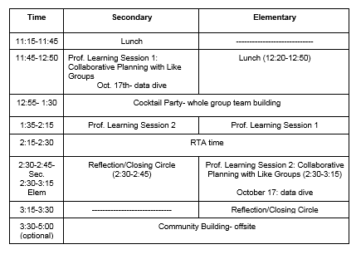
Monday, October 17th Schedule for secondary and elementary:
    - -maintain letter day
    - –Secondary: periods 1-4 for secondary (leave at 11:00am), next time will be 8-5 backwards (lunches at the end)
    - –Elementary: maintain the morning schedule, (leave at 12:15)
    - -must provide both breakfast and lunch for all students K-12
    - -share proposed schedules for school day and professional development
    - For secondary (proposed): lunch on carts delivered to classrooms, as a Title I school we must serve breakfast and lunch. Lunches will be bagged lunches. Elementary is still a work in progress. Minimizing disruption to instruction.

- Review of Design Task Teams

- Health Advisory: K-12, broaden scope to include k-12

- Griffin Pride: include a component to include organizing secondary staff meetings

- Safe and Supportive: No change

- EL Com becomes EL Event Com

- PD; no change

- Elementary High Readiness: refining mission, Sheela, Ingrid, et al will work on it

- No tech committee

- Steering Com: refine role

- Vertical Planning: tasks will be integrated into early dismissal days, disbanded

- Outward Bound: Broaden support, increase fundraising

- SWMM, keep all three levels

- School Service Com: No change

- SLC Committee postponed until next meeting

- Title I Funds
Discussion and explanation of funds from Title I
Approved by unanimous vote
- Future Agenda:
SLC follow-up
Early Dismissal review
REOC Uniform Change
- SCEP
- Calendar-went home for the year in bags K-6, mailed for 8th-12th, will be mailed for 7th grade. Includes all events for staff and families for the year including professional learning and PTC events. Theme- “Conceive, Believe, Achieve”

