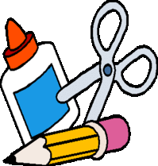
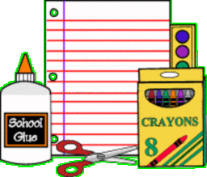
School #46 First Grade
Supply List:

Please do not label supplies, as we will be sharing them in our classroom
community. Thank you!
- 2 boxes of pencils
- 2- 24 packs of Crayola cryaons
- 3 packs of Dry Erase Markers
- 2 packs of markers ( one broad line and one thin line marker)
- 1- 12 pack of colored pencils
- 6 glue sticks
- Ziplock bags (1 gallon size box and 1 sandwich size box)
- disenfectant wipes or spray
- 3 boxes of family sized tissues

** Each student will need a pair of headphones to use, please, no ear buds-they do not work with our Chromebooks! Please mark these with your child’s name



