*Farmington Area Public School District 192* Total Special  
Education System (TSES)

This document serves as the Total Special Education System Plan for *Farmington Area Public School District 192* in accordance with Minnesota Rule 3525.1100 subitem (2). This plan also includes an assurance for compliance with the federal requirements pertaining to districts’ special education responsibilities found in United States Code, title 20, chapter 33, sections 1400 et seq., and Code of Federal Regulations, title 34, part 300. This document is a companion to the Application for Special Education Funds – Statement of Assurances (ED-01350-29).

Kim Chalmers, Farmington Area Public School District*’s* special education director, is responsible for program development, coordination, and evaluation; in-service training; and general special education supervision and administration. Kim may be reached at the ISC, 510 Walnut St., Farmington, MN, phone: (651) 651-463-5022; email: kchalmers@farmington.k12.mn.us

# I. Child Study Procedures

The district’s identification system is developed according to the requirement of nondiscrimination, as Farmington Area Public School Districtdoes not discriminate in education on the basis of race, color, creed, religion, national origin, sex, age, marital status, status with regard to public assistance, sexual orientation, or disability.

## A. Identification

Farmington Area Public School Districthas developed systems designed to identify pupils with disabilities beginning at birth, pupils with disabilities attending public and nonpublic schools, and pupils with disabilities who are of school age and are not attending any school.

Infant and toddler intervention services under United States Code, title 20, chapter 33, section 1431 et seq., and Code of Federal Regulations, title 34, part 303, are available in Farmington Area Public School Districtto children from birth through two years of age who meet the outlined criteria.

The team determines that a child from birth through the age of two years is eligible for infant and toddler intervention services if:

1. the child meets the criteria of one of the disability categories in United States Code, title 20, chapter 33, sections 1400, et. seq., as defined in Minnesota Rules; or
2. the child meets one of the criteria for developmental delay in subitem (1), the criteria in subitem (2) or subitem (3);
3. the child has a diagnosed physical or mental condition or disorder that has a high probability of resulting in developmental delay regardless of whether the child has a demonstrated need or delay; or
4. the child is experiencing a developmental delay that is demonstrated by a score of 1.5 standard deviations or more below the mean, as measured by the appropriate diagnostic measures and procedures, in one or more of the following areas:
5. cognitive development;
6. physical development, including vision and hearing;
7. communication development;
8. social or emotional development; and
9. adaptive development or the child’s eligibility is established through the application of informed clinical opinion. Informed clinical opinion may be used as an independent basis to establish a child’s eligibility under this part even when other instruments do not establish eligibility; however, in no event may informed clinical opinion be used to negate the results of evaluation instruments to establish eligibility.

The team shall determine that a child from the age of three years through the age of six years is eligible for special education when:

1. the child meets the criteria of one of the categorical disabilities in United States Code, title 20, chapter 33, sections 1400 et seq., as defined in Minnesota Rules; or
2. the child meets one of the criteria for developmental delay in subitem (1) and the criteria in subitem (2). Farmington Area Public School Districthas elected the option of implementing these criteria for developmental delay.
3. The child:
4. *has a diagnosed physical or mental condition or disorder that has a high probability or resulting in developmental delay; or*
5. *has a delay in each of two or more of the areas of cognitive development; physical development, including vision and hearing; communication development; social or emotional development; and adaptive development, that is verified by an evaluation using one or more technically adequate, norm-referenced instruments. The instruments must be individually administered by appropriately trained professionals and the scores must be at least 1.5 standard deviations below the mean in each area.*
6. The child’s need for special education is supported by:
7. *at least one documented, systematic observation in the child’s routine setting by an appropriate professional or, if observation in the daily routine setting is not possible, the alternative setting must be justified;*
8. *a developmental history; and*
9. *at least one other evaluation procedure in each area of identified delay that is conducted on a different day than the medical or norm-referenced evaluation; which may include criterion references instruments, language samples, or curriculum-based measures.*

Farmington Area Public School Districtplan for identifying a child with a specific learning disability is consistent with Minnesota Rule 3525.1341. Farmington currently uses discrepancy based eligibility criteria A, B & C for determining if a student has a specific learning disability. Farmington Area Public School Districtplan for identifying a child with a specific learning disability is attached as Appendix A.

### B. Evaluation

The evaluation used to determine whether a child is eligible for infant and toddler intervention services must be conducted within the timelines established in Code of Federal Regulations, title 34, part 303. It must be based on informed clinical opinion; and must be multidisciplinary in nature, involving two or more disciplines or professions; and must be conducted by personnel trained to utilize appropriate methods and procedures. The evaluation must include:

1. A review of the child’s current records related to health status and medical history;
2. an evaluation of the child’s levels of cognitive, physical, communication, social or emotional, and adaptive developmental functioning;
3. an assessment of the unique needs of the child in terms of each of the developmental areas in item B; and
4. at least one documented, systematic observation in the child’s daily routine setting by an appropriate professional or, if observation in the child’s daily setting is not possible, the alternative setting must be justified.

The team shall conduct an evaluation for special education purposes within a reasonable time not to exceed 30 school days from the date the district receives parental permission to conduct the evaluation or the expiration of the 14-calendar day parental response time in cases other than initial evaluation, unless a conciliation conference or hearing is requested.

Farmington Area Public School Districtconducts full and individual initial evaluation before the initial provision of special education and related services to a pupil. The initial evaluation shall consist of procedures to determine whether a child is a pupil with a disability that adversely affects the child’s educational performance as defined in Minnesota Statutes, section 125A.02, who by reason thereof needs special education and related services, and to determine the educational needs of the pupil. The district proposing to conduct an initial evaluation to determine if the child qualifies as a pupil with a disability shall obtain an informed consent from the parent of the child before the evaluation is conducted. Parental consent for evaluation shall not be construed as consent for placement for receipt of special education and related services. The District will not override the written refusal of a parent to consent to an initial evaluation or re-evaluation.

#### Evaluation Procedures

Evaluations and reevaluations shall be conducted according to the following procedures:

1. Farmington Area Public School District shall provide notice to the parents of the pupil, according to Code of Federal Regulations, title 34, sections 300.500 to 300.505, that describes any evaluation procedures the district proposes to conduct.
2. In conducting the evaluation, Farmington Area Public School District shall:
3. use a variety of evaluation tools and strategies to gather relevant functional and developmental information, including information provided by the parent, that are designed to assist in determining whether the child is a pupil with a disability and the content of the pupil’s individualized education program, including information related to enabling the pupil to be involved in and profess in the general curriculum, or for preschool pupils, to participate in appropriate activities;
4. not use any single procedure as the sole criterion for determining whether a child is a pupil with a disability or determining an appropriate education program for the pupil; and
5. use technically sound instruments that are designed to assess the relative contribution of cognitive and behavioral factors, in addition to physical or developmental factors.
6. Farmington Area Public School District ensures that:
7. tests and other evaluation materials used to evaluate a child under this part are selected and

administered so as not be discriminatory on a racial or cultural basis, and are provided and administered in the pupil’s native language or other mode of communication, unless it is clearly not feasible to do so;

1. materials and procedures used to evaluate a child with limited English proficiency are selected and administered to ensure that they measure the extent to which the child has a disability and needs special education and related services, rather than measure the child’s English language skills;
2. any standardized tests that are given to the child have been validated for the specific purpose for which they are used, are administered by trained and knowledgeable personnel, and are administered in accordance with any instructions provided by the producer of such tests;
3. the child is evaluated in all areas of suspected disability, including, if appropriate, health, vision, hearing, social and emotional status, general intelligence, academic performance, communicative status, and motor abilities;
4. evaluation tools and strategies that provide relevant information that directly assists persons in determining the educational needs of the pupil are provided;
5. if an evaluation is not conducted under standard conditions, a description of the extent to which it varied from standard conditions must be included in the evaluation report;
6. tests and other evaluation materials include those tailored to evaluate specific areas of educational need and not merely those that are designed to provide a single general intelligence quotient;
7. tests are selected and administered so as best to ensure that if a test is administered to a child with impaired sensory, manual, or speaking skills, the test results accurately reflect the child’s aptitude or achievement level or whatever other factors the test purports to measure, rather than reflecting the child’s impaired sensory, manual, or speaking skills, unless those skills are the factors that the test purports to measure; and
8. in evaluating each pupil with a disability, the evaluation is sufficiently comprehensive to identify all of the pupil’s special education and related service needs, whether or not commonly linked to the disability category in which the pupil has been classified.
9. Upon completion of administration of tests and other evaluation materials, the determination of whether the child is a pupil with a disability as defined in Minnesota Statutes, section 125A.02, shall be made by a team of qualified professionals and the parent of the pupil in accordance with item E, and a copy of the evaluation report and the documentation of determination of eligibility will be given to the parent.
10. In making a determination of eligibility under item D, a child shall not be determined to be a pupil with a disability if the determinant factor for such determination is lack of instruction in reading or math or limited English proficiency, and the child does not otherwise meet eligibility criteria under parts 3525.1325 to 3525.1351.

#### Additional requirements for evaluations and reevaluations

1. As part of an initial evaluation, if appropriate, and as part of any reevaluation under this part, or a reinstatement under part 3525.3100, the IEP team and other qualified professionals, as appropriate, shall:
2. review existing evaluation data on the pupil, including evaluations and information provided by the parents of the pupil, current classroom-based assessments and observations, and teacher and related services providers observation; and
3. on the basis of the review, and input from the pupil's parents, identify what additional data, if any, are needed to determine whether the pupil has a particular category of disability, as described in Minnesota Statutes, section 125A.02, or, in case of a reevaluation of a pupil, whether the pupil continues to have such a disability, the present levels of performance and educational needs of the pupil, whether the pupil needs special education and related services, or in the case of a reevaluation of a pupil, whether the pupil continues to need special education and related services, and whether any additions or modifications to the special education and related services are needed to enable the pupil to meet the measurable annual goals set out in the individualized education program of the pupil and to participate, as appropriate, in the general curriculum.
4. The district shall administer such tests and other evaluation materials as may be needed to produce the data identified by the IEP team under item A, subitem (2).
5. Each district shall obtain informed parental consent, in accordance with subpart 1, prior to conducting any reevaluation of a pupil, except that such informed parental consent need not be obtained if the district can demonstrate that it had taken reasonable measures to obtain such consent and the pupil's parent has failed to respond.
6. If the IEP team and other qualified professionals, as appropriate, determine that no additional data are needed to determine whether the pupil continues to be a pupil with a disability, the district shall notify the pupil's parents of that determination and the reasons for it, and the right of such parents to request an evaluation to determine whether the pupil continues to be a pupil with a disability, and shall not be required to conduct such an evaluation unless requested to by the pupil's parents.
7. A district shall evaluate a pupil in accordance with this part before determining that the pupil is no longer a pupil with a disability.

When restrictive procedures are used twice in 30 days or when a pattern emerges and restrictive procedures are not included in a child's individualized education program or behavior intervention plan, the district must hold a meeting of the individualized education program team, conduct or review a functional behavioral analysis, review data, consider developing additional or revised positive behavioral interventions and supports, consider actions to reduce the use of restrictive procedures, and modify the individualized education program or behavior intervention plan as appropriate. At the meeting, the team must review any known medical or psychological limitations that contraindicate the use of a restrictive procedure, consider whether to prohibit that restrictive procedure, and document any prohibition in the individualized education program or behavior intervention plan.

#### Procedures for determining eligibility and placement

1. In interpreting the evaluation data for the purpose of determining if a child is a pupil with a disability under parts 3525.1325 to 3525.1351 and the educational needs of the child, the school district shall:
2. draw upon information from a variety of sources, including aptitude and achievement tests, parent input, teacher recommendations, physical condition, social or cultural background, and adaptive behavior; and
3. ensure that the information obtained from all of the sources is documented and carefully considered.
4. If a determination is made that a child is a pupil with a disability who needs special education and related services, an IEP must be developed for the pupil according to part 3525.2810.

#### Evaluation report

An evaluation report must be completed and delivered to the pupil's parents within the specified evaluation timeline. At a minimum, the evaluation report must include:

1. a summary of all evaluation results;
2. documentation of whether the pupil has a particular category of disability or, in the case of a reevaluation, whether the pupil continues to have such a disability;
3. the pupil's present levels of performance and educational needs that derive from the disability;
4. whether the child needs special education and related services or, in the case of a reevaluation, whether the pupil continues to need special education and related services; and
5. whether any additions or modifications to the special education and related services are needed to enable the pupil to meet the measurable annual goals set out in the pupil's IEP and to participate, as appropriate, in the general curriculum.

### C. Plan for Receiving Referrals

Farmington Area Public School District plan for receiving referrals from parents, physicians, private and public programs, and health and human services agencies is attached as Appendix B.

II. Method of Providing the Special Education Services for the Identified Pupils

Farmington Area Public School District provides a full range of educational service alternatives. All students with disabilities are provided the special instruction and services that are appropriate to their needs. The following is representative of Farmington Area Public School District’s method of providing the special education services for the identified pupils, sites available at which service may occur, and instruction and related services are available.

Appropriate program alternatives to meet the special education needs, goals, and objectives of a pupil are determined on an individual basis. Choice of specific program alternatives are based on the pupil’s current levels of performance, pupil special education needs, goals, and objectives, and must be written in the IEP. Program alternatives are comprised of the type of services provided, the setting in which services occur, and the amount of time and frequency in which special education services occur. A pupil may receive special education services in more than one alternative based on the IEP or IFSP.

1. Method of providing the special education services for the identified pupils:
2. *one on one services*
3. small group
4. co-teaching
5. indirect services (consultation)
6. direct service in general education classroom
7. work-based services
8. community-based services
9. Sites available at which services may occur:

*Examples: residential, day programs, mental health, chemical dependency, eating disorders), hospitals, correctional facilities (juvenile and adult detention centers, jails), shelter care facilities, alternative learning centers and programs. Also include early childhood sites, i.e., home, district early childhood special education classroom, and community-based programs.*

1. Farmington Senior High, 20655 Flagstaff Avenue, Farmington, MN 55024 – Grades 9-12 general and special education services
2. Levi P. Dodge Middle School, 4200 208th Street West, Farmington, MN - Grades 6-8 general and special education services (settings 1 & 2)
3. Robert Boeckman Middle School, 800 Denmark Avenue, Farmington, MN - Grades 6-8 general and special education services (settings 1 & 2)
4. Meadowview Elementary School, 6100 195th Street West, Farmington, MN - Grades Preschool-5 general and special education services (settings 1 & 2; Moderate - Severe Cognitive Disabilities )
5. North Trail Elementary School,5580 170th Street West, Farmington, MN - Grades K-5 general and special education services (settings 1 & 2 )
6. Farmington Elementary School, 500 Maple Street, Farmington, MN - Grades K-5 general and special education services (settings 1 & 2 )
7. Riverview Elementary School, 4100 208th Street West, Farmington, MN-Grades K-5 general and special education services (settings 1 & 2; Moderate - Severe Cognitive Disabilities )
8. 917 Intermediate School District. Programs, services and locations can be accessed by clicking on the following link: <http://www.isd917.k12.mn.us/Site_Based_Programs.html>
9. Homebound and home-based services
10. Available instruction and related services:
11. Direct specialized instruction
12. Consultation services
13. Health Services
14. Physical Therapy
15. School Psychology Services
16. Social Work Services
17. Occupational Therapy
18. Physical Therapy
19. Audiological Services
20. Vision Services
21. Music Therapy

## III. Administration and Management Plan.

Farmington Area Public School District utilizes the following administration and management plan to assure effective and efficient results of child study procedures and method of providing special education services for the identified pupils:

1. The following table illustrates the organization of administration and management to assure effective and efficient results of child study procedures and method of providing special education services for the identified pupils:

| **Staff Name and Title** | **Contact Information (phone/email/mailing address/office location)** | **Brief Description of Staff Responsibilities relating to child study procedures and method of providing special education services** | **Additional Information** |
| --- | --- | --- | --- |
| |  | | --- | | [Kim Chalmers](mailto:kchalmers@farmington.k12.mn.us), Director of Special Services | | (651) 463-5022  ISC – 510 Walnut Street, Farmington, Minnesota 55024 | |  | | --- | | Duties involve the supervision of special education staff, program development, program evaluation, fiscal/budget administration of special needs programming, and oversight of due process and compliance requirements. | |  |
| |  |  | | --- | --- | | |  | | --- | | [Craig Mares](mailto:cmares@farmington.k12.mn.us), Assistant Director of Special Services | | | (651) 463-5078  ISC – 510 Walnut Street, Farmington, Minnesota 55024 | Early childhood special education coordination. Department chair for elementary special education programs. |  |
| |  | | --- | | [Marcia Borka,](mailto:mborka@farmington.k12.mn.us) ECSE Inake Coordinator | | (651) 463-5066  Birth-2 - Extended Campus -211 3rd Street, Farmington, MN 55024 | Early childhood special education coordination. |  |

1. Due Process assurances available to parents: Farmington Area Public School Districthas appropriate and proper due process procedures in place to assure effective and efficient results of child study procedures and method of providing special education services for the identified pupils, including alternative dispute resolution and due process hearings. *A description of these processes are as follows:*
2. Prior written notice to a) inform the parent that except for the initial placement of a child in special education, the school district will proceed with its proposal for the child’s placement or for providing special education services unless the child’s parent notifies the district of an objection within 14 days of when the district sends the prior written notice to the parent; and b) state that a parent who objects to a proposal or refusal in the prior written notice may request a conciliation conference or another alternative dispute resolution procedure.
3. Farmington Area Public School District will not proceed with the initial evaluation of a child, the initial placement of a child in a special education program, or the initial provision of special education services for a child without the prior written consent of the child’s parent. A district may not override the written refusal of a parent to consent to an initial evaluation or reevaluation.
4. A parent, after consulting with health care, education, or other professional providers, may agree or disagree to provide the parent’s child with sympathomimetic medications unless medical, dental, mental and other health services are necessary, in the professional's judgment, that the risk to the minor's life or health is of such a nature that treatment should be given without delay and the requirement of consent would result in delay or denial of treatment.
5. Parties are encouraged to resolve disputes over the identification, evaluation, educational placement, manifestation determination, interim alternative educational placement, or the provision of a free appropriate public education to a child with a disability through conciliation, mediation, facilitated team meetings, or other alternative process. All dispute resolution options are voluntary on the part of the parent and must not be used to deny or delay the right to a due process hearing. All dispute resolution processes are provided at no cost to the parent.
6. Conciliation Conference: a parent has the opportunity to meet with appropriate district staff in at least one conciliation conference if the parent objects to any proposal of which the parent receives prior written notice. Farmington Area Public School District holds a conciliation conference within ten calendar days from the date the district receives a parent’s objection to a proposal or refusal in the prior written notice. All discussions held during a conciliation conference are confidential and are not admissible in a due process hearing. Within five school days after the final conciliation conference, the district must prepare and provide to the parent a conciliation conference memorandum that describes the district’s final proposed offer of service. This memorandum is admissible in evidence in any subsequent proceeding.
7. In addition to offering at least one conciliation conference, Farmington Area Public School District informs parents of other dispute resolution processes, including at least medication and facilitated team meetings. The fact that an alternative dispute resolution process was used is admissible in evidence at any subsequent proceeding. State-provided mediators and team meeting facilitators shall not be subpoenaed to testify at a due process hearing or civil action under special education law nor are any records of mediators or state-provided team meeting facilitators accessible to the parties.
8. Descriptions of the mediation process, facilitated team meetings, state complaint, and impartial due process hearings may be found in Farmington Area Public School District’s Procedure Safeguard Notice, attached as Appendix C*.*

## IV. Operating Procedures of Interagency Committees

1. Community Transition Interagency Committee:
2. Farmington Area Public School District is a member of the Dakota County Community Transition Interagency Committee (CTIC) is established in cooperation with other districts in Dakota County for youth with disabilities, beginning at grade 9 or age equivalent, and their families.
3. Dakota County CTIC Governing Membership and Additional Stakeholders: Appendix H
4. The co-chairs of the Community Transition Interagency Committee are Bill Schwartz and Suzette Scheele.
5. The CTIC meets on the second Monday of the month at the Dakota County Technical College, 1300 145th Street East, Rosemount, MN 55068.
6. The Community Transition Interagency Committee’s operating procedures are attached as Appendix D, and include the following:
7. identification of current services, programs, and funding sources provided within the community for secondary and postsecondary aged youth with disabilities and their families;
8. facilitation of the development of multiagency teams to address present and future transition needs of individual students on their individualized education programs;
9. development of a community plan to include mission, goals, and objectives, and an implementation plan to assure that transition needs of individuals with disabilities are met;
10. recommendations of changes or improvements in the community system of transition services;
11. exchange of agency information such as appropriate data, effectiveness students, special projects, exemplary programs, and creative funding of programs; and
12. preparation of a yearly summary assessing the progress of transition services in the community including follow-up of individuals with disabilities who were provided transition services to determine post-school outcomes.
13. The CTIC disseminates the summary to all adult services agencies involved in the planning and the MDE by October 1 of each year. The most current summary is attached as Appendix E.

## Interagency Early Intervention Committee

1. Farmington Area Public School District is a member of the Region 11 Interagency Early Intervention Committee (<http://www.ecsu.k12.mn.us/programsServices/specialeducation/helpMeGrow.html>). This committee is established for children with disabilities under age five and their families.
2. Region 11Interagency Early Intervention Committee consists of the following individuals:

Anoka County Parent TBD Parent

Carver County Parent TBD Parent

Dakota County Parent TBD Parent

Hennepin County Parent Andrea Robinson Parent

Ramsey County Parent Jessica Mattson Parent

Scott County Parent TBD Parent

Washington County Parent TBD Parent

Anoka County IEIC Cathy Lombard Education Special Education Director

Former Carver County IEIC Chris Hansen ECSE Coordinator

Former Dakota County IEIC Janell Schilman Social Services - Help Me Grow Interagency Coordinator

Former Minneapolis IEIC Stephanie Graves Maternal and Child Health MCH Coordinator

Former North Suburban Ramsey/St. Paul IEIC Jayne Cox-Lindsey St. Paul/North Suburban Help Me Grow Service Coordinator/Supervisor

Former NW Hennepin County IEIC Diana Huffman NW Hennepin Help Me Grow Central Intake/Interagency Service Coordinator

Former Robbinsdale IEIC Judy Pilz Hennepin County Health Dept.

Former Scott County IEIC Sharon DeZeeuw Social Services Social Work Case Manager DD

Former South Hennepin County IEIC Jean Cady Richfield ECSE Special Education Supervisor

Former St. Paul IEIC Laura Shae ECSE Supervisor

Former Washington County IEIC Mary Jo Hei ECSE Coordinator/Service Provider

Former West Suburban IEIC Lori Fildes ECSE Director of Special Education

Health Phyllis Haag Ramsey County Dept. of Public Health and Environment PHN Clinician, Family

Health Supervisor Human Services Suzanne Levy Ramsey County Social Services Developmental

Disabilities

County Boards Julie Ring Association of MN Counties Legislative Coordinator & Health and Human

Region 11 Help Me Grow IEIC Project Coordinator Marty Smith marty.smith@metroecsu.org Phone: 651.247.3429

FAX: 612-706-0811

Region 11 Help Me Grow IEIC Child Find Coordinator Kathy McKay kathy.mckay@metroecsu.org

Phone: 651.728.0400

Fax: 612.706.0811

1. The chair of the Early Intervention Committee is Suzie Levy.
2. The Early Intervention Committee meets approximately 5 times during the school year.
3. The Early Intervention Committee’s operating procedures are attached as Appendix F, and include the following:
   1. development of public awareness systems designed to inform potential recipient families, especially parents with premature infants, or infants with other physical risk factors associated with learning or development complications, of available programs and services;
   2. reduction of families’ need for future services, and especially parents with premature infants, or infants with other physical risk factors associated with learning or development complications, implement interagency child find systems designed to actively seek out, identify, and refer infants and young children with, or at risk of, disabilities, including a child under the age of three who: (i) is involved in a substantiated case of abuse or neglect or (ii) is identified as affected by illegal substance abuse, or withdrawal symptoms resulting from prenatal drug exposure;
   3. establishment and evaluation of the identification, referral, child and family assessment systems, procedural safeguard process, and community learning systems to recommend, where necessary, alterations and improvements;
   4. assurances of the development of individualized family service plans for all eligible infants and toddlers with disabilities from birth through age two, and their families, and individualized education programs and individual service plans when necessary to appropriately serve children with disabilities, age three and older, and their families and recommend assignment of financial responsibilities to the appropriate agencies;
   5. implementation of a process for assuring that services involve cooperating agencies at all steps leading to individualized programs;
   6. facilitation of the development of a transitional plan if a service provider is not recommended to continue to provide services;
   7. identification of the current services and funding being provided within the community for children with disabilities under age give and their families;
   8. development of a plan for the allocation and expenditure of additional state and federal early intervention funds under United States Code, title 20, section 1471 et seq. (Part C, Public Law 108-446) and United States Code, title 20, section 631, et seq. (Chapter I, Public Law 89-313) (this plan in attached as *Appendix F**);* and
   9. development of a policy that is consistent with section 13.05, subdivision 9, and federal law to enable a member of an interagency early intervention committee to allow another member access to data classified as not public (this policy is attached at *Appendix F**).*
   10. identification and assistance in removing state and federal barriers to local coordination of services provided to children with disabilities;
   11. identification of adequate, equitable, and flexible use of funding by local agencies for these services;
   12. implementation of polices that ensure a comprehensive and coordinated system of all state and local agency services, including multidisciplinary assessment practices, for children with disabilities ages three to 21;
   13. use of a standardized written plan for providing services to a child with disabilities developed under section 125A.023;
   14. access the coordinated dispute resolution system and incorporate the guidelines for coordinating services at the local level, consistent with section 125A.023;
   15. use the evaluation process to measure the success of the local interagency effort in improving the quality and coordination of services to children with disabilities ages three to 21 consistent with section 125A.023;
   16. development of a transitional plan for children moving from the interagency early childhood intervention system under sections 125A.259 to 125A.48 into the interagency intervention service system under this section;
   17. coordination of services and facilitation of payment for services from public and private institutions, agencies, and health plan companies; and
   18. share needed information consistent with state and federal data practices requirements.
4. The Early Intervention Committee participates in needs assessment and program-planning activities conducted by local social service, health and education agencies for young children with disabilities and their families.
5. The Early Intervention Committee reviews and comments on the early intervention service of this Total Special Education System Plan for Farmington Area Public School District, the county social service plan, the section(s) of the community health services plan that addresses needs of and service activities targeted to children with special health care needs, the section on children with special needs in the county child care fund plan, sections in Head Start plans on coordinated planning and services for children with special needs, any relevant portions of early childhood education plans, such as early childhood family education or school readiness, or other applicable coordinated school and community plans for early childhood programs and services, and the section of the maternal and child health special project grants that address needs of and service activities targeted to children with chronic illness and disabilities.

V. Interagency Agreements the District has Entered

Farmington Area Public School District has entered in the following interagency agreements or joint powers board agreements for eligible children, ages 3 to 21, to establish agency responsibility that assures that coordinated interagency services are coordinated, provided, and paid for, and that payment is facilitated from public and private sources:

| **Name of Agency** | **Terms of Agreement** | **Agreement Termination/ Renewal Date** | **Comments** |
| --- | --- | --- | --- |
| Intermediate School District 917 | Joint Powers Agreement | Annual | The mission of the special education programs of Intermediate School  District 917 is to provide students with disabilities an appropriate  individualized educational program in collaboration with their home  district. These programs and services are offered because the local school districts desire comprehensive special education services that can be offered with enhanced efficiency through a cooperative arrangement under the  direction of District 917. |

## VI. Special Education Advisory Council

In order to increase the involvement of parents of children with disabilities in district policymaking and decision-making, Farmington Area Public School District has a special education advisory council.

1. Farmington Area Public School District Special Education Advisory Council is individually established
2. Farmington Area Public School District*’s* Special Education Advisory Council is not a subgroup of an existing board/council/committee.
3. Farmington Area Public School District*’s* Special Education Advisory Council consists of the following individuals:
   1. Kim Chalmers (school district employee - Director)
   2. Craig Mares (school district employee - Assistant Director)
   3. Heath Oldenburg (parent, co-chair)
   4. Julie Oldenburg (parent, co-chair)
   5. Nancy Aarestad (parent)
   6. Michelle Albeck (parent)
   7. Heather Bergstrom (parent)
   8. Michele Dahn (parent)
   9. Angela Field (parent)
   10. Katie Navratil (parent)
   11. Lisa Reichelt (principal)
   12. Alysha Olson (teacher)
4. Farmington Area Public School District Special Education Advisory Council meets at least 2 times per year (fall and spring).
5. The operational procedures of Farmington Area Public School District Special Education Advisory Council are attached as *Appendix G**.*

## VII. Assurances

Code of Federal Regulations, section 300.201: Consistency with State policies*.* Farmington Area Public School District, in providing for the education of children with disabilities within its jurisdiction, has in effect policies, procedures, and programs that are consistent with the State policies and procedures established under sections 300.101 through 300.163, and sections 300.165 through 300.174. (Authority: 20 U.S.C. § 1413(a)(1)).

*Yes:* Assurance given.

Appendix A: Click here to return to TSES

**Specific Learning Disability (Farmington Public Schools uses A, B & C)**

**Definition**

"Specific learning disability means a disorder in one or more of the basic psychological processes involved in understanding or in using language, spoken or written, that may manifest itself in the imperfect ability to listen, think, speak, read, write, spell or do mathematical calculations, including conditions such as perceptual disabilities, brain injury, minimal brain dysfunction, dyslexia, and developmental aphasia.

The disorder is:

1. manifested by interference with the acquisition, organization, storage, retrieval, manipulation, or expression of information so that the individual does not learn at an adequate rate for the child’s age or to meet state-approved grade-level standards when provided with the usual developmental opportunities and instruction from a regular school environment.
2. demonstrated primarily in academic functioning, but may also affect other developmental, functional, and life adjustment skill areas; and may occur with, but cannot be primarily the result of: visual, hearing, or motor impairment; cognitive impairment; emotional disorder; or environmental, cultural, economic influences, limited English proficiency or lack of appropriate instruction in reading or math.

**Criteria**

A child is eligible and in need of special education and related services for a specific learning disability when the child meets the criteria in items A, B, and C or in items A, B, and D below. Information about each item must be sought from the parent and must be included as part of the evaluation data. The evaluation data must confirm that the effects of the child’s disability occur in a variety of settings. The child must receive two interventions, as defined in Minnesota Statutes, section 125A.56, prior to evaluation, unless the parent requests an evaluation or the IEP team waives this requirement because it determines the child’s need for an evaluation is urgent.

* 1. The child does not achieve adequately in one or more of the following areas: oral expression, listening comprehension, written expression, basic reading skills, reading comprehension, reading fluency, mathematics calculation or mathematical problem solving, in response to appropriate classroom instruction and either:
     1. the child does not make adequate progress to meet age or state-approved grade-level standards in one or more of the areas listed above when using a process based on the child’s response to scientific, research-based interventions (SRBI) or:
     2. the child exhibits a pattern of strengths and weaknesses in performance, achievement or both, relative to age, state-approved grade-level standards, or intellectual development that is determined by the group to be relevant to the identification of a specific learning disability. The performance measures used to verify this finding must be representative of the child’s curriculum or useful for developing instructional goals and objectives. Documentation is required to verify this finding. Such documentation includes evidence of low achievement from the following sources, when available: cumulative record reviews; class work samples; anecdotal teacher records; statewide and district-wide assessments; formal, diagnostic, and informal tests; curriculum-based evaluation results; and results from targeted support programs in general education.
  2. The child has a disorder in one or more of the basic psychological processes which includes an information processing condition that is manifested in a variety of settings by behaviors such as inadequate: acquisition of information; organization; planning and sequencing; working memory, including verbal, visual, or spatial; visual and auditory processing; speed of processing; verbal and nonverbal expression; transfer of information; and motor control for written tasks.
  3. The child demonstrates a severe discrepancy between general intellectual ability and achievement in one or more of the following areas: oral expression, listening comprehension, written expression, basic reading skills, reading comprehension, reading fluency, mathematics calculation or mathematical problem solving. The demonstration of a severe discrepancy shall not be based solely on the use of standardized tests. The group shall consider these standardized test results as only one component of the eligibility criteria. The instruments used to assess the child’s general intellectual ability and achievement must be individually administered and interpreted by an appropriately licensed person using standardized procedures. For initial placement, the severe discrepancy must be equal to or greater than 1.75 standard deviations below the mean of the distribution of difference scores for the general population of individuals at the child’s chronological age level.
  4. The child demonstrates an inadequate rate of progress. Rate of progress is measured over time through progress monitoring while using intensive SRBI, which may be used prior to a referral or as part of an evaluation for special education. A minimum of 12 data points are required from a consistent intervention implementation over at least seven school weeks in order to establish the rate of progress. The rate of progress is adequate when the child’s:
     1. rate of improvement is minimal and continued intervention will not likely result in reaching age or state-approved grade-level standards;
     2. progress will likely not be maintained when instructional supports are removed;
     3. level of performance in repeated assessments of achievement falls below the child’s age or state-approved grade-level standards; and
     4. level of achievement is at or below the fifth percentile on one or more valid and reliable achievement tests using either state or national comparisons. Local comparison data that is valid and reliable may be used in addition to either state or national data. If local comparison data is used and differs from either state or national data, the group must provide a rationale to explain the difference.

Appendix B: Click here to return to TSES

## How do I refer my child?

Parents, teachers, physicians or any concerned person can refer a child for potential special education services.

#### Birth thru Age 5:

Referrals for preschool children ages birth thru 5 may be made by contacting the Early Childhood Special Education Office at (651)463-5066.

#### K-12:

Referrals for students in Kindergarten through grade 12 may be made by contacting the child’s teacher, counselor or the principal of the school your child attends.

**Farmington High School:** 20655 Flagstaff Avenue, Farmington, MN 55024,

Phone: (651) 252-2500

**Levi P. Dodge Middle School:** 4200 208th Street West, Farmington, MN 55024  
Phone: (651) 460-1500

**Robert Boeckman Middle School:** 800 Denmark Avenue, Farmington, MN 55024 Phone: (651) 460-1400

**Riverview Elementary:** 4100 208th Street West, Farmington, MN 55024

Phone: (651) 460-1600

**Akin Road Elementary:** 5231 195th Street, Farmington, MN 55024

Phone: (651) 460-1700

**Farmington Elementary:** 500 Maple Street, Farmington, MN 55024  
Phone: (651) 463-9000

**North Trail Elementary:** 5580 170th Street West, Farmington, MN 55024

Phone: (651) 460-1800

**Meadowview Elementary:** 6100 195th Street West, Farmington, MN 55024

Phone: (651) 460-3100

Once a referral is received, a team of professionals will meet to review the concerns and determine how to proceed. Options available to the team in attempting to resolve the reported academic or behavior problem include:

* developing and implementing interventions within the general education setting that are designed to target the identified problem;
* making a referral to the [Section 504](http://nfld.k12.mn.us/academics/special/section-504-supporting-disabilities/) team to determine if the student is eligible for and needs an Accommodation Plan.
* conducting a comprehensive evaluation to determine if the child is eligible for and needs special education instruction.  If an evaluation is warranted, parents will be asked for their written permission to assess their child before any testing occurs.

## What must occur prior to a special education evaluation for K-12 Students?

To assure that students are given ample opportunity to succeed within the general education program, [Minnesota Statute 125A.56](https://www.revisor.leg.state.mn.us/statutes/?id=125A.56) requires that schools implement and document at least two “instructional strategies, alternatives or interventions” within the general education classroom prior to referring a child for special education evaluation. This stage is called the ‘pre-referral process.’ In many instances, the child’s needs can be met by changing instructional strategies or through other interventions within the general classroom.

The duration of the pre-referral interventions are based on the individual child’s needs. The interventions must be of sufficient duration to allow the child to succeed from the new instructional strategies and/or interventions. However, the pre-referral process must not be used to unduly delay a special education evaluation if it becomes apparent the interventions are not successful.

**For additional information**

**please contact:**

**Farmington Area Public School Special Services at (651) 463-5020**

Appendix C: Click here to return to TSES

The Latest Version of Procedural Safeguards Parental Rights For Public School Special Education Students can be located by clicking on the following link:

<http://education.state.mn.us/MDE/SchSup/ComplAssist/ProcSafe/index.html>

The safeguards are available in multiple languages at the above site.

You may request that a hard copy be mailed to you by calling the Special Services Office at (651) 463-5020.

Appendix D Click here to return to TSES

Dakota County Community Transition Interagency Committee (CTIC) Operating Procedures and additional information can be found by clicking on the link below:

<http://www.isd917.k12.mn.us/ctic.html>

Appendix E: Click here to return to TSES

**Dakota County CTIC 2012-2013 Work Plan Summary**

**CTIC Meeting Dates for 2012/2013:**

9/10/2013, 10/15/2012, 12/10/2012, 1/7/2013, 2/04/2013, 4/01/2013

Chair: Bill Schwartz, MRCI

Facilitator: Janell Schilman.

|  |  |  |  |
| --- | --- | --- | --- |
| **Date** | **Event & Activity** | **Target Audience** | **Number of Participants** |
| October 5, 2013 | Interagency Training-Customized Employment | Interagency staff working with transition age youth | 28 participants attended this training. |
| October 23, 2013 | Youth Event-Reality Store | High School Juniors with LD,EBD, and/or ASD who could live independently once they graduate high school | 70 Youth from 10 different high schools or special education programs. 45 CTIC volunteers assisted this event. |
| October 20, 2013 | South of the River Mental Health Summit-  *Presented on Transition Services for Youth with Mental Health Issues.  *Had a resource booth to distribute CTIC employee readiness materials. | School, county, private agency and faith based staff that work with students with mental health issues | 70 professionals attended the CTIC workshop  350 attended the conference in general with many taking CTIC materials when they stopped by the CTIC booth**.** |
| January 1, 2013 | SPLISE Autism and Other Disabilities Resource Fair. | Parents and professionals working with youth. | CTIC presented one breakout session at this event, including how to prepare youth for employment and training programs they may be eligible for once they graduate. 30 parents attended this session.  CTIC also had a resource booth at this event |
| April 15, 2013 | CTIC Parent Workshop-Guardianship | Parents | 70 parents attended this workshop which was facilitated by ARC, but paid for using CTIC funds. |

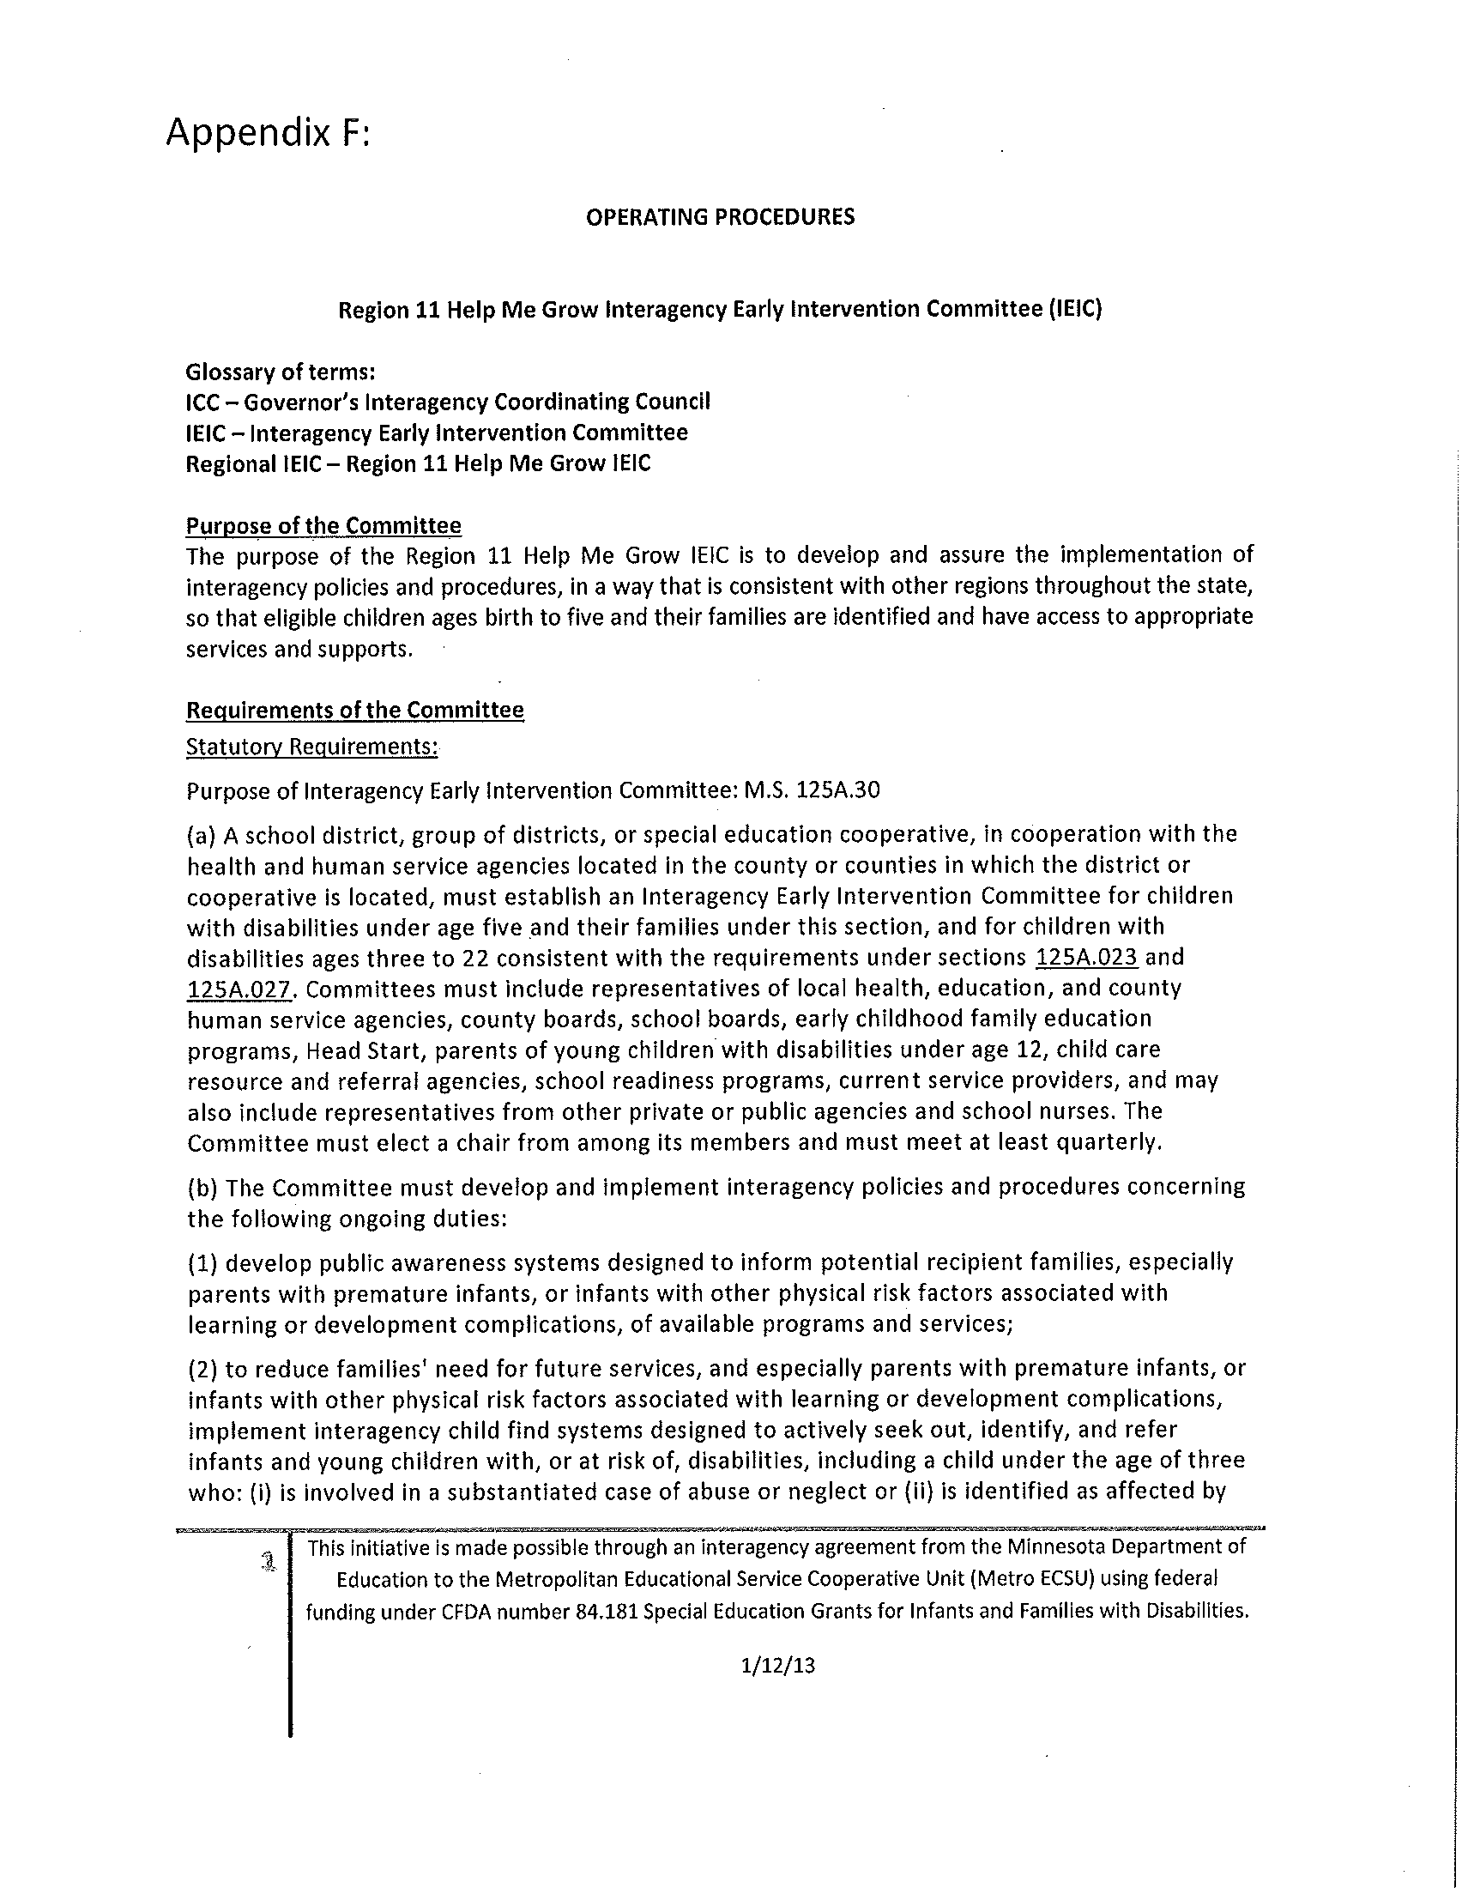

Click here to return to TSES

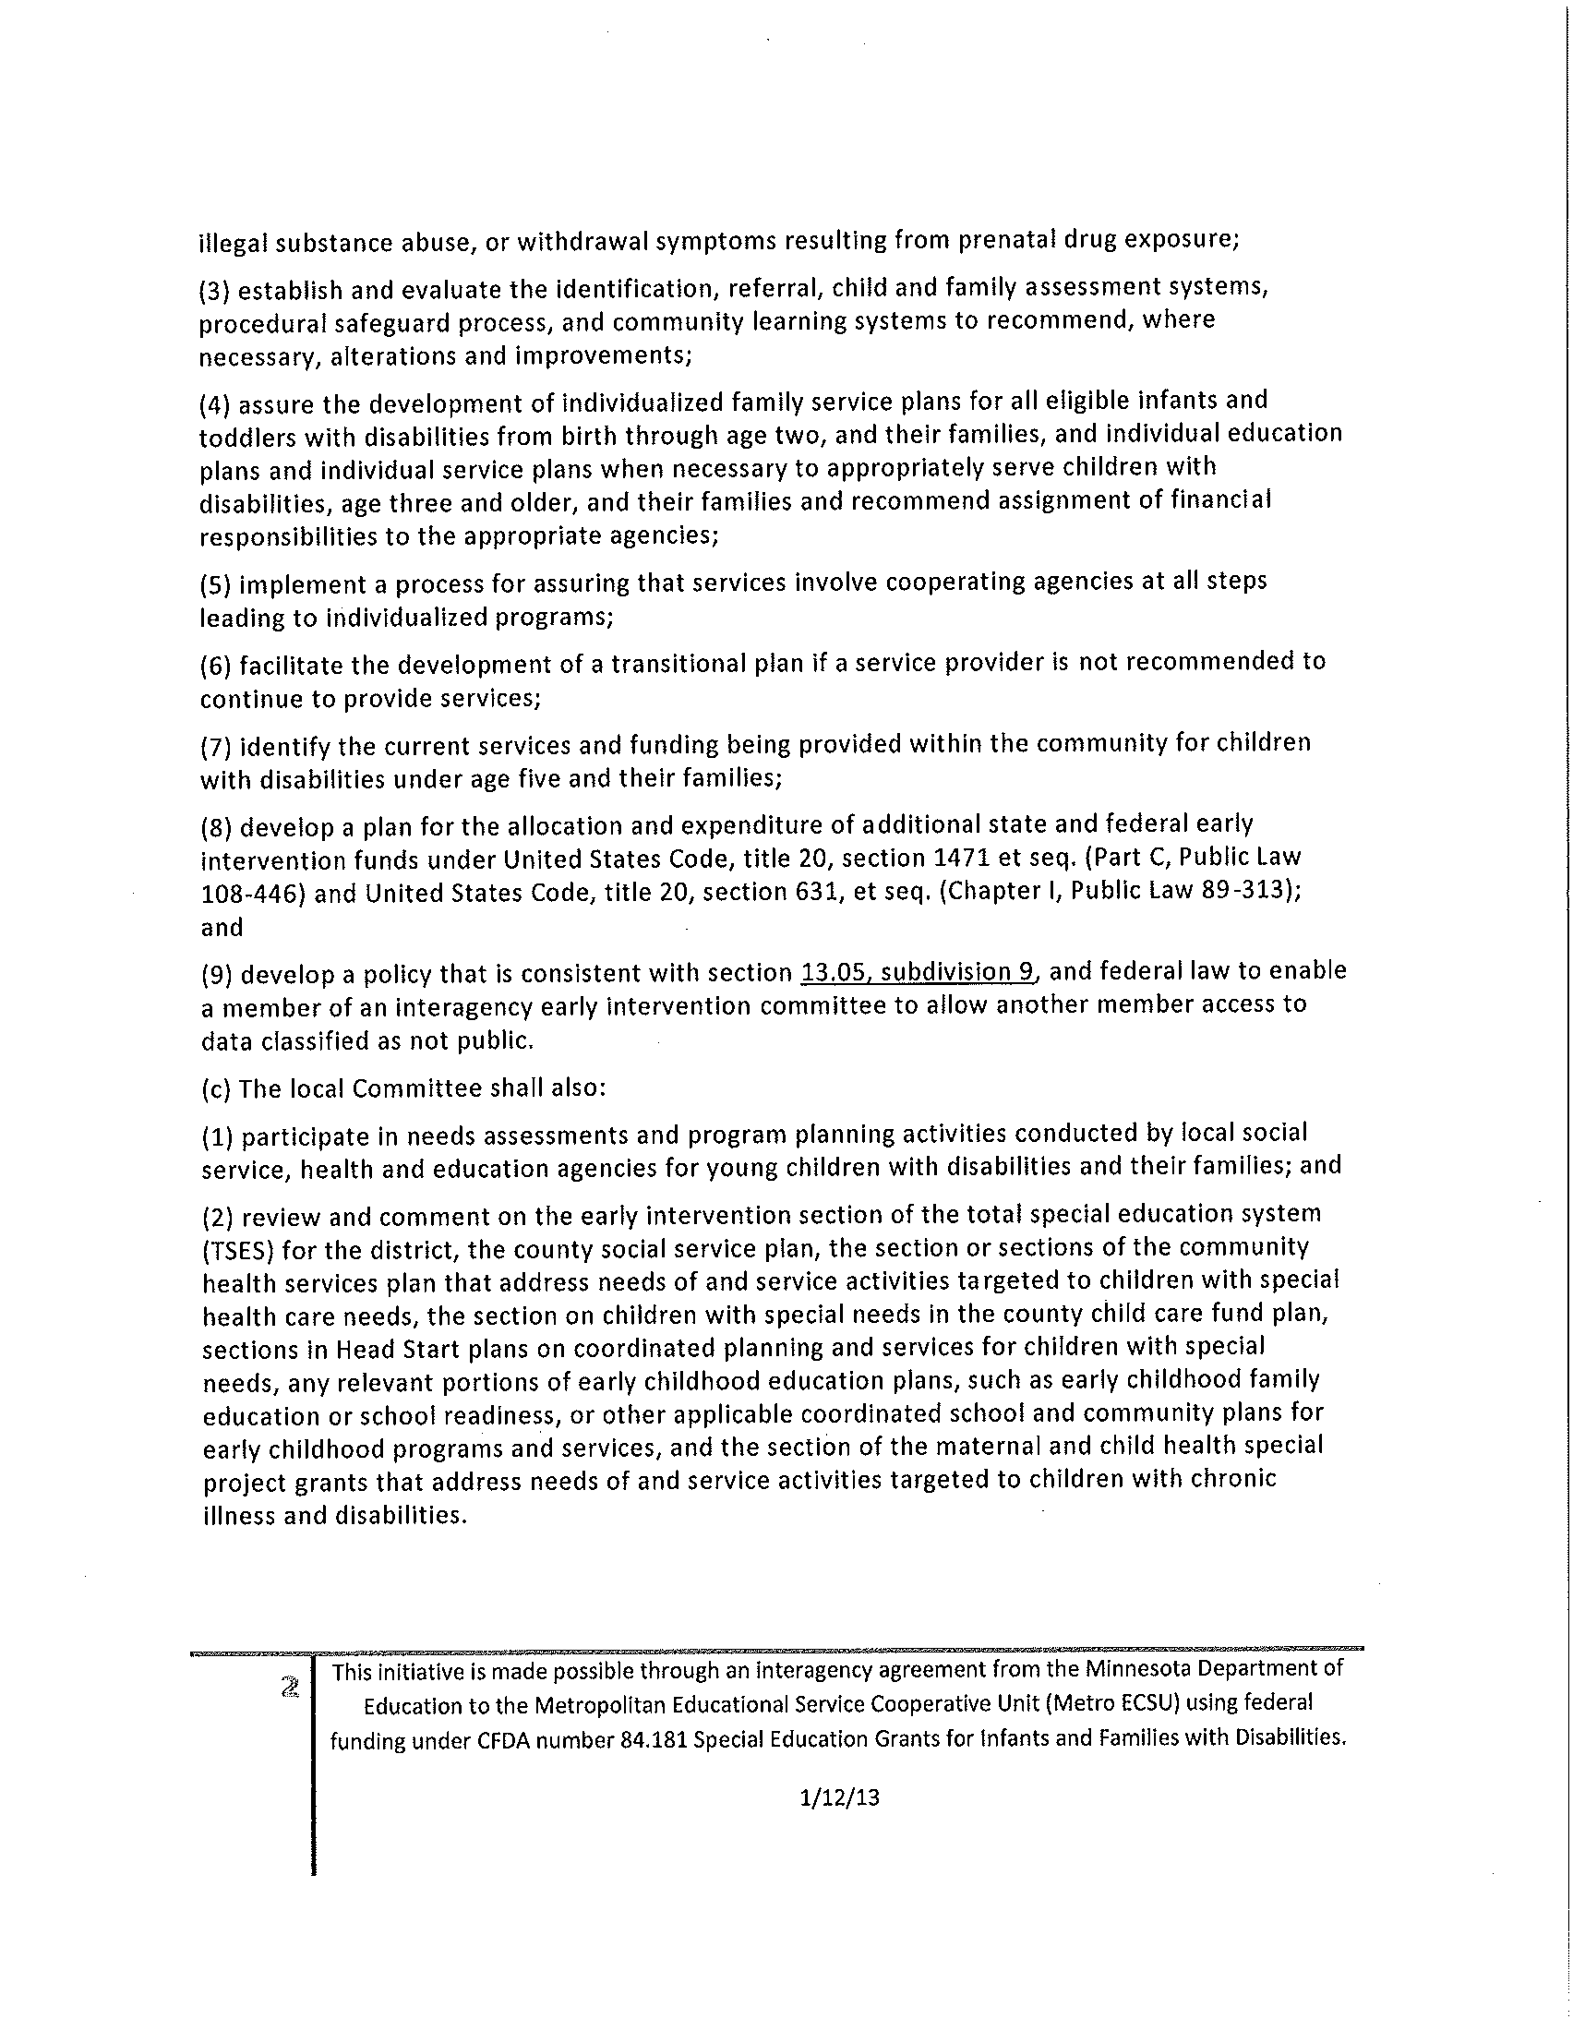

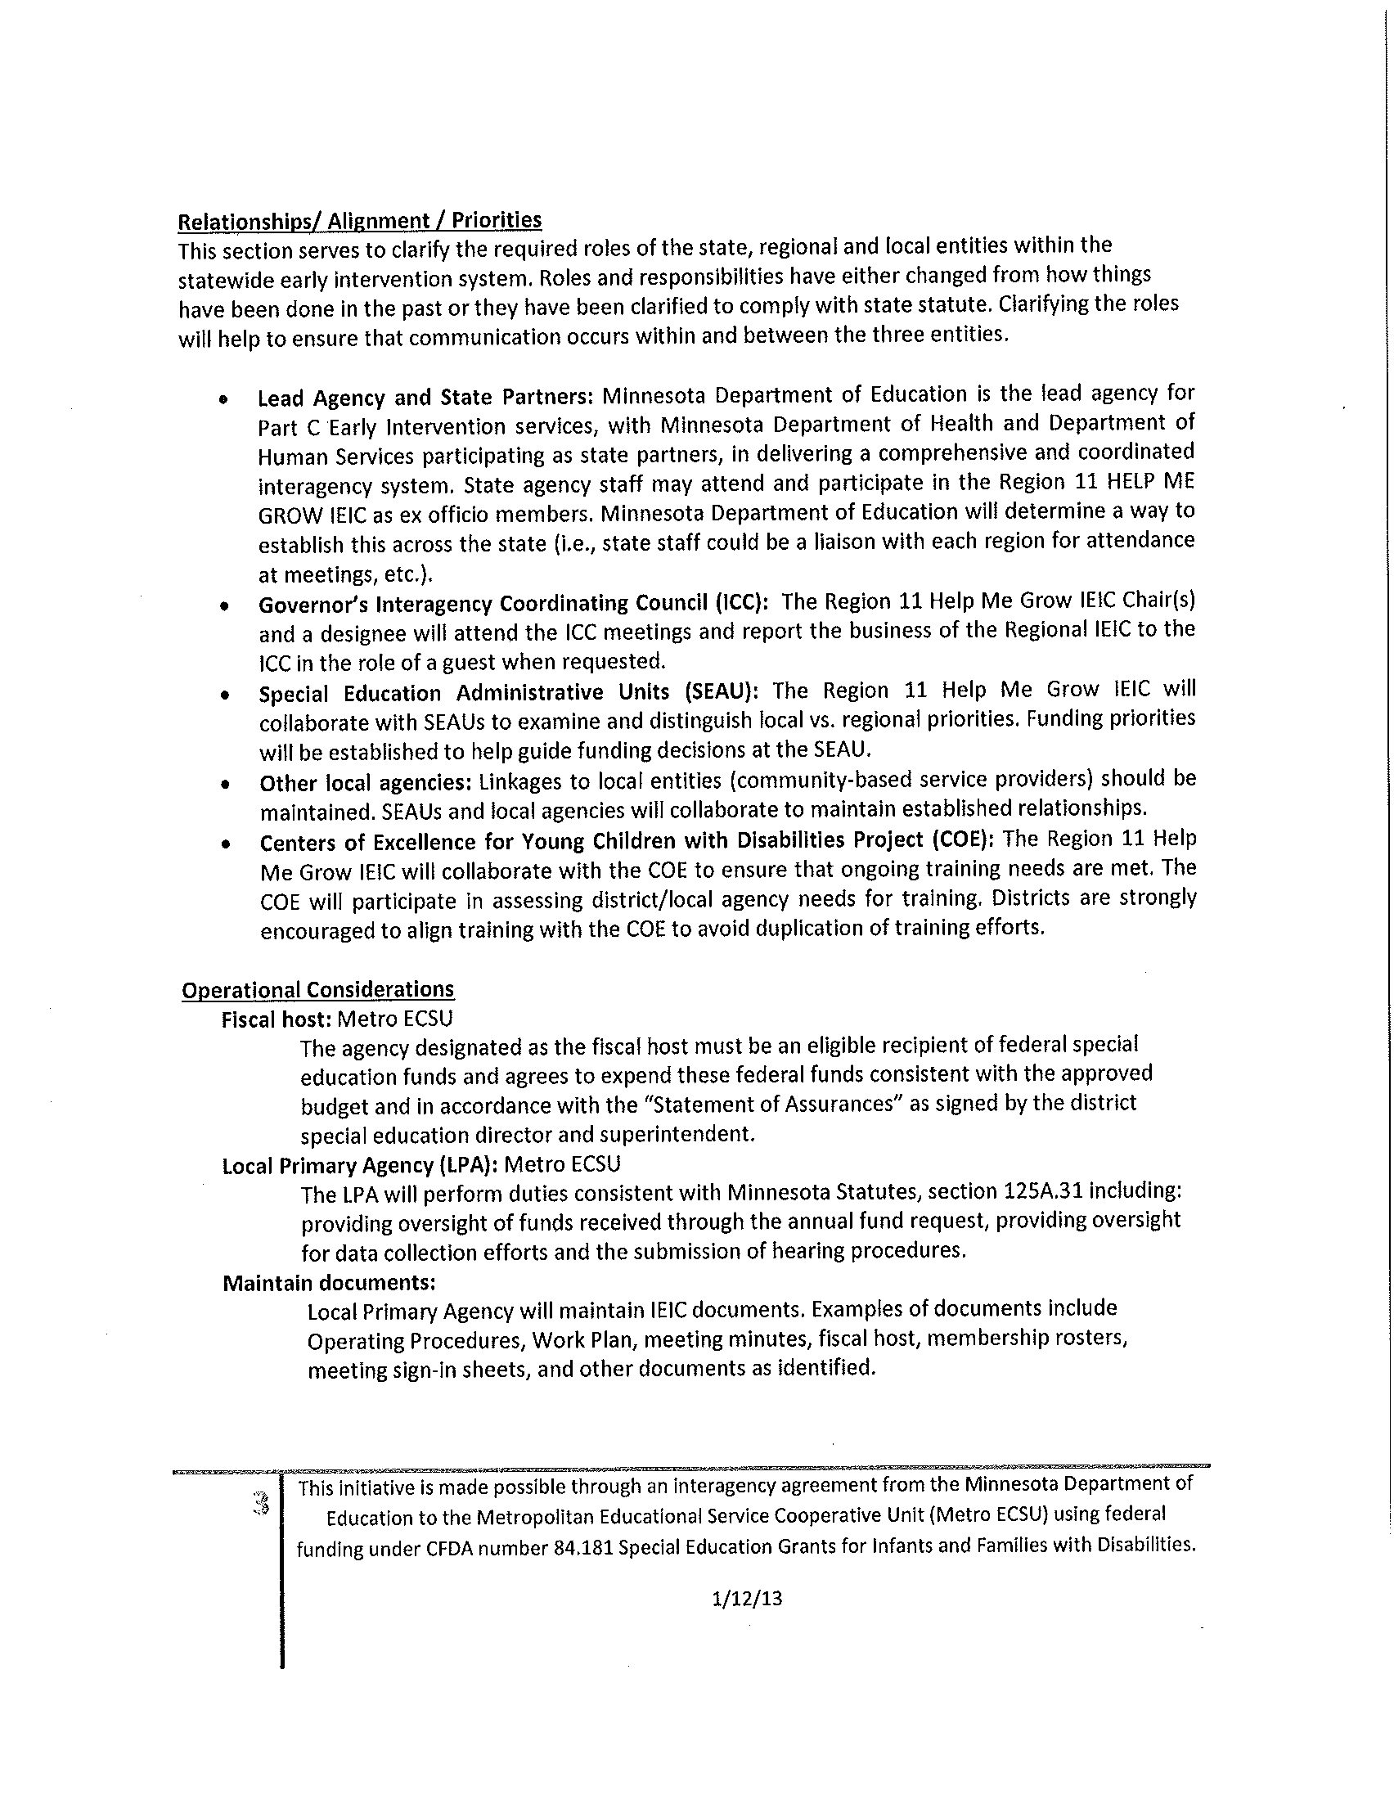

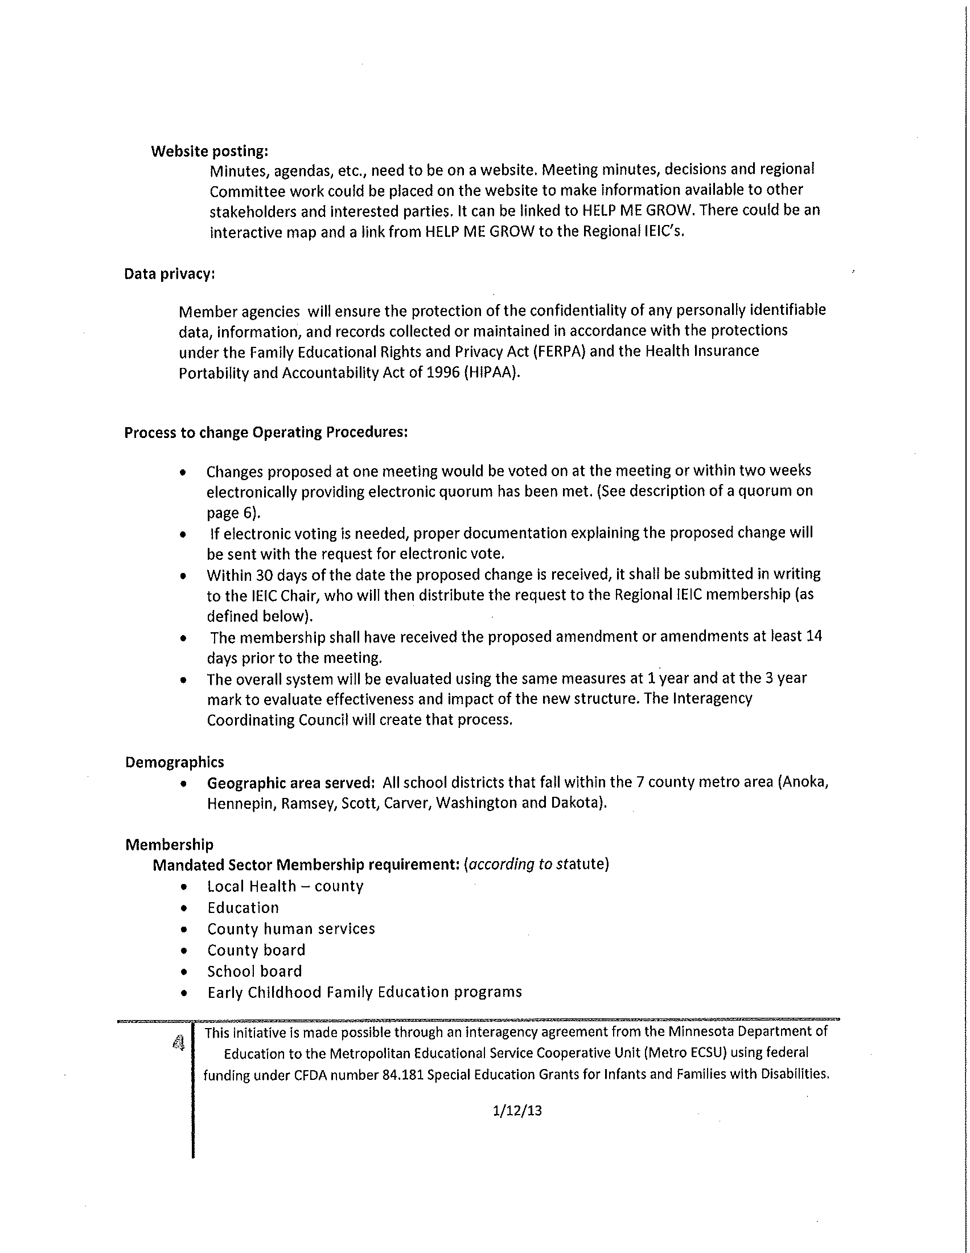

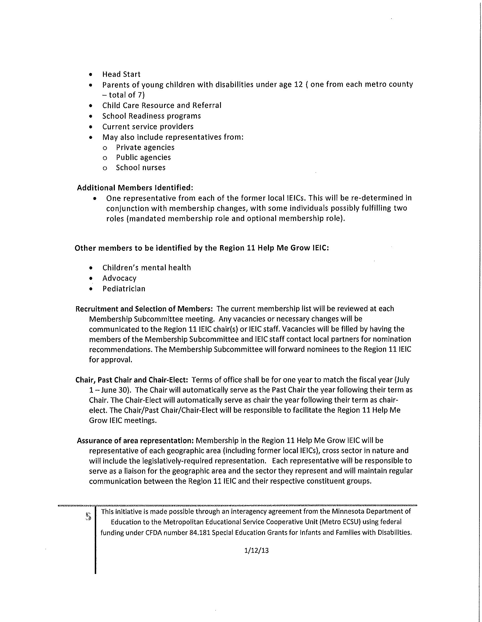

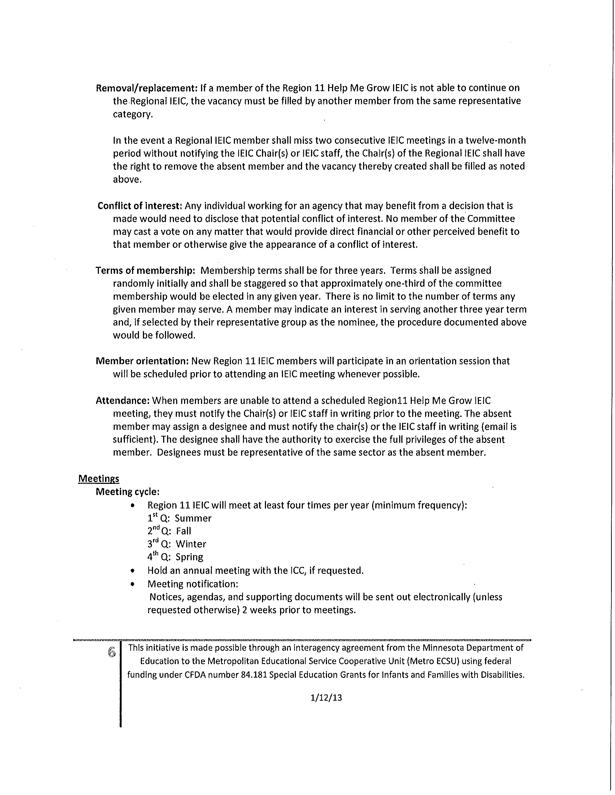

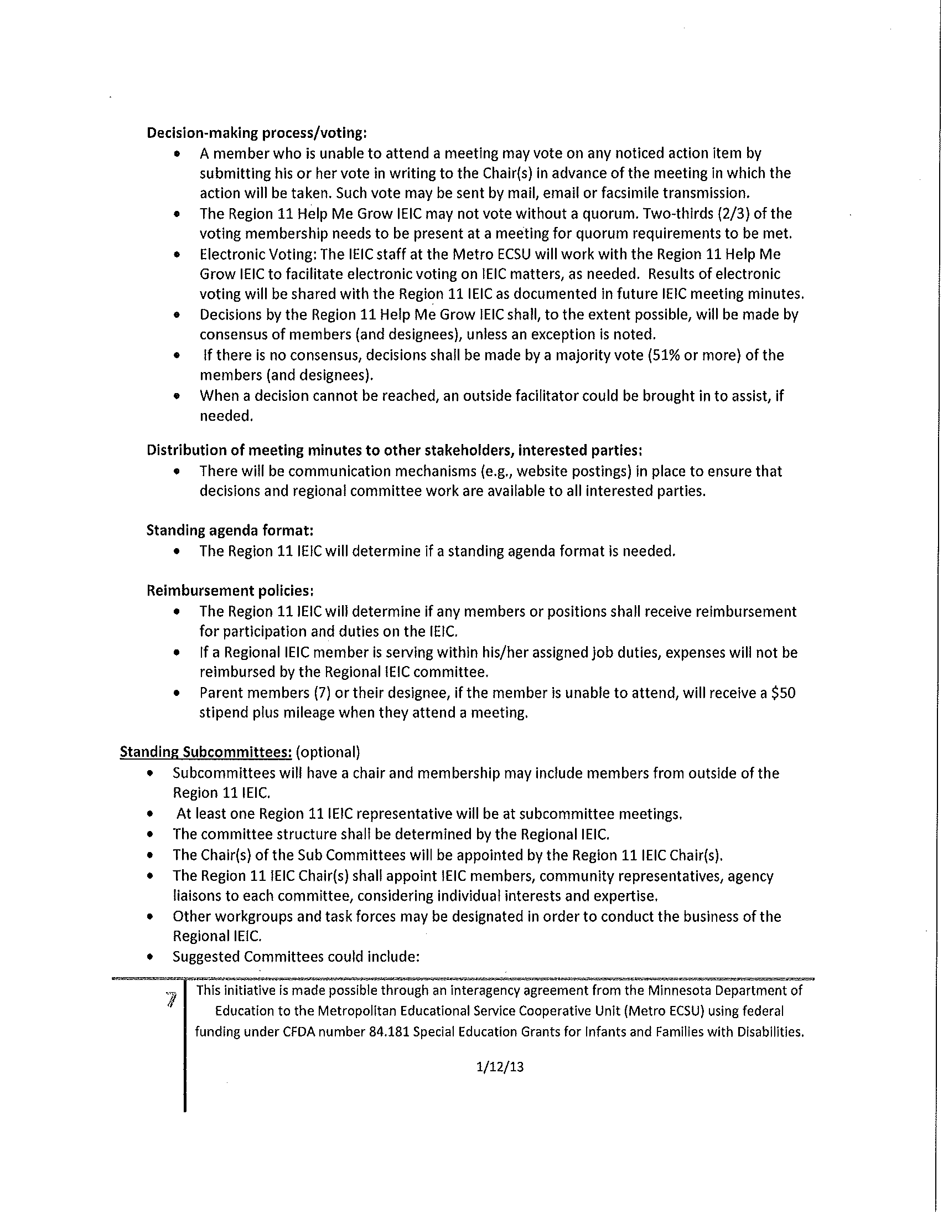

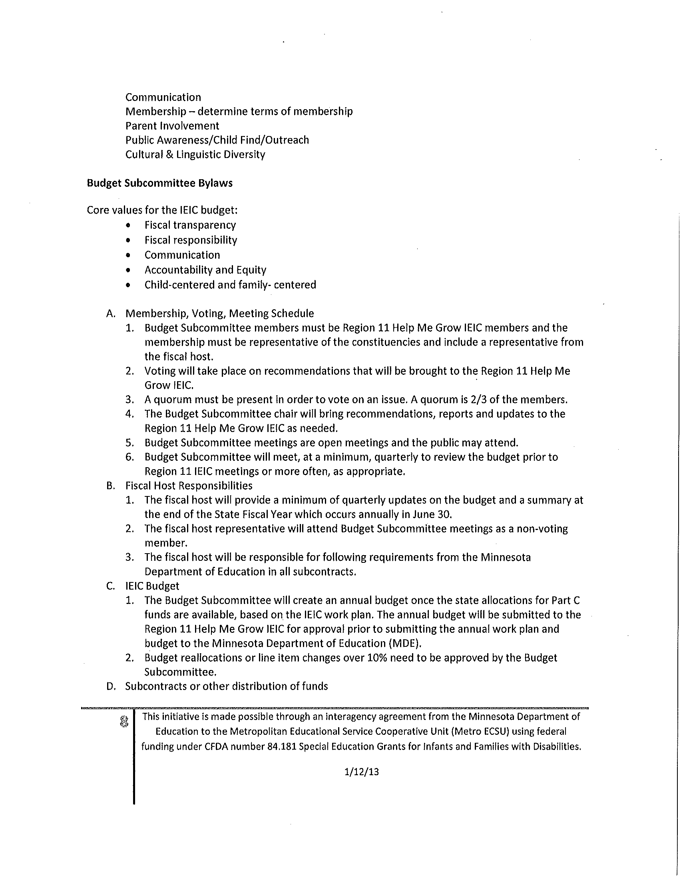

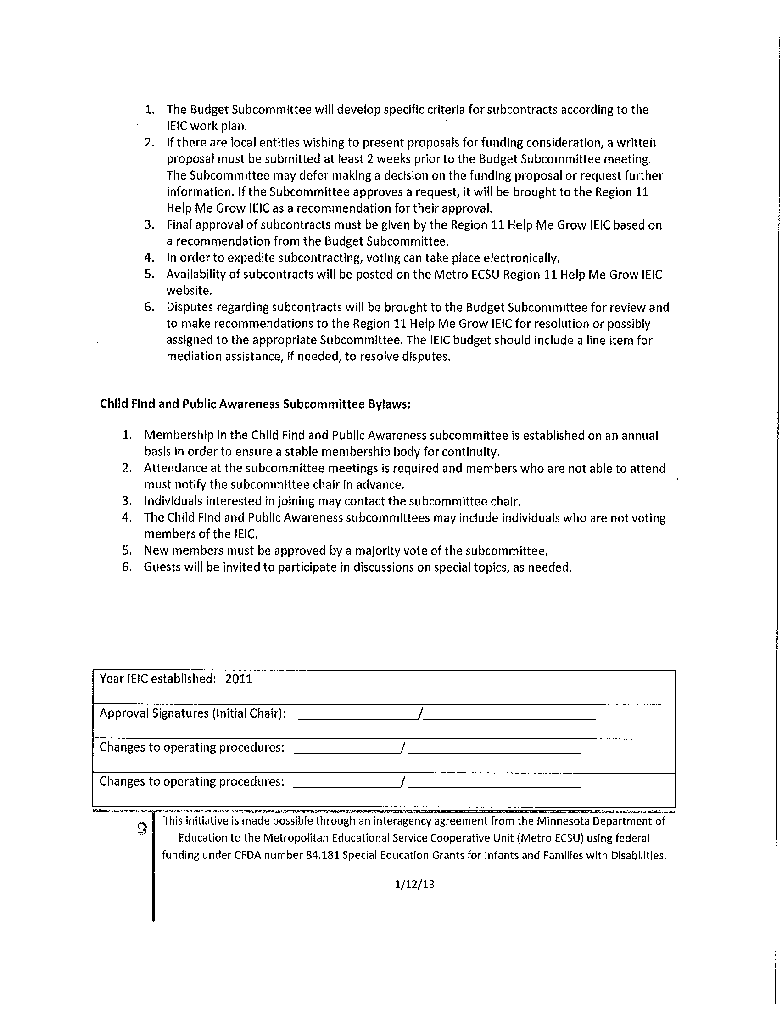

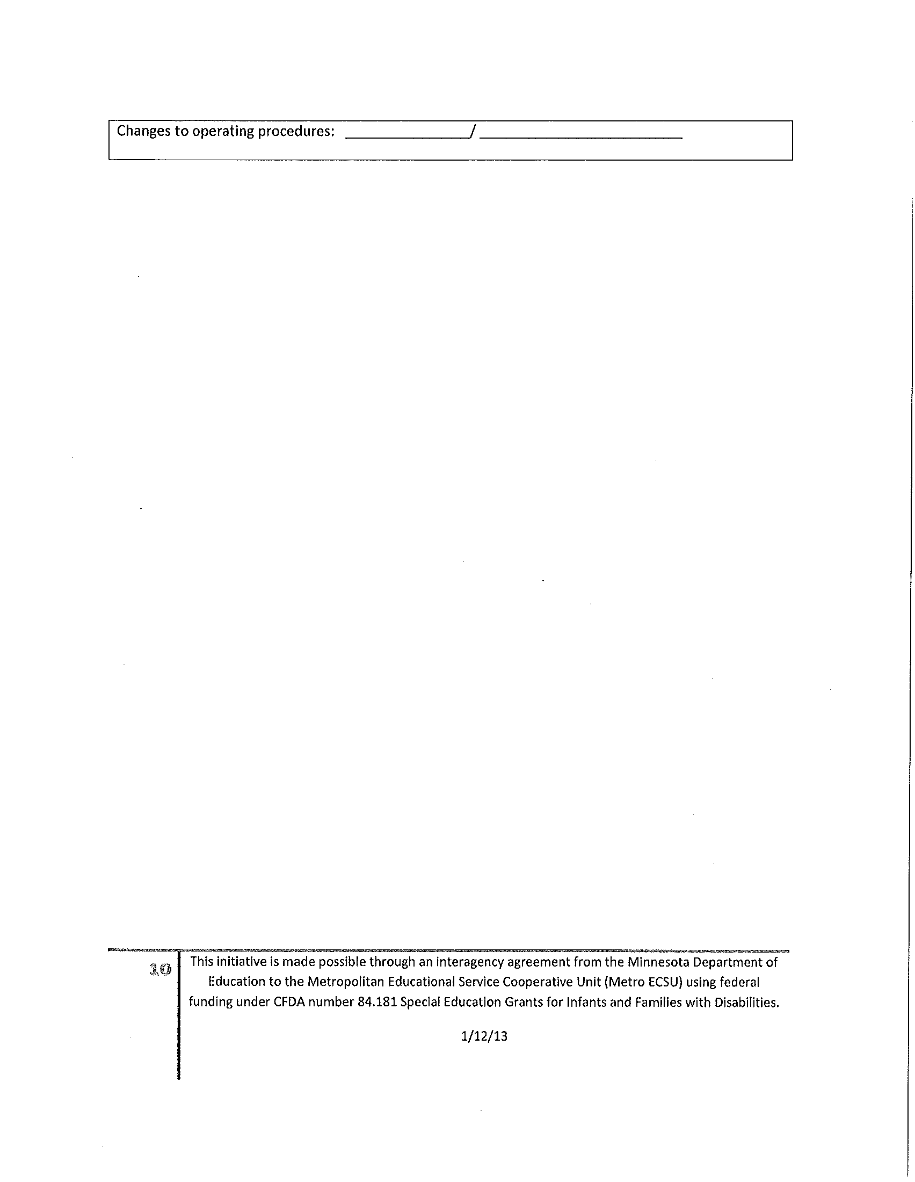

Click here to return to TSES

Appendix G:

Click here to return to TSES

|  |
| --- |
| Special Education Parent Advisory Council (SEPAC) Guidelines |

**The purpose of the Special Education Advisory Council (SEAC) is to assure:**

1. Parental input into the decision-making process of the Farmington Area Public Schools ISD 192.
2. A communication link with the member districts’ parents and special education instructors.
3. Advocacy for high quality regular and special education programs.

### Membership:

The committee shall be limited to 14 members and shall include representatives from parents and district staff. The following are suggested areas of representation:

1. **Seven parents representing children with one or more the following disabilities:**
   1. Emotional/Behavioral Disorder
   2. Specific Learning Disability
   3. Early Childhood Special Education
   4. Developmental Cognitive Disability: Mild-Moderate
   5. Developmental Cognitive Disability: Severe-Profound
   6. Visual Impairment
   7. Deaf or Hard-of-Hearing
   8. Physical Impairment
   9. Other Health Disability
   10. Autism Spectrum Disorder
   11. Traumatic Brain Injury
   12. Speech and Language Impairment
   13. Severe Multiple Impairment
   14. Deaf-Blindness
2. School Staff
   1. Two special education teachers
   2. Director of Special Education, Farmington Area Public Schools ISD 192
   3. Building Principal, School Board Member, Community Education Director

### Terms of Membership:

Committee members will serve for as long as they are interested or until their child graduates from school. School district employees are asked to secure a replacement. The Special Services Administrative Assistant confirms continuation on a yearly basis for all members. Persons interested in membership should call the Director at (651)460-5022 for more information.

#### Meetings:

The Special Education Advisory Council shall meet at least two (2) times per year, once in the fall and once in the spring, with special meetings called at the discretion of the Director of Special Education. One-third of the council membership shall constitute a quorum. Meetings shall be limited to 90 minutes in length. Agendas will be set by the Director. Areas of discussion are set by the committee.

#### Operational Procedures:

The committee role is advisory in nature. Notes of committee meetings shall be taken by the Special Services Administrative Assistant and posted on the Special Services Webpage.

**APPENDIX H:** Click here to return to TSES

|  |  |  |  |  |  |
| --- | --- | --- | --- | --- | --- |
| CTIC Member 2011/2012 Updated May 2012 | Agency | Email | | Phone | |
|  |  |  | |  | |
| **School District Representatives** |  |  | |  | |
| Vacant | ISD 6 |  | |  | |
| Kathy Paulsen, Work Experience Coordinator | ISD 191 | <mailto:kpaulsen@burnsville.k12.mn.us> | | 612-490-2512 | |
| Kim Chalmers, Director of Special Education | ISD 192 | <mailto:kchalmers@farmington.k12.mn.us> | | 651-463-5022 | |
| Derrick Gaborski, Special Education Lead | ISD 194 | [ddgaborski@isd194.k12.mn.us](mailto:ddgaborski@isd194.k12.mn.us) | | 952-232-3639 | |
| Kris Lindsoe, Special Education Lead | ISD 194 | [kjlindsoe@isd194.k12.mn.us](mailto:kjlindsoe@isd194.k12.mn.us) | |  | |
| Todd Endersbe, Special Education Teacher | ISD 194 | [tpendersbe@isd194.k12.mn.us](mailto:tpendersbe@isd194.k12.mn.us) | | 942-232-3706 | |
| Vacant | ISD 195 |  | |  | |
| Paula Krippner, Special Education Coordinator | ISD 196 | [paula.krippner@district196.org](mailto:nancy.recibe@district196.org) | | 952-431-8991. | |
| Nancy Coffeen, Teacher Special Programs | ISD 197 | [Coffeenn@isd197.org](mailto:Coffeenn@isd197.org) | | 651-403-7142 | |
| Robert Dehnert, Assistant Director | ISD 197 | [Robert.Dehnert@isd197.org](mailto:Robert.Dehnert@isd197.org) | | 651/403-7019 | |
| Kim Sievert-Disanto, Special Education Teacher/Work Coordinator | ISD 199 | <mailto:sievertk@invergrove.k12.mn.us> | | 651-306-7131 | |
| Katie Richardson, Transition Specialist | ISD 192 | [krichardson@hastings.k12.mn.us](mailto:krichardson@hastings.k12.mn.us) | | 651-480-7506 | |
| Don Budach, Assistant Director | ISD 917 | [don.budach@isd917.k12.mn.us](mailto:don.budach@isd917.k12.mn.us) | | 651-423-8426 | |
| Cindy Hansen, Special Education Teacher | ISD 917 | [CINDY.HANSON@isd917.k12.mn.us](mailto:CINDY.HANSON@isd917.k12.mn.us) | | 651-423-8342 | |
| **County Social Services Representatives** |  |  | |  | |
| Gena Bossert, CLS Supervisor | Dakota County Social Services Devl. Disabilities | <mailto:Gena.Bossert@co.dakota.mn.us> | | 651-554-6020 | |
| Telesea, Everett, CMH Supervisor | Children Mental Health Services | [Telesea.Everett@CO.DAKOTA.MN.US](mailto:Telesea.Everett@CO.DAKOTA.MN.US) | | 952-891-7400 | |
| Janell Schilman, Interagency Coordinator | IEIC, Collaborative & CTIC Facilitator | [janell.schilman@co.dakota.mn.us](mailto:janell.schilman@co.dakota.mn.us) | | 952-891-7449 | |
| **Vocational Rehabilitation** |  |  |  | |
| Kimberly Glienke | VRS | [kimberly.glienke@state.mn.us](mailto:kimberly.glienke@state.mn.us) | 651-554-6585 | |
| Richard Wagner, Rehabilitation Area Manager | DEED | <mailto:richard.wagner@state.mn.us> | 952-895-7617 | |
| Margie Webb, Senior Rehabilitation Counselor | VRS | [margie.webb@state.mn.us](mailto:amydoering@state.mn.us) | 952-895-7632 | |
| Peg Killen | VRS | [strunk@lifeworks.org](mailto:strunk@lifeworks.org) |  | |
| **Post Secondary Education** |  |  |  | |
| Cherry Crammer, Teacher | ISD 917 Secondary Technical Center | [cherry.cramer@isd917.k12.mn.us](mailto:John.Palmer@isd917.k12.mn.us) | 651-423-8444 | |
| Anne Swanberg, Disability Services Advisor | Dakota County Technical College | [anne.swanberg@dctc.edu](mailto:anne.swanberg@dctc.edu) | 651/423-8469 | |
| **Advocay/ Agencies** |  |  |  | |
| Barb Ziemke, Parent/Advocate | PACER | [bziemke@charter.net](mailto:bziemke@charter.net) |  | |
| Gerogann Rumsey | ARC Greater Twin Cities | [georgannrumsey@arcgreatertwincities.org](mailto:georgannrumsey@arcgreatertwincities.org) | 952-915-3667 | |
| Tanya Weinmeyer, South Metro Family Resoruces Coordinator | MOFAS | <mailto:tanya@fasdfamilyresource.org> | 952-836-7182 | |
| Suzette Scheele, | NAMI Minnesota | [sscheele@nami.org](mailto:sscheele@nami.org) | 651-645-7379 | |
| **Employment and DT&H** |  |  |  | |
| Julie Beckman, | MRCI |  |  | |
| Bill Schwartz, Vice President | MRCI/CTIC Chair | <mailto:BSchwartz@MRCIWorkSource.org> | 651-402-4431 | |
| Teckla Johnson | Lifeworks Burnsville/Apple Valley | [tjohnson@lifeworks.org](mailto:tjohnson@lifeworks.org) | 952-808-1483 | |
| Lori A, Arnold, Team Lead/Bursnville | Lifeworks | [larnold@lifeworks.org](mailto:larnold@lifeworks.org) | 952-808-1483 | |
| Chris Davies, Director of Operations | Kaposia, Inc. | [cdavies@kaposia.com](mailto:jalexander@kaposia.com) | 651-789-2807 | |
| Paul Tatge, Supervisor | East Suburban Resources | [ptatge@esrworks.org](mailto:ptatge@esrworks.org) |  | |
| Heather Deutschlaender, Vocational Coordinator | ProACt, Inc. | [heatherd@proactinc.org](mailto:heatherd@proactinc.org) | 651-289-3163 | |
| Sue Lowe, | ProACt, Inc. | [slowe@proactinc.org](mailto:slowe@proactinc.org) | 651-289-3151 | |
| Susan Trunk, Program Supervisor | Lifeworks, Inc. | [strunk@lifeworks.org](mailto:strunk@lifeworks.org) |  | |
| Joan Decker | Midway Training Services | [jdecker@midwaytraining.com](mailto:jdecker@midwaytraining.com) | 651-288-8896 | |
| Dan Winder, retails Skills Trainer/Case Manager | Goodwill Easter Seals | [DWinder@GoodwillEasterSeals.org](mailto:DWinder@GoodwillEasterSeals.org) | 651-379-5617 | |
| Cathy Tschida | Access to Employment | <mailto:ctschida@accesstoemployment.org> |  | |
| Bobbi VanGrinsven | Community Involvement Programs | [bvangrinsven@cipmn.org](mailto:bvangrinsven@cipmn.org) | 612-876-8034 | |
| Janae Hanson-Parkes | VRS-State Services for the Blind | [jannae.hanson-parkes@state.mn.us](mailto:jannae.hanson-parkes@state.mn.us) | 651-554-6426 | |
| Karl Olson, Assistant Manager | Opportunity Partners | [kolson@opportunities.org](mailto:kolson@opportunities.org) |  | |
| **Community Education/Recreation** |  |  |  | |
| Derek Appleyard, Co | Comm. Education Consortium/River Valley Project Explore | <mailto:derek.appleyard@district196.org> | 651-423-7931 | |
| **Housing** |  |  |  | |
| Kathy Anderson, Non-Residential Services Supervisor | Dakota Communities | [KathyA@dakcom.org](mailto:KathyA@dakcom.org) | 651-688-8808x43 | |
| **Parents/Consumers** |  |  |  | |

Click here to return to TSES