

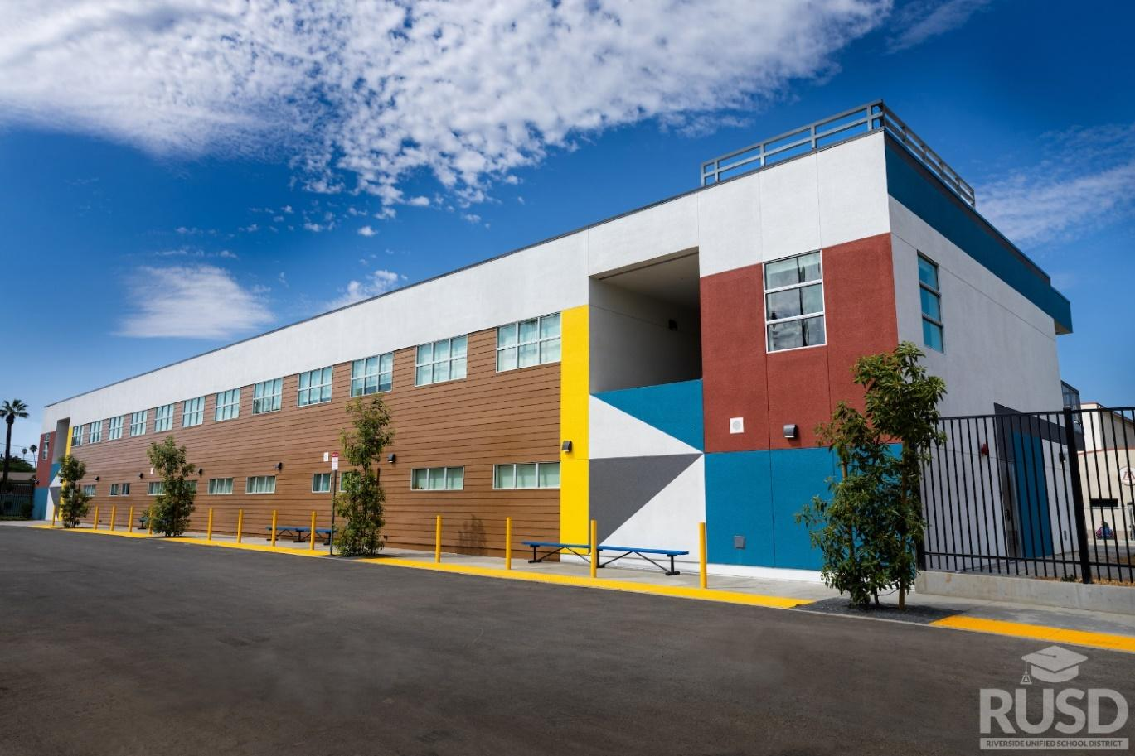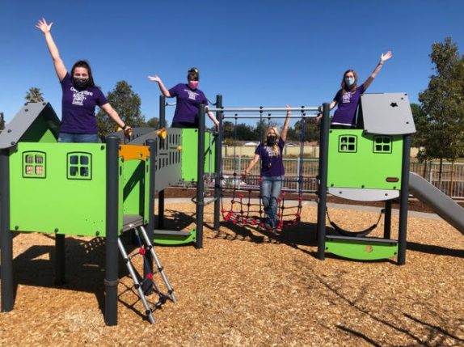

|  | **Table of Contents** | | |
| --- | --- | --- | --- |
|  | Executive Summary |  | 1 |
|  | 2016 Ballot Measure O | 1 | |
|  | Purpose of Committee | 1-2 | |
|  | Committee Membership | 2 | |
|  | Committee Activities | 3-5 | |
|  | Committee Findings | 5 | |
|  | Projects In Construction Photos | 7 | |
|  | Projects Completed Photos | 8-14 | |
|  | Measure O Projects Expenditures | 15 | |
|  | Performance and Financial Audit Reports | 16 | |
|  | Citizen’s Bond Oversight Committee Statement | 17 | |

**Executive Summary**

The Riverside Unified School District (RUSD) was successful passing Measure O General Obligation Bond on November 8, 2016. With a 70% approval rate, the voters approved to issue up to $392,000,000 as the principal amount for the District’s school facilities bond (Measure O). Measure O will generate the dollars over the next 10 to 15 years to improve existing school facilities and build new capital facilities in Riverside Unified School District.

The Long Range Facility Master Plan completed in 2016 serves as the guide to plan projects based on condition, educational program, capacity needs, and available state funding. The Board of Education held three workshops to discuss the needs of district facilities and identify priorities. The workshops primarily focused on educating the Board and public on the prioritization process, providing data on the facilities, determining focus goals, and identifying priority projects.

**2016 Ballot Measure O**

The following is the ballot measure summary presented to the voters by the Riverside Unified School District.

*“To repair and upgrade Riverside schools, including deteriorating roofs, plumbing and electrical systems, improve student safety, security, and seismic safety, upgrade classrooms, science labs, career-training facilities, computer systems and instructional technology to support student achievement in math, science, engineering and skilled trades, and construct, acquire, repair classrooms, sites, facilities and equipment, shall Riverside Unified School District issue $392 million in bonds at legal rates, with citizen oversight, no money for administrator salaries, all money staying local?”*

To view the full ballot proposition:

<http://riversideunified.org/common/pages/DisplayFile.aspx?itemId=14033820>

**Purpose of the Committee**

Pursuant to Section 15278 of the Education Code, the District is obligated to establish an independent Citizens’ Bond Oversight Committee (CBOC) in order to satisfy the accountability requirement of Prop. 39. The Board of Education approved the appointment of the CBOC at its March 20, 2017 Board meeting.

The purpose of the Citizens’ Bond Oversight Committee (CBOC) shall be to inform the public concerning the expenditure of the bond proceeds. The CBOC will review bond program expenditures and outside audits to make sure the will of the voters is strictly followed in accordance with the wording of the original ballot measure.

To carry out its stated purpose, the Committee shall perform the duties set forth in the CBOC bylaws as listed below:

3.1 Inform the Public. The Committee shall inform the public concerning the District’s expenditure of bond proceeds. In fulfilling this duty, all official communications to either the Board or the public shall come from the Chair acting on behalf of the Committee. The Chair shall only release information that reflects the majority view of the Committee.

3.2 Review Expenditures. The Committee shall review expenditure reports produced by the District to ensure that (a) bond proceeds were expended only for the purposes set forth in Measure O; and (b) no bond proceeds were used for teacher or administrative salaries or other operating expenses in compliance with Attorney General Opinion 04-110, issued on November 9, 2004.

3.3 Annual Report. The Committee shall present to the Board, in public session, an annual written report for Measure O, which shall include the following:

(a) A statement indicating whether the District is in compliance with the requirements of Article XIIIA, Section 1(b)(3) of the California Constitution; and

(b) A summary of the Committee’s proceedings and activities for the preceding year.

**Committee Membership**

CALIFORNIA EDUCATION CODE, SECTION 15282.

(a) The citizens' oversight committee shall consist of at least seven members to serve for a term of two years without compensation and for no more than two consecutive terms. While consisting of a minimum of at least seven members, the citizens' oversight committee shall be comprised, as follows:

(1) One member shall be active in a business organization representing the business community located within the district.

(2) One member shall be active in a senior citizens' organization.

(3) One member shall be active in a bona fide taxpayers' organization.

(4) For a school district, one member shall be the parent or guardian of a child enrolled in the district. For a community college district, one member shall be a student who is both currently enrolled in the district and active in a community college group, such as student government. The community college student member may, at the discretion of the board, serve up to six months after his or her graduation.

(5) For a school district, one member shall be both a parent or guardian of a child enrolled in the district and active in a parent-teacher organization, such as the Parent Teacher Association or schoolsite council. For a community college district, one member shall be active in the support and organization of a community college or the community colleges of the district, such as a member of an advisory council or foundation.

(b) No employee or official of the district shall be appointed to the citizens' oversight committee. No vendor, contractor, or consultant of the district shall be appointed to the citizens' oversight committee. Members of the citizens' oversight committee shall, pursuant to Sections 35233 and 72533, abide by the prohibitions contained in Article 4 (commencing with Section 1090) and Article 4.7 (commencing with Section 1125) of Division 4 of Title 1 of the Government Code.

**Committee Activities**

In accordance with the provisions of the Ralph M. Brown Public Act, the committee conducts meetings for the public’s attendance and participation. Meeting agendas and notices are sent to committee members and posted 72 hours in advance of the meeting. Notices are posted at the Riverside Unified School District Administrative office, Business Services office, Facilities, Planning & Development office, and on the District website. Meeting notices, agenda, minutes and all other documents received by the committee are a matter of public record and are available on the Riverside Unified School District website:

<http://riversideunified.org/cms/One.aspx?portalId=580805&pageId=2305262>

The Committee conducts quarterly business meetings to review and discuss facilities projects and project expenditures. The Citizens’ Bond Oversight Committee held meetings on the following dates:

**School Year 16/17**

* June 7, 2017 at 4:30 pm at the District Office

**School Year 17/18**

* October 4, 2017 at 4:30 pm at the District Office
* February 7, 2018 at 4:30 pm at the District Office
* April 10, 2018 at 4:30 pm at the District Office

**School Year 18/19**

* July 31, 2018 at 4:30 pm at the District Office
* October 9, 2018 at 4:30 pm at the District Office
* February 12, 2019 at 4:30 pm at the District Office
* May 29, 2019 at 4:30 pm at the District Office

**School Year 19/20**

* August 21, 2019 at 4:30 pm at the District Office
* October 30, 2019 at 4:30 pm at Nutrition Services Training Room
* January 29, 2020 at 4:30 pm at Highgrove Elementary School
* May 27, 2020 at 4:30 pm - Virtual Meeting

**School Year 20/21**

* August 26, 2020 at 5:30 pm - Virtual Meeting (Meeting stopped)
* September 10, 2020 4:30 pm - Virtual Meeting
* January 29, 2021 at 4:30 pm - Virtual Meeting
* February 26, 2021 at 4:30 pm - Virtual meeting
* April 28, 2021 at 4:30 pm - Virtual Meeting

**School Year 21/22**

* July 8, 2021 4:30 at pm Virtual Meeting (Canceled due to no quorum)
* August 12, 2021 at 4:30 pm - Virtual Meeting
* October 13, 2021 at 4:30 pm at Riverside Polytechnic High School
* March 15, 2022 at 4:30 pm at Thomas Jefferson Elementary - Library
* June 9, 2022 at 4:30 pm at Louisa May Alcott Elementary - Multi Purpose Room

**School Year 22/23**

* September 8, 2022 at 4:30 pm Arlington High School-Lecture Hall
* October 20, 2022 at 4:30 pm Riverside Unified Board Room
* December 7, 2022 at 4:30 pm Riverside Unified Nutrition Services -Conference Room
* March 2, 2023 at 5:00 pm Fremont Elementary School-Multi Purpose Room
* June 14, 2023 at 5:00 pm Sierra Middle School-Multi Purpose Room

**School Year 23/24**

* August 17, 2023 5:00 pm (Special Meeting) District Office-Susan Rainey Conference Room
* September 20, 2023 5:00 pm Longfellow Elementary School – Building G –Classroom G28
* December 6, 2023 5:00 pm District Office - Conference Room 1
* February 13, 2024 5:00 PM North High School – Library

**September 8, 2022**

* District staff presented a new resource handbook for current and incoming CBOC members.

**December 7, 2023**

* Training on Proposition 39 and Citizens’ Bond Oversight Committees by Mr. Robert E. Anslow of Atikinson Anndelson Loya Ruud. The presentation included:
  + - An overview of the history and guidelines of Proposition 39
    - Statutory provisions and ballot statements
    - The principle purpose of the CBOC, CBOC composition, the appointment of CBOC members
    - Authorized activities of the CBOC, CBOC proceedings, the CBOC website
    - The school District support of the CBOC annual audit requirements, and CBOC completion.
    - Review of the Brown Act.

**March 2, 2023**

* Amended Bylaws to allow the CBOC Chairperson to create ad-hoc committees to the CBOC.
* Received the annual audit report from Nigro & Nigro PC – a clean audit. Committee acknowledged this was a late report and request that it be provided sooner in the year next year.
* Presentation on Construction Delivery Methods by Mr. Jason Howarth from Tilden-Coil Construction
* The Committee discussed the importance of member attendance and determined to have the Chairperson communicate to the BOT of any attendance problems.
* Tour of Fremont E.S.

**June 14 2023**

* Committee received a presentation on Community WorkForce Agreements by Mr. Sergio San Martin and how/when they are utilized in District construction projects.
* Committee members requested information about a lawsuit filed against the District on use of Measure O funds. It was determined that the lawsuit was outside of the committee’s jurisdiction.
* Tour of Sierra M.S.

**August 18, 2023 (special meeting)**

* Established an AD HOC committee to develop a draft Annual Report for review and adoption by full committee.

**Measure O – Committee Members**

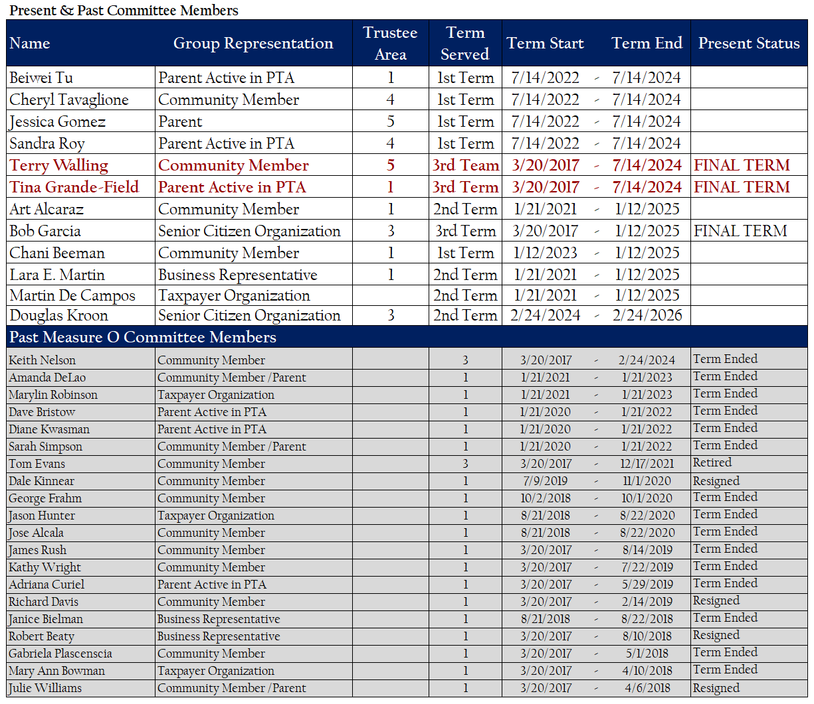

Recruitment is ongoing throughout the year.

It was desired by the Board of Education, that the committee provide an update that includes the most recent meetings as possible for the annual report; therefore, the committee reporting period extends beyond the 22/23 School Year.

All meetings conducted during this time period were in-person. At every meeting, staff reports the status of projects and project financials.

At every meeting, the committee encouraged community input related to any questions or concerns with Measure O funding allocation. These concerns have and will continue to be discussed by the committee as brought forth in public comment.

The Chair may be asked by a majority vote of the committee to communicate a question or concern at a Board of Education meeting.  Committee members are invited to attend any public meetings held by the district.  A member may speak on behalf of themselves at any public meeting.

An independent performance and financial audit was reviewed by the committee.

**September 20, 2023**

* Review and adoption of Annual Report 2021-2022
* Tour of Longfellow E.S.

**December 6, 2023**

* Officer election with suggestion to explore modifying bylaws to allow succession of Vice Chair role to Chair role.
* Clarified the process by which the Committee may request information and/or resources from the BOT: Passing a motion and sending request via Chairperson during public comment at the next scheduled BOT meeting.



| Projects in Progress | | | |
| --- | --- | --- | --- |
|  |  | |  |
| **John W. North High School** | | | |
| John W. North High School was built in 1966. This Project is currently in the construction phase. The Design Team was tasked to develop the scope of work during the 2020/21 school year. Under Measure O, project includes a new 2 story science building and a new 900 seat gymnasium, campus entry site improvements, new seating and shade structure in the quad and the removal of portables. ESSER funding project scope will include HVAC and lighting upgrades to campus buildings that will be performed in phased work to minimize disruption to the site. The HVAC lighting upgrade project will also include new paint, flooring, fire alarm upgrades, and restroom upgrades in building 300.1. | | | |
| **Percent Complete: 7%** | | **Anticipated Completion Date: October 2025** | |
|  | | | |
| **Casa Blanca Neighborhood School** | | | |
| The school site is approximately 9.8 acres located on Lincoln Street. The school will service approximately 750 TK-6 students in the Casa Blanca neighborhood. The new school will include ancillary support buildings, outdoor learning shared spaces, TK-K classrooms with play area, 1st-3rd grade classrooms with play area, 4th-6th classrooms with play area, staff and visitor parking lot, and new bus drop off area. | | | |
| **Percent Complete: 15%** | | **Anticipated Completion Date: August 2025** | |
|  | | | |
| **Eastside Neighborhood School** | | | |
| The District is acquiring various properties within the Eastside neighborhood for a future elementary school. | | | |
| **Percent Complete: In Planning** | | **Anticipated Completion Date: July 2027** | |
|  | | | |
| **Highgrove II Neighborhood School** | | | |
| The site is 13 acres and is located in Spring Mt. Ranch development area. The location of the site is in the northwestern corner of the Silverspot Road and Spring Street intersection. | | | |
| **Percent Complete: In Planning** | |  | |
|  | | | |
| **STEM Education Center** | | | |
| A state-of-the-art public STEM Education Center on the premises of a world class public research university, University of California, Riverside (UCR). This project is currently in the CEQA process. The proposed high school will accommodate 800 students at any given time and will focus on computer science, environmental/ agricultural science, biomedical/allied health, and engineering & advanced manufacturing. | | | |
| **Percent Complete: In Planning** | |  | |



| **Sierra Middle School** | |
| --- | --- |
| Sierra Middle School was built in 1957. Under Measure O, Sierra Middle School received HVAC replacement, light and fire alarm upgrades, ADA accessibility improvements, renovation of SDC classrooms, interior finishes, parking lot expansion, and beautification. | |
| **Completion Date: November 2019** | |
|  |  |

| **Highgrove Elementary School** | |
| --- | --- |
| Highgrove Elementary School was built in 1956. Under Measure O, Highgrove Elementary School received general site improvements, including grading, utilities, paving, new parking and drop-off, a new kinder two-story classroom building with 12 classrooms, and a new HVAC system, playground equipment, roof replacement, interior finishes, and accessibility upgrades. | |
| **Completion Date: August 2020** | |
|  |  |

| **Harrison Elementary School** | |
| --- | --- |
| Harrison Elementary School was built in 1964. Under Measure O, Harrison Elementary School received a new parking and drop-off area, new classroom building with 5 classrooms, HVAC system, frontage to administration, and removal of portables. | |
| **Completion Date: April 2021** | |
|  |  |

| **Jefferson Elementary School** | |
| --- | --- |
| Jefferson Elementary School was built in 1948. Under Measure O, Jefferson Elementary School received a new 1-story 6 kinder classroom building and corresponding playground area, full modernization of Buildings M and N, including sinks, cabinetry, roofing, HVAC, windows, lighting, paint, drinking fountain replacement, upgrades to restroom facilities, and demolition of 5 classrooms. | |
| **Completion Date: April 2021** | |
|  |  |

| **Madison Elementary School** | |
| --- | --- |
| Madison Elementary School was built in 1952. Under Measure O, Madison Elementary School received a 5 kinder classroom building, kinder play area, drop-off and parking lot, lunch shelter, curb appeal improvements, and removal of 5 portables. | |
| **Completion Date: June 2021** | |
|  |  |

| **John Adams Elementary School** | |
| --- | --- |
| John Adams Elementary School was built in 1962 on a 7.6 acre site. Under Measure O, the school received a new single-story five (5) Kindergarten classroom building, removal of five (5) existing portable classrooms, new kindergarten play area that includes new landscaping, shades trees, and playground equipment, new decomposed granite walking path area with new landscape and irrigation, new drop- off area and parking lot off of John Adams Street that includes twenty-two (22) standard parking spaces and two (2) ADA parking spaces, and related site work. | |
| **Completion Date: November 2021** | |
|  |  |

| **Sunshine Early Childhood Center** | |
| --- | --- |
| Sunshine Early Childhood Center was built in 1947. The site program houses the California Children Services (CCS), a county program that services students with special needs. Under Measure O, the site received a new portable building to relocate the CCS Program which relieved 3,000+ square feet for students of Sunshine. The site also received a new play structure, a light modernization, and a front campus facelift. | |
| **Completion Date: December 2021** | |
|  |  |

| **Magnolia Elementary School** | |
| --- | --- |
| Magnolia Elementary School is one of the oldest schools in the District, built in 1898. Under Measure O, the school will receive construction of two (2) new single-story classroom buildings with ten (10) standard classrooms, student restrooms, and a staff restroom, removal of ten (10) existing portable classrooms from the site at the end of the project, new kindergarten play area, new drop-off area off of Maplewood Place, new flooring in cafeteria, and related site work. | |
| **Completion Date: December 2021** | |
|  |  |

| **Andrew Jackson Elementary School** | |
| --- | --- |
| Andrew Jackson Elementary School was built in 1959. Under Measure O, the site received a new two-story classroom building with eight (8) standard classrooms, staff and student restrooms, and custodial areas, removal of eight (8) existing portables, new fencing, new parking lot and drop off areas, thirty-five (35) standard stalls and two (2) HC stalls, renovation of six (6) existing kindergarten classrooms, new kindergarten play area that includes new landscaping, shade trees, and new playground equipment, renovation of existing classroom buildings and library, and site work including the removal and replacement of existing damaged sewer lines, new underground infrastructure for the new building, ADA upgrades, and relocation of Head Start portable classroom, new interior restroom and finishes, new play equipment, landscaping & hard-scape. | |
| **Completion Date: March 2022** | |
|  |  |

| **Riverside Polytechnic High School** | |
| --- | --- |
| Riverside Polytechnic High School was built in 1965. Under Measure O, the site received ADA  upgrades to the main campus, and phase II includes the addition of a new auxiliary gym. | |
| **Completion Date: May 2022** | |
|  |  |
| **Arlington High School** | |
| Arlington High School was built in 1973. Under Measure O, the site received three (3) science and three (3) special education with life skills learning area, upgrades to media arts building, courtyard and site enhancements, moderate modernization, renovation of existing pool, new auxiliary gym, and stadium expansion. | |
| **Completion Date: May 2022** | |
|  |  |

| **Louisa May Alcott Elementary School** | |
| --- | --- |
| Louisa May Alcott Elementary School was built in 1961. Under Measure O, the site received new interior and exterior painting, new t-bar ceiling, new lighting, new HVAC, casework, carpet, restroom and site ADA upgrades, removal of eleven (11) classroom portables, grading, new hard court play yard area, turf, new landscape, irrigation throughout the campus, new fencing, gates, new domestic water, sewer, storm drain, gas line for new building; and a new classroom building with six (6) general education classrooms, four (4) kindergarten classrooms with restrooms, new kinder playground, play equipment and fencing. | |
| **Completion Date: August 2022** | |
|  |  |
| **Fremont Elementary School** | |
| Fremont Elementary School is one of the oldest schools in the District, built in 1917. Under Measure O, the site received a new two-story building with six (6) general classrooms and six (6) kindergarten classrooms with interior restrooms, new play equipment and surfacing, landscape, elevator, covered walkway, exterior restrooms and storage. Site work includes removal of four portables and demo existing building J, new kindergarten play yard, hard court play yard area, turf, ADA upgrades, new visitor parking lot with fifteen (15) regular and two (2) ADA accessible parking stalls, grading, re-stripe and slurry existing parking lot, and domestic water, sewer, storm drain, gas, electrical power upgrades. Existing classroom buildings and administration updates include exterior improvements and roofing, reconfigure administration and interior and exterior paint. | |
| **Completion Date: September 2022** | |
|  |  |

| **Monroe Elementary School** | |
| --- | --- |
| Monroe Elementary School was built in 1955. Under Measure O, the site received a new 1-story classroom building with 5 kinder classrooms, modernization of existing buildings including fire alarm, HVAC, plumbing, roof, door hardware, paint, new carpet, casework, ADA improvements, new school frontage, replacing kinder equipment, updates to irrigation and drainage systems and twenty-three (23) new restroom facilities. Site work includes new playground fields, new water, sewer, gas lines, new parking, and bus drop-off and lunch shelter. | |
| **Completion Date: March 2023** | |
|  |  |
| **Henry W. Longfellow Elementary School** | |
| Henry W. Longfellow Elementary School was built in 1947. It faced logistical challenges due to its small footprint and no onsite parking. The site had 12 portable classroom buildings. The school is on 6 acres. Under Measure O, the project includes a new classroom building with 6 kindergarten and 6 general education classrooms with new play area, new administration building and re-purposing of the existing administration building, new parking lot and modernization of existing buildings. | |
| **Completion Date: December 2023** | |
|  |  |

| **University Heights Middle School** | |
| --- | --- |
| University Heights Middle School was built in 1973. Under Measure O, the site received  seven (7) new classrooms added to existing structure, expansion of the music room, new  finishes, relocation of existing library, ADA upgrades, new concrete running track, fire lane  extension, landscaping and security fencing. | |
| **Completion Date: December 2023** | |
|  |  |



# **PERFORMANCE & FINANCIAL AUDIT REPORT**

**2022/2023 Fiscal Year Project Expenditures**

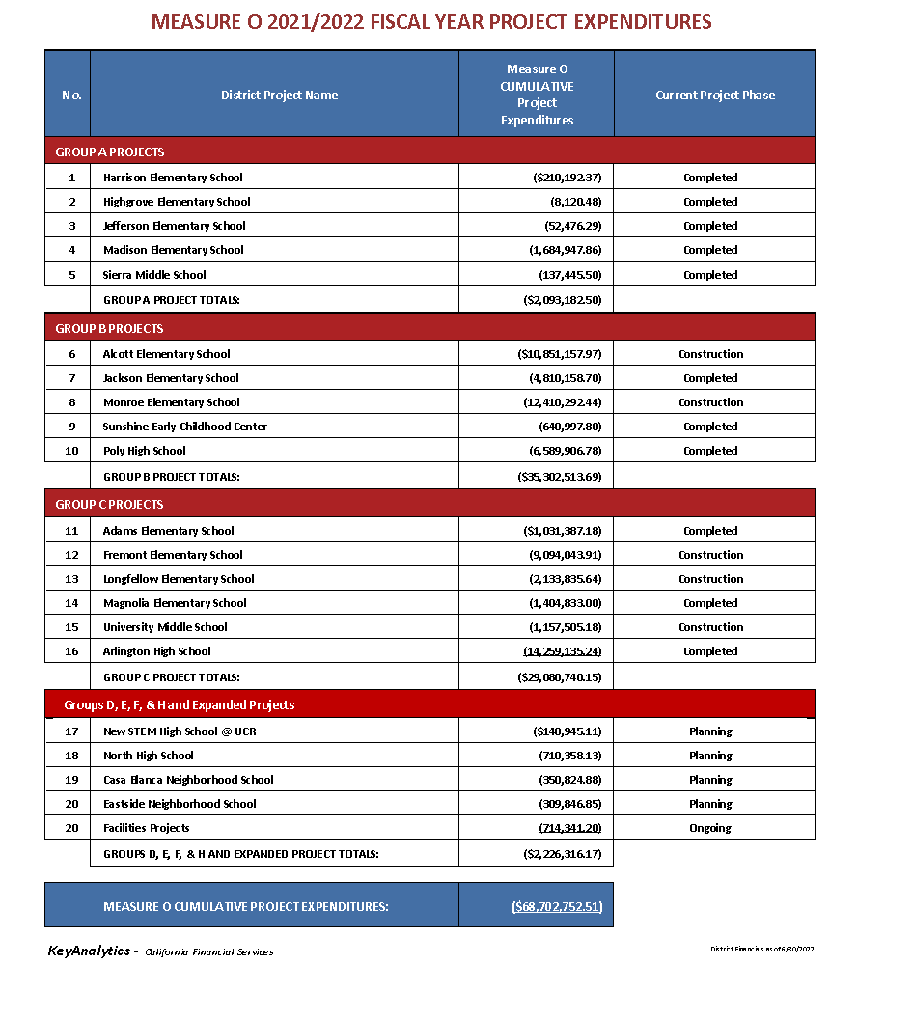

**Financial and Performance Audit Report** 

**Current Year**

**22-23 FY**

https://www.riversideunified.org/departments/business_services/financial_reporting_and_disclosure

**Previous Years**

**21-22 FY**

[https://www.riversideunified.org/common/pages/DisplayFile](https://bit.ly/3ZiAd9A)

**20-21 FY**

<https://www.riversideunified.org/common/pages/DisplayFile.aspx?itemId=17120698>

**19-20 FY**

<https://riversideunified.org/common/pages/DisplayFile.aspx?itemId=15819381>

**18-19 FY**

<https://www.riversideunified.org/common/pages/DisplayFile.aspx?itemId=22071346>

**17-18 FY**

<https://www.riversideunified.org/common/pages/DisplayFile.aspx?itemId=22071348>

**16-17 FY**

<https://www.riversideunified.org/common/pages/DisplayFile.aspx?itemId=22073298>

**Citizens’ Bond Oversight Committee Statement**

The Riverside Unified School District Citizens’ Bond Oversight Committee submits this Annual Report to the Board of Education in conformance with the standards of the Strict Accountability in Local School Construction Bond Act also known as Proposition 39 (California Constitution, Article XIII A, Section 1(b)(3)).

Respectfully Submitted,

_______________________________________

Ms. Chani Beeman, Chairperson

Citizens’ Bond Oversight Committee

Riverside Unified School District