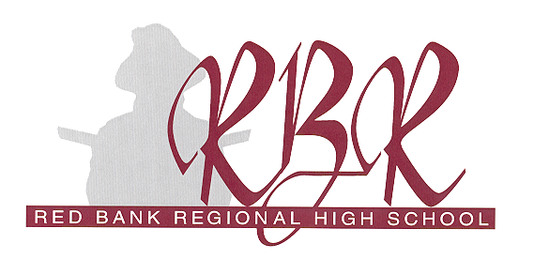

101 Ridge Road
Little Silver, New Jersey 07739
732-842-8000 ext.1-214

Official Document Release Request

Name: ______________________________________________Year of Graduation: ______________
(As it appears on school records)

Address: _____________________________________________________________________________________
_____________________________________________________________________________________

Telephone #: _________________________________________________________________________

Date of Birth: ____________________________Social Security #: _____________________________

I hereby authorize Red Bank Regional High School to release my official transcript to:

School Name: ________________________________________________

Attention: ________________________________________________

Address: ________________________________________________

________________________________________________

_________________________________________________________ _______________
Student Signature Date

______________________________
Date Sent

