**Summer Assignment: Global Studies**

***SUBMISSION DIRECTIONS: MAKE YOUR OWN COPY OF THE GOOGLE DOCUMENT and print the document.*** *Answer all of the focus questions for Parts I and II of the assignment. You may choose to type or handwrite your responses but* ***be prepared to submit a hardcopy of the assignment on the opening day of class****.*

**PART I: HISTORICAL TERMS**

When historians analyze the past, they often divide their thinking into categories like **political**, **economic**, and **sociocultural** to better understand different aspects of historical events and developments. There are terms in each category that students of history should be familiar with in order to better understand those events and developments. Below is a brief description of each of the categories and a list of terms that are important in each category.

**Political** - This category focuses on power, governance, and authority. It includes:

* Forms of government (e.g., monarchy, democracy, dictatorship)
* Laws and legal systems
* Wars, revolutions, and treaties
* Territorial disputes and borders
* Imperialism, colonialism, and decolonization
* Alliances and rivalries between nations

**Economic** - This category deals with resources, trade, and labor—how wealth is produced, distributed, and consumed. It includes:

* Agriculture and industry
* Trade networks and markets
* Taxes and currency
* Labor systems (e.g., slavery, feudalism, capitalism)
* Class structures based on wealth

**Sociocultural** - This broad category looks at innovations, ideas, beliefs, and ways of life. It includes:

* Religion and philosophy
* Art, literature, education, science and technology
* Customs and traditions
* Ethnic and racial identities
* Social norms and values

**HISTORICAL TERMS:**

| **Political Terms** | **Economic Terms** | **Sociocultural Terms** |
| --- | --- | --- |
| Democracy Imperialism  Republic Colonialism  Autocratic  Authoritarian  Totalitarianism  Monarchy Centralized vs  Theocracy Decentralized  Sovereignty | Economy  Capitalism  Communism  Socialism  Mercantilism | Cultural Diffusion  Social Class  Diaspora |

**Definitions:**

**Cultural Diffusion** – The spread of cultural beliefs, practices, and technologies from one society to another.

**Sovereignty** – The ability of a country to govern itself without interference from outside forces.

**Democracy** – A system of government in which citizens have the power to make decisions by voting.

**Monarchy** – A government ruled by a king, queen, or royal family, with leadership typically inherited through generations.

**Totalitarianism** – A form of government in which the state seeks to control all aspects of life, including individual freedoms and beliefs.

**Autocratic** – A system where a single leader holds absolute power, leaving little or no influence for the people in decision-making.

**Republic** – A type of government where officials are chosen by the people to represent their interests and make decisions.

**Capitalism** – An economic system where businesses are privately owned and profit-driven, with minimal government control.

**Communism** – A system where all property is owned collectively, and there are no private businesses, with the goal of equal distribution of wealth.

**Socialism** – A system where the government manages key industries and wealth is more evenly distributed among the population.

**Mercantilism –** An economic system where nations try to get rich by controlling trade and using colonies for resources and markets.

**Theocracy** – A government system in which religious leaders or religious laws hold the power to rule.

**Imperialism** – The practice of expanding a nation’s power and influence by controlling other regions or countries.

**Diaspora –** The scattering or movement of people from their original homeland to different places around the world.

**Decentralized** – A system where power and decision-making are spread out across various levels of government, like local, regional, and national.

**Centralized** – A system where the central government holds the majority of the power and makes most of the important decisions.

**Colonialism** – The act of establishing and maintaining colonies in foreign lands to extract resources and increase wealth for the home country.

**Social Class** – A division of society into groups based on factors like wealth, occupation, or family status.

**TERMS PRACTICE:**

**Fill in the blanks with the appropriate term from the list above.**

Governments around the world vary in how they are structured and how power is distributed. One important concept in government is ___________________ (1), which refers to a nation's ability to govern itself without outside interference. In a _______________ (2), the people have the power to vote and make decisions directly. Another system, called a ______________ (3), allows officials elected by the people to represent them and make decisions on their behalf.

In some systems, power is concentrated in the hands of one person, known as an _____________ (4) government. This type of government limits the people's involvement in decision-making. In contrast, a more extreme form of control is seen in _____________ (5), where the government not only controls political life but also seeks to control every aspect of daily life, including the beliefs of its citizens.

Another form of government is a _______________ (6), where the leadership is passed down through generations, typically within a royal family. Some countries are governed by religious leaders or based on religious laws, which is known as a ______________ (7).

The way power is distributed within a country can also vary. A ______________ (8) system divides power across different levels of government, such as national, regional, and local. On the other hand, a ______________ (9) system consolidates power, meaning that power is concentrated in one central government that makes most decisions.

Throughout history, many powerful nations practiced _________________ (10), which involved extending their influence over other territories to increase their power and wealth. This often led to _______________ (11), where countries set up colonies in other regions to extract resources and gain economic control.

Countries also differ in how they manage their economies. __________________ (12) is an economic system where businesses are owned privately and operate for profit. Some people argue for a different system, like ___________________ (13), where the government controls major industries and wealth is shared more equally among the people. Another system, called _________________ (14), promotes the idea of equal ownership of all resources and goods, with no private businesses.

Another economic theory, __________________ (15), is focused on accumulating wealth through trade, often using colonies to secure resources and markets. As countries trade and interact with each other, __________________ (16) happens, which is the spread of cultural beliefs, practices, and technologies from one society to another.

Within a society, people are often divided into different __________________ (17), based on factors like wealth, occupation, or family background. These divisions can shape the opportunities and challenges people face. Over time, groups of people may move away from their original homeland, forming a ___________________ (18), where they live in new places but continue to keep ties to their culture and heritage.

**Synthesis Question: In our first unit we will be discussing the following terms/concepts. Rank the terms based on how much people can participate in the government system - those systems with the least participation to those systems with the most participation. Justify your rankings. Terms:Theocracy, Monarchy, Republic, Democracy, Centralized, Decentralized**

**Part II: Application - Life in Medieval Europe**

Directions: First, please read the background information as it provides important context for the application. Next, you'll work with a set of historical documents to **analyze**, **interpret**, and **group evidence based on the categories discussed in Part I of the assignment**. The activity will help you focus on developing **historical thinking skills.** The information included in the background and application exercise will be the foundation for class discussions in our opening days.

**BACKGROUND:**

Following the breakdown of the Roman Empire in 476 CE, Western Europe entered an interim period marked by instability that was known as the Middle Ages or the medieval period. Roman rule was replaced by a collection of Germanic tribal kingdoms that fought one another for power and territory. Some historians call the period dating from roughly 500 to 1500 CE the “Dark Ages,” because learning was less widespread than in Roman times and cities were in decline due to tribal warfare and outside invasions from Vikings and Muslim armies. Outside invasions pressured Western European kingdoms and contributed to decentralization of power and chaos in the region.

Politically and socially, the medieval period was characterized by the feudal system. Feudalism grew out of people’s need for protection. With no strong kings to maintain law and order, people turned to local lords for help. Kings offered land, called fiefs, to lords in exchange for loyalty and military service. In turn, lords would provide protection to peasants, some called serfs and some called freedmen, in exchange for labor and food production on the lord’s manor.

The manor supported feudalism economically. Manor grounds included a three field system in which crops were rotated in and out of three fields. Manor grounds also included a church, a blacksmith shop, a mill and homes for serfs and freedmen. The manor system was self-sufficient, providing everything necessary for the people on the manor.

Culturally, the Roman Catholic Church was extremely influential during the Middle Ages. Indeed, it was the only authority that covered much of Europe. Many factors helped the Church keep its influence. First, few people knew how to read or write. Most Church staff, however, were literate. If common people needed something written or read, they asked a Church official to do it. Most manors had a small church and a priest on the grounds. The Catholic faith was central to life in the medieval period with its influence reflected in much of the art, architecture, literature and social institutions of the time.

**DOCUMENT BASED QUESTIONS:**

Use the background information and the source to answer the document based questions.

**Document 1: Source - The Middle Ages, Frantz Funck-Brentano, Heinemann, 1922 (adapted)**

“The barbarians have broken through the ramparts [defensive wall]. The Saracen [Moors] invasions have spread in successive waves over the South. The Hungarians swarm over the Eastern provinces...they sacked town and village, and laid waste in the fields. They burned down the churches and then departed with a crowd of captives.... There is no longer any trade, only unceasing terror.... The peasant has abandoned his ravaged fields to avoid the violence of anarchy. The people have gone to cower [crouch down in fear] in the depths of the forests or in inaccessible regions, or have taken refuge in the high mountains...Society has no longer any government.”

***According to the author, what were conditions like in Europe during the 800s?***

***How did these conditions contribute to the rise of feudalism in Europe?***

**Document 2:**

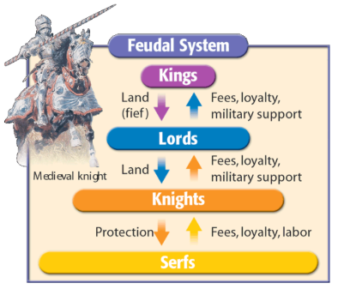

***Explain the mutual obligations(s) as illustrated in this diagram. What was exchanged at each level of the social hierarchy?***

***How does the chart illustrate that feudalism was a decentralized system of governing?***

**Document 3: Source - Excerpt from a letter of Pope Innocent III, 1198**

“The Creator set up two great lights in the heavens; the greater light to rule the day, the lesser light to rule the night. In the same way, the Church has set up two great lights on earth; the greater light, being the Pope, to rule over souls; the lesser light, being the king, to rule over bodies. Just as the moon’s light comes from the sun, does the power of the king come from the Pope. The more closely a king is willing to follow the Pope's rule, the greater his light will be.”

***According to Pope Innocent III, who holds the greater power: the Pope or the King? How does the Pope explain this?***

***How does this document reflect the influence and power of the Catholic Church?***

**Document 4: Source - Kime and Stich, Global History and Geography, STAReview, N & N Publishing Company**

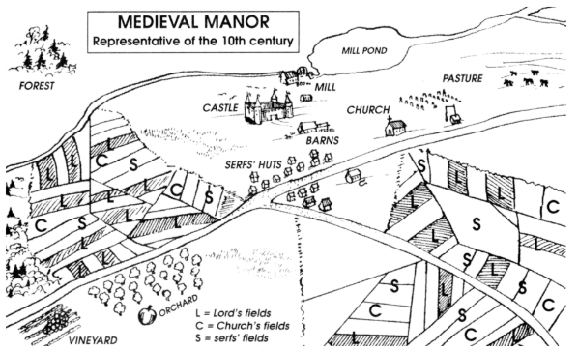

***Based on this diagram, state one economic characteristic of the medieval manor.***

***What evidence does this document provide to prove that the medieval manor was self-sufficient?***

**Document 5: Source- Susan Ramirez et al., World History: Human Legacy, Holt**

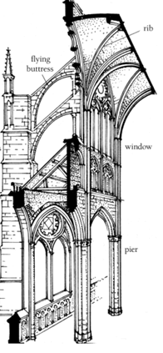

During the later Middle Ages, churches were built in the new Gothic style. Gothic churches were both taller and brighter than earlier churches had been. The design of Gothic churches was made possible by advances in engineering. The most important of these advances was a new type of support called the flying buttress. Earlier churches had used interior columns and braces to support the roof which meant that ceilings were low. Flying buttresses supported a church’s walls from the outside, allowing much higher ceilings and largely eliminating the need for columns. This gave churches a much more [wide-open] feeling.… Church builders were [also] able to include much larger windows than ever before. In order to take advantage of this light, church officials hired artists to create panels of stained glass for the windows.

***How did flying buttresses on Gothic cathedrals improve the spiritual experience of being in a church or cathedral?***

***How might the cathedral illustrate the cultural and social power of the Catholic Church in Medieval Europe?***

**Document 6: Source - Norman F. Cantor, The Civilization of the Middle Ages, Harper Perennial**

“. . . Of necessity, the manor was a self-sufficient economic unit in view of the overwhelming difficulties of transportation in the period. International trade was carried on only to serve the demands of the wealthy, and it was largely in the hands of aliens [different peoples]—Greeks, Jews, Muslims. Local society made almost no use of money. To the extent that local exchange was carried on, it was conducted by barter. The small amount of international trade precluded [ruled out] the need for gold coinage. The Carolingians minted only silver coins, which were all that was usually necessary when the smallest silver coin could buy a cow. When gold coins were needed, Byzantine and Muslim currency was used. . . .”

***According to the source, what are two ways manorialism influenced the economy of***

***Europe?***

**CATEGORIZING HISTORICAL EVIDENCE:**

**Identify which of the documents fall under each of the following categories.**

| ***Political Documents*** | ***Economic Documents*** | ***Sociocultural Documents*** |
| --- | --- | --- |
|  |  |  |