# AP EUROPEAN HISTORY - SUMMER ASSIGNMENT

*What you will need for AP European History:*

* A binder to organize handouts – nothing smaller than 2” – you may want to consider a smaller binder for class and a larger one at home to consolidate completed chapters
* Someplace to keep class notes – this can be a notebook, notepaper, or in Google Docs
* Consumable books
  + VERY STRONGLY RECOMMENDED: *Barron’s AP European History*. The 2024 version is the most current. This can be purchased through any online book retailer*.*  A new copy is encouraged, so that you will have use of the online resources that accompany the book.
    - **This book is not required for the course, but if you are planning to take the AP Exam in May, it will be a valuable resource.**
  + If you would like to purchase an additional study guide for practice and review, *5 Steps to a 5* or *AP Achiever* are well reviewed.

I can be reached at [ashe@ndnj.org](mailto:ashe@ndnj.org) over the summer. I check my e-mail about once a week, so I will get back to you about any questions, but it might take a few days.

**Textbook readings**: A PDF of the textbook can be found at this link: [CHAPTER 11 AND 12](https://drive.google.com/file/d/1zUz6dsReM1CIoG-dqie2SQ1ewT-BR0jN/view?usp=sharing). It is hosted on Google Drive. You **must** be logged into your ND email account in order to be able to view the file.

**Assignments Overview:**

**Assignment 1: 10 Maps on European History – Due 9/2 (Tuesday after Labor Day)**

**Assignment 2: Chapter 12 Reading Guide – Due 9/4 (Thursday after Labor Day)**

**Assignment 3: Renaissance Art Summary – Due 9/8 (Monday)**

**Assignment 1: Maps of Europe – Due 9/2 - Due in Hard Copy**

Please use the map set linked here on [10 Maps on European History](https://www.worldhistory.org/collection/215/10-maps-on-european-history/) to complete the guided analysis questions. They can be found on page 4 of this packet.

**Chapter 11: The Later Middle Ages**

No historical events take place in a vacuum. Two of the most important skills we will be practicing in this course are causation and continuity/change over time – the connections between events, to understand why things happened and how they changed or didn’t change. You can’t talk about the Renaissance without first understanding the period that preceded it.

Read Chapter Eleven, “The Later Middle Ages”. The link to the online PDF of the text is posted on page 1 of this packet. At the end of the reading, you should be familiar with the following ideas and concepts:

1. How did the spread of the plague shape European society?
2. How did the Hundred Years’ War contribute to a new sense of nationhood in England and France?
3. What challenges faced the Catholic Church in the 14th century, and how did church leaders, intellectuals, and ordinary people respond?
4. How did the literature of the era reflect the events, circumstances, and values of the era?

**Suggested viewing: Crash Course World History and World History II on You Tube**

* + Crash Course World History
    - Christianity from Judaism to Constantine
    - Fall of the Roman Empire
    - The Dark Ages…How Dark Were They, Really?
    - The Crusades: Pilgrimage or Holy War?
    - Venice and the Ottoman Empire
    - Russia, the Kievan Rus, and the Mongols
  + Crash Course World History II
    - Disease
    - Climate Change, Chaos, and the Little Ice Age
    - The Vikings
  + Crash Course European History
    - The Middle Ages

Suggested Listening:

* Everything Everywhere Daily - Were the dark ages really that dark? Found [HERE](https://everything-everywhere.com/were-the-dark-ages-really-that-dark/)

**Chapter 12: European Society in the Age of the Renaissance**

**ASSIGNMENT # 2 – Chapter 12 Reading Guide – Due 9/4 - Due in Hard Copy**

*Directions*: Read Chapter 12. Use the information in Chapter 12 to complete the attached reading guide. Resist the temptation to simply google all the answers. You will be doing yourself a disservice not to actually read the chapter.

**ASSIGNMENT # 3 - Art Summary – Due 9/9 - Due Digitally**

Following the model provided, write an art summary outline for the Renaissance. You may use any scholarly source you like for your research into the style. The Annotated Mona Lisa, theartstory.org (they also have a nice app), and Encyclopedia Britannica are all good places to start. Art outlines MUST be typed, and MUST be submitted to Turnitin.com to receive full credit.

Note: Renaissance is the style. The characteristics (what would we notice when we look at a painting from this style) and development (technical elements of a painting) should be for the Renaissance as a whole, not just the single representative work you chose.

*For the Renaissance art summary, you MUST address the differences between Northern and Italian art and techniques, and you MUST include Michelangelo and Jan Van Eyck as two of your artists.*

*Turnitin.com Directions*: You should have already used this program in past history classes. Login via the Google button and use your NDNJ account. The Turnitin.com class ID and password will be provided in the first week of school.

*Vocabulary Directions*: The following terms are essential concepts, people, events, and ideas that you should know by the end of the chapter. We will have regular vocabulary quizzes throughout the semester, some in class and some online. You can use any resource you like to define terms and study for your quizzes, but remember that many Quizlets are made by students and may not be wholly accurate.

*Remember – students make Quizlet!

1. Renaissance
2. Francesco Petrarch
3. Pico della Mirandola
4. Humanism
5. Individualism (the book talks about it but doesn’t use the term)
6. Girolamo Savonarola
7. Cesare Borgia
8. The Medici Family
9. Niccolo Machiavelli
10. Virtu
11. The Donation of Constantine
12. Donatello
13. Leonardo DaVinci
14. Michelangelo
15. Northern Renaissance
16. Johann Gutenberg
17. Christian humanism
18. Jan van Eyck
19. Thomas More
20. Christine de Pizan
21. Desiderius Erasmus
22. Wars of the Roses
23. New Monarchs (Ferdinand and Isabella of Spain, Henry VII of England)
24. New Christians

**10 Maps on European History**

*Use the link provided on page 1 of this packet to access the map set.*

In addition to providing geographical information, maps can be valuable tools to help historians understand change. Europe is a continent (some scholars question this traditional interpretation, but that’s a separate story) that has undergone tremendous and often rapid transformation. This set of 10 maps helps us appreciate the dynamic nature of European society, illustrating the dramatic political, religious, and social changes that have happened over the centuries.

1. Choose one map from the set. Identify the following:
   1. What time period does this map represent?
   2. What data is being presented?
   3. How does this map differ from the one(s) before/after it in the set?
   4. What conclusions can you draw about European history from this map?
2. Consider the map set as a whole and answer the following questions:
   1. How do the maps in this collection reflect the shifting power dynamics in Europe over time?
   2. How can analyzing maps help us understand the causes and effects of territorial conflicts in Europe?
   3. What limitations might these maps have in conveying the complexities of historical events?
   4. How can maps be used to support or refuse historical arguments?
3. Consider map #3, Europe before the fall of Constantinople, c. 1450. (This is where our timeline officially begins). How does the map of Europe in this time compare to the map of Europe today? What has changed in 600 years? What remains the same?
4. Consider map #10, Europe at the end of WWI, 1918. How does the map of Europe in this time compare to the map of Europe today? What has changed in just over 100 years? What remains the same?

*Please type your answers in a separate document and bring the hard copy to school on Tuesday, 9/3. Answers will be collected at that time.*

Art Styles Outline Format

Picture of an especially notable work of the period, with artist and title

Style

Years (approximate)

Major Characteristics of the Style

Developments: new techniques, styles, subgenres, and themes

5-6 Major figures (with a brief synopsis of career including important works):

5-6 Major works that best exemplify the style, with an explanation as to why:

Impact, both on culture and on artistic style to come:

Works Cited (in proper Chicago/Turabian format)

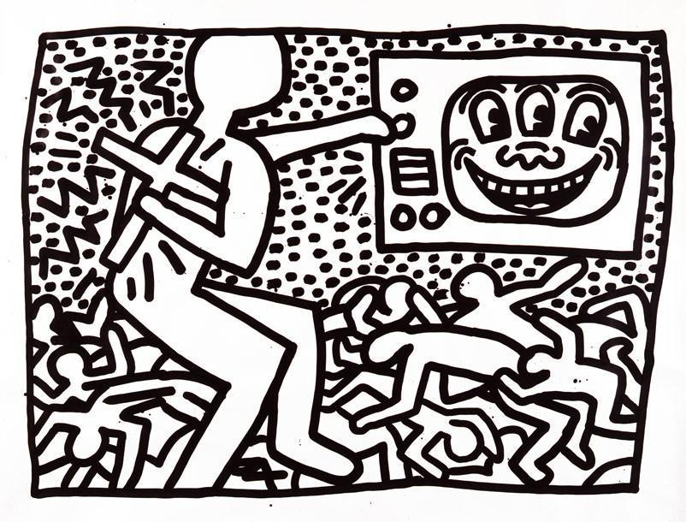  
“Untitled,” Keith Haring

* **Style:** Post-Modernism
* **Years:** Late 20th Century
* **Characteristics:** reaction against artistic influences of the modern period. More political, focusing on contemporary issues like AIDS, homelessness, racism, violence. Used a variety of materials and formats, such as photography and video art, as well as performance art. Postmodern art is meant to be ironic or playful, and blur the line between low and high concepts of art, often with little respect for authority. Lots of emphasis is placed on being original and authentic.
* **Developments**
  + Pop Art makes use of popular culture in art for the first time
  + Photography is more widely used
  + Sub genres include pop art (based on consumer culture), neo-expressionism (based on political commentary), international styles (including African, Latin American, and Asian), and cartooning
  + Graffiti and cartoon are considered art styles for the first time
  + Art does not necessarily have one meaning, determined by the artist. Interactive works became more common.
  + Revisited old painting styles for purposes of parody and pastiche
* **Major figures**:
  + *Julian Schnabel* - American artist and filmmaker, Schnabel forms a bridge between neo-Expressionism and post-modernism. Famous for his "plate paintings"—large-scale paintings set on broken ceramic plates. Uses a variety of materials to create paintings that are almost sculptural. Schnabel claims that he's *aiming at an emotional state, a state that people can literally walk into and be engulfed*. Directed Oscar-nominated film “The Diving Bell and the Butterfly.” Important works include “Hope”
  + *Barbara Kruger* – American conceptual artist. Famous for photographs with bold, declarative captions. Addresses cultural constructions of power, identity, and sexuality. Goal was to create art that was often superficial, without deeper meaning, similar to many Pop artists. Considered to be one of the founders of camp aesthetic in art. Major works include “Belief + Doubt,” “I Shop therefore I Am,” and “Picture This.”
  + *Robert Longo* – American painter and sculptor. Leading figure in the appropriation art subgenre. Best known for the “Men in the City” series and “Cindy”, using dramatized poses and black and white clothing to emphasize sculptural qualities in drawing. Works with illustrator Diane Shea. Also a director of film and music videos.
  + *Cindy Sherman* – American photographer and film director. Best known for portrait work. Emphasizes the role of women in the arts. Focused on the rift between reality and filmed roles and identities of women. Is often the subject of her own photographs, done in series based around a single theme. Best known for the “Untitled Film Stills” series.
  + *Eric Fischl* – American painter, sculptor, and printmaker. Neoexpressionist artist who worked mainly in American suburbs. Often compared to Edgar Degas for his use of light and color to depict individuals. Self-described “painter of the suburbs.” Work often focuses on issues of sexuality. Famous works include “Sleepwalker,” “Bad Boy,” and “Birthday Boy.”
* **Major Works**:
  + “Hope,” Schnabel – A good example of the post-modern style because it illustrates appropriation art and makes a statement on the AIDS crisis.
  + “untitled #228,” Sherman – Illustrates the transformative nature of photographic art. Also an example of appropriation art because it was based on paintings done by the Old Masters.
  + “Cindy,” Longo – draws on commercial images to comment on urban life. Though not specifically pop art, has a similar sensibility.
  + “A Visit To/A Visit From/The Island,” Fischl – In this work Fischl comments on immigration issues in the 20th century. The works are socially topical, and make use of a variety of painting techniques.
  + “untitled,” Keith Haring – Illustrates the rise of graffiti style and cartoon style art.
* **Impact** – Post-modernism has asked viewers of art to reconsider exactly what art is, and what subject matters are appropriate for the artist to touch on. The techniques were often graphic-design oriented, and photography played a much larger role in post-modernism than in earlier art forms.

Works Cited

“Postmodern Art.” *The Art Story: Modern Art Insight*. The Art Story Foundation. 2018. Accessed 5 May 2018.

“Postmodern Art.” *Wikipedia*. Wikimedia Foundation, Inc. 3 January 2018. Accessed 5 May 2018.

Strickland, Carol. *The Annotated Mona Lisa, Second Edition.* Kansas City: Andrews McMeel   
 Publishing. 2007.

