Anchorage School District Fine Arts Department

6th Grade Orchestra and Band Registration Slip and Contract

Commitment: Orchestra and Band is a one-year commitment. Once students are enrolled, they are expected to remain in the program for their entire sixth grade year.

Behavior: Excellent behavior is required. Orchestra and band classes are usually large. Class time is short; we need every minute for learning how to play the instruments!

Effort: Learning an instrument is a challenge! You get out of a musical instrument what you put into it. Students must try their best and develop a “can-do” attitude.

Home Practice: It is very important to set up a daily home practice schedule and stick to it. Consider instrument practice as daily homework.

Supplies: In addition to an instrument, certain supplies are required for class. Students must get all the supplies on the Supply List and bring their supplies and instrument to class every day.

Equipment: Musical instruments are fragile. Students must use all equipment properly and handle only their own instrument. Students and the responsible adult are liable for any damages they cause. Students work together to help set up and take down the chairs and stands in the room.

Performance: Students are expected to participate in all concerts. This includes daytime school assemblies and one or two evening performances.

Safety: Gum, candy, etc. are unsafe and are not allowed in class.

Grades: Each quarter, orchestra and band students will receive academic marks in instrumental music class. Marks are O, S, and N (Outstanding, Satisfactory, Needs Improvement).
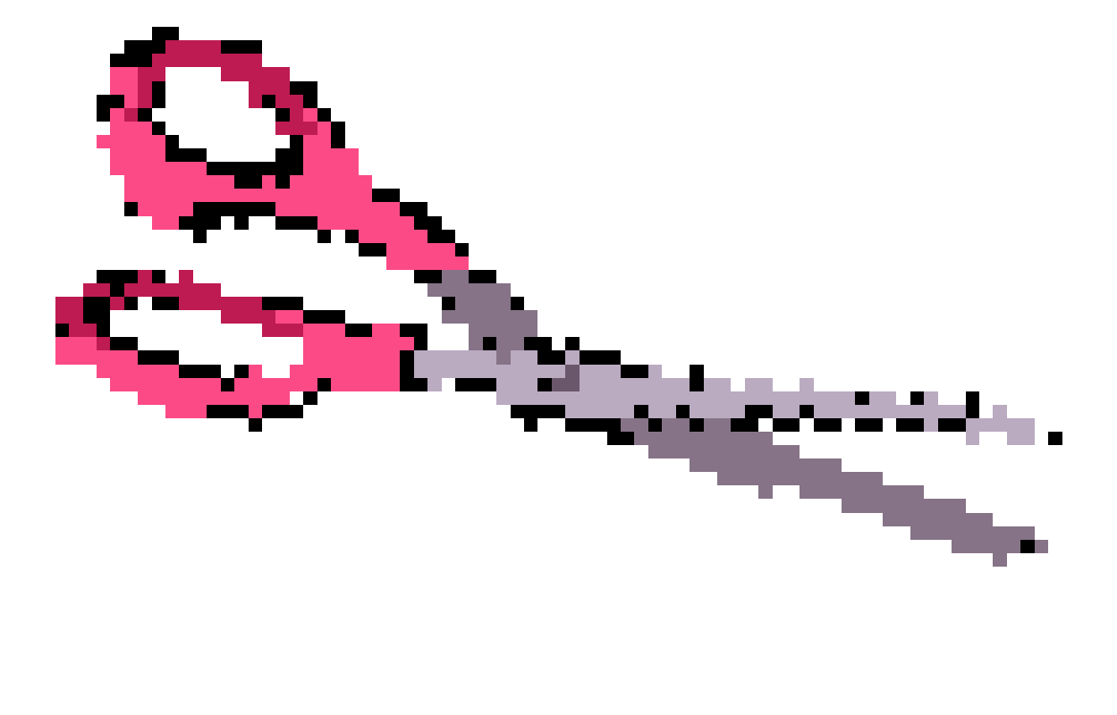 Please save top half and return bottom portion to your teacher by the second Friday in September.
-------------------------------------------------------------------------------------------------------------------

6th Grade Orchestra and Band Registration Slip and Contract

Name (please print) ________________________________________________ School _________________________________

Classroom Teacher _______________________ Name of Parent/Guardian(s) ________________________________________

Instrument 1st Choice ________________________________ Instrument 2nd Choice ________________________________

Primary Phone ____________________________________ Secondary Phone _______________________________________

Address ___________________________________________________________________ Zip Code ______________________

Email ______________________________________________________________________________________________________

Instrument(s) previously studied ____________________________________________ How long? ______________________

I have read and accepted the above contract and am ready to be a part of the instrumental music program at my school.

_______________________________________________________________
Student Signature

I have read and accepted the above contract and give my child permission to enroll in the instrumental music program.

_______________________________________________________________
Parent/Guardian Signature

